Assurance of Student Learning Report
2021-2022
Ogden College of Science and Engineering | School of Engineering and Applied Sciences
Electrical Engineering program, #537
Assessment coordinator: Walter Collett

Use this page to list learning outcomes, measurements, and summarize results for your program. Detailed information must be completed in the subsequent pages.
Student Learning Outcome 1: ABET EAC Outcome #1: Upon graduation our students have the ability to identify, formulate, and solve complex engineering problems by applying principles of engineering, science, and mathematics.
Instrument 1 | Artifacts assessed in certain courses/sections
Instrument 2 | Senior Exit Surveys
Based on your results, check whether the program met the goal Student Learning Outcome 1. |  | Met | Not Met
Student Learning Outcome 2: ABET EAC Outcome #2: Upon graduation, our students have the ability to apply engineering design to produce solutions that meet specified needs with consideration of public health, safety, and welfare, as well as global, cultural, social, environmental, and economic factors.
Instrument 1 | Artifacts assessed in certain courses/sections
Instrument 2 | Senior Exit Surveys
Based on your results, check whether the program met the goal Student Learning Outcome 2. |  | Met | Not Met
Student Learning Outcome 3: ABET EAC Outcome #3: Upon graduation, our students have the ability to communicate effectively with a range of audiences.
Instrument 1 | Artifacts assessed in certain courses/sections
Instrument 2 | Senior Exit Surveys
Based on your results, check whether the program met the goal Student Learning Outcome 3. |  | Met | Not Met
Student Learning Outcome 4: ABET EAC Outcome #4: Upon graduation, our students have the ability to recognize ethical and professional responsibilities in engineering situations and make informed judgments, which must consider the impact of engineering solutions in global, economic, environmental, and societal contexts.
Instrument 1 | Artifacts assessed in certain courses/sections
Instrument 2 | Senior Exit Surveys
Based on your results, check whether the program met the goal Student Learning Outcome 3. |  | Met | Not Met

Student Learning Outcome 5: ABET EAC Outcome #5: Upon graduation, our students have the ability to function effectively on a team whose members together provide leadership, create a collaborative and inclusive environment, establish goals, plan tasks, and meet objectives.
Instrument 1 | Artifacts assessed in certain courses/sections
Instrument 2 | Senior Exit Surveys
Based on your results, check whether the program met the goal Student Learning Outcome 3. |  | Met | Not Met
Student Learning Outcome 6: ABET EAC Outcome #6: Upon graduation, our students have the ability to develop and conduct appropriate experimentation, analyze and interpret data, and use engineering judgment to draw conclusions.
Instrument 1 | Artifacts assessed in certain courses/sections
Instrument 2 | Senior Exit Surveys
Based on your results, check whether the program met the goal Student Learning Outcome 3. |  | Met | Not Met
Student Learning Outcome 7: ABET EAC Outcome #7: Upon graduation, our students have the ability to acquire and apply new knowledge as needed, using appropriate learning strategies.
Instrument 1 | Artifacts assessed in certain courses/sections
Instrument 2 | Senior Exit Surveys
Based on your results, check whether the program met the goal Student Learning Outcome 3. |  | Met | Not Met
Program Summary (Briefly summarize the action and follow up items from your detailed responses on subsequent pages.)
All Student Learning Outcomes were met.

The EE program met on February 17, 2022, to discuss rubric results from Fall 2021 semester. No specific actions were identified as needed.

The EE program faculty conducted a course review for all EE courses taught in the 2020-2021 academic year. Recent changes to EE 300 were also discussed.

Student Learning Outcome 1
Student Learning Outcome | ABET EAC Outcome #1: Upon graduation our students have the ability to identify, formulate, and solve complex engineering problems by applying principles of engineering, science, and mathematics.
Measurement Instrument 1 | Artifacts were assessed in some or all sections of the following courses: EE 300, EE 420, EE 431, EE 460, EE 473, ENGR 490 and ENGR 491.
Criteria for Student Success | The following rubric is used when assessing student performance:  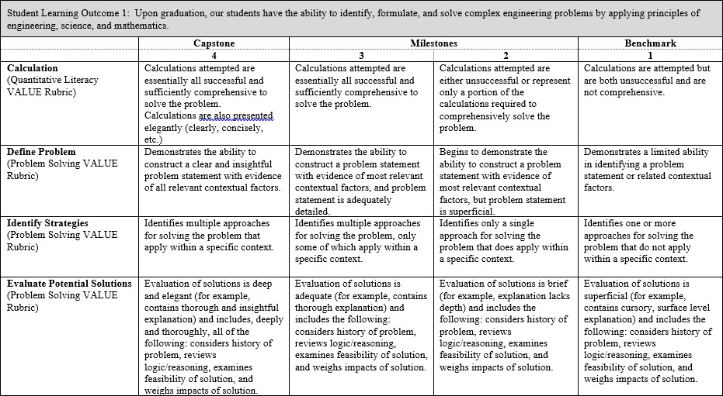  We look for a minimum average of 2.50 for each assessed junior-level course section, and 3.00 for each assessed senior-level course section. Of the courses assessed for this Outcome, EE 300, 420, 431 and 473 are considered junior-level, with the remaining courses considered senior-level.

Program Success Target for this Measurement |  |  | Target weighted averages are 2.50 for assessed junior-level course sections combined, and 3.00 for assessed senior-level course sections combined. |  | Percent of Program Achieving Target Weighted Averages for  course sections  assessed: | Junior-level course sections: 2.88 Senior-level course sections: 3.14
Methods | Instructors choose artifacts to assess, using the above rubric, in their respective courses/sections. These artifacts will be different course section-to-course section, instructor-to-instructor, and semester-to-semester. Each item of the rubric (e.g., calculation, define problem, etc.) was weighted equally when scoring the rubric. In some cases, specific items may not have been scored.  We looked at the average obtained for each course section assessed, with each of the junior-level course sections targeted to achieve a minimum average of 2.50, and each of the senior-level course sections targeted to achieve a minimum average of 3.00. It was observed that most assessed course sections met their targets, but a couple did not.  We also calculated two weighted rubric averages for this Outcome this academic year: one for all assessed junior-level course sections and one for all assessed senior-level course sections. This was done to determine if, overall, the Outcome was met. The minimum weighted averages were expected to be 2.50 and 3.00, respectively. This was our Program Success Target. As indicated above, we achieved averages of 2.88 and 3.14.
Measurement Instrument 2 | Senior Exit Surveys were given to students taking the senior design course during Fall 2021 and Spring 2022. Students were asked to “Rate your ability to identify, formulate, and solve complex engineering problems by applying principles of engineering, science, and mathematics” on a scale of 1 to 5 (with 5 being the highest).
Criteria for Student Success
Program Success Target for this Measurement |  | Target average of 3.75 |  | Percent of Program Achieving Target Weighted Average: |  | 4.11
Methods | For this year there were 15 scores total, 10 for Fall 2021 and 5 for Spring 2022. The above average of 4.11 is the average of all 15 scores received on this particular item from both semesters.
Based on your results, highlight whether the program met the goal Student Learning Outcome 1. |  |  |  |  |  | Met | Not Met
Actions (Describe the decision-making process and actions for program improvement. The actions should include a timeline.)
The EE program met on February 17, 2022, to discuss rubric results for Fall 2021 semester. We did not see a need to address the rubric scores for this particular Outcome.
Follow-Up (Provide your timeline for follow-up. If follow-up has occurred, describe how the actions above have resulted in program improvement.)
The EE program assessment plan calls for rubric collection each semester (fall and spring), and a meeting of EE faculty to discuss the rubric results.
Next Assessment Cycle Plan (Please describe your assessment plan timetable for this outcome)
See above.

Student Learning Outcome 2
Student Learning Outcome | ABET EAC Outcome #2: Upon graduation, our students have the ability to apply engineering design to produce solutions that meet specified needs with consideration of public health, safety, and welfare, as well as global, cultural, social, environmental, and economic factors.
Measurement Instrument 1 | Artifacts were assessed in some or all sections of the following courses: EE 300, ENGR 490, ENGR 491
Criteria for Student Success | The following rubric is used when assessing student performance:  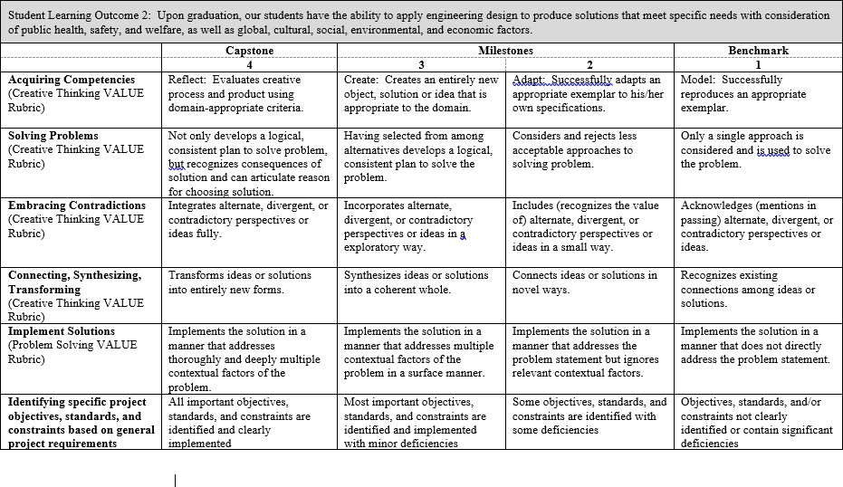  We look for a minimum average of 2.50 for each assessed junior-level course section, and 3.00 for each assessed senior-level course section. Of the courses assessed for this Outcome, EE 300 is considered junior-level, with the remaining courses considered senior-level
Program Success Target for this Measurement |  | Target weighted averages are 2.50 for assessed junior-level course sections combined, and 3.00 for assessed senior-level course sections combined. | Percent of Program Achieving  Target Weighted Averages for course  sections assessed: | Junior-level course sections: 2.55 Senior-level course sections: 3.17

Methods | Instructors choose artifacts to assess, using the above rubric, in their respective courses/sections. These artifacts will be different course section-to-course section, instructor-to-instructor, and semester-to-semester. Each item of the rubric (e.g., acquiring competencies, solving problems, etc.) was weighted equally when scoring the rubric. In some cases, specific items may not have been scored.  We looked at the average obtained for each course section assessed, with each of the junior-level course sections targeted to achieve a minimum average of 2.50, and each of the senior-level course sections targeted to achieve a minimum average of 3.00. It was observed that most assessed course sections met their targets.  We also calculated two weighted rubric averages for this Outcome this academic year: one for all assessed junior-level course sections and one for all assessed senior-level course sections. This was done to determine if, overall, the Outcome was met. The minimum weighted averages were expected to be 2.50 and 3.00, respectively. This was our Program Success Target. As indicated above, we achieved averages of 2.55 and 3.17.
Measurement Instrument 2 | Senior Exit Surveys were given to students taking the senior design course during Fall 2021 and Spring 2022. Students were asked to “Rate your ability to apply engineering design to produce solutions that meet specific needs with consideration for public health, safety, and welfare, as well as global, cultural, social, environmental, and economic factors” on a scale of 1 to 5 (with 5 being the highest).
Criteria for Student Success
Program Success Target for this Measurement |  | Target average of 3.75 | Percent of Program Achieving  Target Weighted Average: | 4.03
Methods | For this year there were 15 scores total, 10 for Fall 2021 and 5 for Spring 2022. The above average of 4.03 is the average of all 15 scores received on this particular item from both semesters.
Based on your results, circle or highlight whether the program met the goal Student Learning Outcome 2. |  |  |  | Met | Not Met
Actions (Describe the decision-making process and actions planned for program improvement. The actions should include a timeline.)
The EE program met on February 17, 2022, to discuss rubric results for Fall 2021 semester. We did not see a need to address the rubric scores for this particular Outcome.
Follow-Up (Provide your timeline for follow-up. If follow-up has occurred, describe how the actions above have resulted in program improvement.)
The EE program assessment plan calls for rubric collection each semester (fall and spring), and a meeting of EE faculty to discuss the rubric results.
Next Assessment Cycle Plan (Please describe your assessment plan timetable for this outcome)
See above.

Student Learning Outcome 3
Student Learning Outcome | ABET EAC Outcome #3: Upon graduation, our students have the ability to communicate effectively with a range of audiences.
Measurement Instrument 1 | Artifacts were assessed in some or all sections of the following courses: EE 300, E 345, EE 380, EE 460, ENGR 490, ENGR 491
Criteria for Student Success | The following rubrics are used when assessing student performance (NOTE: only written communication was assessed in EE 460):  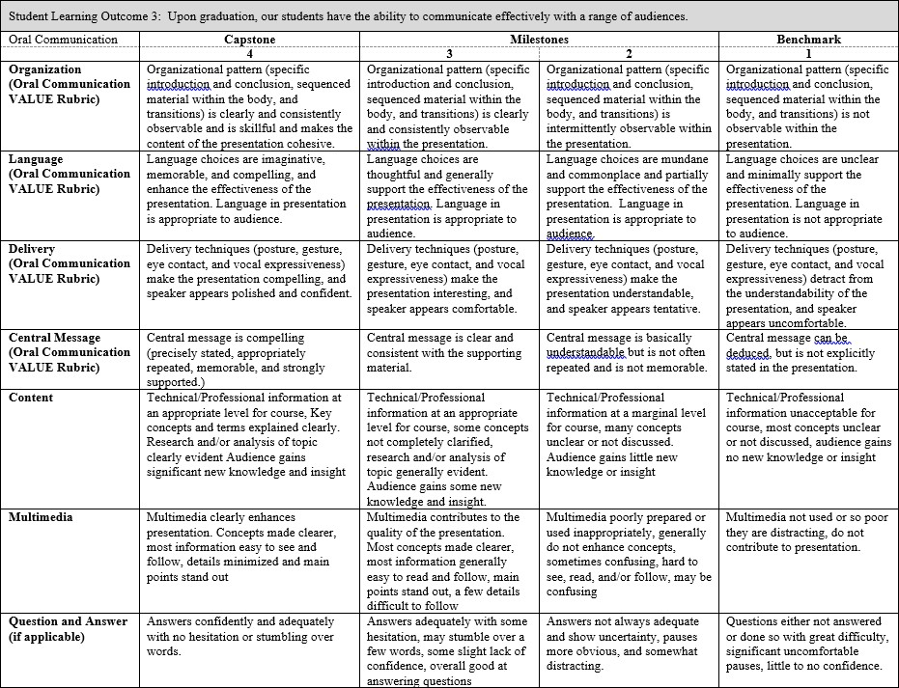

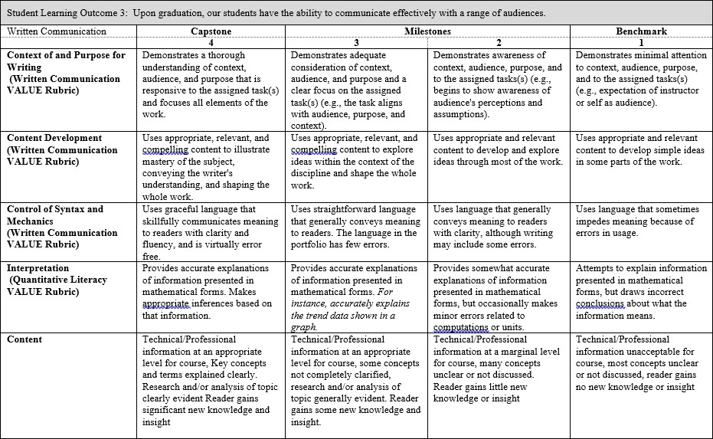
We look for a minimum average of 2.50 for each assessed junior-level course section, and 3.00 for each assessed senior-level course section. Of the courses assessed for this Outcome, EE 300, EE 345 and EE 380 are considered junior-level, with the remaining courses considered senior-level.
Program Success Target for this Measurement |  | Target weighted averages are 2.50 for assessed junior-level course sections combined, and 3.00 for assessed senior- level course sections combined. | Percent of Program Achieving Target Weighted Averages for course sections assessed: | junior-level course sections (oral): 3.40 junior-level course sections (written): 3.55 senior-level course sections (oral): 3.56 senior-level course sections (written): 3.45
Methods | Instructors choose artifacts to assess, using the above rubrics, in their respective courses/sections. These artifacts will be different course section-to-course section, instructor-to-instructor, and semester-to-semester. Each item of the rubrics (e.g., organization, language, etc.) was weighted equally when scoring the rubric. In some cases, specific items may not have been scored.

We looked at the average obtained for each course section assessed, with each of the junior-level course sections targeted to achieve a minimum average of 2.50, and each of the senior-level course sections targeted to achieve a minimum average of 3.00. It was observed that most assessed course sections met their targets.

We also calculated two sets of weighted rubric averages for this Outcome this academic year: one set for all assessed junior-level course sections and one set for all assessed senior-level course sections. This was done to determine if, overall, the Outcome was met. The minimum weighted averages were expected to be 2.50 and 3.00, respectively. This was our Program Success Target. As indicated above, we achieved averages of 3.40/3.55 (oral/written) and 3.56/3.45 (oral/written).
Measurement Instrument 2 | Senior Exit Surveys were given to students taking the senior design course during Fall 2021 and Spring 2022. Students were asked to “Rate your ability to communicate effectively with range of audiences” on a scale of 1 to 5 (with 5 being the highest).
Criteria for Student Success
Program Success Target for this Measurement |  | Target average of 3.75 | Percent of Program Achieving  Target Weighted Average: | 4.24
Methods | For this year there were 15 scores total, 10 for Fall 2021 and 5 for Spring 2022. The above average of 4.24 is the average of all 15 scores received on this particular item from both semesters.
Based on your results, circle or highlight whether the program met the goal Student Learning Outcome 3. |  |  |  | Met | Not Met
Actions (Describe the decision-making process and actions for program improvement. The actions should include a timeline.)
The EE program met on February 17, 2022, to discuss rubric results for Fall 2021 semester. We did not see a need to address the rubric scores for this particular Outcome.
Follow-Up (Provide your timeline for follow-up. If follow-up has occurred, describe how the actions above have resulted in program improvement.)
The EE program assessment plan calls for rubric collection each semester (fall and spring), and a meeting of EE faculty to discuss the rubric results.
Next Assessment Cycle Plan (Please describe your assessment plan timetable for this outcome)
See above.

Student Learning Outcome 4
Student Learning Outcome | ABET EAC Outcome #4: Upon graduation, our students have the ability to recognize ethical and professional responsibilities in engineering situations and make informed judgments, which must consider the impact of engineering solutions in global, economic, environmental, and societal contexts.
Measurement Instrument 1 | Artifacts were assessed in some or all sections of the following courses: EE 300, ENGR 490, ENGR 491
Criteria for Student Success | The following rubric is used when assessing student performance:  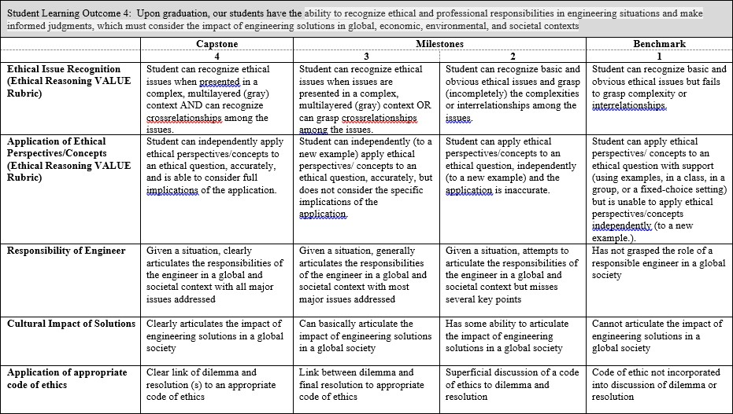  We look for a minimum average of 2.50 for each assessed junior-level course section, and 3.00 for each assessed senior-level course section. Of the courses assessed for this Outcome, EE 300 is considered junior-level, with the remaining courses considered senior-level.
Program Success Target for this Measurement |  | Target weighted averages are 2.50 for assessed junior-level course sections combined, and 3.00 for assessed senior- level course sections combined. | Percent of Program Achieving Target Weighted Averages for course sections assessed: | Junior-level course section: 3.08 Senior-level course sections: 3.52
Methods | Instructors choose artifacts to assess, using the above rubric, in their respective courses/sections. These artifacts will be different course section-to-course section, instructor-to-instructor, and semester-to-semester. Each item of the rubric (e.g., ethical issue recognition, application of ethical perspectives/concepts, etc.) was weighted equally when scoring the rubric. In some cases, specific items may not have been scored.  We looked at the average obtained for each course section assessed, with each of the junior-level course sections targeted to achieve a minimum average of 2.50, and each of the senior-level course sections targeted to achieve a minimum average of 3.00. It was observed that

all assessed course sections met their targets.

We also calculated two weighted rubric averages for this Outcome this academic year: one for all assessed junior-level course sections and one for all assessed senior-level course sections. This was done to determine if, overall, the Outcome was met. The minimum weighted averages were expected to be 2.50 and 3.00, respectively. This was our Program Success Target. As indicated above, we achieved averages of 3.08 and 3.52.
Measurement Instrument 2 | Senior Exit Surveys were given to students taking the senior design course during Fall 2021 and Spring 2022. Students were asked to “Rate your ability to ability to recognize ethical and professional responsibilities in engineering situations and make informed judgments, which must consider the impact of engineering solutions in global, economic, environmental, and societal contexts” on a scale of 1 to 5 (with 5 being the highest).
Criteria for Student Success
Program Success Target for this Measurement |  | Target average of 3.75 | Percent of Program Achieving  Target Weighted Average: | 4.15
Methods | For this year there were 15 scores total, 10 for Fall 2021 and 5 for Spring 2022. The above average of 4.15 is the average of all 15 scores received on this particular item from both semesters.
Based on your results, circle or highlight whether the program met the goal Student Learning Outcome 3. |  |  |  | Met | Not Met
Actions (Describe the decision-making process and actions for program improvement. The actions should include a timeline.)
The EE program met on February 17, 2022, to discuss rubric results for Fall 2021 semester. We did not see a need to address the rubric scores for this particular Outcome.
Follow-Up (Provide your timeline for follow-up. If follow-up has occurred, describe how the actions above have resulted in program improvement.)
The EE program assessment plan calls for rubric collection each semester (fall and spring), and a meeting of EE faculty to discuss the rubric results.
Next Assessment Cycle Plan (Please describe your assessment plan timetable for this outcome)
See above.

Student Learning Outcome 5
Student Learning Outcome | ABET EAC Outcome #5: Upon graduation, our students have the ability to function effectively on a team whose members together provide leadership, create a collaborative and inclusive environment, establish goals, plan tasks, and meet objectives.
Measurement Instrument 1 | Artifacts were assessed in some or all sections of the following courses: EE 300, EE 345, EE 431, ENGR 490, ENGR 491
Criteria for Student Success | The following rubric is used when assessing student performance:  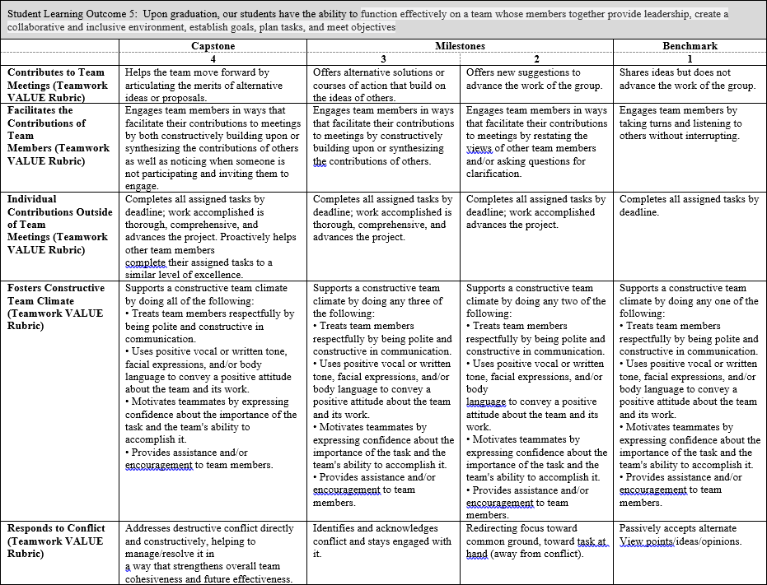  We look for a minimum average of 2.50 for each assessed junior-level course section, and 3.00 for each assessed senior-level course section. Of the courses assessed for this Outcome, EE 300, EE 345 and EE 431 are considered junior-level, with the remaining courses considered senior-level.
Program Success Target for this Measurement |  | Target weighted averages are 2.50 for | Percent of Program | Junior-level course sections: 3.23

 |  |  | assessed junior-level course sections combined, and 3.00 for assessed senior- level course sections combined. | Achieving Target Weighted Averages for course sections assessed: |  | Senior-level course sections: 3.22
Methods | Instructors choose artifacts to assess, using the above rubric, in their respective courses/sections. These artifacts will be different course section-to-course section, instructor-to-instructor, and semester-to-semester. Each item of the rubric (e.g., contributes to team meetings, facilitates the contributions of team members, etc.) was weighted equally when scoring the rubric. In some cases, specific items may not have been scored.  We looked at the average obtained for each course section assessed, with each of the junior-level course sections targeted to achieve a minimum average of 2.50, and each of the senior-level course sections targeted to achieve a minimum average of 3.00. It was observed that most assessed course sections met their targets, but one did not.  We also calculated two weighted rubric averages for this Outcome this academic year: one for all assessed junior-level course sections and one for all assessed senior-level course sections. This was done to determine if, overall, the Outcome was met. The minimum weighted averages were expected to be 2.50 and 3.00, respectively. This was our Program Success Target. As indicated above, we achieved averages of 3.23 and 3.22.
Measurement Instrument 2 | Senior Exit Surveys were given to students taking the senior design course during Fall 2021 and Spring 2022. Students were asked to “Rate your ability to function effectively on a team whose members together provide leadership, create a collaborative and inclusive environment, establish goals, plan tasks, and meet objectives” on a scale of 1 to 5 (with 5 being the highest).
Criteria for Student Success
Program Success Target for this Measurement |  | Target average of 3.75 |  |  | Percent of Program Achieving  Target Weighted Average: |  | 4.42
Methods | For this year there were 15 scores total, 10 for Fall 2021 and 5 for Spring 2022. The above average of 4.42 is the average of all 15 scores received on this particular item from both semesters.
Based on your results, circle or highlight whether the program met the goal Student Learning Outcome 3. |  |  |  |  |  |  | Met | Not Met
Actions (Describe the decision-making process and actions for program improvement. The actions should include a timeline.)
The EE program met on February 17, 2022, to discuss rubric results for Fall 2021 semester. We did not see a need to address the rubric scores for this particular Outcome.
Follow-Up (Provide your timeline for follow-up. If follow-up has occurred, describe how the actions above have resulted in program improvement.)
The EE program assessment plan calls for rubric collection each semester (fall and spring), and a meeting of EE faculty to discuss the rubric results.
Next Assessment Cycle Plan (Please describe your assessment plan timetable for this outcome)
See above.

Student Learning Outcome 6
Student Learning Outcome | ABET EAC Outcome #6: Upon graduation, our students have the ability to develop and conduct appropriate experimentation, analyze and interpret data, and use engineering judgment to draw conclusions.
Measurement Instrument 1 | Artifacts were assessed in some or all sections of the following courses: EE 345, EE 380, EE 431, EE 460, ENGR 490 and ENGR 491
Criteria for Student Success | The following rubric is used when assessing student performance:  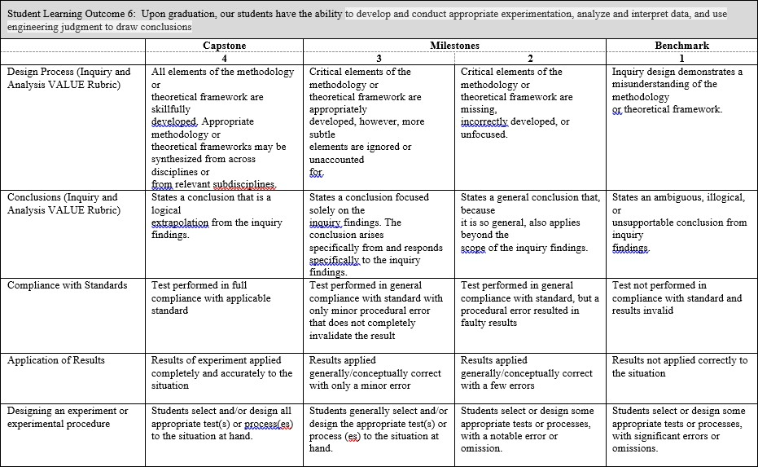  We look for a minimum average of 2.50 for each assessed junior-level course section, and 3.00 for each assessed senior-level course section. Of the courses assessed for this Outcome, EE 345, EE 380 and EE 431 are considered junior-level, with the remaining courses considered senior-level.
Program Success Target for this Measurement |  | Target weighted averages are 2.50 for assessed junior-level course sections combined, and 3.00 for assessed senior- level course sections combined. | Percent of Program Achieving Target Weighted Averages for course sections assessed: | Junior-level course sections: 3.38 Senior-level course sections: 3.33

Methods | Instructors choose artifacts to assess, using the above rubric, in their respective courses/sections. These artifacts will be different course section-to-course section, instructor-to-instructor, and semester-to-semester. Each item of the rubric (e.g., design process, conclusions, etc.) was weighted equally when scoring the rubric. In some cases, specific items may not have been scored.  We looked at the average obtained for each course section assessed, with each of the junior-level course sections targeted to achieve a minimum average of 2.50, and each of the senior-level course sections targeted to achieve a minimum average of 3.00. It was observed that most assessed course sections met their targets, but one did not.  We also calculated two weighted rubric averages for this Outcome this academic year: one for all assessed junior-level course sections and one for all assessed senior-level course sections. This was done to determine if, overall, the Outcome was met. The minimum weighted averages were expected to be 2.50 and 3.00, respectively. This was our Program Success Target. As indicated above, we achieved averages of 3.38 and 3.33.
Measurement Instrument 2 | Senior Exit Surveys were given to students taking the senior design course during Fall 2021 and Spring 2022. Students were asked to “Rate your ability to develop and conduct appropriate experimentation, analyze and interpret data, and use engineering judgment to draw conclusions” on a scale of 1 to 5 (with 5 being the highest).
Criteria for Student Success
Program Success Target for this Measurement |  | Target average of 3.75 | Percent of Program Achieving  Target Weighted Average: | 4.06
Methods | For this year there were 15 scores total, 10 for Fall 2021 and 5 for Spring 2022. The above average of 4.06 is the average of all 15 scores received on this particular item from both semesters.
Based on your results, circle or highlight whether the program met the goal Student Learning Outcome 3. |  |  |  | Met | Not Met
Actions (Describe the decision-making process and actions for program improvement. The actions should include a timeline.)
The EE program met on February 17, 2022, to discuss rubric results for Fall 2021 semester. We did not see a need to address the rubric scores for this particular Outcome.
Follow-Up (Provide your timeline for follow-up. If follow-up has occurred, describe how the actions above have resulted in program improvement.)
The EE program assessment plan calls for rubric collection each semester (fall and spring), and a meeting of EE faculty to discuss the rubric results.
Next Assessment Cycle Plan (Please describe your assessment plan timetable for this outcome)
See above.

Student Learning Outcome 7
Student Learning Outcome | ABET EAC Outcome #7: Upon graduation, our students have the ability to acquire and apply new knowledge as needed, using appropriate learning strategies.
Measurement Instrument 1 | Artifacts were assessed in some or all sections of the following courses: EE 300, ENGR 490, ENGR 491
Criteria for Student Success | The following rubric is used when assessing student performance:  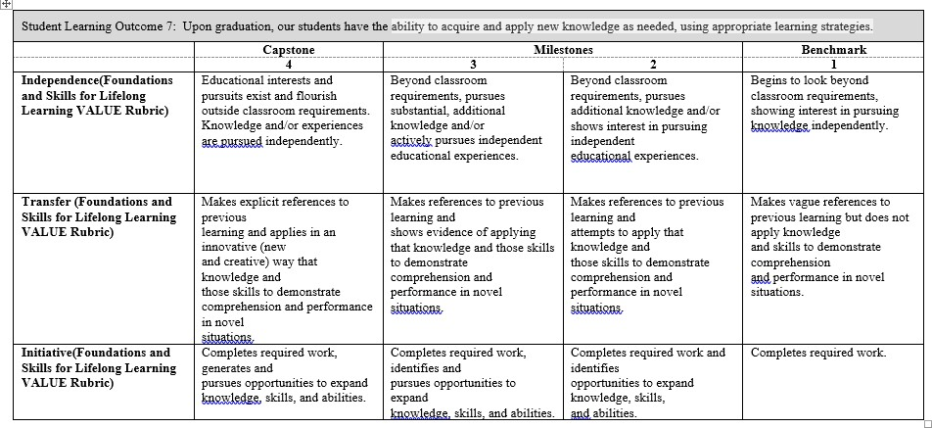  We look for a minimum average of 2.50 for each assessed junior-level course section, and 3.00 for each assessed senior-level course section. Of the courses assessed for this Outcome, EE 300 is considered junior-level, with the remaining courses considered senior-level.
Program Success Target for this Measurement |  | Target weighted averages are 2.50 for assessed junior-level course sections combined, and 3.00 for assessed senior- level course sections combined. | Percent of Program Achieving Target Weighted Averages for course sections assessed: | Junior-level course sections: 2.70 Senior-level course sections: 3.23
Methods | Instructors choose artifacts to assess, using the above rubric, in their respective courses/sections. These artifacts will be different course section-to-course section, instructor-to-instructor, and semester-to-semester. Each item of the rubric (e.g., independence, transfer, etc.) was weighted equally when scoring the rubric. In some cases, specific items may not have been scored.  We looked at the average obtained for each course section assessed, with each of the junior-level course sections targeted to achieve a minimum average of 2.50, and each of the senior-level course sections targeted to achieve a minimum average of 3.00. It was observed that

most assessed course sections met their targets, but one did not.

We also calculated two weighted rubric averages for this Outcome this academic year: one for all assessed junior-level course sections and one for all assessed senior-level course sections. This was done to determine if, overall, the Outcome was met. The minimum weighted averages were expected to be 2.50 and 3.00, respectively. This was our Program Success Target. As indicated above, we achieved averages of 2.70 and 3.23.
Measurement Instrument 2 | Senior Exit Surveys were given to students taking the senior design course during Fall 2021 and Spring 2022. Students were asked to “Rate your ability to acquire and apply new knowledge as needed, using appropriate learning strategies” on a scale of 1 to 5 (with 5 being the highest).
Criteria for Student Success
Program Success Target for this Measurement |  | Target average of 3.75 | Percent of Program Achieving  Target Weighted Average: | 4.17
Methods | For this year there were 15 scores total, 10 for Fall 2021 and 5 for Spring 2022. The above average of 4.17 is the average of all 15 scores received on this particular item from both semesters.
Based on your results, circle or highlight whether the program met the goal Student Learning Outcome 3. |  |  |  | Met | Not Met
Actions (Describe the decision-making process and actions for program improvement. The actions should include a timeline.)
The EE program met on February 17, 2022, to discuss rubric results for Fall 2021 semester. We did not see a need to address the rubric scores for this particular Outcome.
Follow-Up (Provide your timeline for follow-up. If follow-up has occurred, describe how the actions above have resulted in program improvement.)
The EE program assessment plan calls for rubric collection each semester (fall and spring), and a meeting of EE faculty to discuss the rubric results.
Next Assessment Cycle Plan (Please describe your assessment plan timetable for this outcome)
See above.

Electrical Engineering Program
Relationship of Student Outcomes to Required Courses in the Curriculum

 | Outcome 1 | Outcome 2 | Outcome 3 | Outcome 4 | Outcome 5 | Outcome 6 | Outcome 7
EE 101 | X | X |  | X
EE 180 | X
EE 200 | X | X | X | X | X | X | X
EE 210 | X |  | X |  |  | X | X
EE 211 | X |  | X |  |  | X | X
EE 300 | X | X | X | X | X | X | X
EE 345 | X |  | X |  |  | X | X
EE 380 | X |  | X |  |  | X | X
EE 420 | X
EE 431 | X |  |  |  | X | X
EE 460 | X | X | X
EE 473 | X
ENGR 490 | X | X | X | X | X | X | X
ENGR 491 | X | X | X | X | X | X | X

Relationship of Student Outcomes to Elective Courses in the Curriculum

 | Outcome 1 | Outcome 2 | Outcome 3 | Outcome 4 | Outcome 5 | Outcome 6 | Outcome 7
EE 405 | Not taught in several years
EE 410 /411 | X | X | X |  | X | X
EE 432 | Not taught in several years
EE 436 | X | X |  |  |  |  | X
EE 443 | X |  | X |  |  | X | X
EE 445 | X | X |  |  |  |  | X
EE 450/451 | X |  | X |  |  | X
EE 461 | X | X | X
EE 462 | Not taught in several years
EE 470/475 | X
EE 477 | X
EE 479 | X
EE 480 | X | X | X |  | X
EE 490 | X | X | X |  | X
ENGR 360 | X

