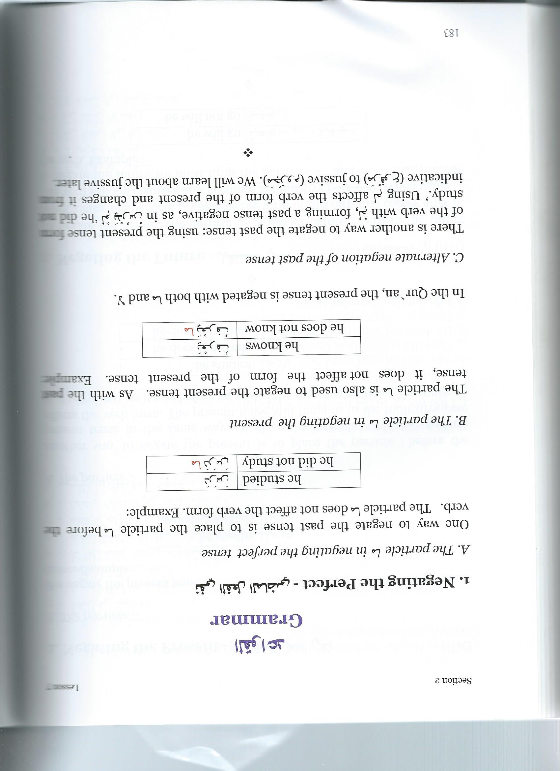
Negating Verbs:
Past
لم
the particle لم. used to make a statement negative in the past:
لم أذهب إلى المكتبة.
I didn’t go to the library.

You learned that the verb that goes with لم is in the present tense (as in the English example above, we don’t say “I didn’t went to the libray”). This is generally true. However, if the verb has a long vowel in it, that long vowel will drop out after لم . This would not be such a big issue, except that a surprisingly large number of Arabic verbs have a long vowel in them.

Note for example:
لم أرك
I haven’t seen you
The verb is أرى (“I see”) but the alif maqsuura drops out because of the لم. It is important to be able to figure out what the base verb is, otherwise you will be confused when you see a verb with لم .
What do the following mean:
لم أزر الشرق الأوسط.
____________________________________________
لم أقل ذلك.
____________________________________________
لم أرد أن أذهب إلى الصف اليوم
___________________________________________
Be careful – this rule does not apply with لن

