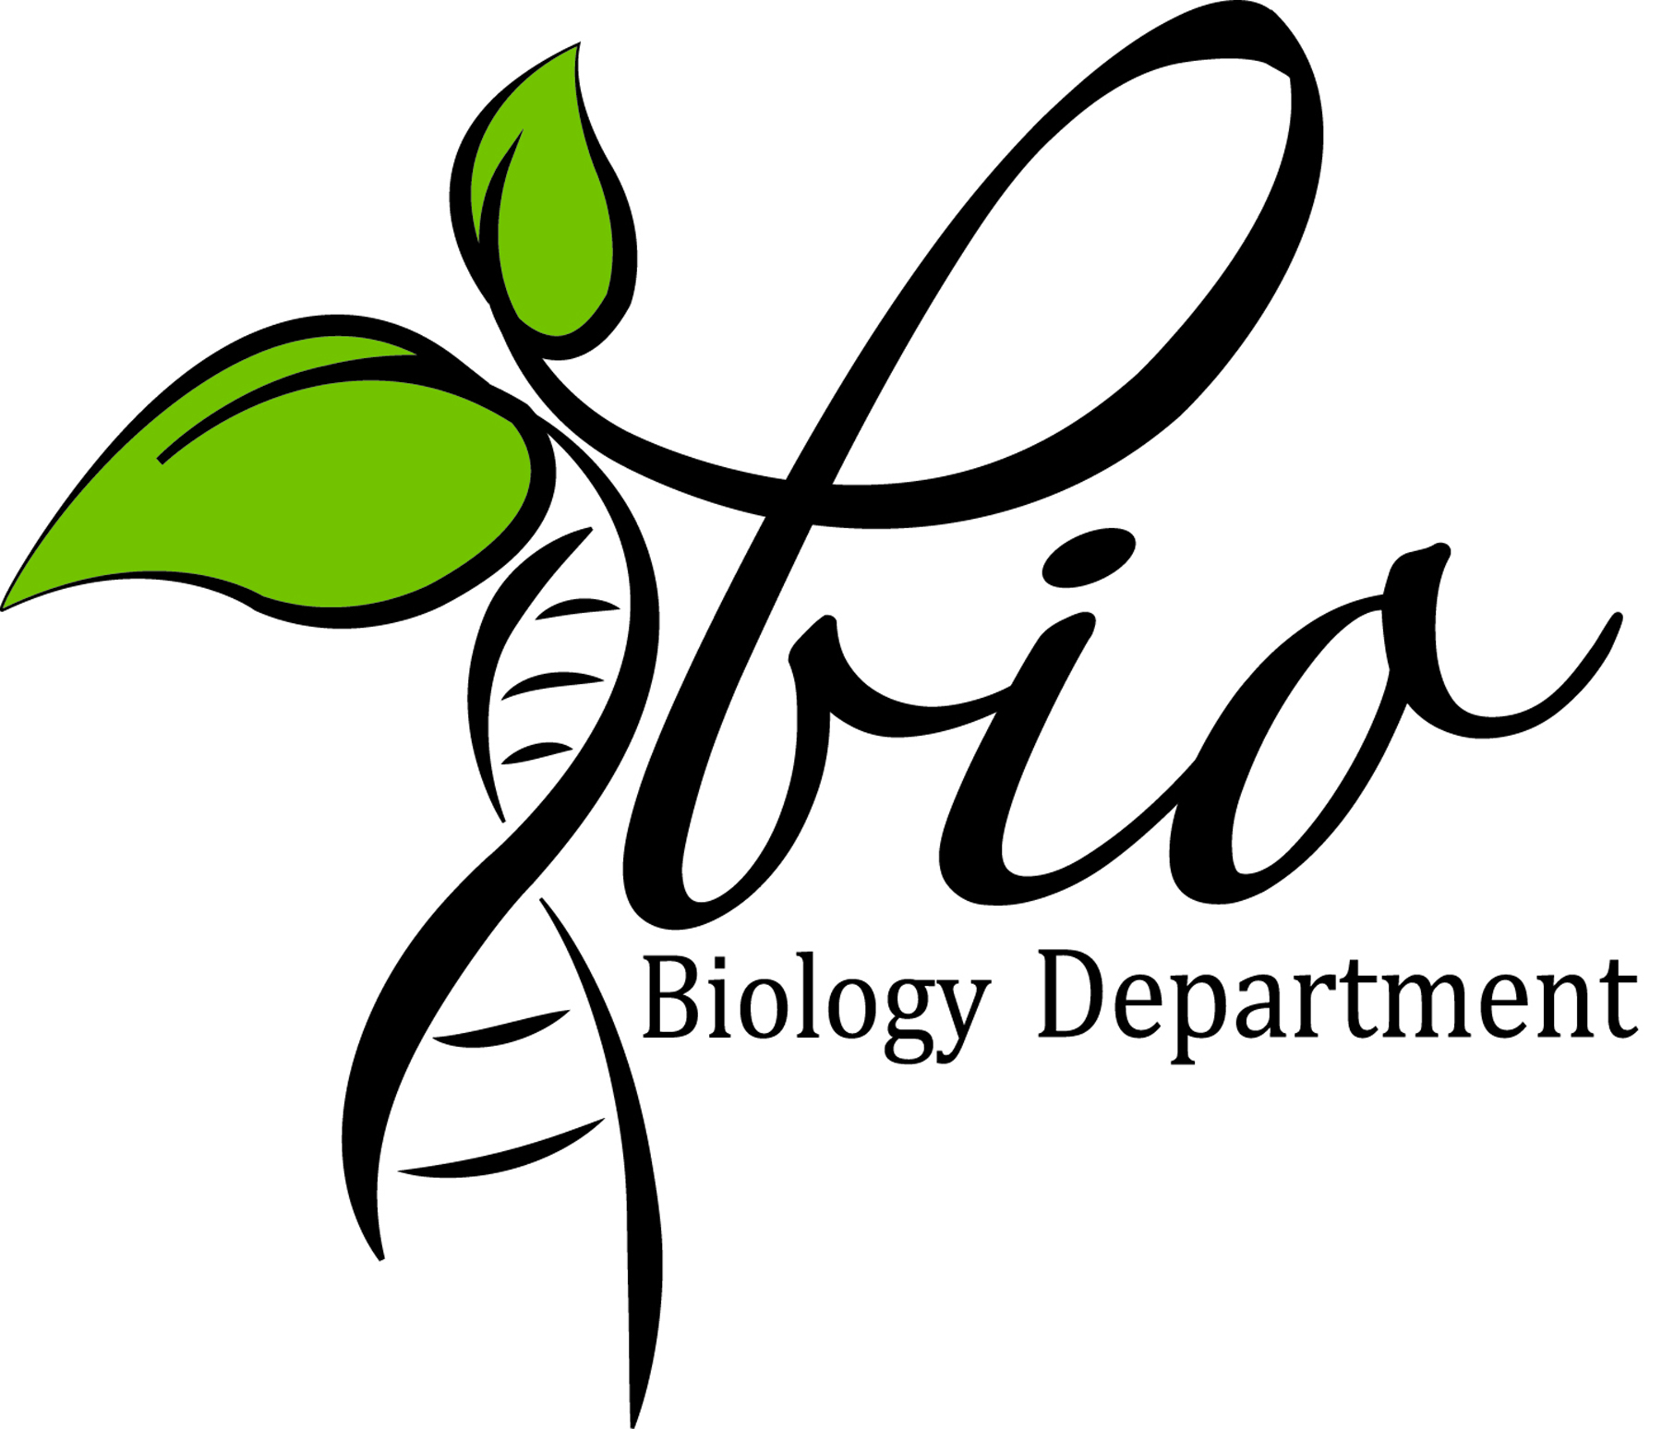
Student Application for
PiC:MiK 2014
Western Kentucky University
A Service Learning Course

Name Email Phone

WKU ID Major GPA Year at WKU (NOT # of hours)

- Why would you like to be a participant in the 2014 Kenya Medical Experience?

- What do you expect to learn while on the Kenya Trip?

- How well do you resolve conflict in a group of diverse individuals?

- What will you personally contribute to the program?

- In what ways will you take the knowledge that you will obtain from the trip and use it to better serve your community?

- Have you ever traveled to or lived in another culture? If yes, please give details.

- Describe your general physical condition.

- Have you ever been on academic or disciplinary probation? If yes, please explain.

- Do you have any siblings?

- Other information you wish to share:

- Letter of reference requested from whom? How long has this person known you?

Student Signature

Date

Applications due April 15, 2013
Email to nancy.rice@wku.edu with “PiCMiK 2014 Application” in the subject line.

For office use only
Application Received Letter Received

