Youth Employment and The Last 30 Years of the Minimum Wage in the United States
The below chart illustrates the impact of minimum wage changes on the youth (aged 16-19) employment rates in the US over the last thirty years.
The red line represents the real minimum wage from 1983-2012 (in 2012 $ x 7 for scale purposes) as provided by the US Department of Labor. The blue line represents the youth employment rate as reported by the US Bureua of Labor Statistics.
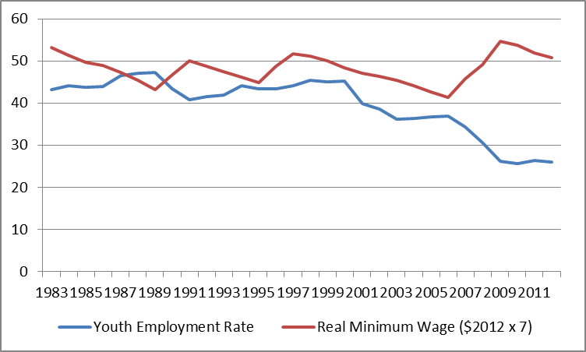
What the graph illustrates:
From 1983 until 1990 the purchasing power of the minimum wage was falling while youth employment increased.
There is an inflection point in 1990 where the value of the minimum wage spikes and youth employment falls. In March 1990, the last month before the minimum wage increased to $3.85 the youth employment rate stood at 47.1%. In April the next year, following an increase in the minimum wage to $4.25, the youth employment rate stood at 42.8%. In a single year, one out of ten teenagers with jobs lost them. The slide continued. By the following March the youth employment rate had fallen to 40.2%.
The minimum wage increases of 1996 and 1997 had a smaller initial impact on youth empployment. The youth employment rate fell from 44.4% to 44.1% the month the wage was incrased in 1996 while it fell from 43.2 to 42.8% the monthe the wage was increased in 1997. The tightening job market of the late 1990’s helped cushion the employment blow of an incrased minimum wage. The national unemployment rate was below 6% and was below 5% from 1998 until 2001.
The 2001 recession saw a large decrease in youth employment. This decline stabilized from 2003 through 2007 as the real value of the minimum wage fell. Increaed globalization decreased the domestic demand for unskilled labor in the US. The 2007, 2008, and 2009 increases in the minimum wage rate failed to take this lower demand into acount. The huge drop in youth employment that came with the last round of minimum wage incrases has only begun to stabilize since 2009, as the value of the minimum wage has been allowed to fall.
Between March 1990 and July 2014 the youth employment rate has fallen from 47.1% down to 27.1%. That is, 44.8% of teenagers who held a job in 1990, no longer hold one in 2014. Youth employment is almost half of what it was 25 years ago.
A climb up the income ladder begins by placing one’s foot on the lowest bar. More important than the wage they earn is the experience, on the job training, and self-respect young people gain. If socieity truly wants more people moving up the income ladder, it must stop removing the lowest rungs of the ladder. Sure, if you outlaw a $7.25 job people won’t legally have them, but the alternative is not a $10.10 job, but rather, no job at all.
If the US increasesed its minimum wage to $10.10 an hour the following would result:
- An increase in demand for illegal low wage labor (often performed by undocumented illegal immigrants)
- A huge reduction in youth employment in lower income areas (rural states and inner cities)
- Increased automation of unskilled work (say hello to the self-serve fast food kiosk that looks like the self-serve airport check-in kiosk)
- The elimination of tipping as a standard American practice if servers are guarenteed $10,10 an hour whether they are tipped or not
- A reductin in US agricultural output if the minimum wage applies to the agricultural industry
- Increased usage of college loans as fewer young people will have access to jobs
If there is any doubt what high minimum wages and highly regulated labor markets give young people, look no further than Europe where the youth unemployment rates are: Greece (57.7%), Spain (54%), Croatia (48.7%), Italy (43%), Cyprus (37.3%), and Portugal (34.8%). Seven and a half million young Europeans between the ages of 15 and 24 are not employed, in school, or in training.
Society cannot take away the lowest rungs on the economic ladder and expect young people to pole vault into the middle class. We know the outcome of eliminating job opportunities for young people and it is not pretty. The purchasing power of the US minimum wage is higher now than it has been for most of the last thirty years. Now is not the time to raise it even higher.

