AGENDA
PROFESSIONAL EDUCATION COUNCIL
3:30 - Wednesday, February 8, 2012

GRH 3073

- Consideration of the Minutes from the December 14, 2011, meeting
(Minutes can be found on the CEBS Home Page – click on Dean’s Office and the
drop down option Meetings Minutes and Agendas)

II. New Business

OFFICE OF TEACHER SERVICES - CEBS

▪ Candidates Completing Requirements for Admission to the Professional Education Unit
December 15, 2011, to February 8, 2012

▪ Student Teacher Candidates List for Spring 2012

OGDEN COLLEGE OF SCIENCE AND ENGINEERING

Department of Mathematics and Computer Science

1. New Course – MATH 506, Mathematical Applications for Middle Grades Teachers

Department of Biology

1. New Course – BIOL 303, Life Science for Middle Grades Teachers

Department of Chemistry

1. Revise Course Credit Hours – CHEM 470, Chemistry/Middle School

Department of Geography and Geology

1. New Course – GEOL 305, Earth System Science for Teachers
2. Revise a Program – 676, Geology Earth and Space Science Concentration

Ogden College Dean’s Office

1. Revise a Program, 734, Middle School Science Education (“MSSE”)

III. Other Business

▪ Proposed Revisions to the By Laws

▪ NCATE Continuing Accreditation Report

CANDIDATES COMPLETING REQUIREMENTS FOR ADMISSION TO PROFESSIONAL EDUCATION UNIT
December 15, 2011 – February 8, 2012

ELEMENTARY P-5
Bartley, Amy
Baxter, Danielle
Blakey, Katlin
Bowen, Rachel
Butler, Stevie
Cabaniss, April
Clayton, Laura
Coates, Jonathan
Davis, Hayli
Estelle, Arlene
Foote, Christine
Galloway, Katherine
Gaw, Kacie
Glenn, Ashlie
Goodman, Chelsea
Grable, Tayler
Kipling, Tiffany
Kirkhart, Jessica
Konermann, Kelsey
Lovan, Rachel
Lutz, Kelli
McKeown, Michael
McKinney, Rhanda
Meyer, Deborah
Miller, Danielle
Moore, Lauren
Ogburn, Bethany
Peerce, Reece
Renfro, Lydia
Riddle, Stephanie
Scott, Amber
Smith, Hailee
Stiles, Jenny
Saujon, Jackie
Terry, Karen
Thompson, Maureen
Thompson, Shannon
Tracy, Melissa
Underhill, Paul
Veach, Kara
Ward, Emily
Webb, Jennifer
White, Amanda
Yandell, Caroline

MIDDLE GRADES

Blessitt, Alyssa Eng/SS
Bryant, Jacob Eng/SS
Bryant, Stephanie Eng/Math
Burnley, Mariah Eng/SS
Fisher, Shelton Science
Harrell, Rachel Math
Knight, Angel Math/SS
Lowe, Lauren SS/English
Lynn, Jonathon SS/Eng
Mattingly, Jordan SS/ENG
McCarty, Jennifer Math
Metcalf, Douglas Science/SS
Nailovic, Sibela Math
Pearson, Erica Eng/SS
Powell, Ashley Math/SS
Reels, Tracy Math Sexton, Shannon SS/Sci
Shirley, Brooke Math
Springer, Alli Eng/SS

5-12

Booth, Jody Bus/Mktg
Michael, Jennifer Bus/Mktg
Poole, Alexa FCS
West, Ashley FCS
Whitney, Misty FCS

P-12

Beach, Kelsey Ex Ed
Cox, Aaron Music - Vocal
Huang, Chen Art
Pace, Katelyn Ex Ed
Robinson, Clayton P.E.
Spurlin, Leah P.E.
Stevens, Candace Spanish
White, Emily Music-vocal
Wright, Bradly P.E.

IECE

Stayer, Rachael

SECONDARY

Anderson, Kassy Math
Boaz, Bradley Math
Conner, Michial Biology
Davis, Tiffany English
Evans, Brittany Biology
Given, Ameliah English
Hill, Amber Social Studies
Hittson, Patrick Social Studies Kirchgessner, Craig Social Studies
McDowell, Lauren English
O’Bryan, Alana Social Studies
Overstreet, Shelby Chemistry
Smith, Nathan Math
Steele, Abigail Social Studies
Wilson, Deborah English

MASTERS

Bell, Yolanda IECE
Dowell, Daniel LBD
Kistler, Ronn D. MGE Science (ARTC/MAE)
McCubbin, Amanda LBD
Ringel, Adelle CD
Taylor, Kelly Ann LME
Vernon, Chasity LBD
Williams, Mildred LME

EdS

Bakari, Heather Psychology

If there are any questions or concerns about the status of any candidate, the person with the question or concern should contact Dr. Fred Carter, Teacher Services (745-4611 or fred.carter@wku.edu) prior to the PEC meeting.

STUDENT TEACHER CANDIDATES FOR SPRING 2012
QUALIFIED
***STUDENT TEACHING APPLICATION ACCEPTED***2/8/12***

WKU ID | FIRST | LAST | MAJOR | D
 | BRYAN | SIRCY | 5-12/AGRICULTURE
 | JORDAN | CRADDOCK | ELEMENTARY
 | MEGAN | MITCHELL | ELEMENTARY
 | MEGAN | REID | ELEMENTARY
 | KIRBY | CARTER | MGE/LA/S.STUDIES
 | PHUONG | DOAN | MGE/MATH
 | RACHEL | HARRELL | MGE/MATH
 | JENNIFER | McCARTY | MGE/MATH
 | SIBELA | NAILOVIC | MGE/MATH
 | NICHOLAS | NEIMAN | MGE/MATH
 | CHELSEY | VEATCH | MGE/MATH
 | VALERIE | FINN | MGE/MATH/S.STUDIES
 | MICHIAL | CONNER | MGE/SCIENCE
 | CHEN | HUANG | P-12/ART
 | JOSHUA | BLOECHER | P-12/MUSIC
 | AARON | COX | P-12/MUSIC
 | JON | RIGDON | SEC/SOCIAL STUDIES
STUDENT TEACHER CANDIDATES FOR SPRING 2012
***STUDENT TEACHING APPLICATION WITHDRAWN***2/8/12***

WKU ID | FIRST | LAST | MAJOR | DATE
 | NANCY | ASKEW | ELEMENTARY | 12/15/11
 | MATTHEW | McCLOUD | ELEMENTARY | 2/3/12
 | ALLISON | NORRIS | MGE/LA/S.STUDIES | 12/22/11
 | MICAH | OGLES | MGE/LA/S.STUDIES | 12/14/11
 | BETH | OLIPHANT | MGE/LA/S.STUDIES | 12/16/11
 | HILLARY | HARPER | MGE/MATH | 12/27/11
 | STEPHANIE | MILLER | MGE/MATH/S.STUDIES | 12/14/11
 | LESLIE | WHITAKER | MGE/S.STUDIES/LA | 12/12/11
 | DEBORAH | GRAHAM | MGE/SCIENCE/S.STUDIES | 1/20/12
 | LANCE | PAULEY | SEC/PHYSICS | 12/22/11
 | LUCAS | MOORE | SEC/SOCIAL STUDIES | 12/14/11
 | CHRISTOPHER | BLAKE | P-12/MUSIC | 12/23/11
 | EMILY | WHITE | P-12/MUSIC | 12/22/11

Proposal Date: November 11, 2011

Ogden College of Science and Engineering
Department of Mathematics and Computer Science
Proposal to Create a New Course
(Action Item)

Contact Person: Summer Bateiha, summer.bateiha@wku.edu, 745-5491

1. Identification of proposed course:
  - Course prefix (subject area) and number: MATH 506
  - Course title: Mathematical Applications for Middle Grades Teachers
  - Abbreviated course title: MATH APPS MIDDLE GRADES TCHR
  - Credit hours and contact hours: 3
  - Type of course: L: Lecture
  - Prerequisites: Middle Grades Mathematics Certification or Permission of Instructor
  - Course catalog listing: Sets, logic, dimensional analysis, functions and modeling, and discrete mathematics with a focus on real-world applications.

2. Rationale:
  - Reason for developing the proposed course: The need for an additional graduate course for middle school teachers has become apparent. MATH 506 was previously offered as a temporary course, with the intent of making it permanent once the new standards for K-12 mathematics had been established. Now, with the new Common Core Standards in mind, this course has been revised to provide applications for the content knowledge required in the middle grades. The content chosen for this course is not covered in any other course offered in the Mathematics Division.
  - Projected enrollment in the proposed course: 15
  - Relationship of the proposed course to courses now offered by the department: This course provides students with applications of middle grades mathematics at the graduate level. It is similar to but more rigorous and broader than the undergraduate course MATH 411: Problem Solving for Elementary and Middle School Teachers.
  - Relationship of the proposed course to courses offered in other departments: There are no comparable courses in other departments.
  - Relationship of the proposed course to courses offered in other institutions: The mathematics education faculty were unable to locate similar courses at other institutions. However, the math educators at WKU are glad to be at the forefront among comparable institutions in preparing teachers to improve their students' problem-solving skills.

3. Discussion of proposed course:
  - Course objectives: Upon completion of this course, students will be able to apply mathematics to real-world problems using sets, logic, dimensional analysis, functions and modeling, and discrete mathematics.
  - Content outline:
Applications of mathematics to real-world problems using the following as problem-solving tools
- Sets and logic
- Dimensional analysis
- Functions and modeling
- Discrete mathematics
  - Student expectations and requirements: The student’s grade in the course will be determined by performance on homework, participation in discussions, tests, and a comprehensive final examination.
  - Tentative texts and course materials:
National Council of Teachers of Mathematics. (2008). Navigating Through Discrete Mathematics in Grades 6-12.

National Council of Teachers of Mathematics. (2005). Navigating Through Measurement in Grades 6-8.

National Council of Teachers of Mathematics. (2008). Navigating Through
Mathematical Connections in Grades 6-8.

National Council of Teachers of Mathematics. (2005). Navigating Through Measurement in Grades 9-12

National Council of Teachers of Mathematics. (2006). Navigating Through Mathematical Connections in Grades 9-12

National Council of Teachers of Mathematics. (2008). Navigating Through Reasoning and Proof in Grades 9-12

Barker-Plummer, D., Barwise, J., and Etchemendy, J.. (2007). Language,

Proof, and Logic. California: CSLI Publications.

Rosen., K. (2012). Discrete Math and Its Applications. McGraw Hill.

4. Resources:
  - Library resources: None
  - Computer resources: None

5. Budget implications:
  - Proposed method of staffing: Mathematics education graduate faculty
  - Special equipment needed: None
  - Expendable materials needed: None
  - Laboratory materials needed: None

6. Proposed term for implementation: Summer 2012

7. Dates of prior committee approvals:

Department of Mathematics & Computer Science: ________11/11/11___

OCSE Graduate Committee ________12/16/11___

Professional Education Council __________________

Graduate Council ___________________

University Senate ___________________

Attachment: Course Inventory Form

Proposal Date: 1/27/12

Ogden College of Science and Engineering
Department of Biology
Proposal to Create a New Course
(Action Item)
Contact Person: Dr. Bruce A. Schulte, bruce.schulte@wku.edu 745-4856
1. Identification of proposed course:
  - Course prefix (subject area) and number: BIOL 303
  - Course title: Life Science for Middle Grades Teachers
  - Abbreviated course title: Life Science for Middle Grades
  - Credit hours and contact hours: 1-3
  - Type of course: A
  - Prerequisites: BIOL 120/121, BIOL 122/123, and 6 hours of SMED 200 level and above courses.
  - Course catalog listing: This course provides pedagogical content and knowledge in life sciences with practicum experience for middle school teachers based on the Kentucky Core Contents items. Not available for credit toward any Biology, Chemistry or Biochemistry major or minor, nor does this course fulfill a general education requirement. Course is repeatable once for a maximum of 4 credit hours.

2. Rationale:
  - Reason for developing the proposed course: The current program for middle school teachers does not address the content and pedagogy for teaching the science content in middle schools. This course will specifically cover the life science content and how to teach the core content items to middle school students. The course is listed at the 300 level because it requires both the introductory biology material and pedagogy from education courses. This course will review, in the greater depth needed by middle grade teacher, selected content from BIOL 120/121 and BIOL 122/123 while also covering additional topics mandated by state and national content standards.
  - Projected enrollment in the proposed course: 20-30
  - Relationship of the proposed course to courses now offered by the department: This course will only be for middle school science majors and will not relate to other courses in the department.
  - Relationship of the proposed course to courses offered in other departments: This course will become a part of the SKyTEACH curriculum for middle school teachers.
  - Relationship of the proposed course to courses offered in other institutions: We surveyed 19 benchmark institutions: seven lack a comparable program, seven have a biology or general science course that is similar, four have more education based programs and one is developing a program. Six institutions have other upper level biology classes that can be applicable for middle school science teachers. The University of Arizona has a very similar course for teaching secondary teachers.

3. Discussion of proposed course:
  - Course objectives: The student will be able to:
- Use the scientific process to examine biological phenomena.
- Implement critical thinking skills to address the acquisition and understanding of biological information.
- Introduction to and practice with a range of activities, projects, demonstrations and assessments teachers need to plan and teach challenging lessons using the 5E model (Engage, Explore, Explain, Extend and Evaluate).
- Practice appropriate safety and care of waste materials for laboratory exercises.
- Describe the relationship between cells, tissues and organs in order to explain function in a multicellular organism.
- Describe the role of genes/chromosomes in the passing of information from one generation to another (heredity).
- Compare inherited and learned traits.
- Explain the relationship between structure and function of the cell components using a variety of representations.
- Describe and compare sexual and asexual reproduction.
- Make inferences about the factors influencing behavior based on data/evidence of various organisms’ behaviors.
- Justify conclusions as to whether a response is innate or learned using data/evidence on behavioral responses to internal stimuli.
- Explain patterns found within groups of organisms in order to make biological classifications of those organisms.
- Describe that biological change over time accounts for the diversity of species developed through gradual processes over many generations.
- Draw conclusions about past life forms, environmental conditions and extinction of species based on the fossil record.
- Represent the flow of energy in ecosystems using data to draw conclusions about the role of organisms in an ecosystem.
- Compare abiotic and biotic factors in an ecosystem and explain consequences of change in one or more factors.
- Predict effects of changing components of an ecosystem while describing the interrelationships within an ecosystem.
  - Content outline:
- Coverage of Explore, College Readiness and literacy and other standards middle grade teachers are expected to teach
- Organization of living things, namely cell, tissue, organ and system structure and function
- DNA and RNA processes
- Genetics, mitosis and meiosis
- Reproduction
- Classification and survey of Kingdoms
- Describe that biological change over time accounts for the diversity of species developed through gradual processes over many generations.
- Major extinction events and the fossil record.
- Food Webs and Energy Flow
- Compare abiotic and biotic factors in an ecosystem and explain consequences of change in one or more factors.
- Predict effects of changing components of an ecosystem while describing the interrelationships within an ecosystem.

  - Student expectations and requirements:
- Satisfactory grades on exams and quizzes
- Completion of inquiry-based activities
- Execute and collect data on a research-based experiment
- Prepare course lesson plans for teaching middle school students
- Examine and critique different mechanisms of evaluation for middle school students

  - Tentative texts and course materials: A typical middle school science textbook, the text/lab books from the BIOL 120-123 series, and other course materials supplied in the form of handouts and web page links.

4. Resources:
  - Library resources: Sufficient
  - Computer resources: Sufficient

5. Budget implications:
  - Proposed method of staffing: Initially with current faculty with expectation that a new faculty line will be required as program expands.
  - Special equipment needed: None
  - Expendable materials needed: Typical introductory biology materials
  - Laboratory materials needed: Typical introductory biology lab materials

6. Proposed term for implementation: Fall 2012

7. Dates of prior committee approvals:
Department of Biology: ____1/27/12________

OCSE Undergraduate Curriculum Committee: ____2/2/12_________

Professional Education Council: __________________

Undergraduate Curriculum Committee: ___________________

University Senate: ___________________

Attachment: Bibliography, Library Resources Form, Course Inventory Form
Proposal Date:1/17/2012

Ogden College of Science and Engineering
Department of Chemistry
Proposal to Revise Course Credit Hours
(Action Item)

Contact Person: Kevin Williams, Kevin.williams@wku.edu, 5-8899

1. Identification of course:
  - Current course prefix (subject area) and number: CHEM 470
  - Course title: Chemistry/Middle School
  - Credit hours: 4

2. Proposed course credit hours: 2-4

3. Rationale for the revision of course credit hours: This is a special topics course that is being converted to a variable hour format. This change is necessary for compatibility and flexibility with the SKyTeach curriculum.

4. Proposed term for implementation: Fall 2012

5. Dates of prior committee approvals:

Chemistry Department __January 20, 2012__

Ogden Curriculum Committee __February 2, 2012__

Professional Education Council __________________

Undergraduate Curriculum Committee ___________________

University Senate ___________________

Attachment: Course Inventory Form

Proposal Date: 9/21/11

Ogden College of Science and Engineering

Department of Geography and Geology
Proposal to Create a New Course
(Action Item)
Contact Person: Margaret Crowder (margaret.crowder@wku.edu), 745-5973

1. Identification of course:
1.1 Course prefix and number: GEOL 305

1.2 Course title: Earth System Science for Teachers

1.3 Abbreviated title: Earth Sys Sci for Teachers

1.4 Credit hours and contact hours: 3.0

1.5 Type of course: Lecture/Lab (C)

1.6 Prerequisites: GEOL 111 and 113, or GEOL 112 and GEOL 114

1.7 Catalog course listing: Collaborative, problem-based learning (PBL) experience, using real-world examples to enhance student understanding of earth system science, with a focus on relevance in science teaching grades K-12. Includes PBL-based lesson plan development. Applicable towards a major in geology only for those students obtaining teacher certification.

2. Rationale
2.1 Reason for developing the proposed course: Earth science is a major component of the Kentucky core content items for K-12. This course is intended to become part of the Middle School Science Education (MSSE) major core, and provide an important senior-level synthesis of student knowledge within the Earth Science education curriculum. The course will also serve the needs of secondary education majors obtaining Earth and Space Science certification. Students will become familiar with the Kentucky core content items for Earth Science, while using a systems approach in inquiry-based student learning.

2.2 Projected enrollment in the proposed course: 15-20 students. Estimate is based on historic enrollment in Middle School Science Education, present enrollment in Geology major #676, Earth and Space Science track, and enrollment of Geol 497, Earth Science for Teachers, which was run as a one-time course offering in Spring 2005.

2.3 Relationship of proposed course to courses now offered by the department:
This course will build on the content of GEOL 111 and 113 or 112 and 114, and will serve as a synthesis course for future K-12 Earth Science educators. Course is similar in design to GEOL 511, but is developed at the undergraduate level for pre-service teachers and will have greater focus on Kentucky core content.

2.4 Relationship of the proposed course to courses offered in other departments:
PHYS 410 Physics for Teachers is “a broad study, including laboratory experiences, of the areas of physics relevant to science teaching in grades K-12.” This course is designed to be similar in its intent, but with an earth science emphasis.
SMED 470 Project-Based instruction involves “methods, techniques, and technologies used to implement and assess problem-based investigations in math and science classrooms.” GEOL 305 will have its primary focus in earth systems relationships.

2.5 Relationship of proposed course to courses offered in other institutions:
A brief review of other institutions reveals similar courses offered through Florida State University - Geology for Pre-Service and In-Service Teachers, Penn State - Earth Systems Science for Teachers, California State University, Long Beach - Earth Science for Teachers, University of Minnesota - Advanced Earth Science for Teachers, Western Michigan University - Earth Science for Teachers, Florida International University - Earth Sciences for Teachers.
The proposed course would explore earth system science with a focus on Kentucky earth science core content.

3. Discussion of proposed course:
3.1 Course objectives: Students will:
- evolve their knowledge about Earth system science and their skills in thinking systemically about specific events.
- learn to develop strong arguments with hypotheses, assertions, and evidence.
- develop collaborative skills for knowledge-building, argument-building, and acting as a critical friend.
- develop PBL experiences designed to take into the K-12 classroom to engage students in using Earth system science thinking.

3.2 Content outline: Topics to be covered include earth systems approaches using real-world events, such as global climate change, El Niño, the 65-million-year-old Yucatán impact, eruptions of Mt. Pinatubo, changes in coral reefs, and tropical forests.

3.3 Student expectations and requirements: Participation in online discussions, completion of laboratory assignments, assessment of individual private theories and PBL lesson design, and team knowledge-building and ESS model-building written exercises.

3.4 Tentative texts and course materials:
Online materials provided through Earth System Science Education Alliance (ESSEA). Western Kentucky University is an ESSEA participating member and receives access to all ESSEA produced materials. Online content available from http://essea.strategies.org

4. Resources:
4.1 Library resources: See attached Library Resources form and bibliography.

4.2 Computer resources: No new additional resources required.

5. Budget implications:
5.1 Proposed method of staffing: Existing faculty will teach this course.

5.2 Special equipment needed: None.

5.3 Expendable materials needed: None.

5.4 Laboratory supplies needed: None.

6. Proposed term for implementation: Fall 2012

7. Dates of prior committee approvals:
Department of Geography and Geology __12/16/2011_____

Ogden College of Science and Engineering _____2/2/12______

Professional Education Council ________________

University Curriculum Committee ________________

University Senate ________________

Proposal Date: November 28, 2011

Ogden College of Science and Engineering
Department of Geography and Geology
Proposal to Revise a Program
(Action Item)

Contact Person: David Keeling (david.keeling@wku.edu), 5-4555

1. Identification of program:
  - Current program reference number: 676
  - Current program title: Geology Earth and Space Science Concentration
  - Credit hours: 32

2. Identification of the proposed program changes:
Delete CS 145, which is no longer offered by the Computer Science program.

3. Detailed program description:

Current Program | Proposed Program
Earth and Space Science | Earth and Space Science
Program Requirements 26 hours  [111, 112, 113, 114, 308, 311, 325, 380, 460, 499] | Program Requirements 26 hours  [111, 112, 113, 114, 308, 311, 325, 380, 460, 499]
Program Electives 6 hours [Any 6 hours of approved  Geology electives] | Program Electives 6 hours [Any 6 hours of approved  Geology electives]
Program Total 32 hours | Program Total 32 hours
Additional Requirements: | Additional Requirements:
MATH 116, PHYS 201, CS 145, GEOG 121, ASTR 104, ASTR 106, ASTR 405, and a minor field | MATH 116, PHYS 201, GEOG 121, ASTR 104, ASTR 106, ASTR 405, and a minor field

4. Rationale for the proposed program change:
CS 145 does not meet the needs of the ESS program and is no longer offered by the
Computer Science program

5. Proposed term for implementation and special provisions (if applicable):
Fall 2012

6. Dates of prior committee approvals:

Department: Geography and Geology ______12/16/2011___

Ogden College Curriculum Committee ______2/2/2012______

Professional Education Council (if applicable) __________________

Undergraduate Curriculum Committee ___________________

University Senate ___________________

Attachment: Program Inventory Form

Proposal Date: 27 January 2012

Ogden College of Science and Engineering
Office of the Dean
Proposal to Revise A Program
(Action Item)

Contact Person: Scott Bonham, scott.bonham@wku.edu, 745-6196

1. Identification of program:
  - Current program reference number: 734
  - Current program title: Middle School Science Education (“MSSE”)
  - Credit hours: 48

2. Identification of the proposed program changes:

2.1 Reduce the number of hours in the major from 48 to 46

2.2 Drop PHYS 105 from the list of required introductory courses, require only one introductory geology course

2.3 Specify a list of required upper level courses
2.4 Reduce the restricted electives to 3 hours and remove courses with upper-level pre-requisites
2.4 Change program title to “Middle School Science”
2.5 Raise minimum GPA to 2.75
2.6 Eliminate need for a waiver from requirement of 50% upper level courses

3. Detailed program descriptions:

Current program Proposed program
General:  1. 30 hours of introductory science courses are required.  2. A science research methods course, SMED 360, is required.  3. 15 hours of upper level science courses are required from a list of restricted electives, including courses in three disciplines.  4. Completion of MATH 117 or 118 or 126 as a support course is required.  5. All courses must be completed with a grade of C or better. All science courses must be completed with an average of 2.5 or better.  6. Students must also complete the SMED major. | General:  1. 23 hours of introductory science core courses are required.  2. A science research methods course, SMED 360, is required.  3. 20 hours of upper level science courses are required including a required course in each of the five disciplines and one from a list of restricted electives.  4. Completion of MATH 117 or 136 or 142 as a support course is required.  5. All courses must be completed with a grade of C or better. All science courses must be completed with an average GPA of 2.75 or better.  6. Students must also complete the SMED major.

Required introductory science courses  ASTR 104 Astronomy of the  Solar System (3)  or ASTR 106 Astronomy of  Stellar Systems (3)  BIOL 120/121 Biological Concepts:  Cells, Metabolism, and Genetics (4)  BIOL 122/123 Biological Concepts:  Evolution, Diversity & Ecology (4)  CHEM 105/106 Fund. of Gen. Chemistry (4)  or CHEM 120/121 College Chemistry I (5)  GEOL 111/113 The Earth (4)  GEOL 112/114 Earth History (4)  PHYS 105 Concepts of Physical World (3)  PHYS 201 College Physics I (4)  or PHYS 231/232 College Physics  and Biophysics I (4) | Required introductory science courses (23 h)  ASTR 104 Astronomy of the  Solar System (3)  or ASTR 106 Astronomy of  Stellar Systems (3)  BIOL 120/121 Biological Concepts:  Cells, Metabolism, and Genetics (4)  BIOL 122/123 Biological Concepts:  Evolution, Diversity & Ecology (4)  CHEM 105/106 Fund. of Gen. Chemistry (4)  or CHEM 120/121 College Chemistry I (5)  GEOL 111/113 The Earth (4)  OR GEOL 112/114 Earth History (4)  PHYS 201 College Physics I (4)  or PHYS 231/232 College Physics  and Biophysics I (4)
Science research course:  SMED 360 Research Methods for  Mathematics and Science Teachers (3) | Science research course:  SMED 360 Research Methods for  Mathematics and Science Teachers (3)
Upper level science courses: Restricted electives, 15 hours including three sciences from among:  ASTR 405 Astronomy for Teachers (3)  PHYS 410 Physics for Teachers (3)  BIOL 319/322 Molecular and Cell Biology (4)  BIOL 325 Insect Biodiversity (3)  BIOL 326 Ornithology (3)  BIOL 327 Genetics (4)  BIOL 334 Animal Behavior (3)  BIOL 348 Plant Taxonomy (3)  BIOL 350 Intro Recombinant  Genetics (3)  BIOL 407 Virology (3)  BIOL 411/412 Cell Biology (4)  BIOL 430 Evolution: Theory and  Process (3)  GEOG 427 Water Resources (3)  GEOG 471 Natural Resource Mgt. (3)  GEOL 308 Structural Geology (3)  GEOL 310 Global Hydrology (3)  GEOL 311 Oceanography (3)  GEOL 325 Intro Minerals and Rocks (3)  GEOL 380 Intro Field Techniques (3)  GEOL 405 Paleontology (3) | Upper level science courses (20 hours):  All of following courses (17 hours):  ASTR 405 Astronomy for Teachers (3)  BIOL 303 Life Sciences for Middle Grades Teachers (4)  CHEM 470 Chemistry/Middle School (4)  GEOL 305 Earth Systems Science for Teachers (3)  PHYS 410 Physics for Teachers (3)  One restricted elective (min. 3 hours) from:  BIOL 319/322 Molecular and Cell Biology (4)  BIOL 325 Insect Biodiversity (3)  BIOL 326 Ornithology (3)  BIOL 327 Genetics (4)  BIOL 334 Animal Behavior (3)  BIOL 348 Plant Taxonomy (3)  GEOG 471 Natural Resource Mgt. (3)  GEOL 308 Structural Geology (4)  GEOL 310 Global Hydrology (3)  GEOL 311 Oceanography (3)  GEOL 325 Intro Minerals and Rocks (3)  GEOL 380 Intro Field Techniques (3)  GEOL 405 Paleontology (4)  SMED 300 Middle Grade Science Skills (3)  SMED 400 Applying Middle Grade Science Across Disciplines (3)
Support course  MATH 117 Trigonometry (3) or  MATH 118 College Alg/Trig (5) or  MATH 126 Calc/Anal Geo I (4.5) | Support course  MATH 117 Trigonometry (3) or  MATH 136 Calculus I (4) or  MATH 142 Calculus with Applications for Life Sciences (5)

4. Rationale for the proposed program change:
This program is designed for future middle school science teachers, who need to be able to teach material from across five science disciplines (Astronomy, Biology, Chemistry, Geology and Physics). Thus, they must complete introductory college-level courses in all of these areas, which leads to a large number of lower-level hours, all of which address core content mandated by the state to be taught in middle school science courses. The Middle Grades Science Education Program is part of the SKyTeach Program for preparing math and science teachers, a cooperative program between the College of Education and Behavior Sciences (CEBS), and Ogden College of Science and Engineering (OCSE). In SKyTeach, all students are double majors, with a math or science content major in Ogden and a pedagogy major, Science and Math Education (SMED), in CEBS.
When this program was first established, there were few upper level courses available that specifically addressed needs of future middle school science teachers, and those that existed were not offered regularly or not available to students at the extended campuses. Thus, a structure with a large number of restricted upper level electives was implemented, although some of the courses on the list served little purpose beyond balancing lower level hours with upper level hours. Now, as a result of intensive discussion, all of the science departments have made a commitment to provide on a regular basis to all students (including those at extended campuses) upper level courses that both reinforce content from introductory courses and better prepare students to teach the material at the middle school level. The new program requires all students to take CHEM 470 and PHYS 410, which provide significant overlap with content and pedagogical approaches covered in PHYS 105, so the latter is being dropped, allowing for a reduction in hours in this relatively large major. Students must now take only one of the introductory geology courses to further reduce the number of lower level courses. The addition of these courses means that only one restricted elective course is needed, so courses on the restricted elective list that have as a pre-requisite another course on the list are being removed. With the reduction in lower level courses and the addition of upper level courses, the need for a waiver for this program has been removed.
The title of this program is being changed in order to drop “Education” from the name. The reason for this is that including “Education” in the title has led to some confusion as to what this program is. It is a science content major housed in OCSE, not an education major—students also must complete the Science and Math Education major with their professional education courses in CEBS. However, including the word “Education” in the name of the OCSE program has, on several occasions, given people the impression that this is an education major, and the change is intended to reduce confusion in the future.
The minimum GPA is being raised to 2.75 in compliance with new regulations from the Education Professional Standards Board.

5. Proposed term for implementation and special provisions (if applicable):

Fall semester 2012

6. Dates of prior committee approvals:

SKyTeach Ad Hoc Dean's Committee: 1-25-2012

Departmental Approval: Biology, Chemistry,
Geography & Geology, Physics and Astronomy 1-27-2012

Ogden College Curriculum Committee 2-2-2012

Professional Education Council __________________

Undergraduate Curriculum Committee ___________________

University Senate ___________________
Approved 11/12/03
Revision approved 7/15/08
Revision approved 09/09/09
Revision approved 06/08/11
Revision proposed 02/08/12

PROFESSIONAL EDUCATION COUNCIL

Western Kentucky University

Bylaws

I. NAME OF THE ORGANIZATION

The name of this body is the Professional Education Council of Western Kentucky University.

II. PURPOSE

The Professional Education Council of Western Kentucky University has as its purpose to provide planning, oversight, and direction for all of the University’s professional education programs.

III. FUNCTIONS

- To make recommendations to appropriate bodies and/or officials regarding academic programs, academic policies, and scholastic regulations pertaining to professional education courses and programs at Western Kentucky University

- To review and act upon all proposals submitted to it by departments and programs within the University

- To initiate studies and develop policies pertaining to the curriculum, to scholastic regulations, or to other matters referred to the Professional Education Council by the Dean of the College of Education and Behavioral Sciences, the Provost/Vice President for Academic Affairs, or the University Senate

- To recommend to appropriate bodies and/or officials the establishment of new programs for the preparation of students to meet professional, state, and institutional standards for practice in Preschool through Grade 12 settings

- To establish and implement policies and standards for admission to professional education

- To establish and implement policies and standards for admission to student teaching

- To review and act upon applications for admission to professional education and applications to do student teaching

- To receive and review annual reports regarding the assessment of programs leading to certification by Kentucky’s Education Professional Standards Board

- To receive and review annual reports regarding the use of assessment data in programs leading to certification by Kentucky’s Education Professional Standards Board

- To provide oversight of student progress (including student teaching, internships, and other field experiences) toward program completion

- To make decisions and hear student appeals regarding admission to and continuance in the university’s professional education programs, and to hear appeals of decisions to dismiss students from programs leading to certification by Kentucky’s Education Professional Standards Board.

- To establish subcommittees as needed for accomplishing the work of the Council

IV. COMPOSITION OF THE PROFESSIONAL EDUCATION COUNCIL

- Ex-officio Members (voting)
1. Dean, College of Education and Behavioral Sciences (chair)
2. Associate Dean for Academic Programs, or other college faculty member or administrator appointed by the Dean (vice chair)
3. Director, Office of Teacher Services and School Relations
4. Director, EdD program

- Elected Faculty Members (voting)
1. Each academic department/unit that offers a program leading to certification by Kentucky’s Education Professional Standards Board (EPSB) may elect one faculty representative per program area. A “program area” is defined as a content area in which an EPSB-approved graduate and/or undergraduate major is offered.
2. Graduate Council representative
3. University Senate representative

- Student Members and Alternates (voting)
1. One undergraduate student representative and one undergraduate student alternate representative, both enrolled in programs leading to certification by Kentucky’s Education Professional Standards Board, and appointed by the Student National Education Association
2. One graduate student representative and one graduate student alternate representative, both enrolled in programs leading to certification by Kentucky’s Education Professional Standards Board, and appointed by the Professional Education Council

- Professional Educator Members and Alternates (voting)
1. One classroom teacher appointed by the Kentucky Education Association. One alternate classroom teacher representative may be appointed.
2. One school principal, superintendent, guidance counselor, school psychologist, or pupil personnel director appointed by the Executive Director of the Green River Regional Educational Cooperative. One alternate representative may be appointed.

- Advisory Members (non-voting)
1. University Registrar
2. Teacher Certification Officer
3. Associate Dean for Accountability and Research

The Dean may appoint other advisory members as appropriate.

V. QUALIFICATIONS AND TERMS OF OFFICE

- Faculty
1. Membership Qualifications: Individuals holding full-time faculty appointments are eligible for election as representatives to the Professional Education Council.

2. Term of Office: Elected faculty representatives shall serve two-year terms that begin August 15 of the first year and end twenty-four months later on August 14 of the second year. Elections to fill vacancies shall be conducted by the department where the vacancy has occurred and shall be only for the unexpired term. Faculty representatives are eligible for re-election.

- Students
1. Membership Qualifications: Student representatives must be enrolled in programs leading to certification by the Education Professional Standards Board and are appointed by the Student National EducationAssociation.

2. Term of Office: Student representatives shall serve one-year terms and may be reappointed.

- Professional Educators
1. Membership Qualifications: The classroom teacher representative and alternate shall be appointed by the Kentucky Education Association. The school principal, superintendent, guidance counselor, school psychologist, or pupil personnel director representative and alternate shall be appointed by the Executive Director of the Green River Regional Educational Cooperative.

2. Term of Office: Professional educator representatives shall serve two-year terms.

VI. OFFICERS OF THE PROFESSIONAL EDUCATION COUNCIL

- Chair: The Dean of the College of Education and Behavioral Sciences shall serve as chair.

- Vice Chair: The Dean of the College of Education and Behavioral Sciences shall appoint a vice chair from among the college faculty or administrators.

- Secretary/Recorder: The Chair shall appoint a Secretary/Recorder, who need not be a member of the Professional Education Council.

VII. COMMITTEES OF THE PROFESSIONAL EDUCATION COUNCIL

- Standing Committees
1. Academic Policy Committee
The Academic Policy Committee shall have as its purpose to develop, implement, and review academic policies related to programs in professional education. Five members shall be appointed by the Chair from the membership of the Professional Education Council, with no more than two members from any one college. The members of the Academic Policy Committee shall select one member to serve as chair. Meetings will be called as needed.

2. Admission and Retention Committee
The Admission and Retention Committee shall have two purposes: to hear appeals regarding denial of admission to programs leading to certification by Kentucky’s Education Professional Standards Board, and to review the status of students admitted to certification programs and make recommendations regarding continuance. Five members shall be appointed by the Chair of the Professional Education Council from the membership of the Council: one PEC member who holds a professional certificate in education; three university faculty members, at least one of whom represents a department outside the College of Education and Behavioral Sciences; and the vice chair of the Professional Education Council, who shall serve as chair of the Admission and Retention Committee. Meetings will be called as needed. The committee may propose such rules as it deems necessary for the conduct of committee business, and these rules must be approved by the full Professional Education Council.

- Ad Hoc Committees
The Chair of the Professional Education Council may create ad hoc committees as needed and may appoint members of ad hoc committees from either the membership or from outside the membership, as appropriate to the purpose for which the ad hoc committee is created.

VIII. AMENDMENTS TO BYLAWS

Amendments to the Bylaws of the Professional Education Council require a two-thirds majority vote of the membership for adoption.

IX. RULES AND PROCEDURES OF THE PROFESSIONAL EDUCATION COUNCIL

- Organization
1. Chair: The Chair shall preside at the meetings of the Professional Education Council and shall be responsible for seeing that the agenda is prepared and that the minutes of the meetings are properly kept. The Chair may create ad hoc committees as needed and may appoint members thereto.

2. Vice Chair: The Vice Chair shall preside at meetings of the Professional Education Council in the absence of the Chair and shall assume other duties at the request of the Chair.

3. Secretary/Recorder: The Secretary/Recorder shall be responsible for preparing the agenda for all meetings, keeping the minutes for all meetings, and notifying the members of all meetings.

- Meetings

1. Schedule: Regular meetings of the Professional Education Council shall be held on the second Wednesday of the month at 3:30 PM. Exceptions may be made for holiday periods. June and July meetings shall begin at 2:00 PM. Special meetings may be called at the discretion of the Chair.

2. Quorum: A quorum shall consist of a simple majority of the voting members of the Professional Education Council.

3. Parliamentary Authority: the Sturgis Standard Code of Parliamentary Procedure shall be the parliamentary authority of the Professional Education Council.

4. Voting Requirements: An affirmative vote of a majority of those present shall be required for passage of motions. Normally, voting shall take place by voice or by show of hands, but any member may request a vote by secret ballot, and that request shall be granted.

Discussion pertaining to a specific department/unit may be conducted without representation from that department or unit. However, action on any matter pertaining to a specific department or unit shall occur only if a representative from that department/unit is present.

On occasion, with consent of the membership, a vote may be conducted electronically. The conditions and requirements for conducting an electronic vote shall be specified at the time that a matter is put to a vote. If a member objects to making a decision by voting electronically, a meeting shall be called at a time announced by the Chair.

5. Visitors: All meetings shall be open to visitors, but visitors may be seated separately from members. The privilege of addressing the members of the Professional Education Council may be granted to a visitor at the Chair’s discretion.

6. First and Second Readings: Most matters brought before the Professional Education Council require only one reading. Proposals to amend the bylaws of the PEC and proposals related to other substantive matters, as determined by the Chair, require two readings. Prior to a vote on a motion, a member may move to require two readings on that motion. The motion to require two readings may be debated, and it requires approval by two-thirds of the voting members present. If the Chair has ruled that a matter requires two readings, a member may move to waive the second reading. The motion to waive the second reading may be debated, and it requires approval by two-thirds of the voting members present.

7. Agenda and Minutes: The agenda for a meeting of the Professional Education Council and the minutes of the previous meeting shall be prepared by the Chair with the assistance of the Secretary/Recorder. Items for inclusion on the agenda must be submitted to the Secretary/Recorder by the deadline stipulated by the Chair. All proposals must follow the formats established by the Undergraduate Curriculum Committee. The agenda and the minutes of the previous meeting shall be distributed to Professional Education Council members a reasonable time prior to the meeting.

8. Alternates: A faculty member who cannot attend a meeting is responsible for designating another faculty member in the member’s department (or unit of representation) to attend and vote in the member’s place. A student member who cannot attend a meeting shall be responsible for designating another qualified student member to attend and vote in the member’s place. Professional educator members who cannot attend a meeting are asked to notify their appointed alternates to attend and vote in the member’s place. The member should provide the alternate with agenda materials. Members are expected to notify the Secretary/Recorder when they have asked alternates to attend in their places.

A member who misses two consecutive meetings or three non-consecutive meetings within an academic year without sending his/her alternate may be removed from office if a majority of the Professional Education Council votes to recommend removal. The department of the member who has been removed will then be contacted and asked to elect another representative.

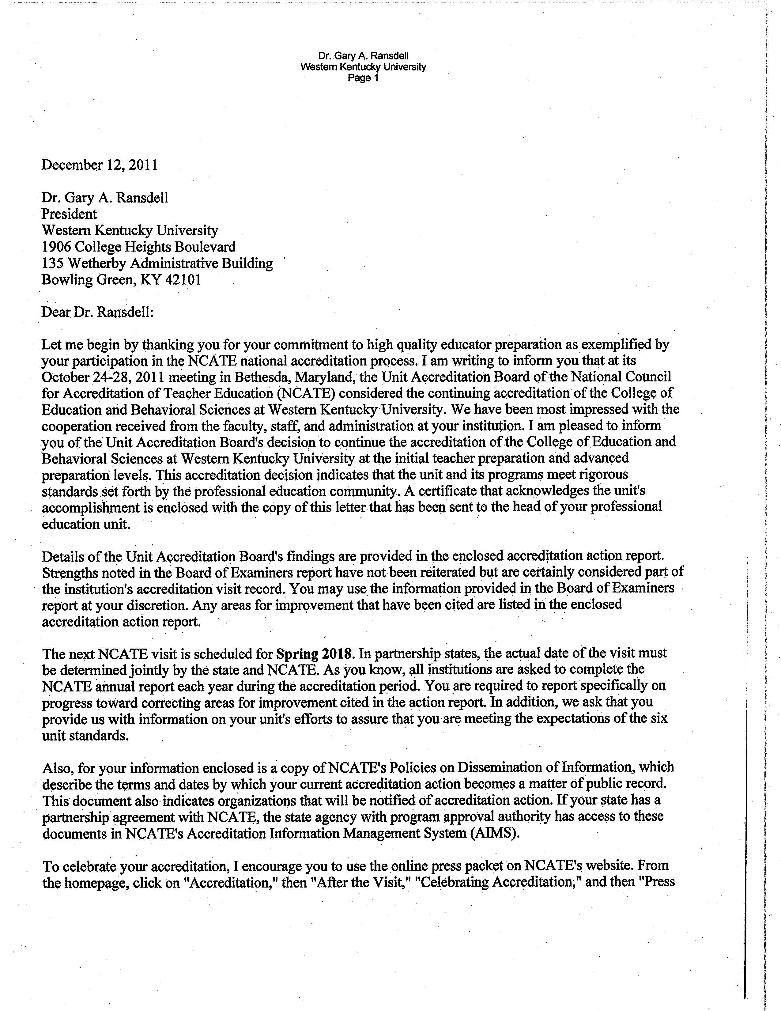

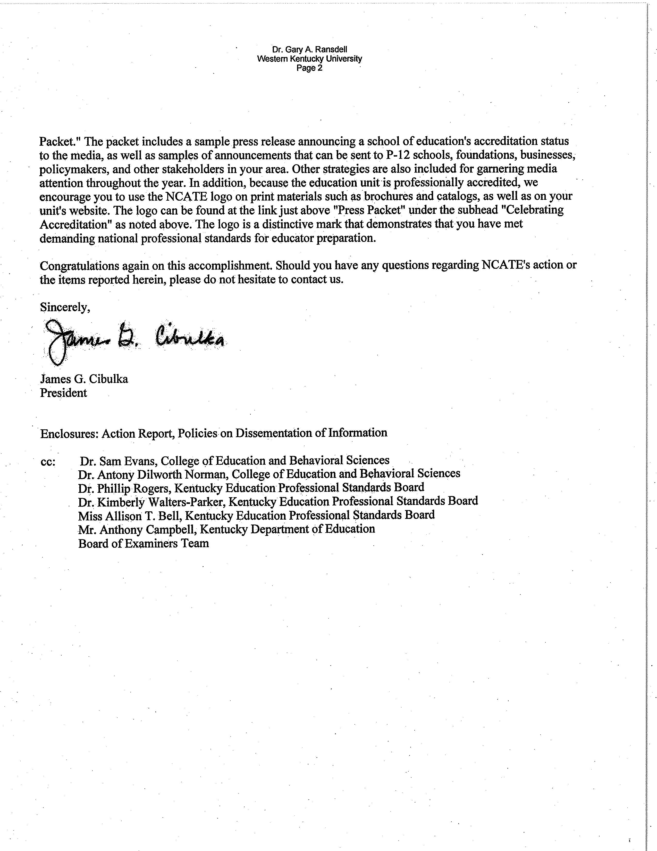

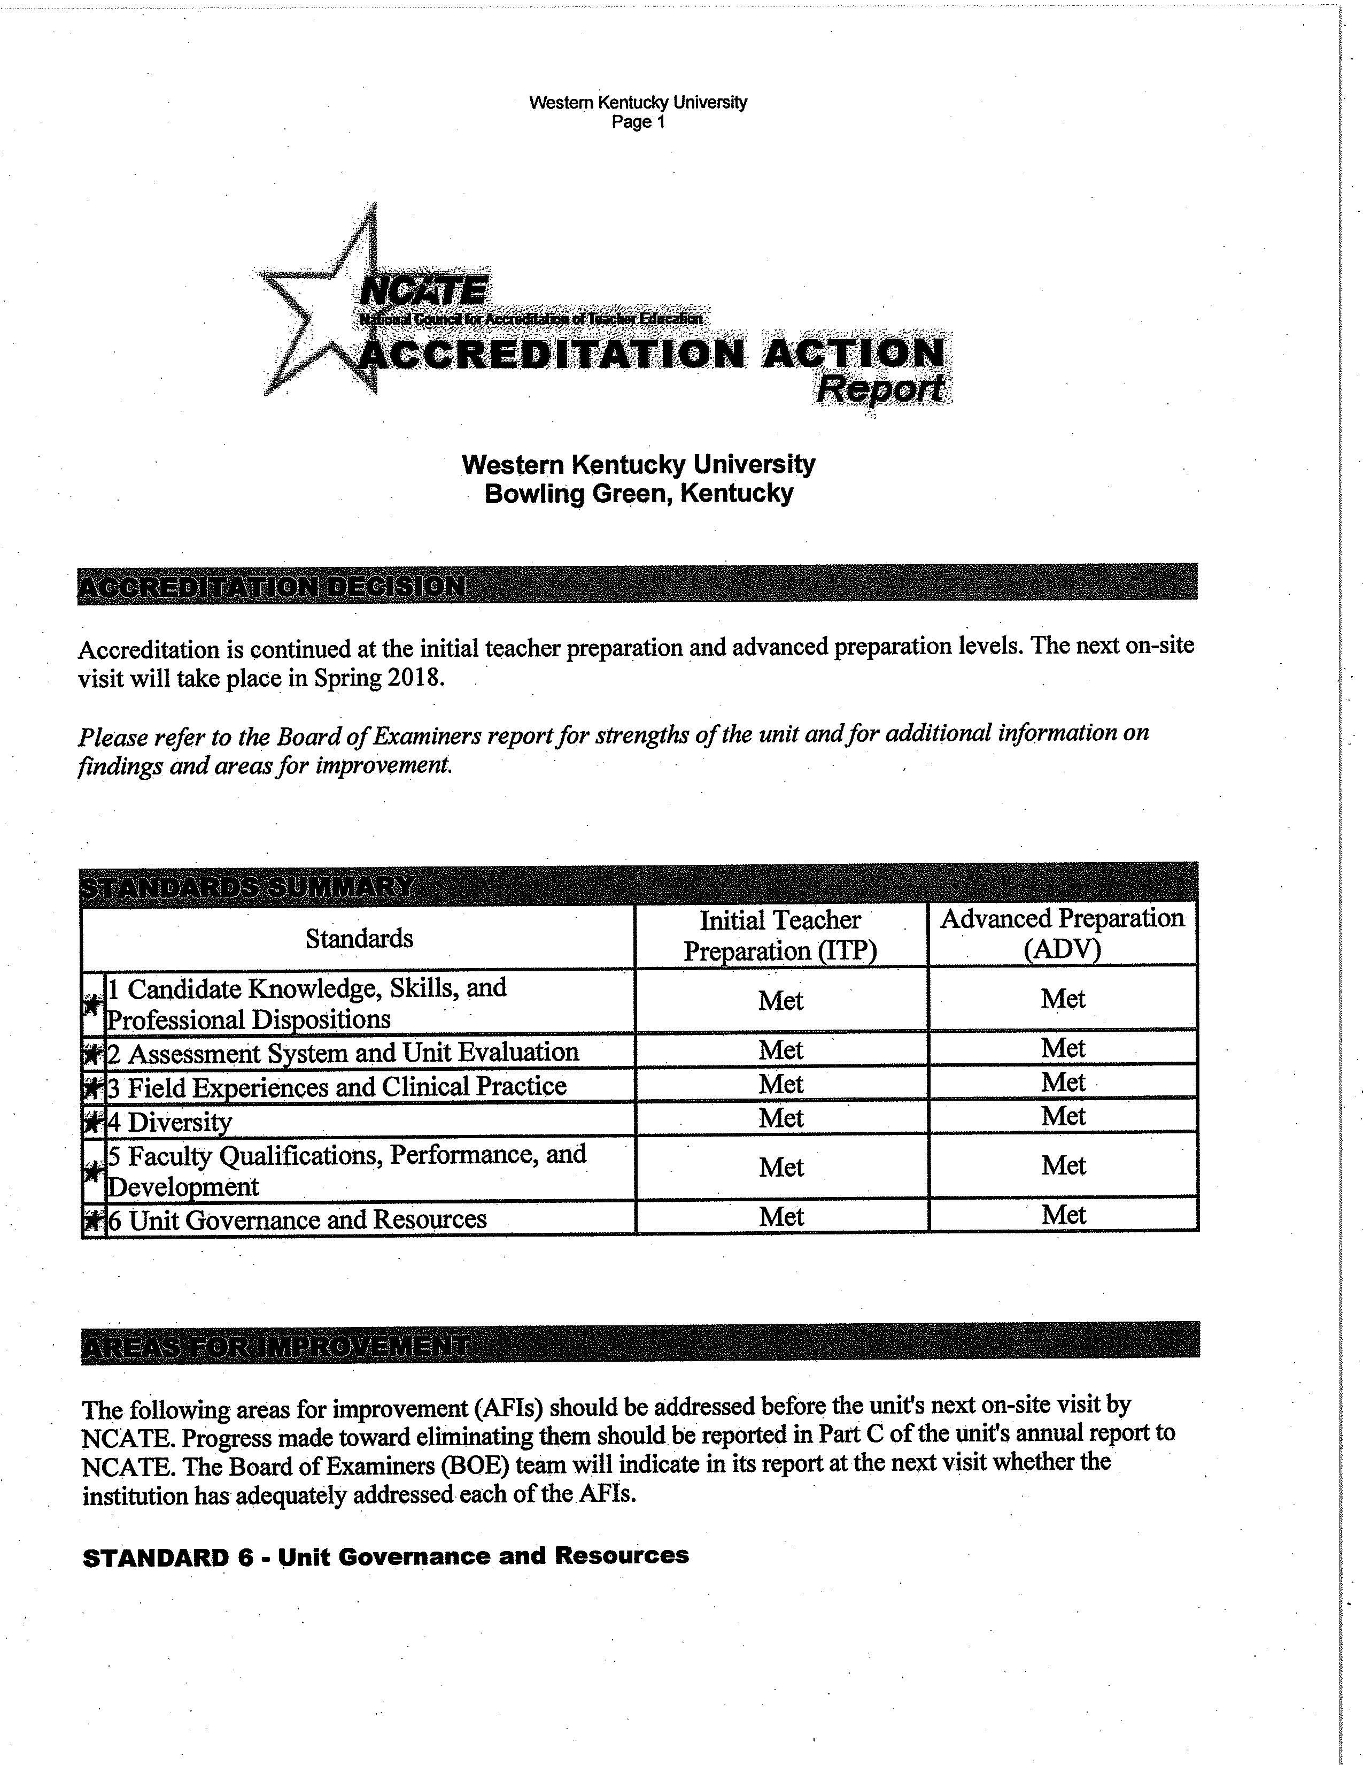

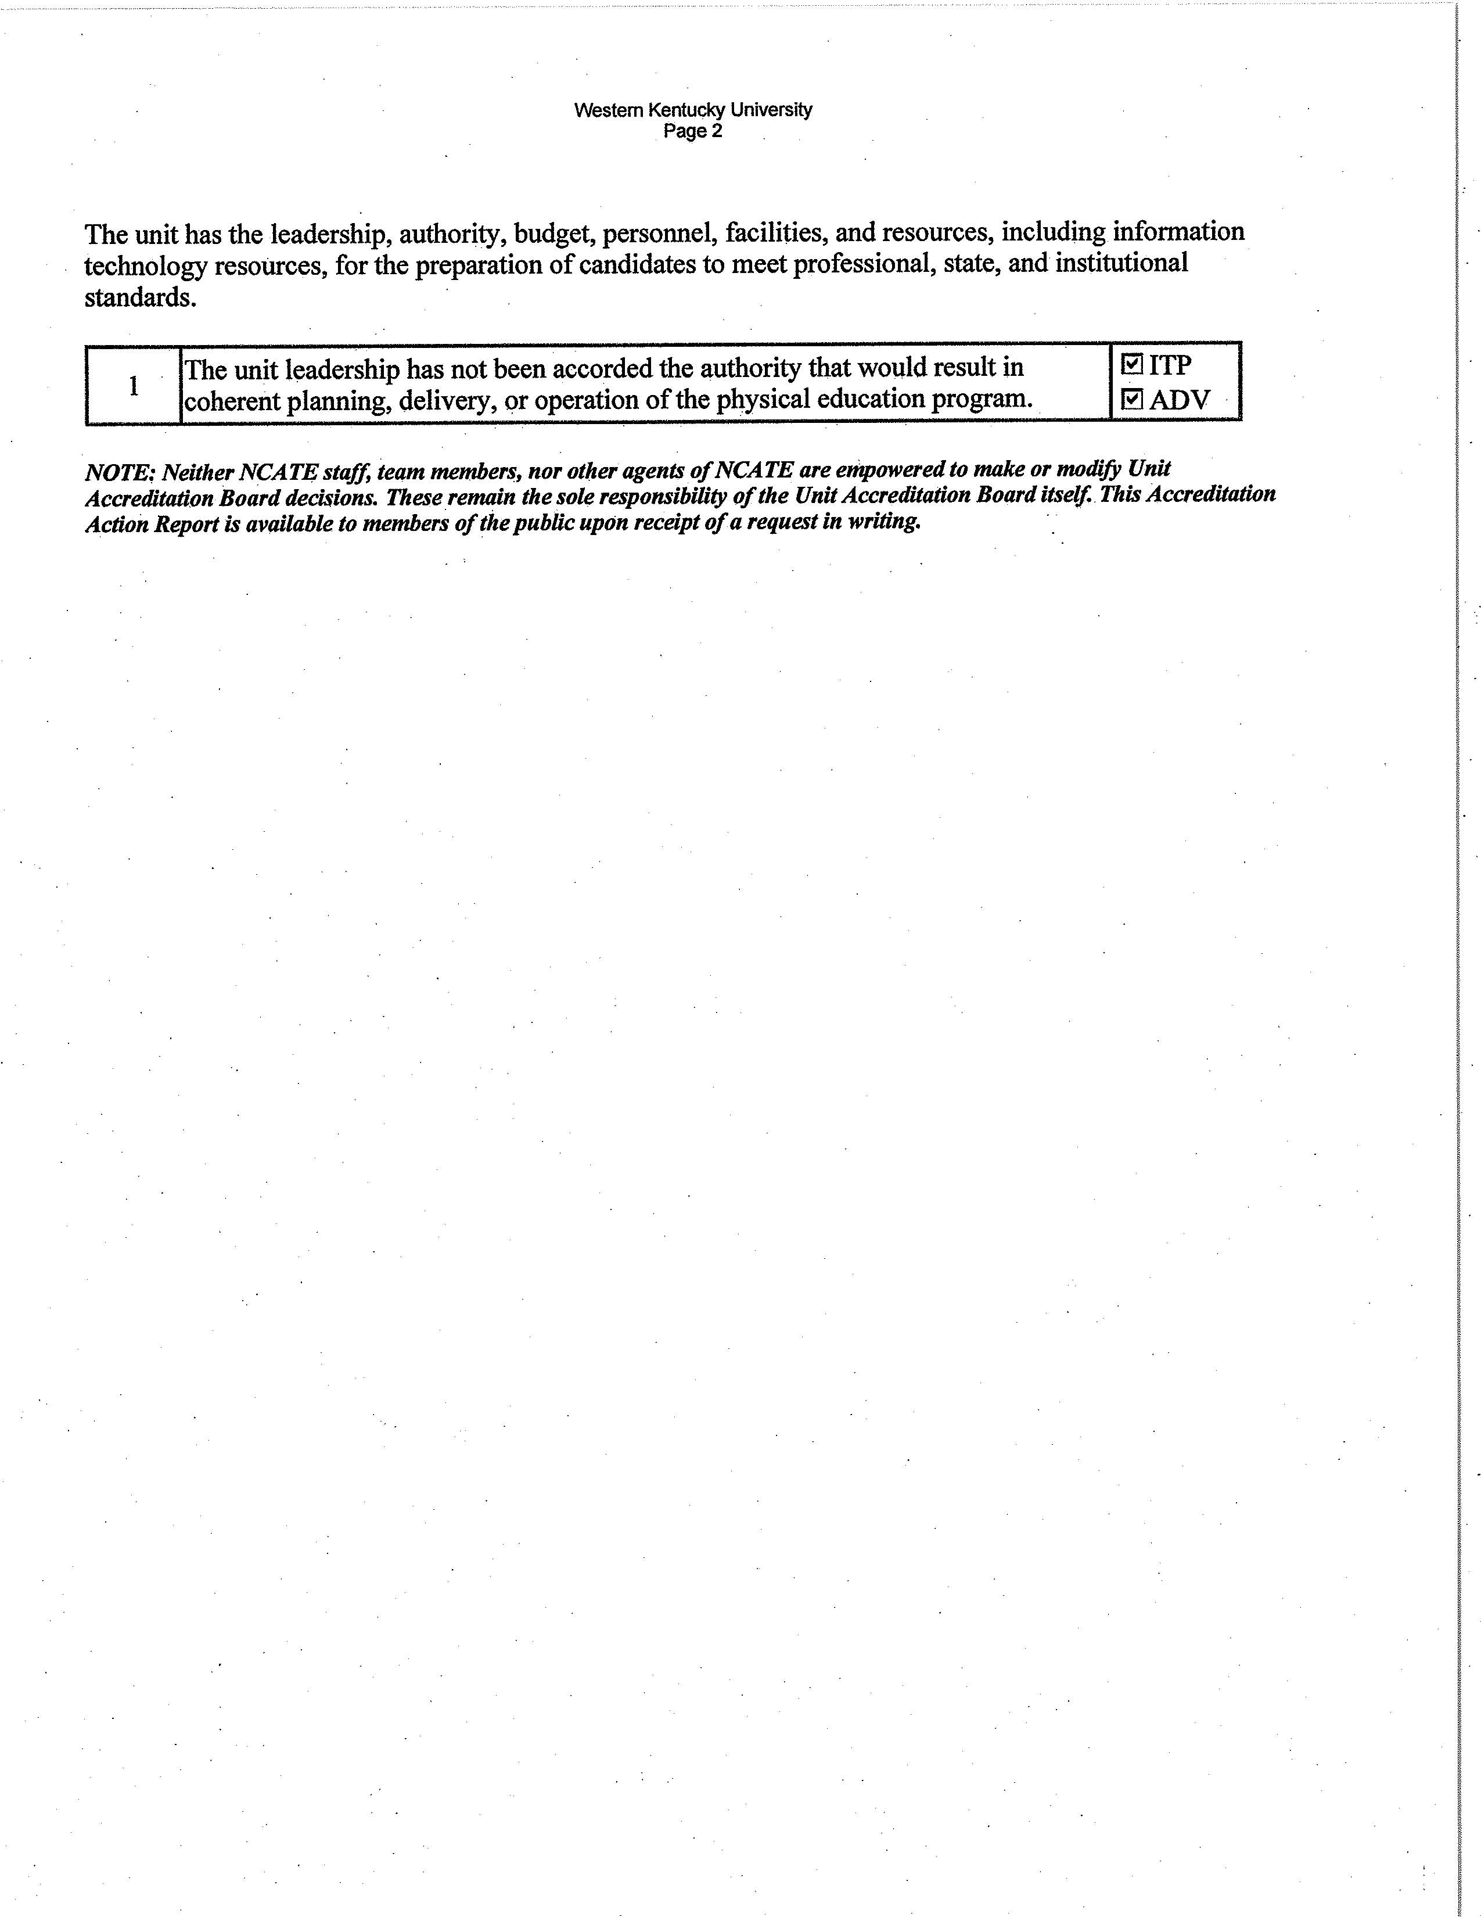

The need for introductory science courses in all the disciplines is the reason for the original need for a 6 hour waiver from the rule of 50% upper level courses. All SKyTeach students carry a double major in a content area and in Science and Math Education (SMED), so a broad science content major is needed for the middle school teachers. This revision eliminates the need for such a waiver.

