Environmental Education Projects

Muhlenberg High School Agriculture
Project Title: Wood Duck Nesting Boxes
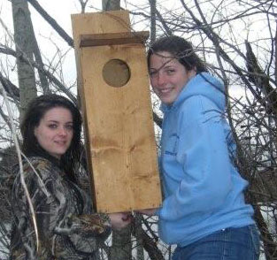  Stimulus for Project: Earth Force Project  Grade Level: Secondary  Issue-Keywords: Wood duck, habitat, land, water, species  Who is impacted? Students, school, community, and any others who make use or take part.  Contact Person: Scott Allen Cronin  Location: Muhlenberg Co. High School – West Campus | Project Description: Students worked with a partner in building a nesting box to be mounted in the local community around ponds, lakes, swamps, reclaimed mining sites, and other watersheds. The project is to help improve a habitat for the wood ducks to have more nesting areas. Students researched wood ducks, their habitat, organizational efforts for waterfowl, and learned about waterfowl reproduction, habitat, and other characteristics.  Outcomes/Evaluation Brief Description: One of the project outcomes is to show how basic efforts can help improve wildlife and environment along with showing students basic construction skills for projects. Students took ownership of their world to help understand sustainability and how public land can be managed in big and small portions. This project also opened up career opportunities for students. Students found this experience to be fun, rewarding, exciting, practical, realistic, and productive.

Hopkinsville Middle School

Project Title: Exploring How Water is Affected in a Sinkhole
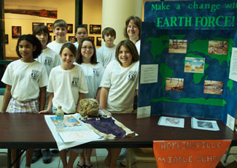  Stimulus for Project: Earth Force Project  Grade Level: Middle School  Issue-Keywords: Water, run-off, sinkhole, karsts, erosion  Who is impacted? school, students, community  Contact Person: Amy Porter  Location: Hopkinsville Middle School, KY  Project | Project Description:  There is a sinkhole on our school property which has an overflow drain. Where does this water flow? Does this drain lead into Little River? Littler River, located near our school, drains into Kentucky Lake. Our drinking water comes from Kentucky Lake. How did this sinkhole on our school property form? How does litter impact our water quality?  Project Outcomes/Evaluation Brief Description:  We invited WKU's Hoffman Institute to come to our school and to do a Dye Trace in our drain. Due to some miscommunication, the dye was placed in the wrong drain, so we did not get "true" results from our sinkhole. Students, however, learned a great deal through the investigation and research involved with the Earth Force project and they were proud of the work they completed.

Warren East Middle School
Project Title: New Beginnings Outdoor Classroom
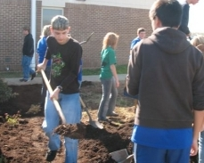  Stimulus for Project: Earth Force Project School-Based Initiative  Grade Level: Middle Grades  Issue-Keywords: soil, mulch, erosion, weed control, percolation, soil formation  Who is impacted? Students, faculty  Contact Person: Susie Comer  Location: Warren East Middle School | Project Description:  Outdoor Classroom - Students mentored with the Warren East High School Agriculture students to apply classroom studies of soil formation, erosion, plants and interactions of each of these and man. This project was implemented as soil erosion prevention.  Project Outcomes/Evaluation Brief Description:  Our students mentored with high school students as resources in an effort to give back to their community. The emphasis for this project is to promote character education and diversified instruction in the middle school classroom. We hope to promote lifetime learning in our community.

