Anthology-Portfolio QuickStart Guide for Faculty – Sharing a Portfolio

Step 1: Access Your Portfolio
- Log into into Anthology Portfolio: https://wku.chalkandwire.com/
- From the dashboard, click Go to My Portfolios to locate the portfolio you would like to share.

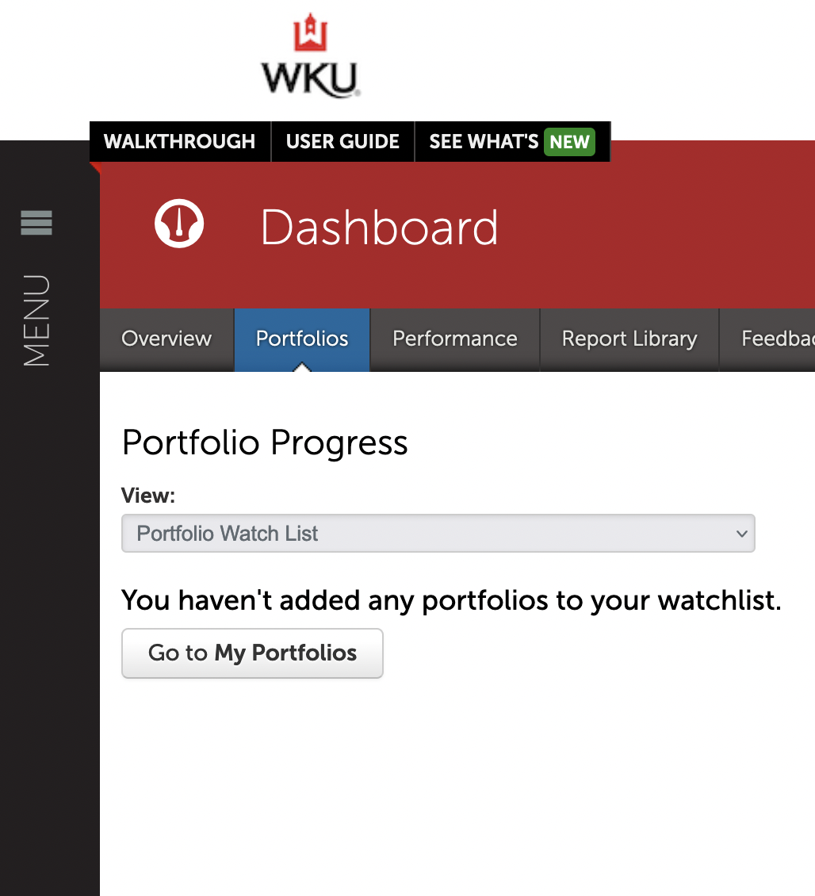
- Click anywhere on the portfolio’s row to reveal its options. 1. Select Edit Portfolio.

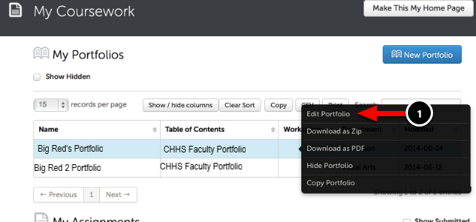

Step 2: Select the Portfolio Page to Share
- The Sharing feature enables you to create a secure URL that links to your portfolio.
- Before beginning, click on the page name you would like to share (e.g. Curriculum Vita).
- Click on the Share this Page (2).

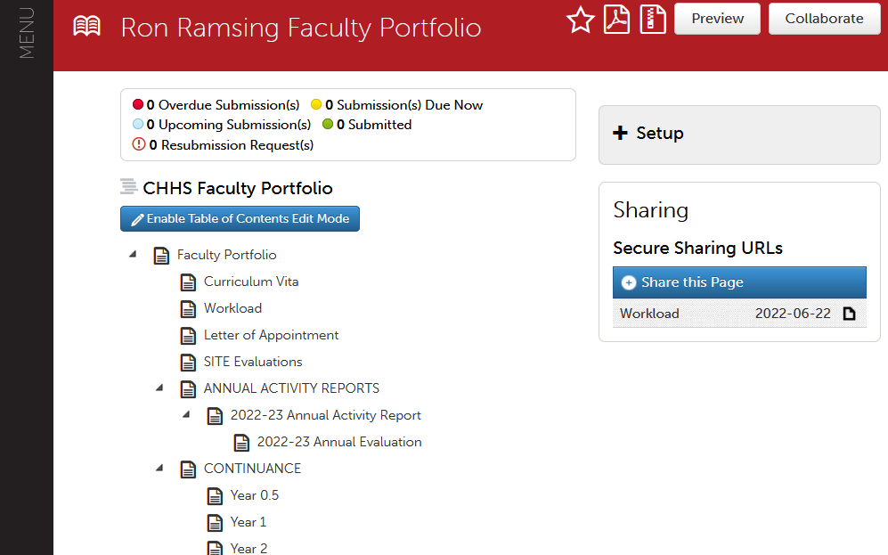

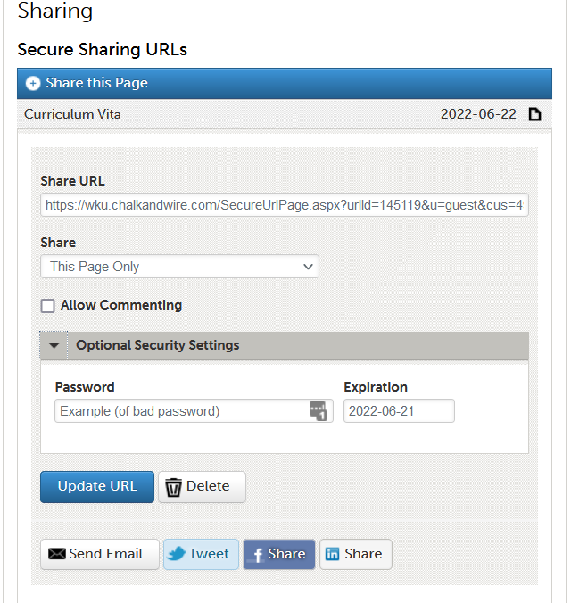

- Under the Share pull down menu, select This Page Only.
- Select Generate Share URL. The Share URL field will be filled with the secure, direct URL once you have generated the URL.
- Select Send Email and a new email message will be created with the url embedded (this option does not work with all emails systems). Alternatively, you can copy the URL, by highlighting it in the Share URL text box, and paste it in an email.
- View previous shares by clicking on them. You may also delete previous shares.
- Optional security settings. To ensure the security of the generated URL, you may create a unique password that also has an expiration date.
- Option to view:
  - By copying and pasting the Secure URL into a new browser window, you are able to see how your shared portfolio will appear to others.

