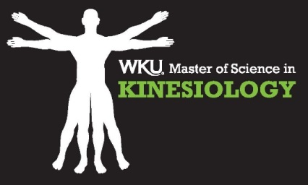

Kinesiology Graduate Assistantships – 2 Positions Available (Fall 2016)
Graduate Assistants (GA’s) have responsibilities in the graduate Kinesiology and undergraduate Exercise Science academic programs within the School of Kinesiology, Recreation & Sport. GA’s reports to the Graduate Coordinator, Dr. Mark Schafer, and will have the opportunity to work with all Kinesiology faculty members to support and assist with a wide range of teaching and research opportunities. Graduate Assistantships operate on a two-year renewable term and include a stipend and tuition waiver.
Description of Responsibilities
- Assist faculty-led research by participating in study design, IRB submission, data collection and analysis, subject recruitment, manuscript preparation, and all other aspects of the research process
- Provide assistance with conducting Exercise Science courses and laboratory sections
- Supervise and maintain the Exercise Physiology & Biomechanics Labs by providing supervision of open lab hours and providing instruction to undergraduate students preparing for practical exams
- Apply for internal research funding and conference & research travel grants
- Prepare abstracts and present research findings at local, regional and/or national conferences
- Serve as a student reviewer for the International Journal of Exercise Science, with the potential opportunity to serve as student managing editor
- Review and update the Exercise Physiology Laboratory Manual and provide basic maintenance for the laboratory equipment
- Represent department and program at various recruiting fairs
Application Information
Students wishing to apply for a Graduate Assistantship must submit the following materials:
- Completed KRS Graduate Assistantship Application
- Cover Letter detailing:
  - the knowledge and skills that make you a competitive candidate
  - career goals and/or research interests
- Resume – including contact information for 3 references
All materials must be submitted electronically to Dr. Brad Stinnett at brad.stinnett@wku.edu and Dr. Mark Schafer at mark.schafer@wku.edu. Applications are due no later than March 15th for committee review. Successful applicants will be contacted by April 15th, and all applicants will receive a decision notification by April 30th.

