Setting Up Your
Higher One Account

Introduction:

By now all WKU students should have received their WKU debit card in the mail. If you have not already activated your card, these instructions will allow you to do so with ease.
In the past, the WKU debit card has been used solely to distribute residual refunds to students. However, Higher One is now in charge of processing WKU payroll for all student employees. Students must now choose their payroll preference once they log onto their Higher One account.
Many students do not receive refunds and therefore have not activated their cards. Now that Higher One is also processing payroll it is important that all students who currently work for student employment, or plan to in the future, activate their cards and choose a payroll preference. Many options are available to them. They may choose to have funds deposited into their one accounts, or set up direct deposit with a bank of their choice which they currently have an account with.
To begin the process, please follow the steps outlined in these instructions. Check first that you have all required materials and information readily available to save time.
Required Materials:

- WKU Debit Card (which you should have received in the mail)

- Computer/internet access

- Personal Information (phone number, address, etc.)

- Driver’s license information

- Valid email address

- Cell phone number (if you would like to have alerts sent to you via text message)

- Alternate checking account information (if you wish to have funds deposited to an account other than your Higher One account)

Let’s Begin!

- Getting Started: After you have located your WKU debit card you will need to go to www.wkudebitcard.com

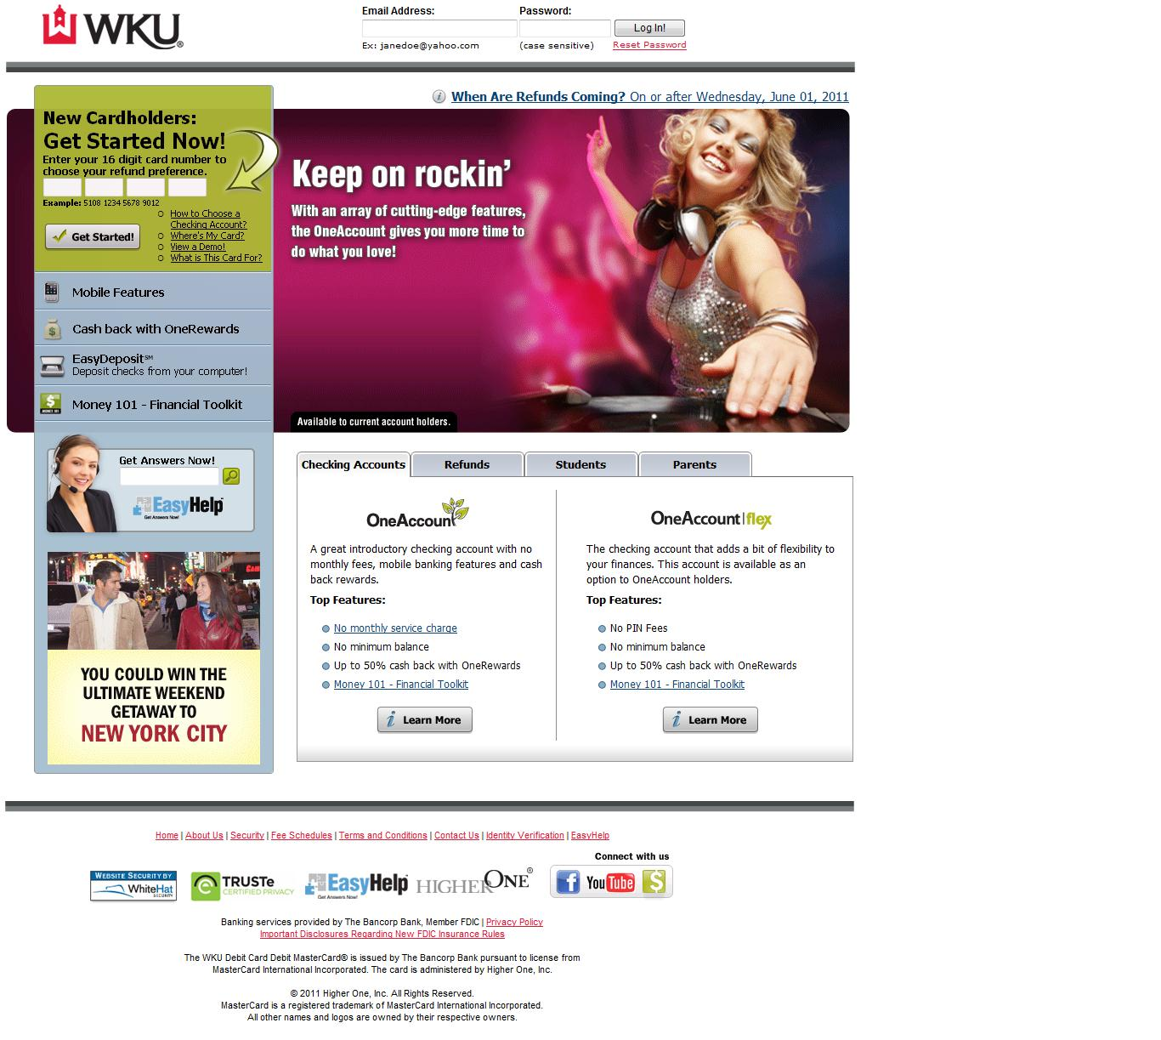

- Input card information: To the left of this page you will see an option to input your card number to begin the activation process. Enter your 16 digit card number now and click, “Get Started.”

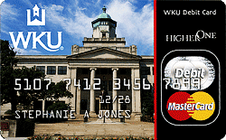

- Authentication: Here you will be asked to confirm information. The information asked to confirm may be different for each cardholder. However, it will usually consist of entering your card security code along with your student I.D., birth date, or social security number. Enter the required information and hit “next.”

- Create your login information: Provide your email address and password here. Be sure to use an email you check often and a password you can remember as this will be used as your means for logging in to your One Account.

- Select your refund preference:
  - Easy Refund: This is the fastest refund choice which deposits funds into your One Account the first day they are available to you. You will also get access to other One Account advantages with this choice.
  - ACH Deposit: This choice takes 2-3 days and will deposit your funds into the bank account of your choice.

- Easy Refund:
If you have chosen the Easy Refund option in Step 5 you will now be prompted to a page where you need to verify personal information such as name, address, and date of birth.

- ACH Deposit:
If you have chosen an ACH deposit refund preference in Step 5 you will now be asked to verify some information concerning the bank account you are using. This information will include the bank name, routing number, the account type (checking or savings), and the account number. Now generate and print the ACH form which you will need to mail to Higher One. Soon you will be ready to receive your refunds and payroll

- Identity Verification: Easy Refund preference cardholders will now be asked to verify their identity. All cardholders are pre-approved for the account, but federal regulations require Higher One to include this step. Simply verify you are a U.S. citizen or Resident Alien and input your driver’s license information.

- Set up your pin: In cases where cash is needed, you will need a pin number to get money from an ATM. At this step you will be asked to select and verify a pin for this purpose. Be sure to choose a pin you will remember.

- Terms and Conditions: Read and agree to the “Terms and Conditions”

- Adding money from an outside account: If you would like to add money to your One Account from a separate account, please enter the appropriate information now.

- Higher One Features: Now a list of available features will be presented to you as a One Account cardholder. Check the features you would like to take advantage of and click “Next.”

- Email Notifications: As with the features in Step 12 you can now choose which email notifications you would like to receive. Check the desired ones and click “Next.”

- Summary: A summary of all that you have set up with your One Account will now be presented to you. Read over it. If any changes need to be made go back to the appropriate steps and make the necessary changes. If no changes are needed you are FINISHED!

Conclusion:

After you have completed card activation you are ready to login and manage your account. Go to www.wkudebitcard.com and login with your email and password to begin!

To see a video tutorial of this process please visit:
https://wkudebitcard.higheroneaccount.com/demos/Activation.htm

