WKU Wireless fix for WKU Secure

How to setup windows as the default wireless connection manager.

Step 1 – Disable the Intel/Dell/3rd party Controller
The different adapters and different versions will have the toggle in different locations. Look for something that says “use windows to manage” or “turn on wireless zero config”. If there is an option to save this for future use make sure to check that box. Also look for anything that states “Hide this icon, or hide this utility”, as we won’t be using the 3rd party software any longer.

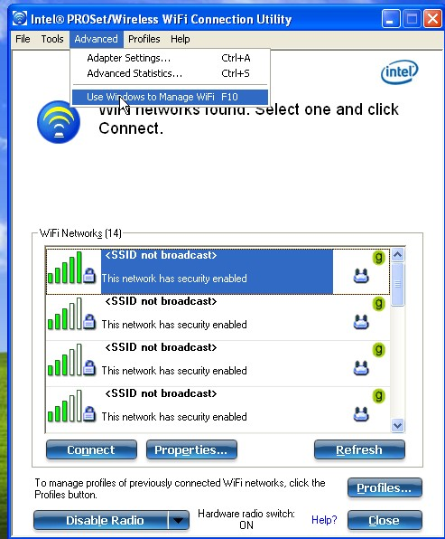
Step 2 – Fix the services.msc
To access the service list click on the start menu and go to the run command. Type in services.msc and click ok
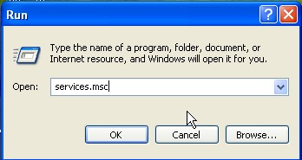
Find windows wireless zero config, right click, and stop the service.
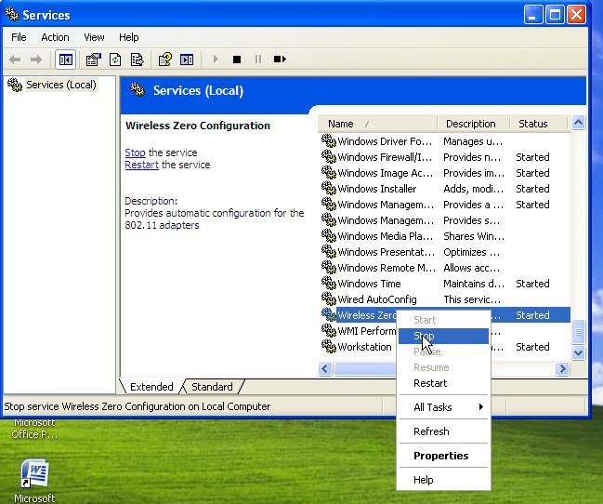
Next find the Error Reporting and Event Log services. Both of these need to be started, and set to automatic. Right click on the service to start and double click to open the menu to set to automatic.

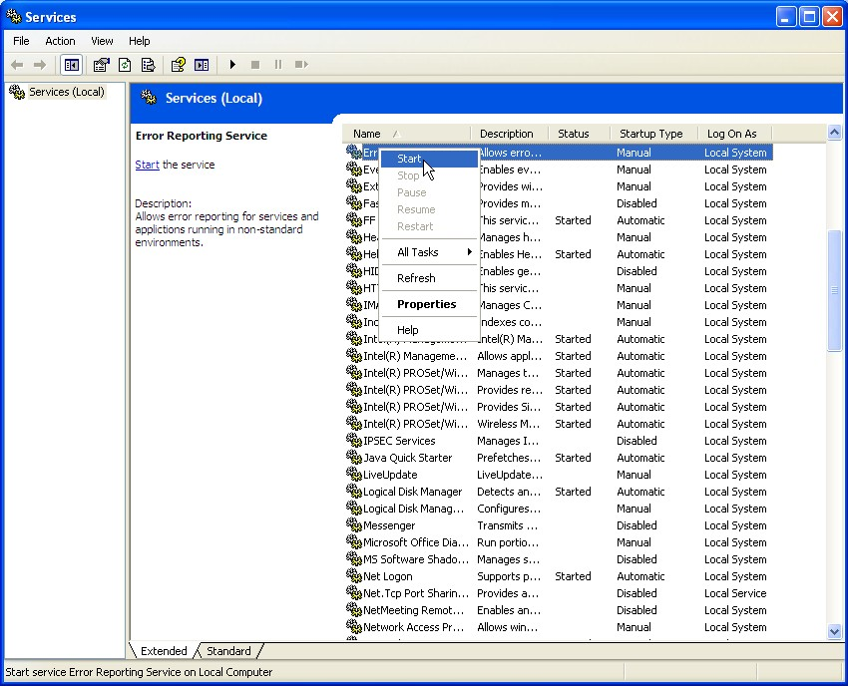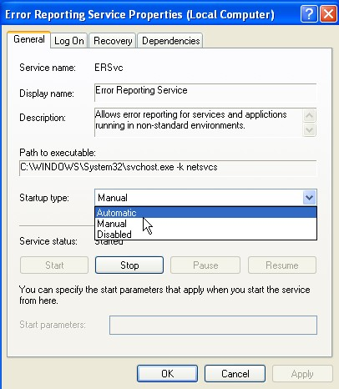

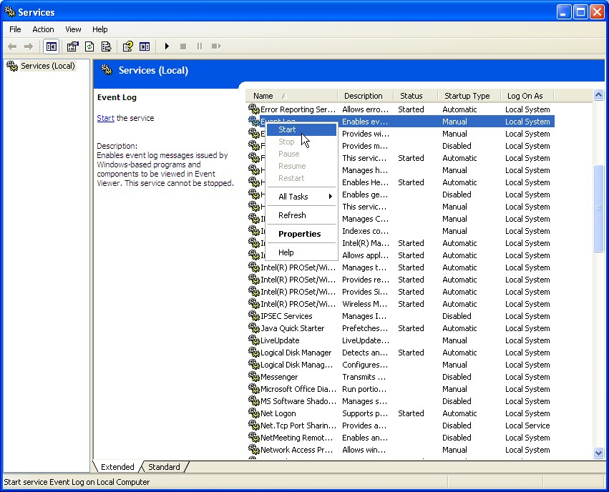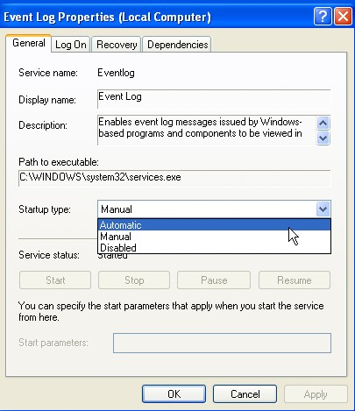

Start the wireless zero config.
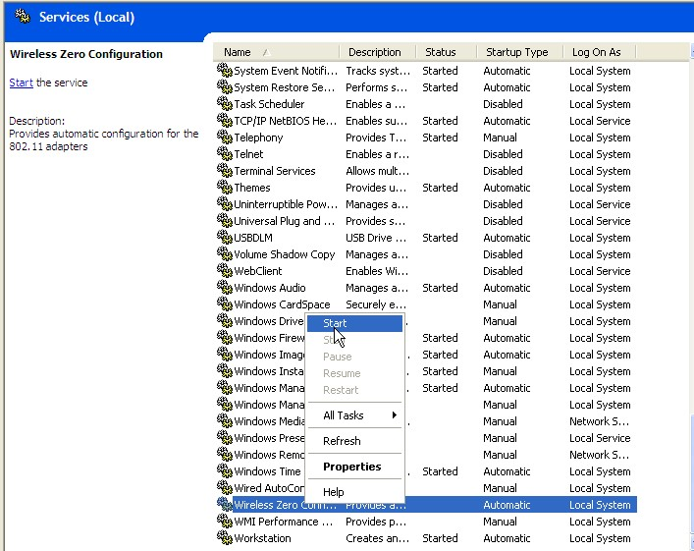

Step 3 – Connect to WKU-SECURE

Right click on the wireless icon and select view available networks. Click on WKU-SECURE and click connect.
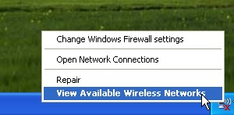
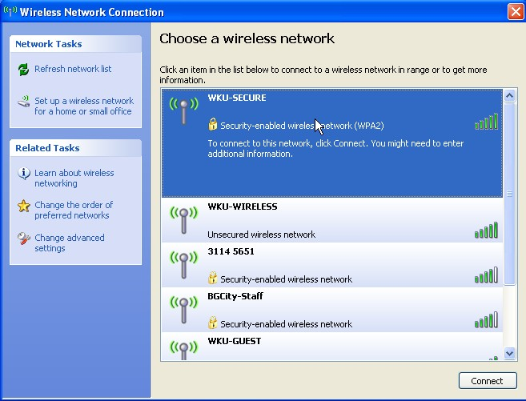
Configuring WKU-SECURE as the default Wireless Client

Step 1 – Configure the preferred networks

- Right-click the Windows Wireless icon in system tray.
- Select View Available Wireless Networks.
- Select WKU-SECURE and click Connect.
- Click Change Advanced Settings in the left-side menu bar.
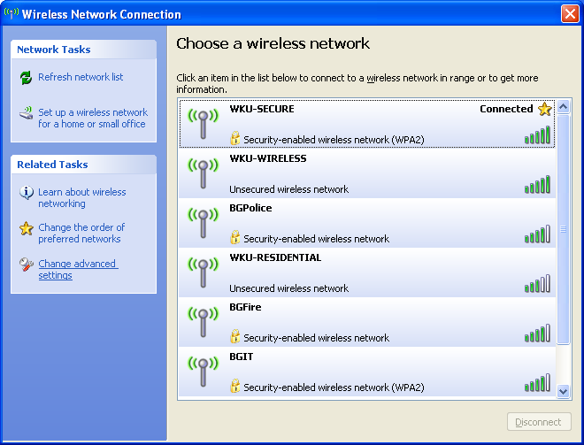

- Click the Wireless Networks tab.

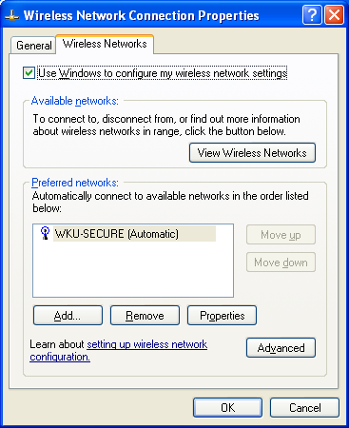

- Select WKU-SECURE.
- Click the Properties button.
- Click the Authentication tab.

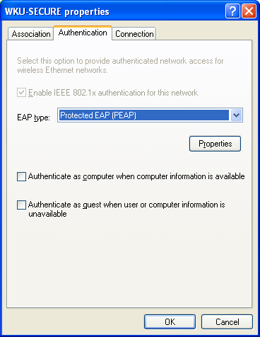

- Uncheck the box for "Authenticate as computer when computer information is available."
- Under EAP type, select "Protected EAP (PEAP)".
- Click the Properties button.

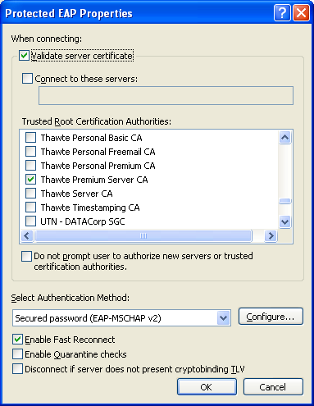

- Check the box for "Validate server certificate."
- Under "Trusted Root Certification Authorities," check the box for "Thawte Premium Server CA".
- Click the Configure button.

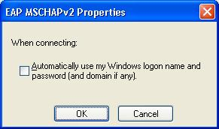

- Uncheck the box for "Automatically use my Windows logon name and password (and domain if any)."
- Click OK, OK, OK, OK to close all the open windows.

- Right-click the Windows Wireless icon in the system tray.
- Select View Available Wireless Networks.
- Select "Change the order of preferred networks" in the left-side menu bar.
- Select WKU-SECURE and click the Move Up button until it is at the top of the list.

