BSPH/MPH Meeting Minutes
Meeting Setting

Meeting Time
- November 17, 2023 9:30 am CT
Zoom Recording Link: https://wku.zoom.us/rec/share/YaCItPYYI07erFvC1IL5dY3gYpz96P4Sab0wYjHl5FXKR6uZVzgcA1oSnq_LcTuu.VA7SUqB7UdoMuglH
- Passcode: =i3Y5WgY

Participants
- Kristen Brewer, Jae Kim, Grace Lartey, Edrisa Sanyang, Angel Shoemake, Landon Rager, Susan Eagle, Xiuhua Ding, and Mary Catherine Rush, Sabita Shrestha

Welcome

New Business
- Landon is our new department member
  - He is helping with Accreditation for all of our programs in the DPH
    - ACA, HCA, BSPH, MPH, etc.
  - He is also helping with tours on campus

Agenda
- KPHA Reports
- External Advisory Board Updates & Meeting
- BSPH-MPH Curriculum Updates
- CEPH Accreditation
  - Self-Study Update
  - Site Visit Information and Agenda Draft

KPHA Reports

Open Issues
- KPHA is also doing a toy drive with the hospital and a sorority on campus
  - The boxes will be in the Academic Complex
  - Anyone can drop of toys to Stephanie or Grace
  - Ends on Tuesday 11/22
  - The toys must be NEW toys
- KPHA has elections coming up
  - We want graduate students to join as well
  - An email will go out after Thanksgiving with more information
  - Encourage the students to participate by sharing this information

Action Items
- Drop off a new toy for donation before the end of the day on 11/22
- Encourage students to participate in KPHA elections by sharing information

New Business
- The last KPHA meeting was a presentation from the Medical Center in Bowling Green
  - Amy Hardin is in charge of their activities
      - She has done a great job coordinating how we can participate in those events
      - The students had a great time working with her
  - She presented opportunities that the medical center has for our students
    - For example, the medical center is rolling out a new electronic health record (EHR) system
      - They want to test this system, so they need interns who can work the help desk to direct calls to the IT center to resolve any problems with the new EHR
      - We had four students from HIM, PH, HCA, and HS who reached out
- KPHA also recently completed a personal hygiene drive for the international center
  - The drive is looking for toothpaste and toothbrushes
  - Dental Hygiene was able to donate some things
  - Dr. Lartey was able to bring some items that she bought from the store
    - She dropped them oof on Tuesday

Questions
N/A

External Advisory Board Updates & Meeting

Open Issues
- During the last MPH meeting, the external advisory board was discussed
- There is a list of 12 names to contact
  - Potential members had until 11/10 to RSVP
    - Nine responded out of 12
Dr. Doug Thoroughman
Dr. Matt Hunt
Cori Covington
Catherine Malin
Heath Ray
Scott Williams
Jill Ford
Selina Blick
Joshua Horton
*Reminders were sent to India Martinez, Ashli McCarty, Vanesha Stewart-Amoah.
*Committee suggested that Ashli McCarty and India Martinez be contacted again. Another person, Alexis Morgan was suggested as another person to be contacted. Grace Lartey will contact the three individuals.

New Business
- After receiving the RSVPs, a meeting time with the Core Advisory Board was chosen:
  - The meeting is currently set for December 1st, 8:30-10:00 am CT
    - The meeting is virtual
  - Meeting Agenda:
    - Welcome, Self-Study, Site Visit Dates, Third Party Comment (Workforce Development and Needs), Discussion of program review to prepare for stakeholder meeting portion of the site visit

Action Items
- Please reach out with additional suggestions for members
  - We have an email template to invite other people

Questions
- Are we all attending this meeting? If so, can we be cc’d on this information? What about schedule conflicts?
  - We will all attend this meeting
  - The email invitation will be emailed soon, and we will all be cc’d
  - Please try to attend
  - You may show up late (better late than never)
  - if you cannot attend, there will be a recording

BSPH-MPH Curriculum Updates

Open Issues
- Last meeting, MPH was looking at acceptance requirements
  - They talked about the student learning objectives
  - They talked about Citi training
    - They have not figured out how to include ethical training in to the curriculum
    - This issue is on hold now

New Business
- BSPH Updates
  - No new information on the BSPH side
- MPH Updates
  - The new positions for the MPH program have been approved and posted:
      - Assistant Associate Professor Pedagogical Track
      - MPH Program Coordinator
    - The review will begin in March for that position
      - The review committee has been selected:
        - Grace, Angel, Ed, Xiuhua, and Jae
  - The MPH team also discussed program processes regarding the applied practical experience and ILE forms
- BEKY Meeting
  - Dr. Ding attended the recent Building Epidemiologic Capacity in Kentucky (BECKY) Meeting
  - There is a shortage of epidemiologists (30% vacancies)
    - UK developed a masters in epidemiology program to support these vacancies
      - There is a disconnect between the state and academic involvement
    - We need to consider shaping our curriculum to help develop the workforce in the state
      - WKU is the only university in the State with an epidemiology certificate

CEPH Accreditation

New Business
- Self-Study Site Visit Update
  - The site visit date is scheduled for March 11-12
  - Our final self-study needs to be sent by February 12th
  - Here is a screenshot of the email to the program coordinator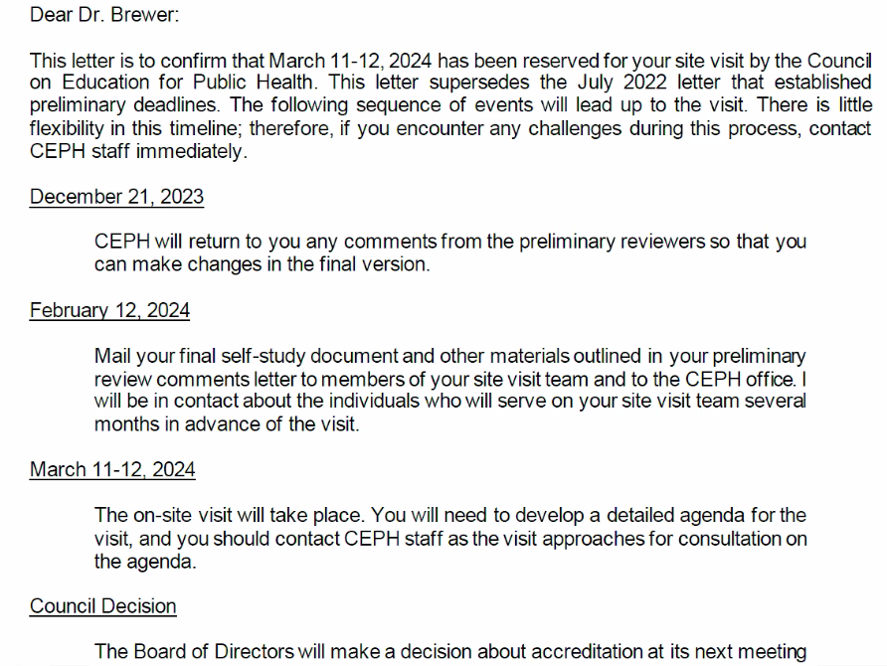
- Site Visit Information and Agenda Draft
  - CEPH has a specific format for the site visit meetings
  - We have to send a draft agenda to CEPH by January 15th (our false deadline is January 9th)
  - The final agenda will be sent with our final self-study on February 12th
  - Dr. Lartey and Landon are currently organizing the agenda in accordance with those guidelines
    - They will share this information with us
    - It includes the timeline, who is involved, and what will be discussed
- We will consider a mock site visit to make sure everyone is prepared
- We still have to coordinate all logistics for the site visit

Action Items
- Make sure that you have a plan for those classroom dates for the site visit (March 11-12)
- We also need to post CEPHs email address on our website to allow for third party comments during the site visit
  - They need names for:
    - Current Students
    - Stakeholder feedback and alumni
- We also need to make sure the students are aware of what is happening with the site visit

Questions
1. Why are the MPH faculty not on the new hiring committee?
- This is a question for Dr. Mkanta
2. Will this information be shared?
- Yes, more information about site visits will be shared with us via email soon

Any Other Business
- Emergency classroom preparedness
  - Some faculty are concerned that there is no emergency classroom training to facilitate emergency response (medical emergencies, fire, active shooters, tornadoes, etc.)
  - We can potentially discuss this issue with Dr. Mkanta in accordance with university or college-level protocol at the next departmental meeting
Next Meeting

MPH/BSPH Meeting
- There will be a Doodle Poll sent out soon
- Here are some tentative dates:
  - January 19th
  - February 16th
    - Remember that the final draft of the self-study is due February 12th
  - March 8th
    - This meeting will be earlier because of the site visit
    - We can discuss any last minute issues related to the site visit
  - April 19th

Core Advisory Committee Meeting
- The meeting is currently set for December 1st, 8:30-10:00 am CT
  - The meeting is virtual

