BSPH/MPH Workday Meeting Minutes

Meeting Setting

Meeting Time
October 13, 2023, 9:00 am—12:00 pm Central Time

Meeting Location
Zoom Meeting
Zoom Recording:
https://wku.zoom.us/rec/share/WU7zGaa94vmx8XpMuUQIp9x0SpI5c8hATQ3oHu48WejskYSZhpDcm3k48hHHBhhD.3j1S9xZqRZlVu9YS
Passcode: WPze6&T7

Participants
Kristen Brewer, Xiuhua Ding, Susan Eagle, Edrisa Sanyng, Jae Kim, Grace Lartey, Angel Shoemake, Sabita Shrestha, and Mary Catherine Rush

Meeting Agenda
- Welcome
- MPH Curriculum/Program Updates
- Self-Study Updates
- Advisory Board Membership and Meeting
- Determine Next Program Meeting Schedule
- AOB
  - KDPH Updates
  - Tuition Assistance Program
  - BECKY
  - KPHAST
  - High School Program
  - University Program
  - Student Internships
- Criterion D Breakout Session

Next Program Meeting
- Friday, November 17th at 9:30 am –10:30 am via Zoom

MPH Curriculum/Program Updates

Admissions
- Our program compared admission criteria with other universities
  - WKU wants to stay competitive
- These are proposed changes:
  - We removed the GRE requirement
  - Pathway 2: cumulative undergraduate GPA updated to 3.0 GPA
  - Pathway 5: updated to 2.75 GPA plus 3 years professional experience
  - New pathway added
    - Pathway 6: Completion of WKU graduate certificate with a 3.0 GPA
- Motion passed to approve these changes

Self-Study Updates
- We are working on it
  - It is almost completed
- Dr. Lartey will send us document drafts as they are ready
  - Make sure to review the documents and to inform Grace of any edits or additions
  - Keep in mind that some people can be added to guest speakers
- The final draft of the preliminary report should get to CEPH office by the 24th
  - It needs to be mailed and emailed
  - The mail bundle must arrive by the 24th
  - Grace plans on getting everything in by Wednesday or Thursday
- This is a preliminary report
  - It will not be perfect
  - It gives us time to review gaps and provide edits for the final report
    - The final self-study report is due in February
    - The Site Visit may be in March
  - We need to work on section D
    - How our program aligns with competencies and how we assess the competency alignment

Advisory Board Membership and Meeting
- We will not pass this section of the self-study if we do not have it
Here is a screenshot of the policy draft: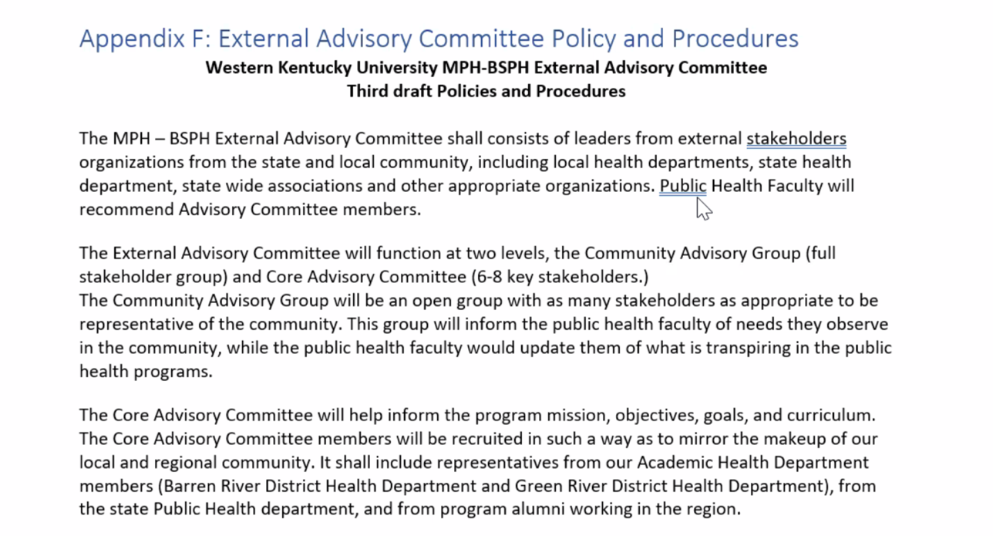
- This committee is an external body that reviews our program
- The current system has two levels
  - Core Advisory Committee
  - Community Advisory Group
- Grace is thinking that we should just have a single group to facilitate the process and to make it easier on the members
  - The current system involves too many meetings
  - A few faculty are questioning whether two levels are necessary
  - It is a lot of work because we are the drivers of the process
  - We need to make sure we can actually get the work done
- Susan explains why it was developed with two levels
  - Description of both levels:
    - The first level involves community members at large
      - We need to be aware of what is happening in the community from the stakeholders involved
    - The second level (Core Advisory Committee) involves specific stakeholders from the community with expert knowledge
      - These stakeholders can provide the specific feedback we need for our mission, vision, goals, etc. in our program
      - The stakeholders in this level do not have to be a part of the Community Advisory Group, but they are allowed to be if they want
- Justification for two levels:
  - People in the community at large are not necessarily savvy on how an academic program functions
  - We want folks with expert knowledge to provide review of our program at this level
    - For example, future hiring organizations of our graduates
- We need ideas for committee members
  - Grace has a list of 12 potential members
  - She will update MC with the list
  - We motioned to accept these changes and potential members
- We need to carefully consider the logistics and workload of planning these meetings and achieving committee objectives

Program Meeting Schedule
- We determined that Fridays are the best time
- The next program date is listed at the beginning of this document
AOB

KDPH Updates
- KDPH has formed a collaboration with all universities
  - There is a standing monthly meeting
  - We must attend this meeting
    - On top of that meeting, there are additional meetings
- KDPH does a lot of work to improve public health and public health education/workforce
  - Tuition assistance program (TAP)
    - They support tuition of employees for furthering their education
    - The college had to present on the online programs available for full-time employees
    - The college admitted three TAP students
      - MPH got one of these TAP students
    - We need to find ways to set ourselves apart and grow this program
      - We would like to find out why this student selected our program
  - BECKY
    - BECKY will be held next year Nov. 1st at EKU
      - Four MPH students and Dr. Ding will attend
    - This is a collaborative epidemiologic conference for the commonwealth of Kentucky
  - KPHAST
    - This is a training program for students to be certified in emergency and disaster preparedness
      - Students must choose to complete this training
      - There are three levels
      - More information will be shared with us in the future
  - High School Program
    - Infectious disease simulation program
    - They are asking if we can have one here
      - We are working on this program for next year
        - We are proposing to have this program in the Spring of the 2024-2025 academic year (still preliminary)
  - University Program
    - We would also like to have this program here next year
    - We are working with Amy Wininger (upward bound) and Catherine Malin (director of AHEC)
    - Now we are working with KDPH to propose to have the college program in the fall of the 2024-2025 academic year (still preliminary)
  - KDPH Student Internships
    - The way this program is set up is not great for students
      - IT is set up from September to January
    - We shared our concerns with them
      - They mentioned that it is dependent on state and federal funding and which programs that need support

CHHS Halloween Party
- The college is hosting a Halloween party and costume contest on Tuesday, October 31st
  - There is an email with a flyer and more information
- The DPH is competing with a *top secret* group costume that is sure to win the contest
  - If you would like to participate in this group costume, please reach out to Angel or Mary Catherine

Criterion D Breakout
- Review objectives, competencies, and assignment alignments for the MPH and BSPH programs
  - Provide any feedback or revisions
- After this review today, Grace will provide more drafts for us to review for the final preliminary report
- Please make sure to go through the D-9 document carefully to ensure that our competency alignments are the same as those listed on the course syllabi

