iBook Content Outline: Recycling and Surplus

Why WKU Recycles
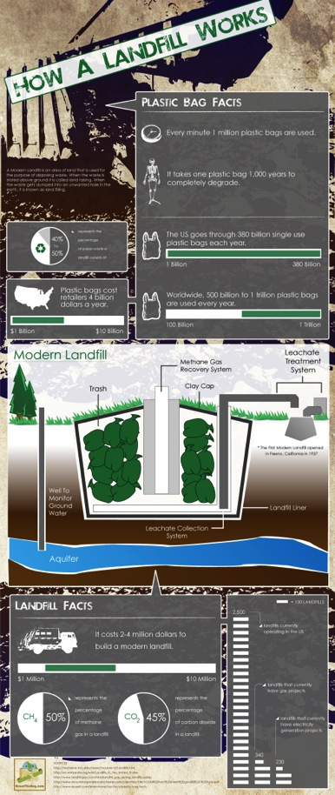
Recycling to the everyday student may be as simple as throwing their water bottle in the right container, but for WKU Recycling and Surplus, it’s a way of life! WKU chooses to recycle not only because it is cost effective and makes sense financially, but because it is the right thing to do for the environment.

For every pound of recycling collected at WKU, that is $.05 that WKU avoids paying in landfill cost. $.05 may not seem like a lot of money, but considering we recycle tons of cardboard, plastics, aluminum cans and various metals, paper, and glass every year- it can add up fast! Avoiding the landfill means more than just saving money. Recycling means the prevention of methane being released from the landfill, slowing the depletion of natural resources across the globe, and contributing to economic growth and supporting green jobs.

When we think about recycling, we think about more than just the process of getting plastic in the right container. We think about the full life cycles of products like plastic bottles. Plastic bottles make up 1.5 million tons of waste each year and the average amount of time it take to biodegrade is ____ years. When we choose to recycle commodities we are closing the loop on these life cycles for some of the items. (INFOGRAPHIC ABOUT RECYCLING OR LANDFILLS HERE- like the one below, but I did not make it)

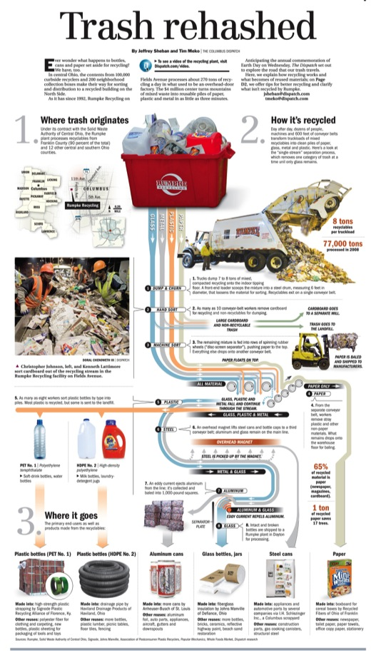
The Process

Today, the process of recycling at WKU is a result of years of trial and error- and we are still a work in progress! In April of 20011, WKU transitioned to “single stream” recycling. This means that the most common recycled items” paper, plastic, aluminum, and small pieces of cardboard can all be placed into one recycling bin. We continue to separate out larger pieces of cardboard out and compact it at one of 2 cardboard compactors on campus. Recycling is collected in multiple locations including: Residence Hall lobbies, desk side recycling bins in offices, exterior “Victor Stanley” containers, game day/special event containers, community bins and finally the exterior building containers where the interior bins are emptied into.

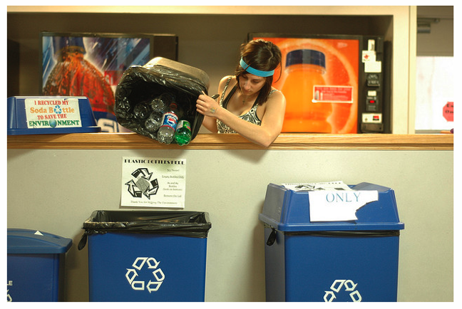
Residence Hall Containers
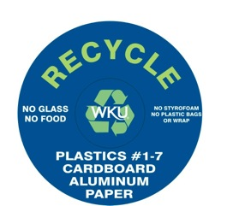Signage for a Victor Stanley Container

Community bins

The community bins are used heavily by businesses, homes, and numerous locations where curb-side recycling is not available. The bins provide three options for recycling: glass, cardboard, and single stream. Single stream recycling means you can put all of your recyclables into one bag— making recycling much simpler and more convenient!
The community bins are located behind the Service and Supply building on campus, at the intersection of University Blvd. and Russellville Road (diagonal to the baseball fields). If you live or work off-campus and don’t have curb-side recycling, we hope you’ll take advantage of these bins. They are, after all, here for you!

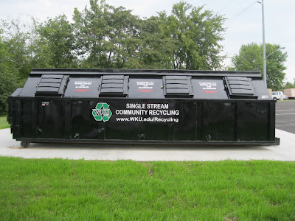
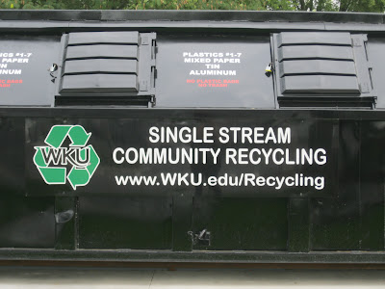

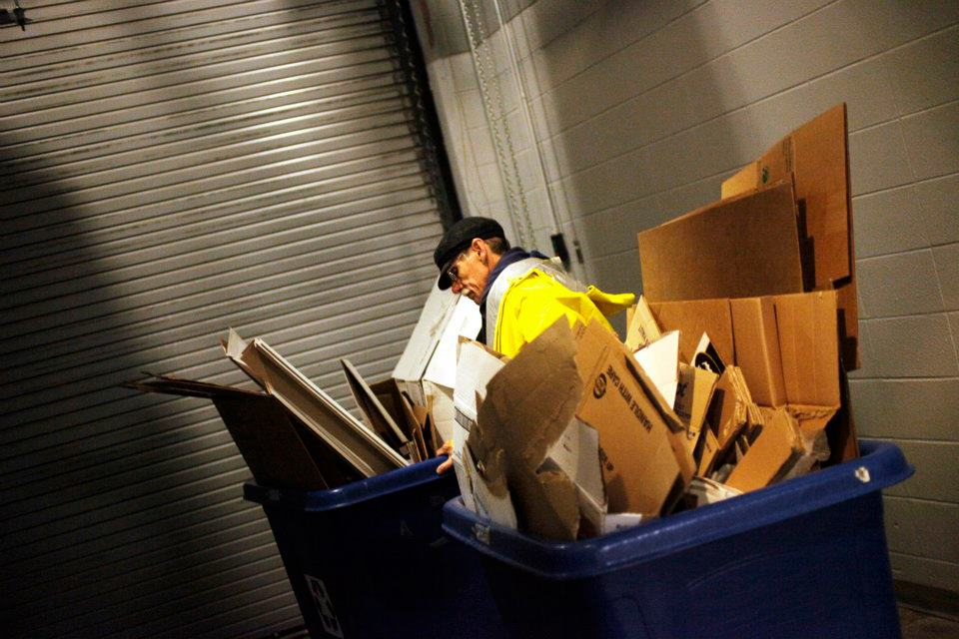

Route Stop Containers

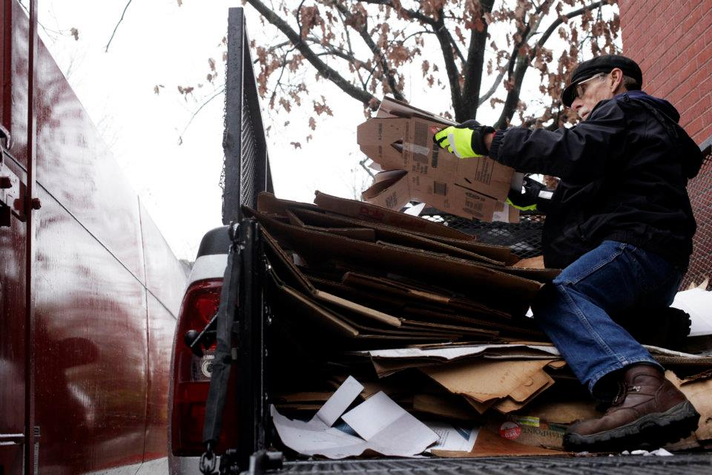

Bill, Full Time Recycler at Compactor

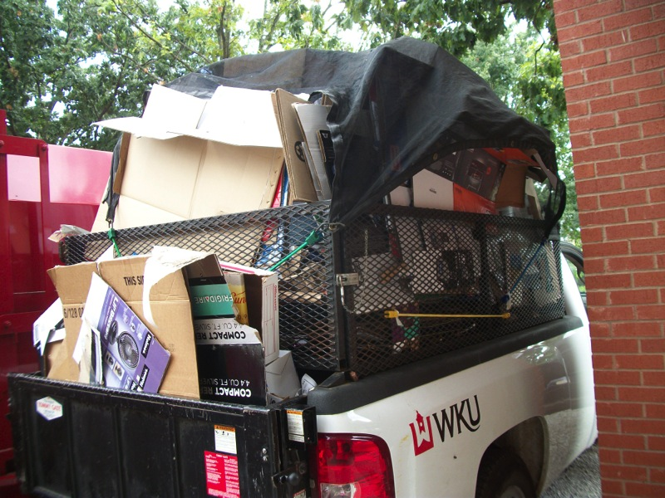

Cardboard at the Cardboard Compactor

Where the Recycling Goes

The collected single-stream recycling goes to a recycling company in Nashville, TN called QRS (Quality Recycling Solutions) www.qrsrecycling.com

Once our recycling reaches their facility, it then goes through a series of conveyor belts where the items are separated and eventually bailed. From there, QRS strives to sell the materials to end users within a 4 state radius.

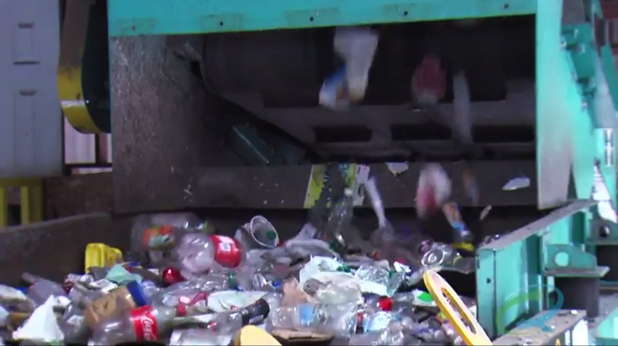

QRS SORTING FACILITY
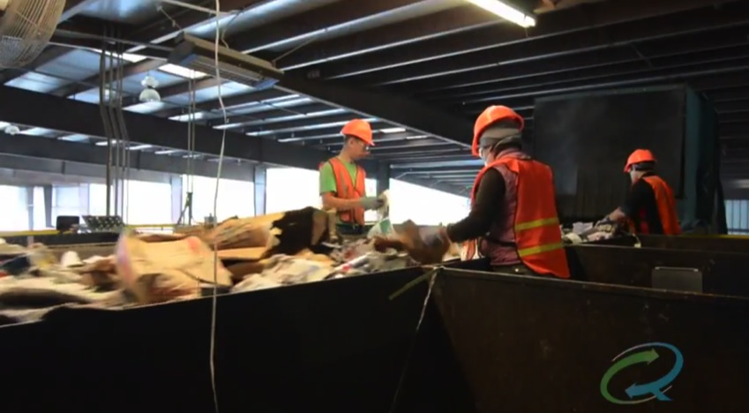

QRS SORTING FACILITY

A note about glass…

Currently, we do not accept glass in the single stream recycling on main campus. We do accept it at the community bins and take it to a local facility. From there it is sent to a company called “Strategic Materials” where it is turned into a raw material called cullet. It is then sold back to bottle and jar manufacturers to be turned into new jars and glass.
Reduce and Reuse! Recycling also involves surplus operations at WKU

In August of 2011, WKU Recycling encompassed surplus operations on campus. Surplus operations involve a range of tasks disposing of broken furniture to sale of automobiles.

In just 1 year, WKU Recycling was able to successfully create a computer donation and refurbishing program, a website called “Topper Trader” that allows for easy reuse of office items on campus, surplus sales that totaled over $30,000, and a more sustainable way to dispose of un-usable items.

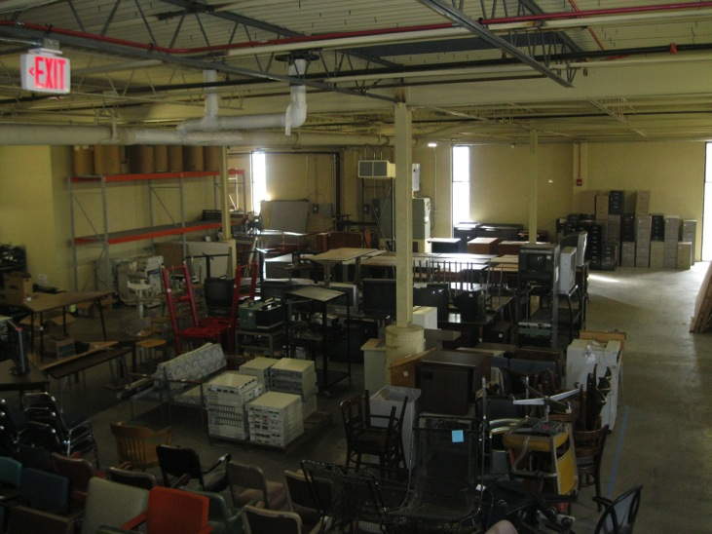
Recycling managed Surplus Operations Include: Ambitious approach was to re-organize surplus operations

- Designated office hours
  - Recycling dedicates student workers to remain in surplus during designated open hours. This is a huge part of why surplus re-use increased significantly under Recycling. Because faculty/staff are able to see what items they may be able to use in their office or classroom without appointment any day of the week, we have allowed for more opportunities for items to be reclaimed on campus.
- Topper Trader
  - Perhaps the most useful improvement of Recycling-managed surplus is the creation of a website, found at www.wku.edu/recycling, that allows for easy viewing and reserving of items that faculty/staff may be able to use for their spaces. Currently, this is only open to WKU faculty and staff. We will also deliver the items to you free of charge.

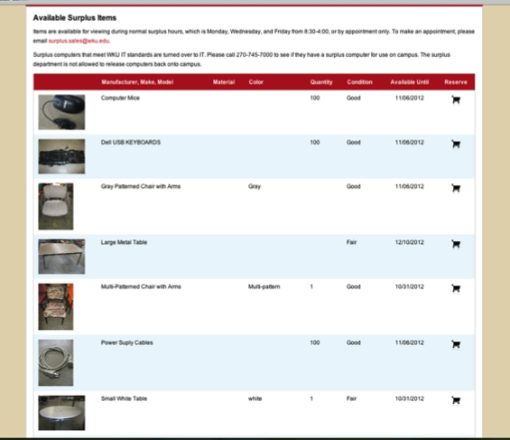
- Computer Donation and Refurbish Program
  - One of the first objectives when Recycling took over surplus was to ensure the sustainable disposal of electronics that were obsolete. However we quickly found that items were being sent to be e-scrapped that hand plenty of life in them. In September 2o12 Recycling dedicated a student worker with IT experience to sanitize and refurbish computers that we then work with Connect Kentucky (http://www.connectkentucky.org/) to donate to area non-profits.

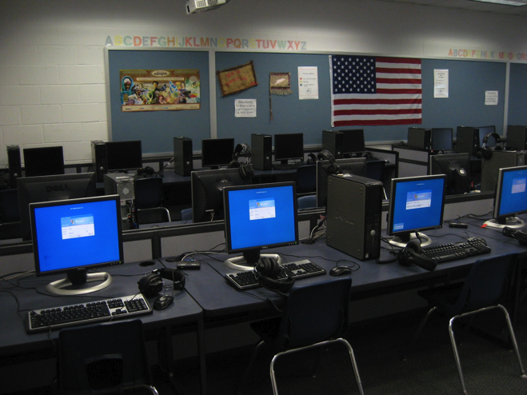

Classroom set of computer monitors donated to Edmonson County Schools in Kentucky

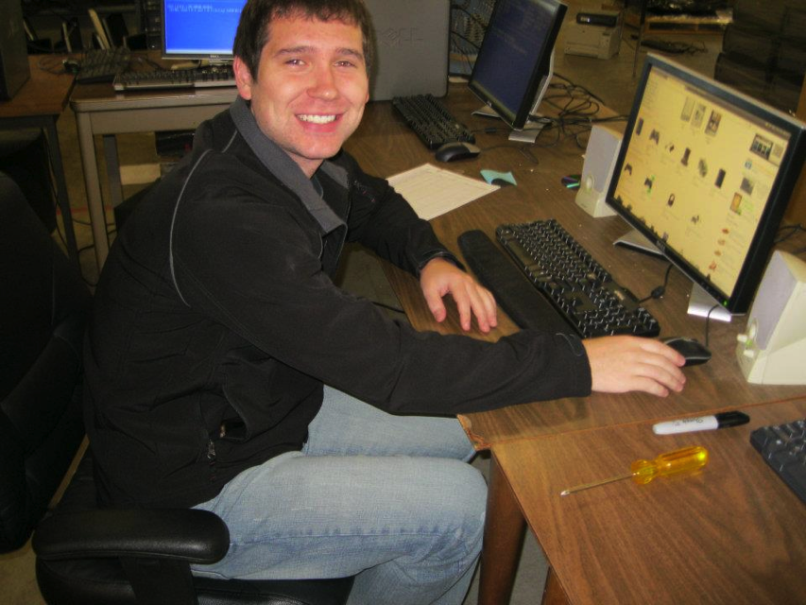

Wes Taylor, our Recycling student who refurbished computers

Staffing

Currently, the Recycling and Surplus Department is made up of 3 FTEs and a crew of up to 9 student workers. Our setup includes:

ORGANIZATIONAL CHART

Bottom up

Students (up to 10)

Recycling Associate Surplus Associate ( Full time)

Recycling and Surplus Coordinator (Full Time)

Outreach and Community Involvement- Reduce Reuse Recycle REEDUCATE

The students and staff in the Recycling and Surplus department work with the community and on outreach when they are not running a business or collecting tons of recyclables! Initiatives have ranged from field trips for local schools and Girl Scouts to learn about the RRR’s of recycling to Earth Day Festival demonstrations.

Community Outreach- Field Trips
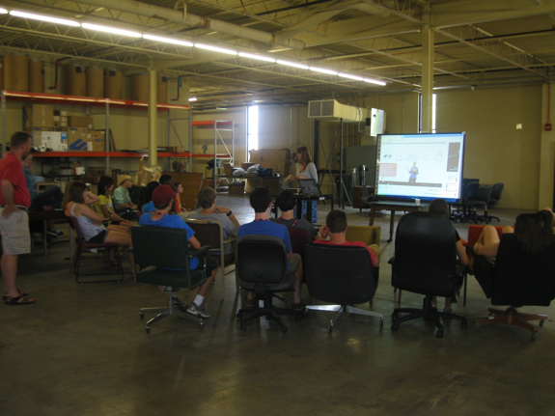

Earth Day Festival Demonstration- Garbology!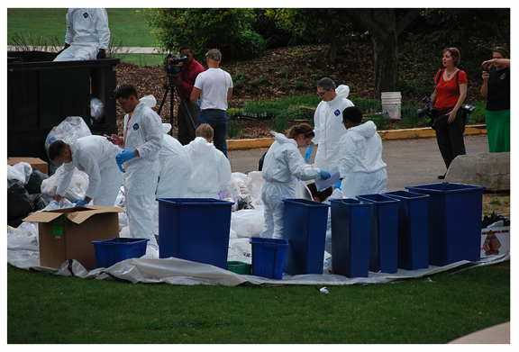
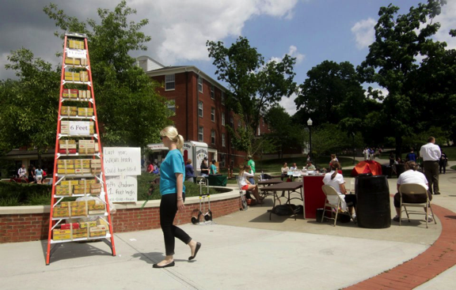 Earth Day Demonstration- How tall is our garbage if it was in the football stadium?
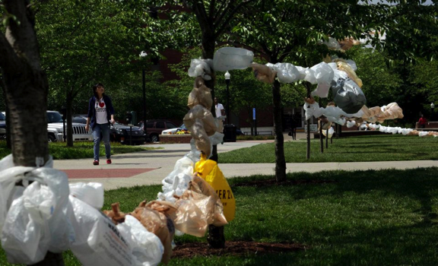
Earth Day Demonstration- how many plastic bags does the average American throw away?

Cardboard Collection Drive

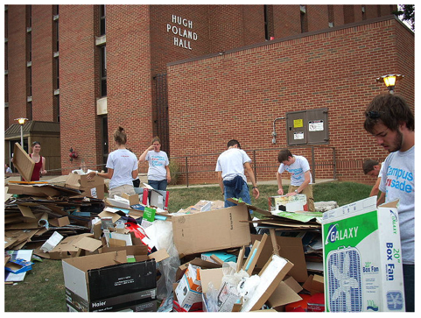
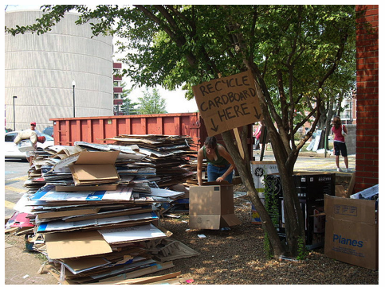
The first day of move in for students on campus is the first big opportunity to engage student in recycling efforts. We work with the grounds crew in facilities management to monitor 15 residence halls and ask students and parents to break down the cardboard. In the past we have also worked with students groups as volunteers to help facilitate the efforts.

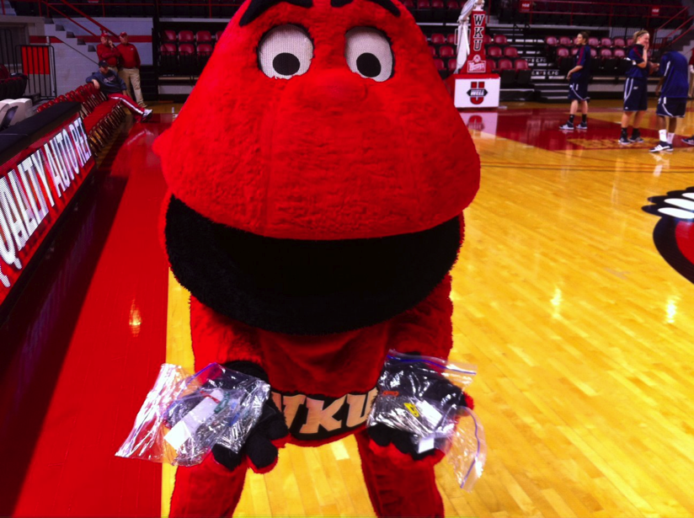

The surplus staff created baggies of paperclips and sent out to staff and faculty for free. Paperclips were from boxes of stationary in surplus. The objective was to raise awareness about the items in surplus. It was a great success!

At the Fair Trade Fair, surplus and recycling students took old maps from surplus and used them to create a free gift wrapping station while letting students know about GreenToppers.
