Assurance of Student Learning 2020-2021
College of Education and Behavioral Sciences | School of Teacher Education
Libraries, Informatics and Technology in Education (0497)

Use this page to list learning outcomes, measurements, and summarize results for your program. Detailed information must be completed in the subsequent pages.
Student Learning Outcome 1:
Graduate students will be able to design and plan a diversity themed project where they analyze the profile of the community, school, and the media center (or educational technology center); create goals and objectives for the project; and create an annotated bibliography of appropriate resources needed to address the diverse populations in the school.
Instrument 1 | LITE faculty members will review and score facilities evaluation with an emphasis on access for all in LITE 501 using the scoring rubric for the project. Ninety percent of the graduate students will earn a score of 3 (Proficient) or higher.
Instrument 2 | LITE faculty members will review and score the diversity themed projects in LITE 501 using the scoring rubric for the project. Ninety percent of the graduate students will earn a score of 3 (Proficient) or higher.
Instrument 3
Based on your results, circle or highlight whether the program met the goal Student Learning Outcome 1. |  | Met | Not Met
Student Learning Outcome 2:
Graduate students will be able to review and discuss different "advocacy toolkits" provided by professional education associations. LITE graduate students will use these toolkits to develop an effective message related to a global educational issue and successfully communicate needs to persons of influence in their communities, and on the state, national and international levels.
Instrument 1 | Using an online discussion board format, students will collaborate on developing their messages, discuss their experiences with this kind of engagement activity, and assess the usefulness of the “advocacy toolkits” provided by education professions. LITE faculty

1
 | members will review and score the discussion board postings in LITE 512 using the scoring rubric. Students must score 3 or higher on the scoring rubric.
Instrument 2 | Students will be required to develop a message related to the identified issue in LITE 512 and communicate that message to a person or organization of influence. Students will send the message and share their responses. LITE faculty members will review and score the discussion board postings using the scoring rubric. Students must score 3 (Proficient) or higher on the scoring rubric.
Instrument 3
Based on your results, circle or highlight whether the program met the goal Student Learning Outcome 2. |  | Met | Not Met
Student Learning Outcome 3:
Graduate students will be able to design and conduct an Action Research Project intended to increase usage of library information and resources, increase collaboration between media specialists and teachers, or increase technology integration in teaching and learning.
Instrument 1 | When evaluated by members of the LITE faculty in a review using the LITE Standardized Scoring Rubric for the Action Research Project, ninety percent of graduate students who complete the Research project chart in LITE 508 will score 2 (Developing) or higher on the rubric for the Action Research Project.
Instrument 2 | When evaluated by members of the LITE faculty in a review using the LITE Standardized Scoring Rubric for the Action Research Project, ninety percent of graduate students who complete the Research project presentation LITE 508 will score 2 (Developing) or higher on the rubric for the Action Research Project.
Instrument 3
Based on your results, circle or highlight whether the program met the goal Student Learning Outcome 3. |  | Met | Not Met
Program Summary (Briefly summarize the action and follow up items from your detailed responses on subsequent pages.)

2

We in the LITE program are proud of our program and its revision to include the Library Media Certification and Educational Technology Endorsement. This revision is strongly supporting the strength of our candidates. To continue to develop we are looking forward to adding greater feedback and more explicit examples in the following areas.

Course outcomes will be reviewed as they relate to more global programmatic change and adjustments will be made to LITE in support of continued student growth and success. The data displays clearly in order to strongly support student success we will need to:

Our support increase in this cycle addressing assignment direction and examples show candidate improvement. Continue to implement greater focus on the justification and resources identified to support in the school library environment. To support this process we will be providing greater assignment direction, explicit examples and opportunity for revision. This will be implemented in the fall 2021 section of LITE 501.

Our support increase in this cycle addressing assignment direction and examples show candidate improvement. Continue to engage greater focus on the relationship and reflection identified to support in the school library through advocacy. To support this process we will be providing greater assignment direction, explicit examples and opportunity for revision. This will be implemented in the spring 2022 section of LITE 512.

Our support increase in this cycle addressing assignment direction and examples show candidate improvement. Continue to exact greater focus on the relevance and reflection identified to support in the school library through data understanding. To support this process we will be providing greater assignment direction, explicit examples and opportunity for revision. This will be implemented in the summer 2022 section of LITE 508.

3
Student Learning Outcome 1
Student Learning Outcome | Graduate students will be able to design and plan diversity themed projects where they analyze the profile of the community, school, and the media center (or educational technology center); create goals and objectives for the project; and create an annotated bibliography of appropriate resources needed to address the diverse populations in the school.
Measurement Instrument 1 | LITE faculty members will review and score the facilities evaluation projects LITE 501 using the scoring rubric for the project. Ninety percent of the graduate students will earn a score of 3 (Proficient) or higher.

Students excel in this project because they are able to identify special needs or under-served populations and they
realize that budgets need expansion for all school libraries. The criteria included to support the developing
identification of needs are Community Context, ADA Justification and Resources. The criteria included are measured
at | the level or Novice (1 = Needs Much Improvement), Apprentice (2 = Needs Some Improvement), Proficient (3 = Good or

Criteria for Student Success | Acceptable), and Distinguished (4 = Excellent).
Program Success Target for this Measurement |  | 90% of students will earn a score of 3 (Proficient) or higher and on no individual rubric dimension will the average score across all students be less than 3. | Percent of Program Achieving Target | 100% of graduate students scored 3 or higher on the LITE 501 Diversity  Purchasing projects and on no dimension will the candidates average score be less than 3.
Methods | This diversity themed project is a component of the LITE 501 course, all of our program participants are required to complete this course and project. The number of students that completed for the 2020-2021 year were 23. 23 students successfully designed the diversity themed purchasing project.

4
Measurement Instrument 2 | LITE faculty members will review and score the diversity themed book selection projects in LITE 501 using the scoring rubric for the project. Ninety percent of the graduate students will earn a score of 3 (Proficient) or higher.

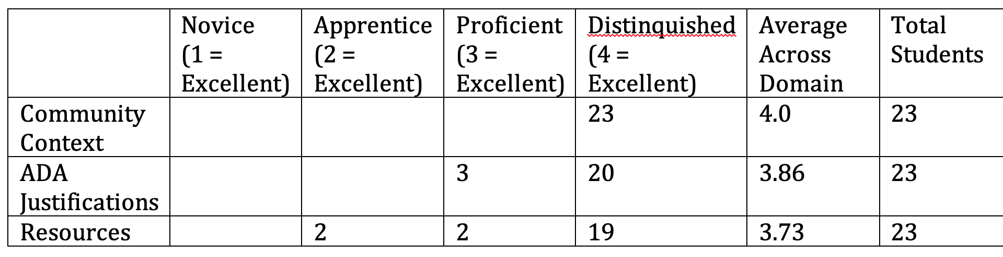

Students engage strongly in this project because they are able to identify special needs or under-served populations
and they realize that budgets need expansion for all school libraries. The criteria included to support the
developing |  | identification of needs are Context, Justification and Resources. The criteria included are measured at the
level or Novice |  |  | (1 = Needs Much Improvement), Apprentice (2 = Needs Some Improvement), Proficient (3 = Good or

Criteria for Student Success | Acceptable), and Distinguished (4 = Excellent).
Program Success Target for this Measurement |  | 90% of students will earn a score of 3 (Proficient) or higher and on no individual rubric dimension will the average score across all students be less than 3. | Percent of Program Achieving Target | 100% of graduate students scored 3 or higher on the LITE 501 Diversity  Purchasing projects on no dimension will the candidates average score be less than 3.
Methods | This diversity themed project is a component of the LITE 501 course, all of our program participants are required to complete this course and project. The number of students that completed for the 2020-2021 year were 23. 23 students successfully designed the diversity themed purchasing project.

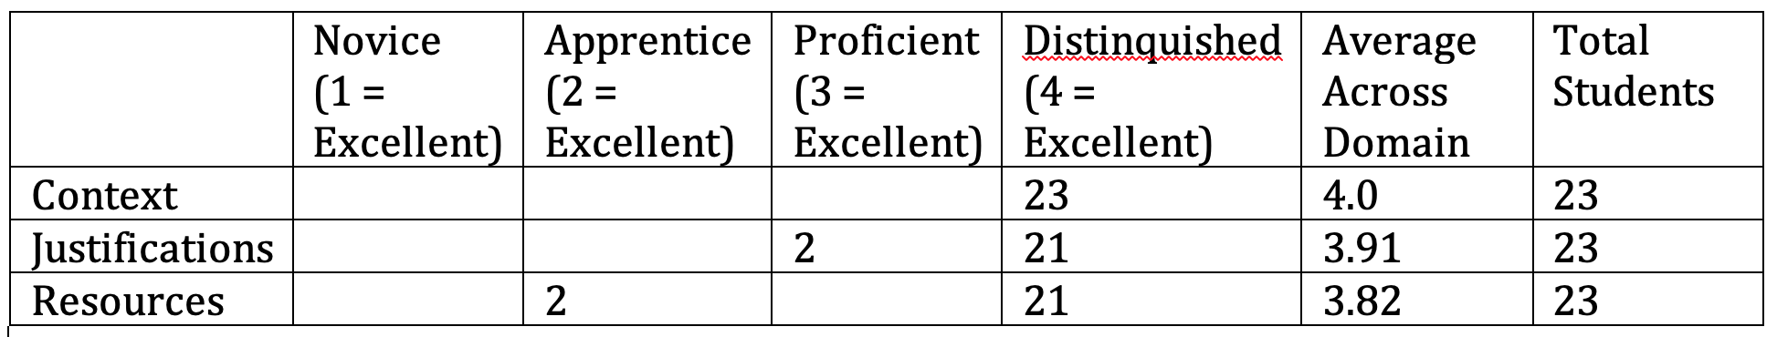
5
Based on your results, circle or highlight whether the program met the goal Student Learning Outcome 1. | Met

Actions (Describe the decision making process and actions planned for program improvement. The actions should include a timeline.) | Course outcomes were reviewed as they relate to more global programmatic change and adjustments were made to organization to support continued student growth and success. The data displays clearly that we need to implement greater focus on the justification and resources identified to support in the school library environment. To support this process we will be providing greater assignment direction, explicit examples and opportunity for revision. This will be implemented in the fall 2021 section of LITE 501.
Follow-Up (Provide your timeline for follow-up. If follow up has occurred,  describe how the actions above have resulted in program improvement.) | The 2020/2021 implemented programmatic revisions will be related to the diversity projects and will continue to influence implementation based on needs to more closely align with SPA AASL standards and in-field changes based on evolving needs due to the possible continuation of NTI.
Facility Evaluation Rubric  Criteria Novice  1 = Needs Much Improvement Apprentice  2 = Needs Some Improvement Proficient  3 = Good or Acceptable |  |  | Not Met

6

Distinguished 4 = Excellent

Facility Evaluation Assignment Checklist

- Context
  - Profile of community
  - Profile of school
  - Profile of LMC or EdTech center
    - Physical facility
    - Collection
    - Program

Novice
1 = Needs Much Improvement Apprentice
2 = Needs Some Improvement Proficient
3 = Good or Acceptable Distinguished
4 = Excellent

- Justification
  - Rationale
  - Goal statement for the
  - Objectives

Novice
1 = Needs Much Improvement Apprentice
2 = Needs Some Improvement Proficient
3 = Good or Acceptable Distinguished
4 = Excellent

- Resources

- A listing of specific resources vary in format
supporting quotes and citations from reviews name of review source
prices with a running total and final total
- Summary
explaining how and why selections were made, difficulties in locating resources, and assessment of the value of the experience
How the goals and objectives align with the Vision, Mission written for blog assignment ?

Novice
1 = Needs Much Improvement Apprentice
2 = Needs Some Improvement Proficient
3 = Good or Acceptable Distinguished
4 = Excellent
4. Writing mechanics and APA format Novice
1 = Needs Much Improvement
Apprentice
2 = Needs Some Improvement Proficient
3 = Good or Acceptable Distinguished
4 = Excellent

Facility Evaluation Rubric
Diversity Purchasing Assignment Checklist Criteria
Novice

1 = Needs Much Improvement Apprentice
2 = Needs Some Improvement Proficient
3 = Good or Acceptable Distinguished
4 = Excellent Design Principles 20% 5 points
Responses to facility evaluation are not specific and demonstrate a lack of understanding of basic design Responses to facility evaluation are specific but demonstrate a weakness in understanding good basic design Responses to facility evaluation are specific and demonstrate an understanding of the basics of design principles. Responses to facility evaluation demonstrate an understanding of the basics of design principles. Responses are specific and extensive.
ADA
20% 5 points
Responses show little understanding of ADA as applied in a library or technology facility Responses show some understanding of ADA as applied in a library or technology facility Responses show adequate understanding of ADA as applied in a library or technology facility Responses show outstanding understanding of ADA as applied in a library or technology facility Recommendations for change 20% 5 points
No recommendations for change Few recommendations for change
Specifically addresses recommendations for change.
Makes extensive recommendations for change, supported by observations of need. Writing Elements
10% 2.5 points
More than five errors in spelling, punctuation, sentence structure, and/or APA. Three to five errors in spelling, punctuation, sentence structure and/or APA Less than three errors in spelling, punctuation, sentence structure and/or APA No errors in spelling, punctuation, sentence structure and/or APA
References / Citations 10% 2.5 points
No References / Citations
References / Citations indicate limited source reading and application References / Citations indicate acceptable source reading and application References / Citations indicate wide source reading and application Include illustrations of your facility 10% 2.5 points
Include discussion paragraph on Learning Commons Concept 10% 2.5 points

Using an online discussion board format, students will collaborate on developing their messages, discuss their experiences with this kind
of | engagement activity, and assess the usefulness of the “advocacy toolkits” provided by education professions. LITE faculty members
will |  | review and score the discussion board postings in LITE 512 using the scoring rubric. Students must score 3 or higher on the scoring

Students became more aware of the need to advocate for library legislation, funding, and staffing. The criteria included to support the
developing identification of the organizations description, relationships and standards. The criteria included are measured at the level
or | Novice (1 = Needs Much Improvement), Apprentice (2 = Needs Some Improvement), Proficient (3 = Good or Acceptable), and

Student Learning Outcome 2
Student Learning Outcome | Graduate students will be able to review and discuss different "advocacy toolkits" provided by professional education associations. LME graduate students will use these toolkits to develop an effective message related to a global educational issue and successfully communicate needs to persons of influence in their communities, and on the state, national and international levels.
Measurement Instrument 1 | rubric.
Criteria for Student Success | Distinguished (4 = Excellent).
Program Success Target for this Measurement |  | 90% of students will earn a score of 3 (Proficient) or higher and on no individual rubric dimension will the average score across all students be less than proficient. | Percent of Program Achieving  Target | 100% of graduate students scored 3 or higher on the LME 512 advocacy project elements and on no dimension will the candidates average score be less than 3.
Methods | This “advocacy toolkits” project is a component of the LITE 512 course, all of our program participants are required to complete this course. The number of students that completed for the 2020-2021 year were 18. 18 students successfully designed the “advocacy toolkit” project.

10

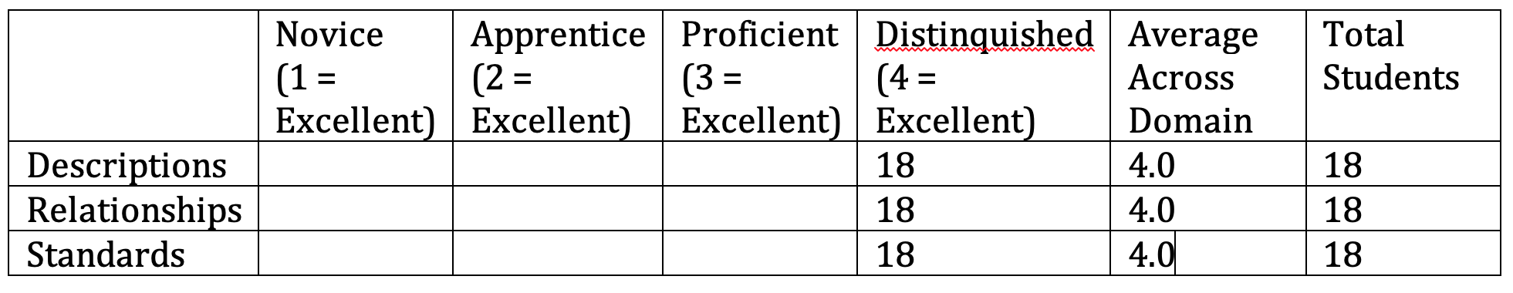
Students will be required to develop a message related to the identified issue in LITE 512 and communicate that message to a person
or | organization of influence. Students will send the message and share their responses. LITE faculty members will review and score
the

Measurement Instrument 2 | discussion board postings using the scoring rubric. Students must score 3 or higher on the scoring rubric.
Criteria for Student Success | Students became more aware of the need to advocate for library legislation, funding, and staffing. The criteria included to support the developing advocacy that is expressed through a report, reflection and discussion. The criteria included are measured at the level or Novice (1 = Needs Much Improvement), Apprentice (2 = Needs Some Improvement), Proficient (3 = Good or Acceptable), and Distinguished (4 = Excellent).

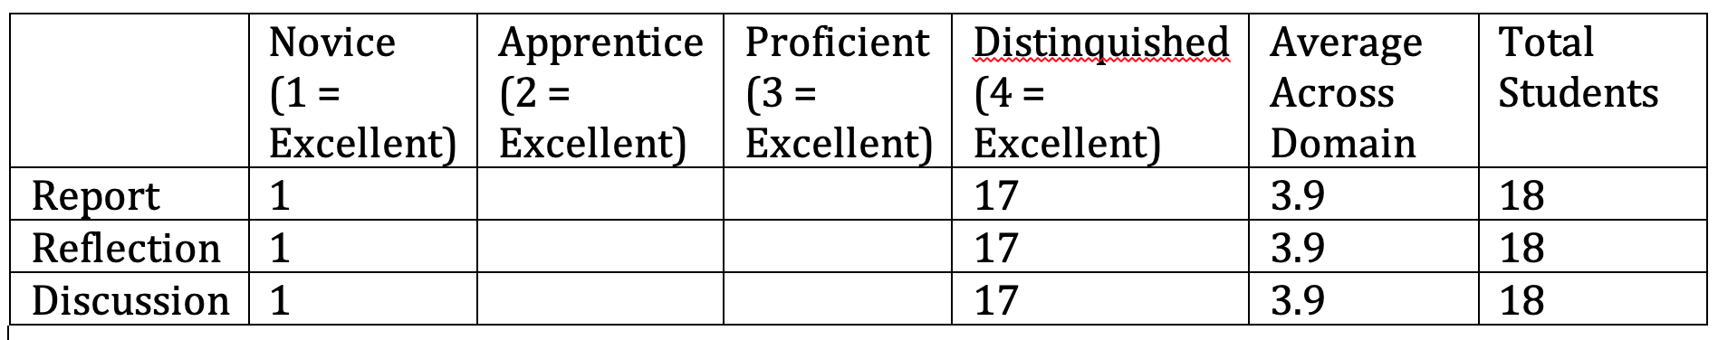
11

Program Success Target for this Measurement |  | 90% of students will earn a score of 3 (Proficient) or higher and on no individual rubric dimension will the average score across all students be less than proficient. | Percent of Program Achieving  Target | 100% of graduate students scored 3 or higher on the LME 512 projects and on no dimension will the candidates average score be less than 3.
Methods
Based on your results, circle or highlight whether the program met the goal Student Learning Outcome 2. | Met
Actions (Describe the decision making process and actions planned for program improvement. The  actions should include a timeline.) | Course outcomes were reviewed as they relate to more global programmatic change and adjustments were made to organization to support continued student growth and success.The data displays clearly that we need to implement greater focus on the relationship and reflection identified to support in the school library through advocacy. To support this process we will be providing greater assignment direction, explicit examples and opportunity for revision. This will be implemented in the spring 2022 section of LITE 512.
 |  |  | Percent of Program Achieving Target
Follow-Up (Provide your timeline for follow-up. If follow-up has occurred, describe how the actions above have resulted in program  improvement.) | The 2021/2022 implemented programmatic revisions will be related to the “advocacy toolkit” projects and will continue to influence implementation based on needs to more closely align with SPA AASL standards and in-field changes based on evolving needs due to possible continuation of NTI.

- Title of the Organization/Standard - 10 Points
- URL of the Organization/Standard - 10 Points
- Description of the Organization/Standard in sufficient detail for other students to be able to get the gist of the organization/standard - 20 Points
- Description of the Organization/Standards relationship to Libraries, Informatics and Technology in Education - 20 Points
- Primary areas of impact in education with which that the Organization/Standard is concerned - 20 Points

12

- Your experience in using or working with this Organization/Standard - 20 Points
- Advocacy Toolkit or Website this Organization/Standard maintains - 20 Points
- Brief report on current events or developments related to this standard - 20 Points
- A descriptive reflection of how what you have learned will impact your future practice with three concrete examples - 20 Points 10. The discussion will include APA reference section and in-text citations. - 20 Points
11. Editorial Reviews of the advertisements of others - 20 Points

Grading:
4) Distinguished:
Advertisement contains all required elements from the discussion board and incorporates clear and organized writing style and effective/creative visual design to present the information appropriately.
Advertisement is of sufficient depth and detail to provide others with an overall understanding of the standard/organization and its role in education, including the areas addressed, locations for more information, current events, and primary issues addressed.
No spelling or grammar errors detract from the information. Discussion board is present and outlines proposed article. Editorial Reviews of the advertisements of others
Entry and resources in APA style well done.
3) Proficient:
Advertisement contains all required elements, writing style and visual design organize entry effectively.
Advertisement is of sufficient detail to provide others with an overall understanding of the standard/organization and its role in education, including the areas addressed, locations for more information, current events, and primary issues addressed.
Few spelling or grammar errors detract from the information. Discussion board is present and outlines proposed article. Editorial Reviews of the advertisements of others
Entry and resources in APA style present.
- Apprentice:
Advertisement contains most but not all required elements, writing style and visual design do not organize entry effectively.
Advertisement lacks sufficient detail to provide others with an overall understanding of the standard/organization and its role in education. Many spelling or grammar errors detract from the information.
Discussion board is present and outlines proposed article.
Editorial Reviews of the advertisements of others not fully completed Entry and resources in APA style present but not complete.
Novice:
Advertisement is missing many required elements, writing style and visual design do not organize entry effectively. Advertisement lacks detail and does not provide others with an overall understanding of the standard/organization and its role in education. Many spelling or grammar errors detract from the information.
Editorial Reviews of the advertisements of others not present
Entry and resources in APA style not complete.

Student Learning Outcome 3
13

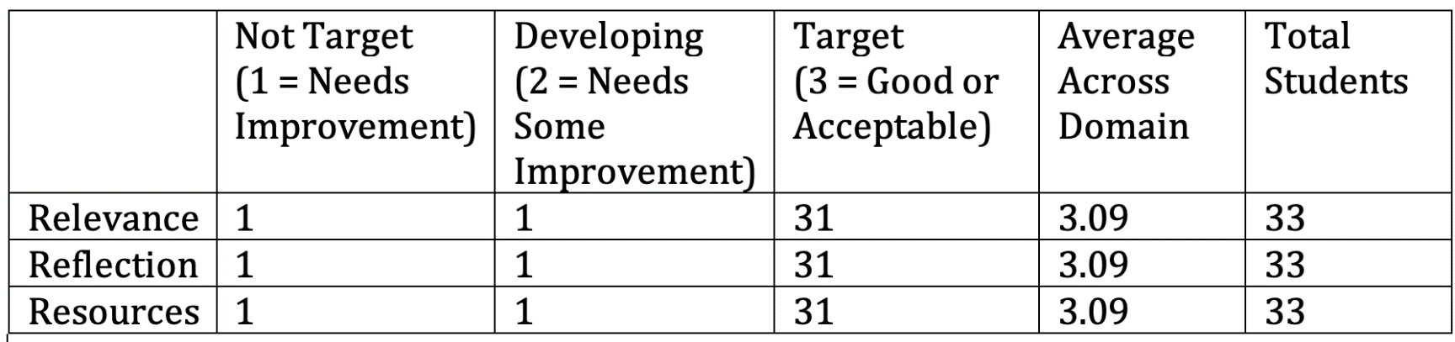
Student Learning Outcome | Graduate students will be able to design and conduct an Action Research Project data analysis intended to increase understanding of library information and resources, increase collaboration between media specialists and teachers, or increase technology integration in teaching and learning.
Measurement Instrument 1 | When evaluated by members of the LITE faculty in a review using the LITE Standardized Scoring Rubric for the Action Research Project, ninety percent of graduate students who complete the Research project in LITE 508 will score 2 (Developing) or higher on the rubric for the Action Research Project.
Criteria for Student Success | Students developed an awareness of the importance of collecting and analyzing data in the library media center (or educational technology center) to support the effect of the library on student learning.
Program Success Target for this Measurement |  | 90% of students will earn a score of 2 (Developing) or higher and on no individual rubric dimension will the average score across all students be less than Developing. | Percent of Program Achieving Target | 96.8% of graduate students scored 2 or higher on the LITE 508 projects and on no dimension will the candidates average score be less than 2.
Methods | This action research project is a component of the LITE 508 course, all of our program participants are required to complete this course. The number of students that completed for the 2020-2021 year were 33. 33 students successfully designed the action research project one student did not successfully complete.

Measurement Instrument 2
When evaluated by members of the LITE faculty in a review using the LITE Standardized Scoring Rubric for the Action Research Project Mini-Implementation, ninety percent of graduate students who complete the Research project Mini-implementation presentation LITE 508 will score 2 (Developing) or higher on the rubric for the Action Research Project.
14

Measurement
Instrument

Criteria for Student Success | Students developed an awareness toward advocacy of the importance in collecting, analyzing, interpreting, and presenting data in the library media center (or educational technology center) to support the effect of the library on student learning.
Program Success Target for this Measurement |  | 90% of students will earn a score of 2 (Developing) or higher and on no individual rubric dimension will the average score across all students be less than proficient. | Percent of Program Achieving Target | 96.8 of graduate students scored 2 or higher on the LITE 508 projects and on no dimension will the  candidates average score be less than 2.
Methods | This action research project presentation is a component of the LITE 508 course, all of our program participants are required to complete this course. The number of students that completed for the 2020-2021 year were 32. 32 students successfully designed the action research project one student did not successfully complete.
3
Criteria for Student Success

15

Program Success Target for this Measurement |  |  | Percent of Program Achieving Target
Methods
Based on your results, circle or highlight whether the program met the goal Student Learning Outcome 3. |  |  |  | Met | Not Met
Actions (Describe the decision-making process and actions planned for program improvement. The actions should include a timeline.)
Course outcomes were reviewed as they relate to more global programmatic change and adjustments were made to organization to support continued student growth and success.The data displays clearly that we need to implement greater focus on the relevance and reflection identified to support in the school library through data understanding. To support this process we will be providing greater assignment direction, explicit examples and opportunity to revise. This will be implemented in the summer 2022 section of LITE 508.
Follow-Up (Provide your timeline for follow-up. If follow-up has occurred, describe how the actions above have resulted in program improvement.)

The 2020/2021 implemented programmatic revisions related to the action research project will continue to influence implementation based on needs to more closely align with SPA AASL standards and in-field changes. It is our hope to align the rubric to express greater variation in product quality and increase our opportunities for programmatic improvement.
Grading Rubric:
Research Process Chart – 100 pts

- Target - All elements of the chart are complete. Required sections of the chart or required revisions are completed on time. All statements in the chart are in complete sentences and are relevant to the study. All citations follow APA format
- Developing - All elements of the chart are complete. Required sections of the chart or required revisions are completed on time All statements in the chart are in complete sentences and are relevant to the study. Most citations follow APA format
- Not on Target - Not all elements of the chart are complete. Required sections of the chart or required revisions are not completed on time All statements in the chart are not in complete sentences and/or are relevant to the study. The citations contained APA format errors
Quality of Research Process – 200 pts

16

  - Target - All elements of the research process were developed and executed thoroughly and thoughtfully, with each step representing an understanding of the research question and the methods used to answer the question. The literature review is comprised of high quality, relevant journal articles from WKU databases such as EBSCO. The data collection and analysis were completed with accuracy and the discussion of the results, conclusions and limitations reflect a thinking process related to the research question. Data visualization tools were used effectively to highlight the results of the study. The results and conclusion provide insights into topics relevant to the libraries, informatics, or technology in education.
  - Developing - All elements of the research process were developed and executed, with most steps representing an understanding of the research question and the methods used to answer the question. The literature review is comprised of high quality, relevant journal articles from WKU databases such as EBSCO. The data collection and analysis were completed with accuracy and the discussion of the results, conclusions and limitations are related to the research question. Data visualization tools were used effectively to highlight the results of the study. The results and conclusion provide information on topics relevant to the libraries, informatics, or technology in education.
  - Not on Target - Not all elements of the research process were developed and executed. Many of the elements did not communicate an understanding of the research question and the methods used to answer the question. The literature review is not comprised of high quality, relevant journal articles from WKU databases such as EBSCO. Data visualization tools were not used effectively to highlight the results of the study. The data collection and analysis were not completed with accuracy and the discussion of the results, conclusions and limitations are not related to the research question. The results and conclusion fail to provide information on topics relevant to the libraries, informatics, or technology in education.
Presentation - 100 pts

  - Target - The presentation made effective use of data visualization, design and media technology to communicate the research process, results and conclusion in an engaging manner. Data is displayed for participants to easily understand the results of the study. The Animation Module was used in the presentation and related to the research project. Student reviewed two presentations of another student. The presentation was no more than 20 minutes in duration.
  - Developing - The presentation made use of data visualization, design and media technology to communicate the research process, results and conclusion. The results of the study are displayed visually. The Animation Module was used in the presentation and was related to the research project. Student reviewed one of the presentations of another student. The presentation was no more than 20 minutes in duration.
  - Not on Target - The presentation did not make effective use of design and media technology to communicate the research process, results and conclusion. There is no visual display of the data. The Animation from the Animation Module was not used in the presentation or was not related to the research project. Students did not review the presentations of other students. The presentation was less than 5 or more than 20 minutes in duration.

17

