Assurance of Student Learning Report
2021-2021
Ogden College of Science and Engineering | Physics and Astronomy
Homeland Security Sciences 413
Ivan Novikov

Is this an online program? Yes No

Use this page to list learning outcomes, measurements, and summarize results for your program. Detailed information must be completed in the subsequent pages.
Student Learning Outcome 1: Students will demonstrate successful use of critical laboratory methods required for empirical measurements.
Instrument 1 | Student overall performance on presentations of the results of their research activities as part of the Physics 598 course requirements.
Instrument 2 | Successful defense of the MS Thesis
Based on your results, check whether the program met the goal Student Learning Outcome 1. |  | Met | Not Met
Student Learning Outcome 2: Students will demonstrate a mastery of empirical methods via written expression
Instrument 1 | Written summary of research projects in graduate seminar (Physics 598).
Instrument 2 | Evaluation of the written thesis document
Based on your results, check whether the program met the goal Student Learning Outcome 2. |  | Met | Not Met
Student Learning Outcome 3: Students will demonstrate a mastery of empirical methods via oral expression

Instrument 1 | Oral presentation of research projects in graduate seminar (Physics 598)
Instrument 2 | Evaluation of the oral portion of the thesis defense
Based on your results, check whether the program met the goal Student Learning Outcome 3. |  | Met | Not Met
Program Summary (Briefly summarize the action and follow up items from your detailed responses on subsequent pages.)
Graduate students are required to take 3 semesters of Physics 598, write a thesis and present the thesis results in an oral thesis defense. The graduate director coordinates the Physics 598 course and provides feedback to the thesis mentors on student performance in the construction and presentation of their research in Physics 598. The graduate director also meets with the thesis committee after the thesis defense to discuss each student's individual progress and performance. Information gained from these discussions is used as feedback to adjust the content of the Physics 598 course to better train students in research presentation and is provided to faculty mentors to inform them of student strengths and weakness so that they may adjust their expectations and training methods accordingly. Follow-up occurs after every thesis defense, which is typically 0-3 times per academic year. No thesis defenses occurred during the current assessment period.

The program added two new concentrations (Cybersecurity and EMDS) in the 2021-22 academic year. The program oversite committee will meet this summer to revise the program assessment of learning for the next review cycle.

Student Learning Outcome 1

Student Learning Outcome | Students will demonstrate successful use of critical laboratory methods required for empirical measurements.
Measurement Instrument 1 | Student presentation in the Physics 598 class are evaluated on a rubric (see attached).
Criteria for Student Success | 100% of all students evaluated will have an overall score (oral +written) of good or better.
Program Success Target for this Measurement |  |  | 100 |  | Percent of Program Achieving Target | 100
Methods | Student presentations are evaluated on a rubric (see attached) with the goal that 90% of all students evaluated will have an overall combined score (oral + written) of good or better. In the 2020-2021 AY, the cohort size was 2 students.
Measurement Instrument 2 | Successful defense of the MS Thesis
Criteria for Student Success | Students will have successfully defend the MS Thesis
Program Success Target for this Measurement |  | 100 |  | Percent of Program Achieving Target |  | 0 (no thesis defenses occurred in the assessment period)
Methods | MS student projects will be overseen by a committee of faculty who will evaluate their oral (MS defense) and written (MS Thesis) presentation of their thesis project via the attached rubric. The oral thesis defense is judged based on quality of the presentation and the ability of the students to clearly explain their research and answer questions about their experimental methodology. The written thesis is evaluated based on the ability of the students to clearly explain in writing their research and their experimental methodology. In AY 2021-22, the cohort size was 2 students.
Based on your results, highlight whether the program met the goal Student Learning Outcome 1. |  |  |  |  |  | Met | Not Met
Actions (Describe the decision-making process and actions for program improvement. The actions should include a timeline.)
The graduate director coordinates the Physics 598 course and provides feedback to the thesis mentors on student performance in the construction and presentation of their research in Physics 598. He also coordinates the Physics 598 course and meets with the thesis committee after the thesis defense to discuss each student's individual progress and performance. Information gained from these discussions is used as feedback to adjust the content of the Physics 598 course to better train students in research presentation and is provided to faculty mentors to inform them of student strengths and weakness so that they may adjust their expectations and training methods accordingly.

Follow-Up
Follow-up occurs after every thesis defense, which is typically 0-3 times per academic year. Follow-up is used adjust content focus areas in Physics 598 and inform faculty mentors of identified student weaknesses that can be addressed in the process of the thesis research.

Next Assessment Cycle Plan
This will be assessed in the next assessment cycle.

Student Learning Outcome 2
Student Learning Outcome | Students will develop a mastery of empirical methods via written expression
Measurement Instrument 1 | Written summary of research projects in graduate seminar (Physics 598).
Criteria for Student Success | 100% of all students evaluated will have an overall score of good or better on the written abstract.
Program Success Target for this Measurement |  |  | 100 |  | Percent of Program Achieving Target | 100
Methods | The writing examples are evaluated on a rubric (see attached) with the goal that 100% of all students evaluated will have an overall score of good or better. In the 2020-2021 AY, the cohort size was 2 students.
Measurement Instrument 2 | Evaluation of the Thesis document
Criteria for Student Success | 100% of all students evaluated will have an overall score of good or better.
Program Success Target for this Measurement |  | 100 |  | Percent of Program Achieving Target |  | 0 (no thesis defenses occurred during the assessment period)
Methods | The written thesis is evaluated on a rubric (see attached) with the goal that 100% of all students evaluated will have an overall score of good or better. In the 2021-2022 AY, the cohort size was 0 students.
Based on your results, circle or highlight whether the program met the goal Student Learning Outcome 2. |  |  |  |  |  | Met | Not Met
Actions (Describe the decision-making process and actions planned for program improvement. The actions should include a timeline.)
Rubric results are immediately returned to faculty mentors who have responsibility for mentoring the students in their written expression and taking any necessary corrective steps.
Follow-Up (Provide your timeline for follow-up. If follow-up has occurred, describe how the actions above have resulted in program improvement.)
Mentors keep track of student results from written thesis and Physics 598 presentations and adjust their mentoring paradigms as appropriate.
Next Assessment Cycle Plan (Please describe your assessment plan timetable for this outcome)
This item will be assessed in the next cycle.

Student Learning Outcome 3
Student Learning Outcome | Students will demonstrate a mastery of empirical methods via oral expression
Measurement Instrument 1 | Oral presentation of research projects in senior seminar (Physics 598).
Criteria for Student Success | Students evaluated will have an overall score of good or better on the oral presentation
Program Success Target for this Measurement |  |  | 100 |  | Percent of Program Achieving Target | 100
Methods | Student oral presentation are evaluated on a rubric (see attached) with the goal that 90% of all students evaluated will have an overall score of good or better.
Measurement Instrument 2 | Evaluation of the oral portion of the thesis defense
Criteria for Student Success | Students evaluated will have an overall score of good or better on the oral presentation of their thesis
Program Success Target for this Measurement |  | 100 |  | Percent of Program Achieving Target |  | 0 (no thesis defenses occurred during the assessment period)
Methods | Student presentation are evaluated on a rubric (see attached) with the goal that 90% of all students evaluated will have an overall score of good or better.
Based on your results, circle or highlight whether the program met the goal Student Learning Outcome 3. |  |  |  |  |  | Met | Not Met
Actions (Describe the decision-making process and actions for program improvement. The actions should include a timeline.)
Rubric results are immediately returned to faculty mentors who have responsibility for mentoring the students in their oral expression and taking any necessary corrective steps.
Follow-Up (Provide your timeline for follow-up. If follow-up has occurred, describe how the actions above have resulted in program improvement.)
Mentors keep track of student results from the oral thesis presentations and Physics 598 oral presentations and adjust their mentoring paradigms as appropriate.

Next Assessment Cycle Plan (Please describe your assessment plan timetable for this outcome)
This will be assessed in the next cycle.

*** Please include Curriculum Map (below/next page) as part of this document

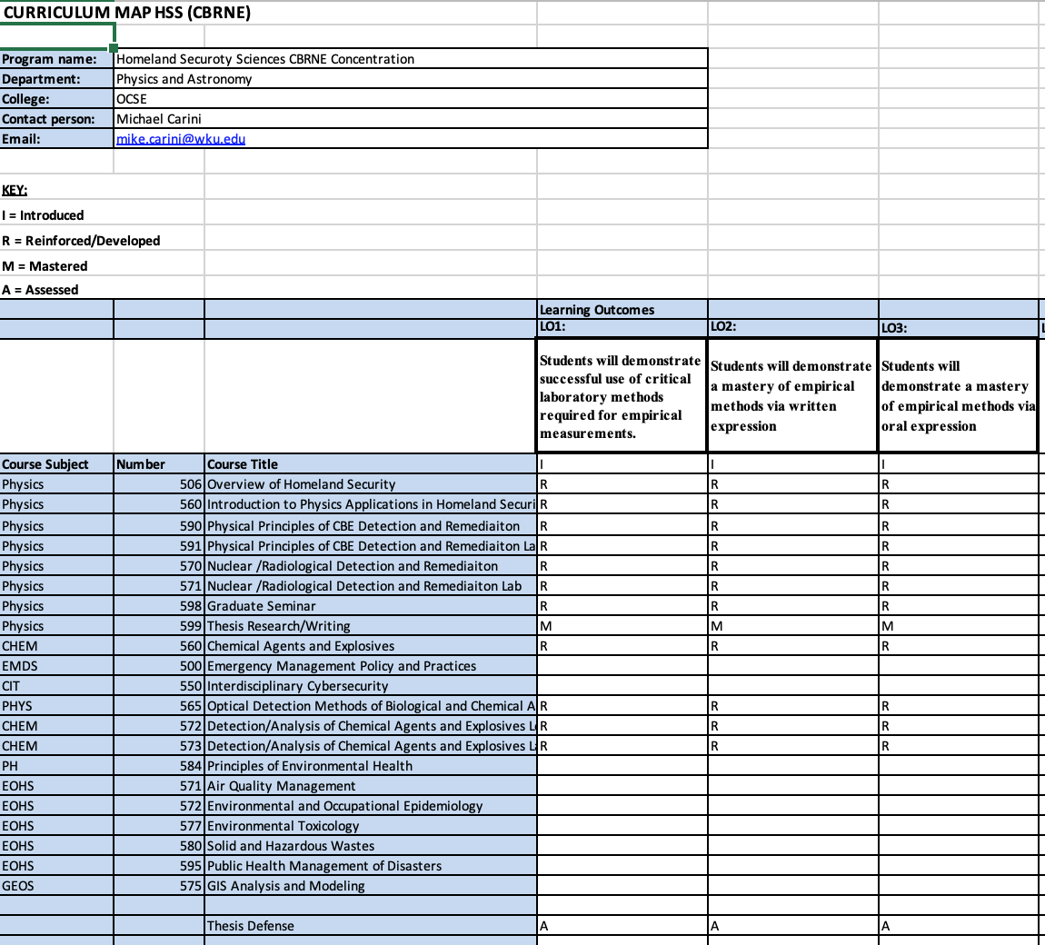

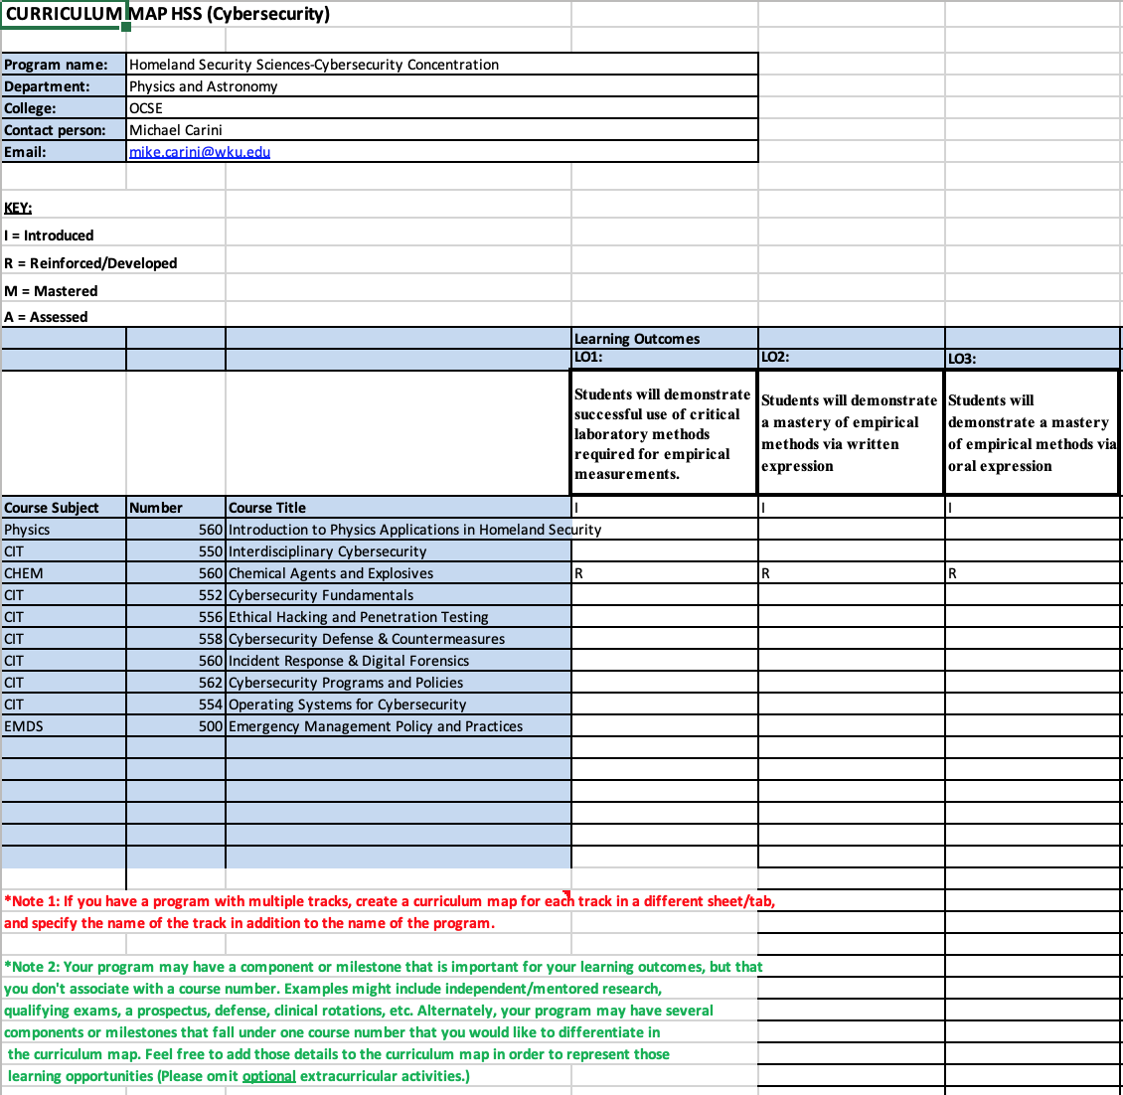

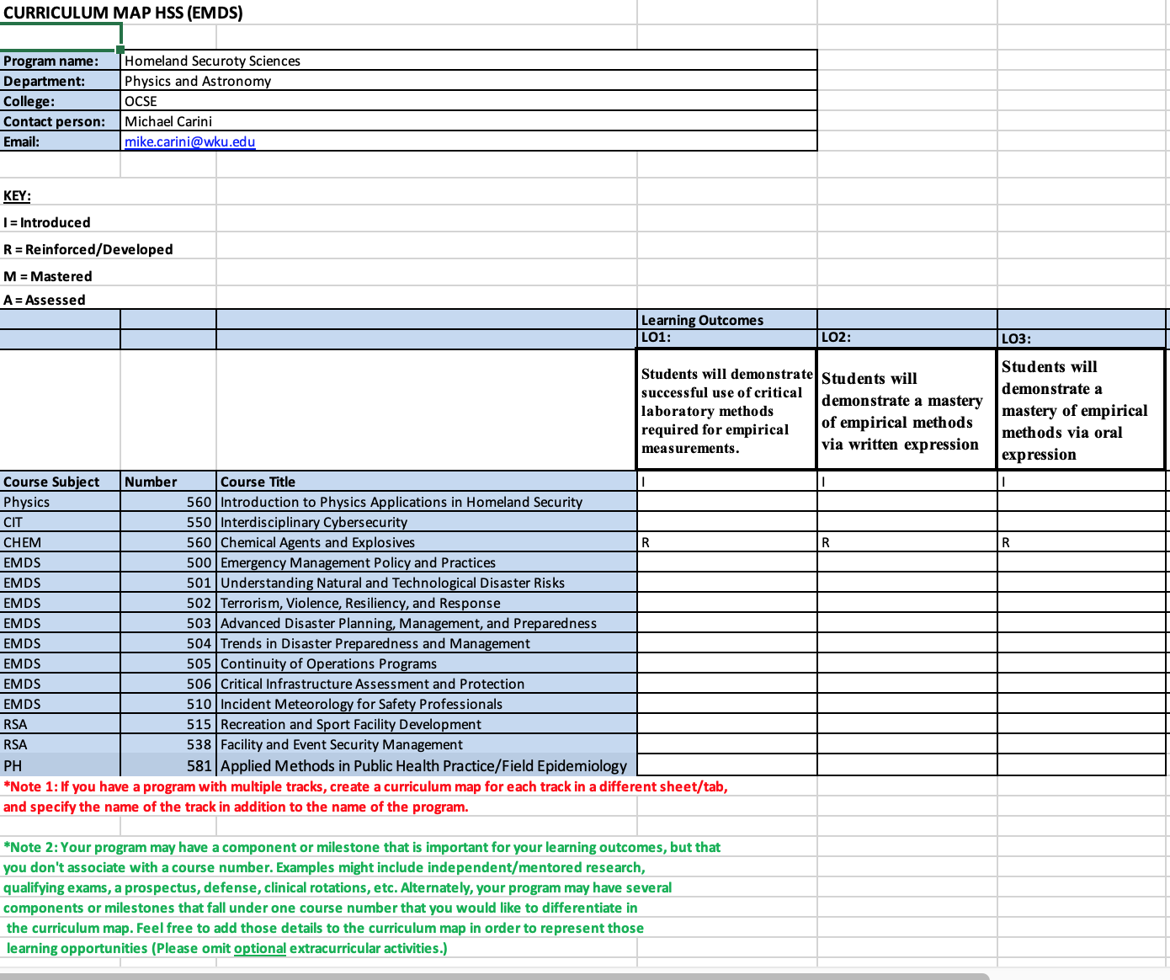

Oral Presentation evaluation rubric
Based on presentation of work in Graduate seminar.
 | 4: Excellent | 3: Good | 2: Needs some improvement | 1: Needs major improvement
Understanding of material | Presentation demonstrated excellent understanding of the topic and its context. | Presentation demonstrated adequate understanding of the topic and its context. | Presentation demonstrated some gaps and/or errors in student understanding of the topic and context. | Presentation demonstrated significant gaps or errors in student understanding of the topic and context.
Presentation organization and flow. | Presentation was well organized and seamlessly presented. | Presentation was logically organized and adequately presented. | There were minor issues with the organization and flow of the presentation. | Presentation was disorganized and/or confusingly presented.
Interaction with audience | Student developed excellent rapport with the audience during the presentation. | Student interacted with the audience and made eye contact most of the time. | Student had a little interaction with the audience and made eye contact some of the time. | Student did not interact with or look at audience.
Answering questions | Student provided thoughtful, quality responses to questions from audience. | Student provided adequate responses to questions from audience. | Student had some difficulties in understanding or answering questions from audience. | Student completely misunderstood or was unable to provide answers to questions from audience.

Scientific Work evaluation rubric
Based on written abstract and presentation
 | 4: Excellent | 3: Good | 2: Needs some improvement | 1: Needs major improvement
Research question | Research question is original, clearly articulated and of compelling importance. | Research question is clear and doable. | Research question is presented but it is poorly articulated, too broad or narrow in scope, or otherwise problematic. | No identifiable research question presented.
Research methodology | Research methodology exceptionally well designed and executed to answer research question. | Employs a research methodology that is appropriate for answering the question. | Research methodology is mismatched or incomplete for answering research question. | No research methodology employed, or that employed seems unrelated to the research question.
Data and theory | Compelling, high-quality data collected & analyzed and/or an ambitious theoretical investigation completed. | Sufficient data collected and analyzed OR theoretical investigation carried out to answer research question. | Some data collected and analyzed OR theoretical investigation conducted giving a suggestive or partial answer to research question. | No/insufficient data collected and analyzed, or incomplete theoretical investigation, such that cannot begin to answer research question.
Conclusions | Clear, articulate and compelling conclusions drawn from investigation. | Appropriate conclusions drawn from investigation. | Conclusions ambiguous or only partially supported by the investigation. | No conclusions presented or the conclusions are unrelated to the scientific investigation.

