Assurance of Student Learning Report 2022-2023
Ogden | School of Engineering and Applied Sciences
Mechanical Engineering, 543
Program Coordinator: Joel Lenoir

Use this page to list learning outcomes, measurements, and summarize results for your program. Detailed information must be completed in the subsequent pages.
Student Learning Outcome 1: Ability to identify, formulate, and solve complex engineering problems by applying principles of engineering, science, and mathematics. (ABET #1 May 2022 report)
Instrument 1 | Program faculty apply a scoring rubric that are specifically structured to directly assess the attributes stated in the outcome based selected student work from Thermodynamics (ME220), Mechanics of Deformable Bodies (EM303) and Heat Transfer (ME325).
Instrument 2 | Exit surveys of ME seniors
Instrument 3 | Average grades in relevant courses
Based on your results, check whether the program met the goal Student Learning Outcome 1. |  | Met | Not Met
Student Learning Outcome 2: Ability to recognize ethical and professional responsibilities in engineering situations and make informed judgments, which must consider the impact of engineering solutions in global, economic, environmental, and societal contexts. (ABET #4 May 2022 report)
Instrument 1 | Program faculty apply a scoring rubric, included at the end of this section, that are specifically structured to directly assess the attributes stated in the outcome based selected student work from sophomore design (ME200) and senior capstone design (ENGR490). Students in ME 200 review and assess the Incident at Morales case study from Texas Tech. Seniors in the ENGR 490 do individual case study assignments reviewing and assessing ethical behaviors.
Instrument 2 | Evaluate performance of ME seniors in the ENGR490 capstone project team using CATME Instrument Peer Influences questions. CATME is a nationally recognized instrument for measuring teamwork, but also has some capability to measure team-based ethical behaviors on design teams. Specific questions asked of each team member in the online CATME assessment allows each team’s faculty advisor to informally assess each team member using the question responses.
Instrument 3 | Senior Student Exit Survey
Based on your results, check whether the program met the goal Student Learning Outcome 2. |  | Met | Not Met
Student Learning Outcome 3: Graduates have an ability to function effectively on a team whose members together provide leadership, create a collaborative and inclusive environment, establish goals, plan tasks, and meet objectives. (ABET #5 May 2022 report)
Instrument 1 | The Comprehensive Assessment of Team Member Effectiveness (CATME) online evaluation tool is the primary teamwork assessment tool.
Instrument 2 | Faculty assessment of capstone design teams in ME 400 or ENGR 490 using a standardized rubric. Scores for all the student members in those courses are averaged together and normalized to a scale of 4.
Instrument 3 | Student exit survey at graduation. Students self-assess with a rubric their ability to function effectively on an engineering team. The question asked is, “Are you able to function effectively on a multidisciplinary team?”.
Based on your results, check whether the program met the goal Student Learning Outcome 3. |  | Met | Not Met
Program Summary (Briefly summarize the action and follow up items from your detailed responses on subsequent pages.)
The assessment of student performance under Student Learning Outcomes 1, 2 and 3 is acceptable according to rubric-based evaluation of student work. In addition, graduates are completing relevant courses with good grades, and students have positive perceptions of skills learned. Program assessment indicates the curriculum for Mechanical Engineering prepares graduates with the abilities and skills needed to be successful practicing engineers. The WKU Mechanical Engineering Program will continue to prepare graduates using the same Student Learning Outcome activities and measures.

Student Learning Outcome 1
Student Learning Outcome  (ABET #1) | Graduates of the mechanical engineering program should show an ability to identify, formulate, and solve complex engineering problems by applying principles of engineering, science, and mathematics
Measurement Instrument 1 | A scoring rubric specifically structured to directly assess the attributes stated in the outcome is applied to exam questions in the engineering science courses EM303, ME220, ME325, which capture key aspects of both the mechanical systems and thermo-fluid systems which mechanical engineering students’ study. The rubric assesses 4 main attributes of problem solving. The selected courses have math and physics pre-requisites and utilize those specific skills in the solution of engineering problems. The mechanical systems component is captured by EM303, the thermo-fluids systems component is captured by both ME220 and ME325. The ME325 course is usually taken in the senior year and students have by then developed strong analytical skills and have experience applying math and science concepts in earlier design course projects and in earlier engineering science courses.
Criteria for Student Success | Numerical results from applying the rubric to student work should reach a value of 3.56 on a 4.0 scale for senior level work. Scores of sophomore/junior level work may be somewhat lower, which can be used to track student development in the curriculum.
Program Success Target for this Measurement |  |  | Cohort average of 3.0 on a 4.0 scale | Percent of Program Achieving Target |  | Senior cohort score of 89%, (in ME325)
Methods | The exam solutions from each student in the course are reviewed separately from course grading. Select questions are identified and the outcome rubric applied to assess achievement. Values from each student are recorded, and a class average is determined. This approach captures every student graduating in the assessment year, and students who are rising to senior status. As such ME325 results give a representation of the graduating cohort for each academic year since it is offered once per year. Over the years the graduating cohorts have been as small as 18, and as large at 48 students.
Measurement Instrument 2 | Exit surveys of ME Seniors. One question on the Senior Exit Survey is used to assess their ability to apply knowledge of mathematics, science, and engineering, asking ME graduates about their awareness of this knowledge focused training in their program and their resulting ability to apply effectively.
Criteria for Student Success | ME graduates self-report that they know about the mathematics, science, and engineering training they were receiving and are capable of performing at a level indicated by a numerical scale.
Program Success Target for this Measurement |  | Score of 4.0 or higher on a 5.0 scale |  |  | Percent of Program Achieving Target | 86%
Methods | Graduating students complete a survey of their academic experience in the program while enrolled in their capstone course. A part of this survey is their assessment of the program learning outcomes. The May 2022 ME graduates self-reported that they knew about the mathematics, science, and engineering training they were receiving and could perform at a level of 3.9/5.0, a consistent but lower score for this self-assessment relative to last year with a 4.7/5.0, This value is fairly consistent with the other measurements for this outcome.

Measurement Instrument 3 | Average grades in relevant courses. The mechanical engineering curriculum builds upon math and science courses with engineering science courses in both mechanical systems and thermo-fluids systems courses. These courses are indicators of student capabilities in this student learning outcome. Reports are generated each semester by WKU Institutional Research for the grades of each ME graduate.
Criteria for Student Success | The mechanical engineering student performance in these core classes are expected to be at a high C grade on average. This indirect instrument method helps to identify areas of weakness in student performance and is used on a continual basis to track student learning.
Program Success Target for this Measurement |  | Average score of 3.0 on a 4.0 scale | Percent of Program Achieving Target | 77.5%
Methods | Grades tabulated from reports from Institutional Research:  MATH: 3.30 PHYS: 2.65 ENGINEERING MECHANICS: 3.09 MECHANICAL ENGINEERING COURSES: 3.21
Based on your results, highlight whether the program met the goal Student Learning Outcome 1. |  |  |  | Met | Not Met
Actions (Describe the decision-making process and actions for program improvement. The actions should include a timeline.)
The assessment of student performance under Outcome 1 is acceptable according to rubric-based direct evaluation of student work. Graduates are expected to be completing relevant courses with satisfactory grades in the curriculum assuring that ME graduates have the ability to identify, formulate, and solve complex engineering problems by applying principles of engineering, science, and mathematics. The WKU Mechanical Engineering Program will continue to prepare graduates with the same curriculum content, and monitor this student learning outcome with these measures. The near-automatic generation of grade reports from IR coupled with Qualtrix surveys of students have made this assessment much easier.
ME program is considering adding final reports from Senior Seminar (ENGR490) for the future assessment to assess ME graduates performance in solving open-eneded engineering problems.
Follow-Up (Provide your timeline for follow-up. If follow-up has occurred, describe how the actions above have resulted in program improvement.)
The mechanical engineering faculty will continue with program assessment on an annual basis. The accrediting agency, ABET, requires continual improvement through systematic assessment of student learning outcomes.
Next Assessment Cycle Plan
This SLO will be assessed each academic year, with data from both terms, as part of the regular ABET program assessment activities.

Rubric Applied to Student work for Student Learning Outcome 1, Measurement Instrument 1

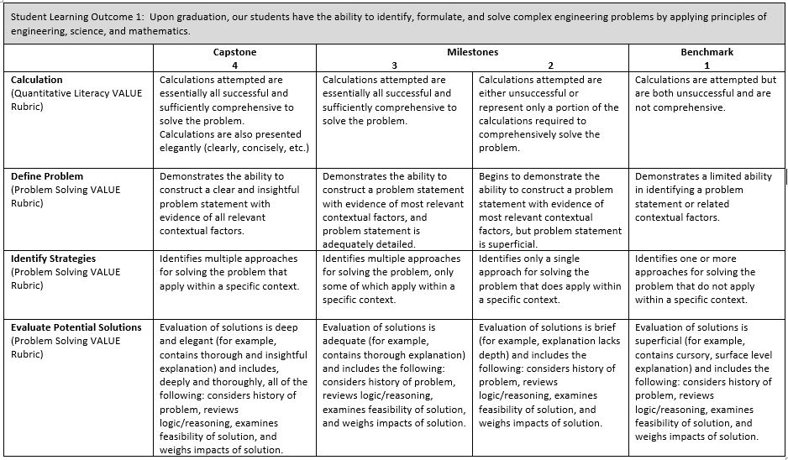

Student Learning Outcome 2
Student Learning Outcome  (ABET #4) | Ability to to recognize ethical and professional responsibilities in engineering situations and make informed judgments, which must consider the impact of engineering solutions in global, economic, environmental, and societal contexts.  Ethical expectations and evaluation tools are conveyed in a structured form across the program. Student accomplishments are measured through evaluation of representative work using a scoring rubric assessed by the ME faculty assigned to evaluate this Outcome. In addition, students on each capstone senior project assess team member professionalism using externally validated survey questions (from CATME); a senior student survey is implemented to self-assess graduates’ opinions of their own abilities to achieve this outcome.
Measurement Instrument 1 | Program faculty apply a scoring rubric, included at the end of this section, that are specifically structured to directly assess the attributes stated in the outcome based selected student work from sophomore design (ME200) and senior capstone design (ENGR490). Students in ME 200 review and assess the Incident at Morales case study from Texas Tech. Seniors in the ENGR 490 do individual case study assignments reviewing and assessing ethical behaviors.
Criteria for Student Success | Numerical results from applying the rubric to student work should reach a value of 3.0 on a 4.0 scale. These scores are tracked each year for those courses and exercises.
Program Success Target for this Measurement |  |  | Score of 3.0 out of 4.0 |  | Percent of Program Achieving Target | ENGR 490 97%
Methods | The ethics assignments from each student in the course are reviewed separately from course grading. The outcome rubric (shown below) is applied to assess achievement. Values from each student are recorded, and a class average is determined. This approach captures every student graduating in the assessment year, as well as students in the middle of the curriculum. This allows for a check that student growth in ethical judgement is occurring. Long term tracking of these values is ongoing, these current numbers are trending the same.
Measurement Instrument 2 | Evaluate performance of ME seniors in the ENGR490 capstone project team using CATME Instrument Peer Influences questions. CATME is a nationally recognized instrument for measuring teamwork effectiveness, but also provides the capability to measure team-based ethical behaviors on design teams. Specific questions asked of each team member in the online CATME assessment allows each team’s faculty advisor to informally assess each team member using the question responses.
Criteria for Student Success | Numerical results from the CATME tool are an indication of team-based ethical decisions.
Program Success Target for this Measurement |  | Score of 3.0 out of 5.0 (sometimes) |  | Percent of Program Achieving Target |  | ENGR 490: 90%
Methods | CATME is an online tool for evaluating teamwork, WKU has a subscription to the platform. It is used in all team-based project courses in the ME curriculum to not only allow student self-reporting but also reporting about the teamwork dynamics within each team.

Measurement Instrument 3 | Senior Student Exit Survey
Criteria for Student Success | Mechanical Engineering seniors self assess their ability to recognize ethical and professional responsibilities in engineering situations and make informed judgements.
Program Success Target for this Measurement |  | 4.0 out of 5.0 | Percent of Program Achieving Target | 96%
Methods | Each graduate of the WKU ME program completes an exit survey, students rank their ability to satisfy the ethical and professional responsibilities spelled out in the assessment plan
Based on your results, circle or highlight whether the program met the goal Student Learning Outcome 2. |  |  |  | Met | Not Met
Actions (Describe the decision-making process and actions planned for program improvement. The actions should include a timeline.)
The assessment of student performance under Outcome 2 is acceptable according to the three assessment measures used. The WKU Mechanical Engineering program has demonstrated that our graduates have an ability to to recognize ethical and professional responsibilities in engineering situations and make informed judgments, which must consider the impact of engineering solutions in global, economic, environmental, and societal contexts. The WKU Mechanical Engineering Program will continue to prepare graduates with the same curriculum content, and monitor this student learning outcome with these measures. Our annual reviews indicate we have met the goal of Learning Outcome 2. No need for programmatic adjustments has been found.

Follow-Up (Provide your timeline for follow-up. If follow-up has occurred, describe how the actions above have resulted in program improvement.)
The mechanical engineering faculty will continue with program assessment on an annual basis. The accrediting agency, ABET, requires continual improvement through systematic assessment of student learning outcomes.
Next Assessment Cycle Plan
This SLO will be assessed each academic year, with data from both terms, as part of the regular ABET program assessment activities.

Rubric Applied to Student work for Student Learning Outcome 2, Measurement Instrument 1
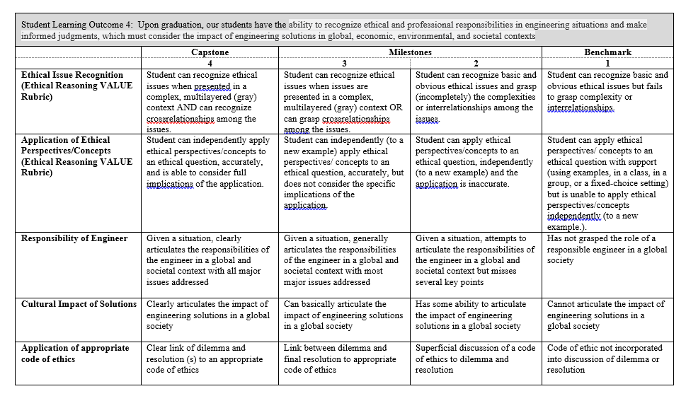

Student Learning Outcome 3
Student Learning Outcome  (ABET #5) | Graduates have an ability to function effectively on a team whose members together provide leadership, create a collaborative and inclusive environment, establish goals, plan tasks, and meet objectives
Measurement Instrument 1 | The Comprehensive Assessment of Team Member Effectiveness (CATME) online evaluation tool is the primary teamwork assessment tool.
Criteria for Student Success | Numerical results from applying the tool indicates a score of 1.00 for an effective team member. Scores of sophomore/junior level work may be somewhat lower, which can be used to track student development in the curriculum
Program Success Target for this Measurement |  |  | Target score of 1.00 |  | ME 200: Sophomore Design  ENGR 490: Senior Design | ME 200: 59%  ME 400: 73%
Methods | CATME is an independent external tool in use since 2005, used by over 1 million students and nearly 20,000 instructors, from over 2,200 institutions in 85 countries. The tool allows students to score themselves and their team mates in five areas in team effectiveness, and the scores are supported by interpretive graphs for the students to better understand the results. CATME assessment is conducted regularly in all ME design courses to track student development in teamwork skills.
Measurement Instrument 2 | Faculty assessment of capstone design teams in ME 400 or ENGR 490 using the standardized rubric below. Scores for all the student members in those courses are averaged together and normalized to a scale of 4.
Criteria for Student Success | Faculty assessment scores greater than the target indicate that graduates are seen by the faculty as effective team members.
Program Success Target for this Measurement |  | Target score greater than 3 |  | Percent of Program Achieving Target |  | 83%
Methods | This assessment of student performance under Outcome 3 is acceptable according to rubric-based direct evaluation of student work. The WKU Mechanical Engineering Program will continue to prepare graduates with the same curriculum content, and monitor this student learning outcome with these measures. No need for programmatic adjustments has been found.
Measurement Instrument 3 | Student exit survey at graduation. Students self-assess with a rubric their ability to function effectively on an engineering team. The question asked is, “Are you able to function effectively on a multidisciplinary team?”.
Criteria for Student Success | Students are aware of the emphasis on teamwork due to the use of CATME throughout the curriculum, and recognize the importance of being a good team member in design courses.
Program Success Target for this Measurement |  | 4 out of 5.0 |  | Percent of Program Achieving Target |  | 92%
Methods | This assessment of student performance under Outcome 3 is acceptable according to rubric-based direct evaluation by the graduates. The WKU Mechanical Engineering Program will continue to prepare graduates with the same curriculum content, and monitor this student learning outcome with these measures. No need for programmatic adjustments has been found.

Based on your results, circle or highlight whether the program met the goal Student Learning Outcome 3. | Met | Not Met
Actions (Describe the decision-making process and actions for program improvement. The actions should include a timeline.)
The assessment of student performance under Outcome 3 is acceptable according to rubric-based direct evaluation of student work. Graduates are completing relevant courses with satisfactory grades in the curriculum assuring that ME graduates have the ability to develop and conduct appropriate experimentation, analyze and interpret data, and use engineering judgment to draw conclusions. The WKU Mechanical Engineering Program will continue to prepare graduates with the same curriculum content, and monitor this student learning outcome with these measures. No need for programmatic adjustments has been found.

Follow-Up (Provide your timeline for follow-up. If follow-up has occurred, describe how the actions above have resulted in program improvement.)
The mechanical engineering faculty will continue with program assessment on an annual basis. The accrediting agency, ABET, requires continual improvement through systematic assessment of student learning outcomes.

Next Assessment Cycle Plan (Please describe your assessment plan timetable for this outcome)
This SLO is assessed annually

Rubric for Faculty Advisor Assessment of ME Senior Design Teams: Ability to work effectively on Multi-Disciplinary Teams
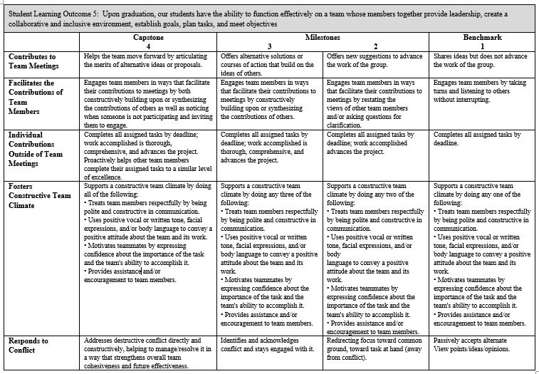

Mechanical Engineering Curriculum Map

ABET Outcome | 1 | 2 | 3 | 4 | 5 | 6 | 7
ME176 | X | X | X | X | X
ME180 |  | X | X |  |  |  | X
ME200 |  | X | X | X | X | X | X
ME220 | X | X |  |  |  |  | X
ME240 | X | X |  |  |  |  | X
ME241 |  |  |  |  |  | X | X
ME300 | X | X | X | X | X |  | X
ME310 | X | X |  |  |  | X | X
ME325 | X | X | X |  |  |  | X
ME330 | X | X |  |  |  |  | X
ME333 | X |  |  |  |  | X | X
ME344 | X | X | X |  |  |  | X
ME347 |  |  |  |  |  | X | X
ENGR490 | X | X | X | X
ENGR491 | X | X | X | X | X |  | X
EM222 | X | X |  |  |  |  | X
EM303 | X | X |  |  |  |  | X
EM313 | X | X |  |  |  |  | X
EE210 | X |  | X |  |  | X | X
CHEM116 | X |  |  |  |  | X
MA136 | X
MA137 | X
MA237 | X
MA331 | X
PHYS25x | X |  |  |  |  | X
PHYS26x | X |  |  |  |  | X

