**Going somewhere? Here are the steps to help you complete your Employee Travel Authorization Form.**

**STEP 1:** LOGIN TO YOUR ESIGNATURE PAGE

(THROUGH PROTAL OR AA WEBSITE <https://asaweb.wku.edu/php/prod/wkuforms/source/WKUFormsLogoff.php> ) 

Your TopNet pin is numeric only and what you previously used to login to TopNet before the NetId.

**STEP 2:** SELECT EMPLOYEE TRAVEL AUTHORIZATION FORM

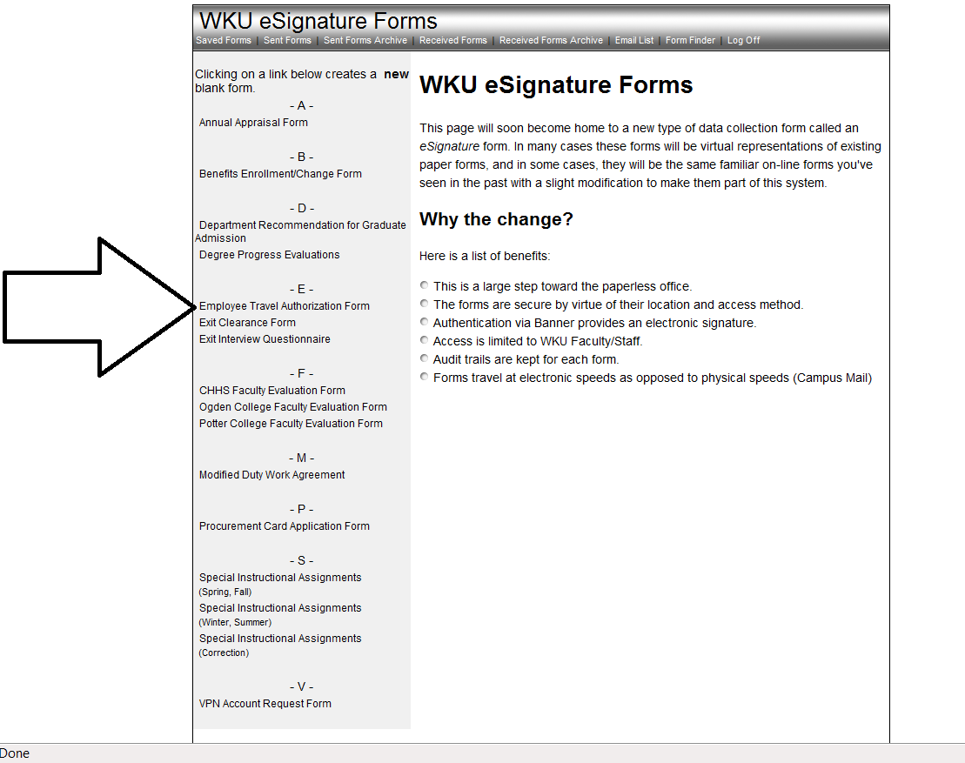

**STEP 3:** ENTER APPROPERIATE INFORMATION INTO THE BLANK BOXES

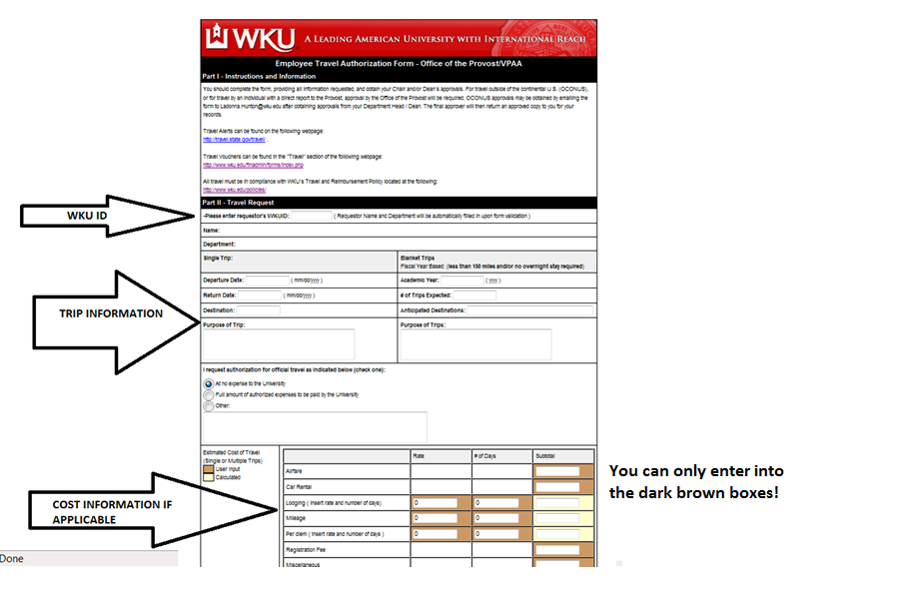

**STEP 4:** CLICK THE VALIDATE BUTTON AT BOTTOM OF THE FORM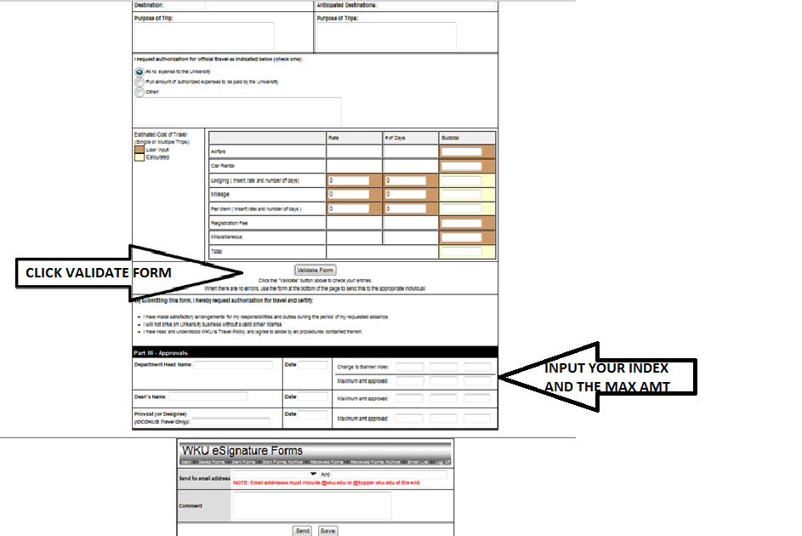

**STEP 5:** DID YOUR FORM VALIDATE CORRECTLY? IF SO, AFTER YOU VALIDATE THE FORM YOU WILL SEE THE BELOW SCREEN

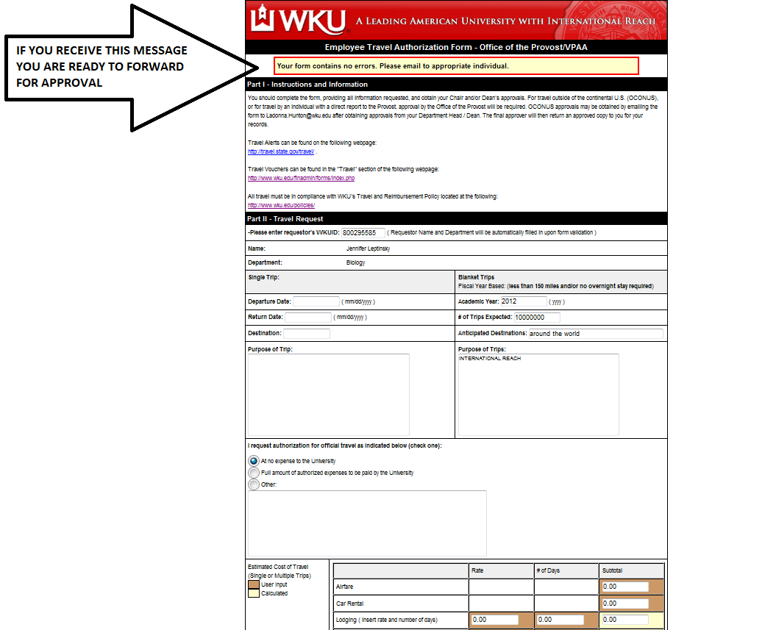

**STEP 6**: CONGRATULATIONS! YOU ARE NOW READY TO FORWARD YOUR FORM TO THE APPROPERIATE PERSON.

Please make sure you enter the index(es) and the maximum amount if there are expenses. If you have questions about this, you can send the form to Jessica and in the COMMENT section put your question(s).

IF YOU ARE TRAVELING WITH NO EXPENSE TO THE UNIVERSITY - FORWARD TO JENNIFER LEPTINSKY (SEE BELOW).

IF YOU ARE TRAVELING AND YOU HAVE EXPENSES – FORWARD THE FORM TO JESSICA DUNNEGAN (SEE BELOW).

**STEP 7:** SENDING YOUR FORM TO JESSICA OR JENNIFER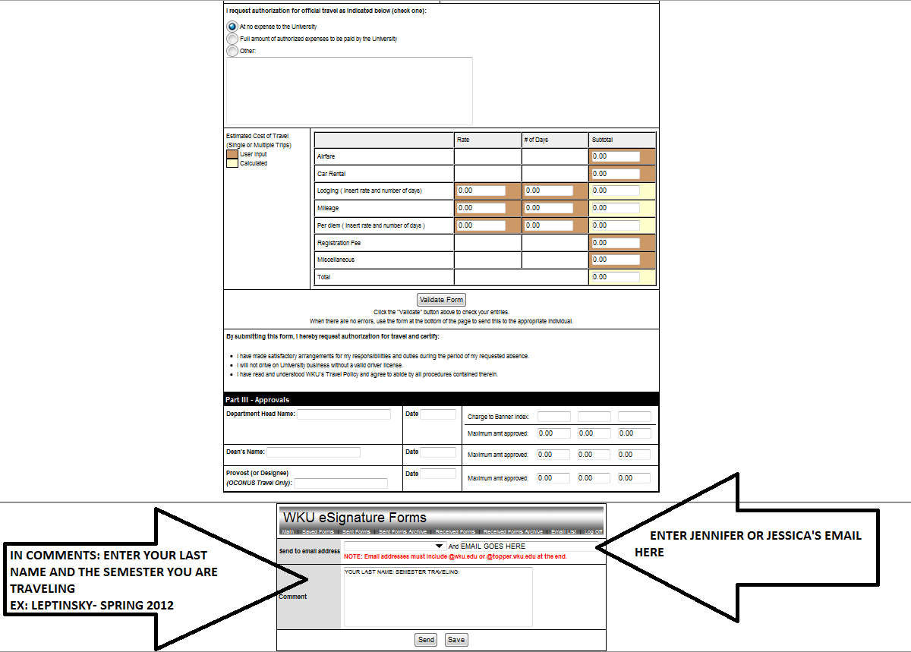

**STEP 8:** CLICK THE SEND BUTTON TO SEND TO THE APPROPERIATE PERSON

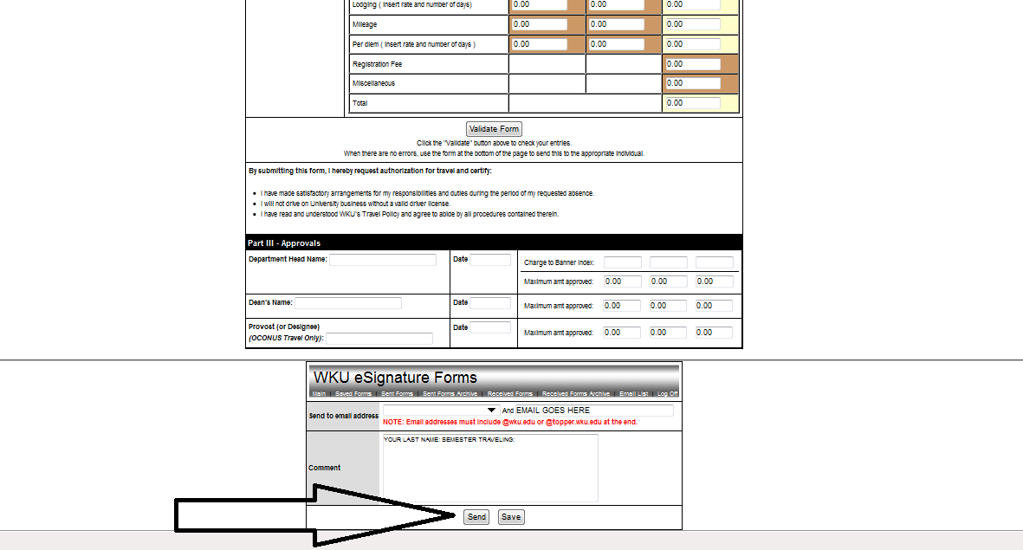

**STEP 9:** JESSICA OR JENNIFER WILL SEND TO BRUCE WHO WILL/WILL NOT APPROVE. YOU WILL GET YOUR FORM BACK AFTER ALL APPROVALS ARE COMPLETE. IF YOU WANT TO SEE WHERE YOUR FORM IS IN THE APPROVAL PROCESS CLICK ON SENT FORMS WITHIN WKU Esignature forms.

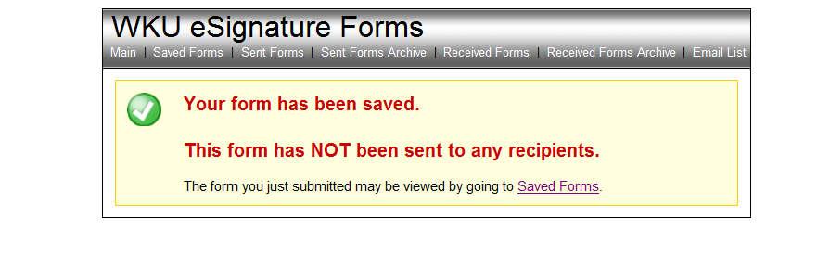

**STEP 10:** SELECT YOUR APPROPERIATE FORM YOU WOULD LIKE TO TRACK AND ROLL TO BOTTOM TO SEE WHERE IT IS IN THE APPROVAL PROCESS

ONCE YOU HAVE RECEIVED YOUR FORM BACK WITH APPROVALS, YOU ARE READY TO TRAVEL!

**Note regarding email names**: If you send forms to particular individuals regularly, then you can add them to your drop down list. If you are adding a name to your list while working on a form, make sure to save the form first or you will lose your work when you go to “Email List.”