There’s more than Cheese in Wisconsin

On Saturday mornings when I was a kid, ABC routinely ran public service announcements. One that I still remember featured a character that encouraged cheese consumption. Amongst other things, he said, “When my get up and go has got up and went, I hanker for a hunk of cheese”. Wisconsin, the unofficial “cheese state”, caused quite a stir today when many state senators just “got up and went” as they fled the state to avoid a quorum.

Apparently there is more than cheese in Wisconsin (and corn in Indiana if you believe 1980’s commercials paid for by Indiana Beach). They actually have a majority of state politicians who understand that supersized public sector benefits and pensions have contributed to their state’s budget problems. Who knew that politicians could figure out that 1+1=2?

The Wisconsin Senate bill would make non public safety public employees fund half of their pension costs and 12% of their health care costs. This of course is nowhere close to what private sector employees pay in pension and health care costs. According to the Bureau of Labor Statistics, the average single local public employee pays 11% of their health care costs compared to 20% in the private sector. They also report that said public employees are much more likely than private sector employees to receive pensions, and when they do, said pensions are about 10% more generous. The following is a chart based on BLS data created by Mandel on Innovation and Growth.

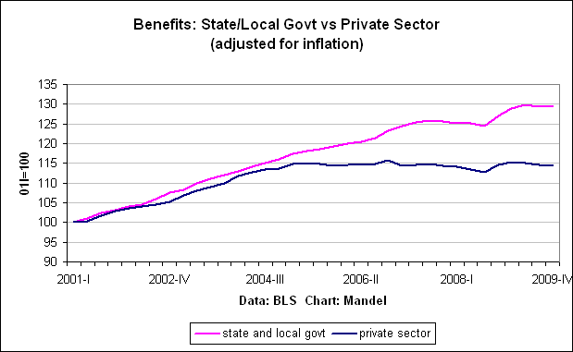

The reality is that many public sector employees throughout the country have been allowed to live in fantasy land. Their compensation package, though once comparable to the private sector, was allowed to swell such that it no longer could be deemed as just, or affordable, compensation. State pension systems are going broke in a hurry. Kentucky’s pension fund stands to be completely empty by 2022.

In 2005, when I became a city commissioner in Bowling Green, KY, I found that many city employees at that time paid 0% of their health care costs. In fact, they were given family plans that required employees to pay 0% of the cost. The city also had a large number of employees who could retire with full benefits after only 20 years of work. To say that this strained the city’s budget is an understatement. Yet, I can certainly appreciate Wisconsin Governor Walker’s position as he gazed upon thousands of union protestors today. I myself got profane messages left on my home answering machine when I suggested that public employees should have to share in their health care costs.

I have to hand it to Wisconsin’s new governor. This is the second time he has really impressed me. The first time came last month when he ran ads in the Chicago media market emphasizing Wisconsin’s attractive business climate following Illinois’ decision to up income taxes by 67%.

Ignoring budget problems won’t fix them. If only having a hunk of cheese could solve Wisconsin’s “got up and went” problem they would be set. Intellectually honest people know that cheese can’t solve fiscal crises, yet it appears that not all of Wisconsin’s politicians are intellectually honest.

