Environmental Education Project
Parker Bennett-Curry Elementary School
Project Title: Outdoor Classroom/Wildlife Habitat
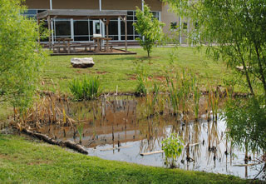  Stimulus for Project: Education for Sustainability  Grade Level: Elementary  Issue-Keywords: food, water, shelter, space, habitat, soil, organism, diversity, photosynthesis  Who is impacted? Students, school, wildlife  Contact Person: Kandy Fear  Location: Parker Bennett-Curry Elem. | Project Description:  Students from various classes helped install plants that produce flowers and berries; a pond for a source of water; and trees to establish food and shelter. The area received a certificate from Fish and Wildlife recognizing it as a wildlife habitat. A pavilion has been installed to provide a sitting area for instructions, observation and documentation.  Project Outcomes/Evaluation Brief Description: The students have observation on a regular basis when unloading and loading from their bus. They pass through the area when walking to the playground and can watch the area from the cafeteria when eating breakfast and lunch. They investigate and research the area when studying different topics.

