Default Report
CNS Student Exit Survey - 2019 Spring Comps
May 28th 2019, 10:41 am CDT
Q1 - 1. List your age.

1. List your age.
27
25
25
24
23
41
23
25
24
24
42
28
24
28
25
37
29
26
24
32
24
24
23
45

Q2 - 2. List the gender with which you identify.

2. List the gender with which you identify.
female
male
Female
Female
female
female
F
female
female
female
female
Male
Female
female
female
female
Cis male
female
female
female
Female
Female
female
female

Q3 - 3. Select your sexual orientation.
Unable to export widget. Please contact Qualtrics Support.

Q4 - 4. Select your partner status.
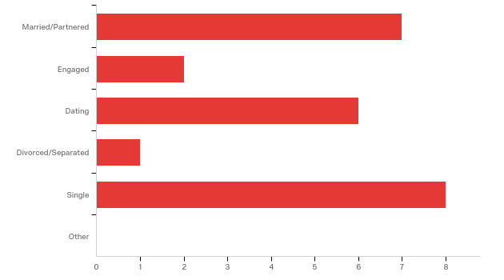

# | Answer | % | Count
1 | Married/Partnered | 29.17% | 7
2 | Engaged | 8.33% | 2
3 | Dating | 25.00% | 6
4 | Divorced/Separated | 4.17% | 1
5 | Single | 33.33% | 8
6 | Other | 0.00% | 0
 | Total | 100% | 24

Q5 - 5. Select your ethnicity/race/national origin (mark one):
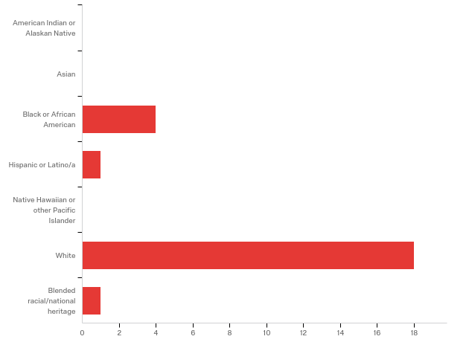

# | Answer | % | Count
1 | American Indian or Alaskan Native | 0.00% | 0
2 | Asian | 0.00% | 0
3 | Black or African American | 16.67% | 4
4 | Hispanic or Latino/a | 4.17% | 1
5 | Native Hawaiian or other Pacific Islander | 0.00% | 0
6 | White | 75.00% | 18
7 | Blended racial/national heritage | 4.17% | 1
 | Total | 100% | 24

Q6 - 6. Choose the most appropriate answer that best represents your employment while you were enrolled as a student.
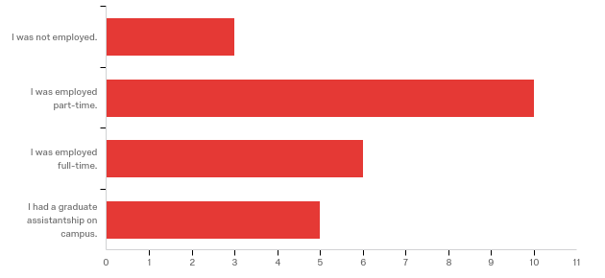

# | Answer | % | Count
1 | I was not employed. | 12.50% | 3
2 | I was employed part-time. | 41.67% | 10
3 | I was employed full-time. | 25.00% | 6
4 | I had a graduate assistantship on campus. | 20.83% | 5
 | Total | 100% | 24

Q7 - Which program in the Department of Counseling and Student Affairs did you complete?
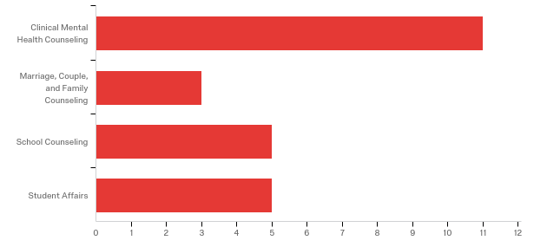

# | Answer | % | Count
1 | Clinical Mental Health Counseling | 45.83% | 11
2 | Marriage, Couple, and Family Counseling | 12.50% | 3
3 | School Counseling | 20.83% | 5
4 | Student Affairs | 20.83% | 5
 | Total | 100% | 24

Q8 - Did you complete any of the Department’s Graduate Certificate Programs? Please check all that apply:
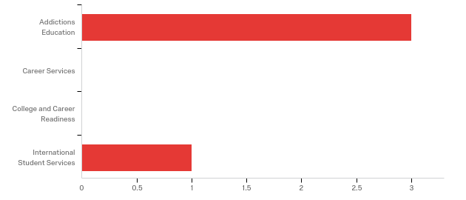

# | Answer | % | Count
1 | Addictions Education | 75.00% | 3
2 | Career Services | 0.00% | 0
3 | College and Career Readiness | 0.00% | 0
4 | International Student Services | 25.00% | 1
 | Total | 100% | 4

Q9 - When did you or do you expect to graduate?

# | Answer | % | Count
0 | 2017 | 0.00% | 0
4 | 2018 | 0.00% | 0
8 | 2019 | 100.00% | 24
12 | 2020 | 0.00% | 0
16 | 2021 | 0.00% | 0
20 | 2022 | 0.00% | 0
24 | 2023 | 0.00% | 0
28 | 2024 | 0.00% | 0
32 | 2025 | 0.00% | 0
 | Total | 100% | 24

# | Answer | % | Count
1 | Spring, May | 100.00% | 24
2 | Fall, December | 0.00% | 0
3 | Summer, August | 0.00% | 0
 | Total | 100% | 24

Q10 - Please check any scholarship awards you received while you were a graduate student?
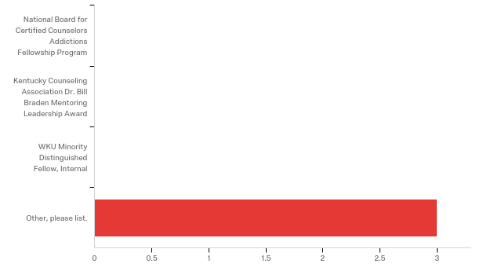

# | Answer | % | Count
1 | National Board for Certified Counselors Addictions Fellowship Program | 0.00% | 0
2 | Kentucky Counseling Association Dr. Bill Braden Mentoring Leadership Award | 0.00% | 0
3 | WKU Minority Distinguished Fellow, Internal | 0.00% | 0
4 | Other, please list. | 100.00% | 3
 | Total | 100% | 3

Other, please list.
Other, please list. - Text
Marcus Stubbs
Addictions Scholarship

Q11 - If you received a scholarship award while you were a graduate student here, in what year(s) did you receive the award?
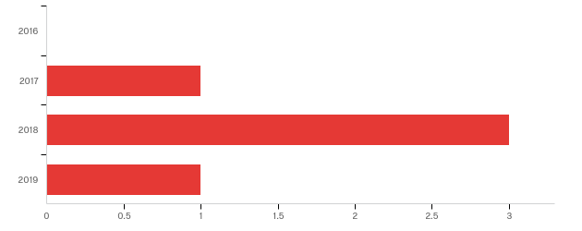

# | Answer | % | Count
2 | 2016 | 0.00% | 0
3 | 2017 | 20.00% | 1
4 | 2018 | 60.00% | 3
5 | 2019 | 20.00% | 1
 | Total | 100% | 5

Q12 - Please check if you were a member of these student organizations while you were a student.
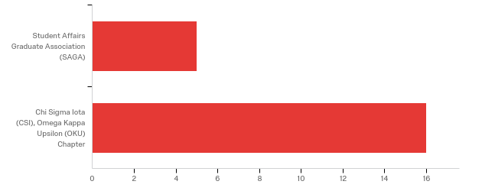

# | Answer | % | Count
1 | Student Affairs Graduate Association (SAGA) | 23.81% | 5
2 | Chi Sigma Iota (CSI), Omega Kappa Upsilon (OKU) Chapter | 76.19% | 16
 | Total | 100% | 21

Q13 - While you were a graduate student, were you involved in any leadership roles?
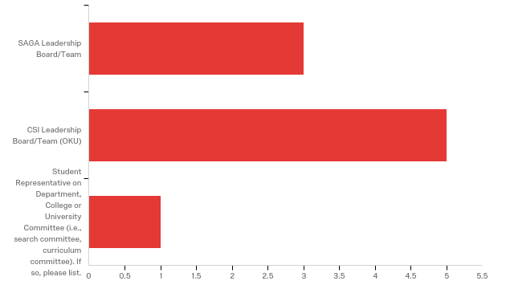

# | Answer | % | Count
1 | SAGA Leadership Board/Team | 33.33% | 3
2 | CSI Leadership Board/Team (OKU) | 55.56% | 5
3 | Student Representative on Department, College or University Committee (i.e., search committee, curriculum committee). If so, please list. | 11.11% | 1
 | Total | 100% | 9

Student Representative on Department, College or University Committee (i.e....
Student Representative on Department, College or University Committee (i.e., search committee, curriculum committee). If so, please list. - Text
Search committee - Student Support Services

Q14 - Please check any of the following professional activities that you were involved in while a graduate student in the Department of Counseling and Student Affairs (CACREP Section 3.D):
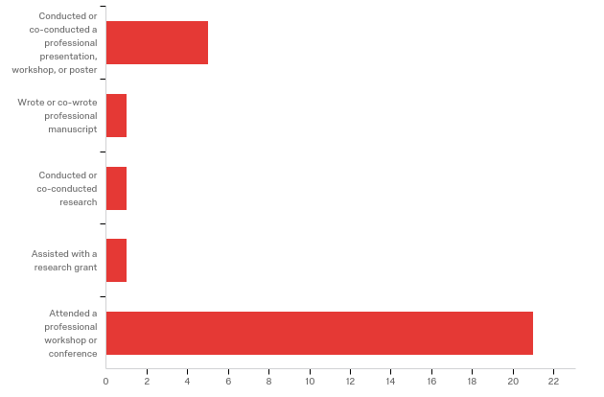

# | Answer | % | Count
1 | Conducted or co-conducted a professional presentation, workshop, or poster | 17.24% | 5
2 | Wrote or co-wrote professional manuscript | 3.45% | 1
3 | Conducted or co-conducted research | 3.45% | 1
4 | Assisted with a research grant | 3.45% | 1
5 | Attended a professional workshop or conference | 72.41% | 21
 | Total | 100% | 29

Q15 - What resources did you take advantage of while you were a graduate student in the Department of Counseling and Student Affairs (CACREP Section 3.D):
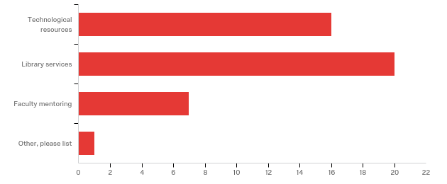

# | Answer | % | Count
1 | Technological resources | 36.36% | 16
2 | Library services | 45.45% | 20
3 | Faculty mentoring | 15.91% | 7
4 | Other, please list | 2.27% | 1
 | Total | 100% | 44

Other, please list
Other, please list - Text
Health and Wellness programs on campus

Q16 - Please rate your satisfaction with the program you graduated from. (APR B.4b)
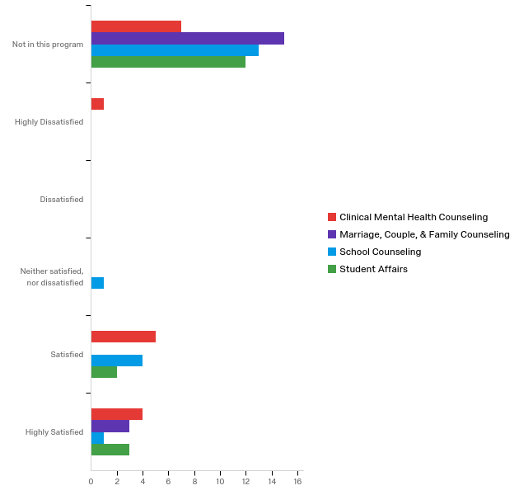

# | Question | Not in this program |  | Highly Dissatisfied |  | Dissatisfied |  | Neither satisfied, nor dissatisfied |  | Satisfied |  | Highly Satisfied |  | Total
1 | Clinical Mental Health Counseling | 41.18% | 7 | 5.88% | 1 | 0.00% | 0 | 0.00% | 0 | 29.41% | 5 | 23.53% | 4 | 17
2 | Marriage, Couple, & Family Counseling | 83.33% | 15 | 0.00% | 0 | 0.00% | 0 | 0.00% | 0 | 0.00% | 0 | 16.67% | 3 | 18
3 | School Counseling | 68.42% | 13 | 0.00% | 0 | 0.00% | 0 | 5.26% | 1 | 21.05% | 4 | 5.26% | 1 | 19
4 | Student Affairs | 70.59% | 12 | 0.00% | 0 | 0.00% | 0 | 0.00% | 0 | 11.76% | 2 | 17.65% | 3 | 17

Q17 - The Department of Counseling and Student Affairs is committed to providing quality programs and maintaining highly satisfied students and graduates. (APR E.1) Please check any of the following that you experienced as strengths of the program: Curriculum and Programming Please insert comments next to any of the strengths.
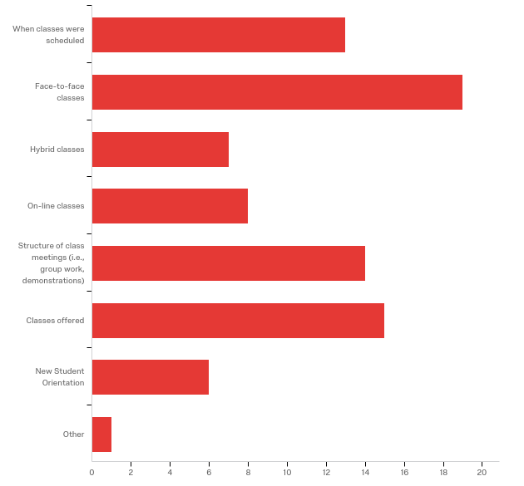

# | Answer | % | Count
1 | When classes were scheduled | 15.66% | 13
2 | Face-to-face classes | 22.89% | 19
3 | Hybrid classes | 8.43% | 7
4 | On-line classes | 9.64% | 8
5 | Structure of class meetings (i.e., group work, demonstrations) | 16.87% | 14
6 | Classes offered | 18.07% | 15
7 | New Student Orientation | 7.23% | 6
8 | Other | 1.20% | 1
 | Total | 100% | 83

When classes were scheduled
When classes were scheduled - Text
I had no complaints of when classes were scheduled. I am glad that they were in the afternoon on weekdays. This helped me to work first shift for the most part.
Of course it sucked having night classes but you do what you have to do to get to the next level.
Having evening classes helped with work schedule
Night and weekend classes were better for working full time.
night class times were an advantage and helped with holding a job and internship.
Quite a variety, but for Internship and Practicum, the 6:45 to 8:15 is a hard time slot for students who work from 8 to 5 and have small children.
late class times were convenient

Face-to-face classes
Face-to-face classes - Text
Resource Management was one of my favorite classes during my time in the program. i believe it should be a requirement!
It was great to learn in a face-to-face environment environment to learn different perspectives from the faculty and colleagues
I love Dr. Hughey, and Dr. Burke no complaints here.
Enjoyed face to face classes for more hands on experience
Face-to-face classes were more personal and provided more opportunity to learn.
Held the most weight in the program and I learned the most in these types of classes.
I received a better understanding of the subjects when I can ask question(in a classroom setting) and had visual ad or my peer acting out an situation I may have in the counseling field.
very interactive with professor/classmates
These classes gave me the ability to practice techniques with others and develop cohort relationships.
I feel like the face to face classes give a perspective that you just can't get online-- human interaction
I liked having that interaction.

Hybrid classes
Hybrid classes - Text
Allowed to have more balance
Love the hybrid classes with 3 meetings and online work.

On-line classes
On-line classes - Text
Online classes were straight forward and easy to follow.
Online classes were helpful because I got a chance to work more hours for a variety of jobs that I had.
How I survived discussion boards, graduate school 101... I’m ready to tell my story.
Interactive
These classes were most convenient for me because of working full time, and being a wife, and mother. It worked better with my schedule and allowed me to work on things without requiring a specific time and place to be.

Structure of class meetings (i.e., group work, demonstrations)
Structure of class meetings (i.e., group work, demonstrations) - Text
We had a lot of group work, but it was important since we will be working in groups for most of our careers.
I was happy that we had a diverse range of faculty members that offered different teaching styles. It kept the classes interesting and fun!
Group work became draining after awhile but you get through it.
Working in a group provided more peer feedback to get a different perspective.
Structured and full of important experiential learning
Got to learn thing throught other point of view.
I liked working together as it gave me the opportunity to connect with other students.

Classes offered
Classes offered - Text
The classes offered was essential to understanding the theoretical concepts of higher education.
Cancel college student experience and make resource management a permanent class! Dr. Hunton is the GOAT (GREATEST OF ALL TIME)
Elective classes provided more learning that could be used in the field.
A large variety of extra important and interesting classes, like play therapy were offered as electives as well.
classes provided important information/activities for future career

New Student Orientation
New Student Orientation - Text
Benficial
I really liked having an in-person orientation. I think having that allowed me to meet more people from my cohort. I think moving it to completely online is a great downfall for the new cohorts.

Q18 - The Department of Counseling and Student Affairs is committed to providing quality programs and maintaining highly satisfied students and graduates. (APR E.1) Please check any of the following that you experienced as strengths of the program: Faculty Please insert comments next to any of the strengths.
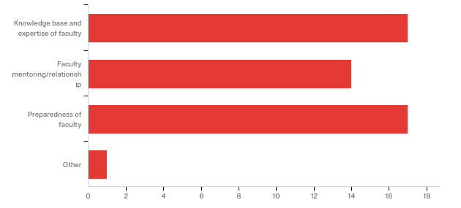

# | Answer | % | Count
1 | Knowledge base and expertise of faculty | 34.69% | 17
2 | Faculty mentoring/relationship | 28.57% | 14
3 | Preparedness of faculty | 34.69% | 17
4 | Other | 2.04% | 1
 | Total | 100% | 49

Knowledge base and expertise of faculty
Knowledge base and expertise of faculty - Text
Please refer to "Structure of class meetings"
Dr. Burke and Dr. Hughey Rock!
Staff offered a variety of knowledge
The faculty was open, honest, helpful and was there for us to learn. They wanted the best for the students
Some really great faculty - Dr. Wolfe rocks!
Professors were very knowledgeable of material and would share personal examples
Very insightful and helpful. They were able to be flexible with various learning styles to meet the needs of students in their classes. Always helpful when I asked a question or needed assistance with understanding.

Faculty mentoring/relationship
Faculty mentoring/relationship - Text
Faculty mentoring/relationship had an "open door" policy when it came to mentoring and fostering relationships. They made sure we were taken care of!
I know they genuinely cared for me and my future, no matter what it was genuine!
Faculty was supportive
Dr. Wolf has been a phenomenal faculty member and goes out of her way to help students succeed.
Faculty is always willing to help when needed
Provided support during a very difficult personal experience
Easy to form a relationship with the faculty!
The faculty cares about their students and any time I had a concern or question I was able to meet with them and get it figured out.

Preparedness of faculty
Preparedness of faculty - Text
I believe we have the best faculty in the nation when it comes to preparing us for the higher education realm! They are legends in their won right when it comes to doing research and workshops (face-to-face and online) at different conferences. They have written books and did research in a variety of topics that we have learned from them. They have even received awards that affirms that they are serious about their position as faculty members.
Everything was great!
Most faculty- not all.
Dr. Wolf
Always felt the faculty knew the information and were always willing to learn and find out more if they were unsure.
Most staff were very prepared with multiples resources for the class
Well prepared and organized group of professors!
I would say most of the faculty is pepared. However I want to include that I didn't feel Dr. Mason was with theories. She really only taught us solution based and reality thearpy when there are a lot more major theories than that

Q19 - The Department of Counseling and Student Affairs is committed to providing quality programs and maintaining highly satisfied students and graduates. (APR E.1) Please check any of the following that you experienced as strengths of the program: Personal and Professional Development Please insert comments next to any of the strengths.
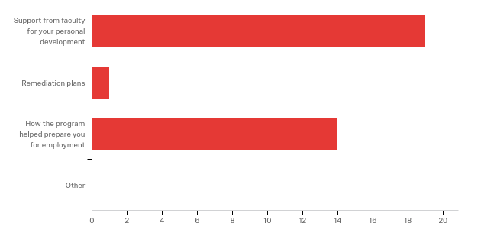

# | Answer | % | Count
1 | Support from faculty for your personal development | 55.88% | 19
2 | Remediation plans | 2.94% | 1
3 | How the program helped prepare you for employment | 41.18% | 14
4 | Other | 0.00% | 0
 | Total | 100% | 34

Support from faculty for your personal development
Support from faculty for your personal development - Text
Please refer to "Faculty mentoring/relationship"
Nothing but genuine support and love!
Staff was supportive
Dr. Jenkins, Dr. Wolf, and Dr. Sauerheber constantly encourage student's personal development not only as it applies to counseling but as human beings.
The faculty is there for more than just classes. They offer as much support to create a well rounded person and counselor.
Faculty, other than my advisor, helped me through career plans.
Dr. Wolf was available and accommodating for students.
staff was available for any questions and would always try to help
I have always felt that I could go to any of the faculty if I needed help with something.

Remediation plans
Remediation plans - Text
Worked well to help students get back on track.

How the program helped prepare you for employment
How the program helped prepare you for employment - Text
The internship classes has prepared me to understand the concept of "life after college". I had an idea of what was to be expected and to understand the game plan of possible employment for an entry level position.
Definitely prepared me for employment Dr. Burke’s internship prepared me for a lot and I’m thankful
Internship help prepared for employment.
Experience was the most important and getting into the field and learning first hand.
resume building, interview practice and building confidence in myself so I speak highly of my ability to obtain and maintain a counseling job.
from my classes I felt very prepared for my practicum/internship. Internship was the best part of my experience of my masters
I especially love that Dr. Wolf is hosting "so you're graduating, now what?" to help us gain employment and I enojoyed the internship fair to help us find internships

Q20 - The Department of Counseling and Student Affairs is committed to providing quality programs and maintaining highly satisfied students and graduates. (APR E.1) Please check any of the following that you experienced as strengths of the program: Professional Development Opportunities Please insert comments next to any of the strengths.
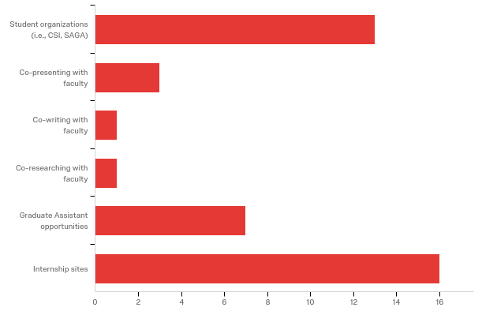

# | Answer | % | Count
1 | Student organizations (i.e., CSI, SAGA) | 31.71% | 13
2 | Co-presenting with faculty | 7.32% | 3
3 | Co-writing with faculty | 2.44% | 1
4 | Co-researching with faculty | 2.44% | 1
5 | Graduate Assistant opportunities | 17.07% | 7
6 | Internship sites | 39.02% | 16
 | Total | 100% | 41

Student organizations (i.e., CSI, SAGA)
Student organizations (i.e., CSI, SAGA) - Text
I had the chance to be a part of SAGA activities and implementing them as well! The activities that I have been a part of has helped to gain a sense of community and to gain relationships amongst faculty, staff and colleagues at WKU! In addition, we also had the chance to mend relationships wiht other universities such as Vanderbilt University and University of Louisville!
Didn’t do too much with SAGA
CSI is well involved

Co-presenting with faculty
Co-presenting with faculty - Text
N/A

Co-writing with faculty
Co-writing with faculty - Text
N/A

Co-researching with faculty
Co-researching with faculty - Text
N/A

Graduate Assistant opportunities
Graduate Assistant opportunities - Text
I am currently a graduate assistant instructor for the professional studies department. I am also the coordinator for the SouthCentral Kentucky Community and Technical College Student Ambassadors.
I had a hard time finding a GA BUT God had other plans. I feel wku in general is really low with graduate assistantships. Not fair and could really make people feel like they aren’t qualified.

Internship sites
Internship sites - Text
I have interned at: 1) Vanderbilt University's International Student and Scholar Services. 2)Co-taught for a university experience class for a semester
Loved my internships!!! I think the one at Sky may need to go because I don’t like the way Kyle has treated some of my peers
Internship helped prepared for employment and provide a good hands-on learning experience.
There is a huge variety and the faculty and staff are always in contacted to ensure it is the best fit.
Talley is a great site for students. You get the practice right from the start in practicum
The best experience for me was hands-on internship learning.
being at the elementary and middle school I have had many of different options to work with student in different siting such as one-on-one ,group counseling and classroom guidance.
Provided so much hands on experience at every level of K-12
I was able to choose the site where I teach and this was helpful to work with my schedule.

Q21 - The Department of Counseling and Student Affairs is committed to providing quality programs and maintaining highly satisfied students and graduates. (APR E.1) Please check any of the following that you experienced as weaknesses of the program: Curriculum and Programming Please insert comments next to any of the weaknesses.
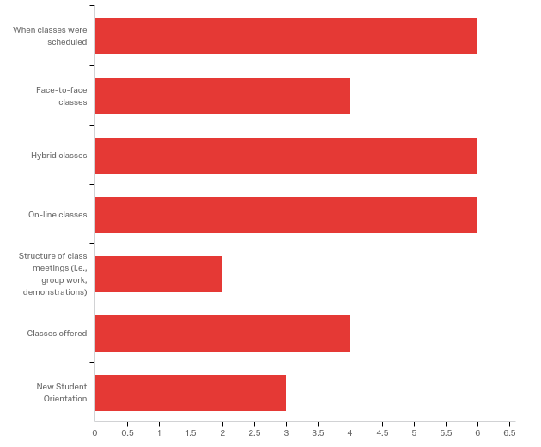

# | Answer | % | Count
1 | When classes were scheduled | 19.35% | 6
2 | Face-to-face classes | 12.90% | 4
3 | Hybrid classes | 19.35% | 6
4 | On-line classes | 19.35% | 6
5 | Structure of class meetings (i.e., group work, demonstrations) | 6.45% | 2
6 | Classes offered | 12.90% | 4
7 | New Student Orientation | 9.68% | 3
 | Total | 100% | 31

When classes were scheduled
When classes were scheduled - Text
Late classes are onerwhelminb sometimes
early afternoon were not helpful
Again, the 6:45 to 8:15 slot is hard for students with full-time jobs until 5 and small children.
Some class times were not convenient for some students.
Classes were sometimes unavailable for students that work full times, Leading students to have to out source the classes from another university.
There were some classes scheduled at 2 or 3 in the afternoon. That makes it extremely hard for internship and for any job. I was working as a teacher and it made it really hard to get to class. I quit working as that when time came for internship but then those classes make it harder to get internship hours that I needed because my internship site operated 9am-4pm. I would recommend that classes don't start until 4:30 or later

Face-to-face classes
Face-to-face classes - Text
No complaints
I felt that a lot of my school counseling work focused on a specific population of students and I would have liked to have evenly explored other populations as well.
I wish there had of been more offerings of online classes and weekend classes.

Hybrid classes
Hybrid classes - Text
No complaints
a disadvantage at times.
We learned very little in our theories class because our professor decided to only really cover two theories. I understand having certain people teach these classes, but I believe there are better people in the department to teach these.
I didn't really feel like I learned much to these. Too much crammed into too little time and Dr. Stickle and Dr. Mason were too tangental in their class meetings.
Some of the hybrid classes I felt should have been classes that met weekly to properly go over and understand the content.

On-line classes
On-line classes - Text
Discussion boards are draining
Online classes end up being a waste. I learned very little from my theories class. I would prefer this be offered as both fully online or hybrid to get actual practice working with addictions
some classes/material for online did not have much purpose

Structure of class meetings (i.e., group work, demonstrations)
Structure of class meetings (i.e., group work, demonstrations) - Text
Group work is draining

Classes offered
Classes offered - Text
Enjoyed
The school counselor program had changes all the time which made it very hard to set a goal of what I want to go and how fast I want to complete the program.
I wish there had been more classes available in the summer or winter terms.

New Student Orientation
New Student Orientation - Text
I feel as if the orientation I went to was geared more towards counseling majors.
Enjoyed

Q22 - The Department of Counseling and Student Affairs is committed to providing quality programs and maintaining highly satisfied students and graduates. (APR E.1) Please check any of the following that you experienced as weaknesses of the program: Faculty Please insert comments next to any of the weaknesses.
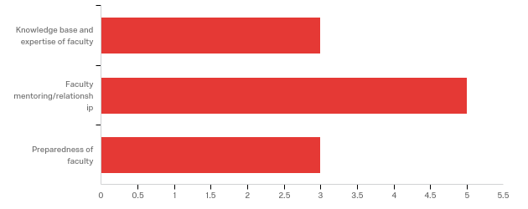

# | Answer | % | Count
1 | Knowledge base and expertise of faculty | 27.27% | 3
2 | Faculty mentoring/relationship | 45.45% | 5
3 | Preparedness of faculty | 27.27% | 3
 | Total | 100% | 11

Knowledge base and expertise of faculty
Knowledge base and expertise of faculty - Text
No complaints
Dr. Mason is not equipped to be teaching theories. She read directly from powerpoints and does not listen to student feedback. I feel extremely unprepared taking my Cpce exam because of my lack of conceptualization of theories due to her lack of knowledge base and expertise.

Faculty mentoring/relationship
Faculty mentoring/relationship - Text
No complaints
There are some faculty in the program who are only willing to mentor certain students. They also have given these particular students special treatment either in class or in the office as a GA. We had many issues with a couple of GAs who would not come in at their work times and would do homework instead of asking other GAs or professors if they needed help. When this was brought up to a faculty member, we were told that it had been discussed in faculty meeting but the same faculty member who is giving special treatment in class was giving special treatment in the office.
My advisor was there if I reached out to her, but I felt little guidance in regards to curriculum initiated on her part.

Preparedness of faculty
Preparedness of faculty - Text
No complaints
some faculty was not always the best with the clarification of questions/class assignments

Q23 - The Department of Counseling and Student Affairs is committed to providing quality programs and maintaining highly satisfied students and graduates. (APR E.1) Please check any of the following that you experienced as weaknesses of the program: Personal and Professional Development Please insert comments next to any of the weaknesses.
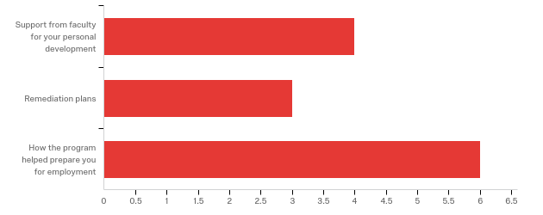

# | Answer | % | Count
1 | Support from faculty for your personal development | 30.77% | 4
2 | Remediation plans | 23.08% | 3
3 | How the program helped prepare you for employment | 46.15% | 6
 | Total | 100% | 13

Support from faculty for your personal development
Support from faculty for your personal development - Text
No complaints
some faculty played favoritism and was obvious in classes

Remediation plans
Remediation plans - Text
No complaints

How the program helped prepare you for employment
How the program helped prepare you for employment - Text
No complaints
I do not feel prepared to bill licensure or write notes; I only feel this because of my site supervisor
Throughout the whole program I felt as though I was being trained for a mental health counselor - which is helpful, but there were times when school counseling was never mentioned in a class.
I wish there were more focus on school counseling and how the special education aspect is within the job description of a school counselor. IEP's and 504 plans are something I feel less prepared for than actual counseling students. The paperwork and meetings that go along with those type of student plans are invasive and a lot of work. Therefore I wish I had more preparedness for that aspect of the job.
I have felt a little lost in the application process and what to do next.

Q24 - The Department of Counseling and Student Affairs is committed to providing quality programs and maintaining highly satisfied students and graduates. (APR E.1) Please check any of the following that you experienced as weaknesses of the program: Professional Development Opportunities Please insert comments next to any of the weaknesses.
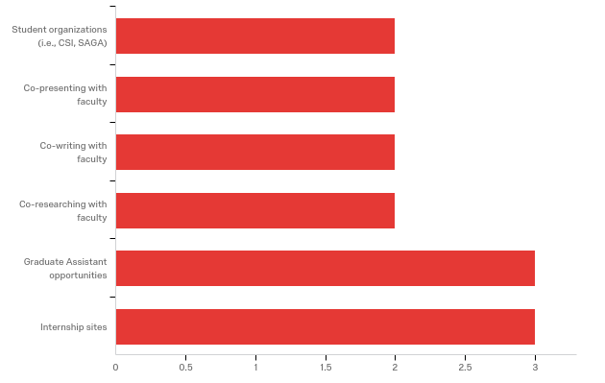

# | Answer | % | Count
1 | Student organizations (i.e., CSI, SAGA) | 14.29% | 2
2 | Co-presenting with faculty | 14.29% | 2
3 | Co-writing with faculty | 14.29% | 2
4 | Co-researching with faculty | 14.29% | 2
5 | Graduate Assistant opportunities | 21.43% | 3
6 | Internship sites | 21.43% | 3
 | Total | 100% | 14

Student organizations (i.e., CSI, SAGA)
Student organizations (i.e., CSI, SAGA) - Text
No complaints

Co-presenting with faculty
Co-presenting with faculty - Text
N/A

Co-writing with faculty
Co-writing with faculty - Text
N/A

Co-researching with faculty
Co-researching with faculty - Text
N/A

Graduate Assistant opportunities
Graduate Assistant opportunities - Text
N/A

Internship sites
Internship sites - Text
N/A
I do wish there was a way I would have been able to get experience in another site without the amount of time requiring me to be outside of my classroom and school during the school day.

Q25 - Have you sought employment since graduating? (APR B.5.)
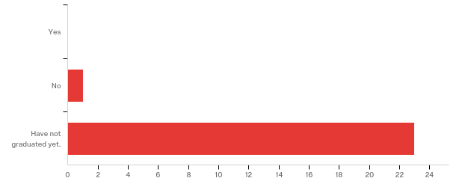

# | Answer | % | Count
1 | Yes | 0.00% | 0
2 | No | 4.17% | 1
3 | Have not graduated yet. | 95.83% | 23
 | Total | 100% | 24

Q26 - Have you gained employment in the field of your degree program? (APR B.5) Please choose the most appropriate response.

# | Answer | % | Count
1 | Full-time employment. Please list employer, city and state. | 0.00% | 0
2 | Part-time employment. Please list employer, city and state. | 0.00% | 0
3 | Have not been hired in the field of my degree. | 0.00% | 0
 | Total | 100% | 0

Full-time employment. Please list employer, city and state.
Full-time employment. Please list employer, city and state. - Text
Part-time employment. Please list employer, city and state.
Part-time employment. Please list employer, city and state. - Text

Q27 - If you gained employment, please describe the setting of your employer.
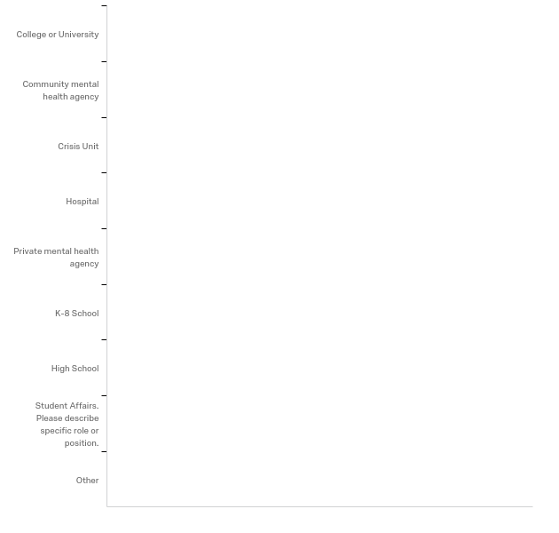

# | Answer | % | Count
1 | College or University | 0.00% | 0
2 | Community mental health agency | 0.00% | 0
3 | Crisis Unit | 0.00% | 0
4 | Hospital | 0.00% | 0
5 | Private mental health agency | 0.00% | 0
6 | K-8 School | 0.00% | 0
7 | High School | 0.00% | 0
8 | Student Affairs. Please describe specific role or position. | 0.00% | 0
9 | Other | 0.00% | 0
 | Total | 100% | 0

Student Affairs. Please describe specific role or position.
Student Affairs. Please describe specific role or position. - Text

Q28 - If you gained employment in your respective field, how long after you graduated were you employed?

# | Answer | % | Count
1 | Prior to graduation | 0.00% | 0
2 | Three months or less | 0.00% | 0
3 | Six months or less | 0.00% | 0
4 | A year or less | 0.00% | 0
5 | More than a year | 0.00% | 0
 | Total | 100% | 0

Q29 - If you gained employment, where did you secure employment? (APR B.5)

# | Answer | % | Count
1 | In Kentucky. Please list city. | 0.00% | 0
2 | Outside of Kentucky. Please list city and state. | 0.00% | 0
 | Total | 100% | 0

In Kentucky. Please list city.
In Kentucky. Please list city. - Text
Outside of Kentucky. Please list city and state.
Outside of Kentucky. Please list city and state. - Text

Q30 - After graduation, did you/do you plan to seek graduate/professional school admission (i.e., doctoral degree program)? (APR B.5)
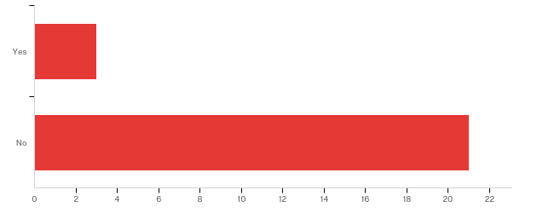

# | Answer | % | Count
1 | Yes | 12.50% | 3
2 | No | 87.50% | 21
 | Total | 100% | 24

Q31 - If you sought graduate/professional school admission (i.e., doctoral degree program), were you admitted? (APR B.5)
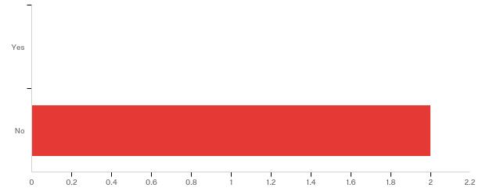

# | Answer | % | Count
1 | Yes | 0.00% | 0
2 | No | 100.00% | 2
 | Total | 100% | 2

Q32 - If you were admitted to graduate/professional school (i.e., doctoral degree program), are you planning on attending/already enrolled? (APR B.5)

# | Answer | % | Count
1 | Yes. Please list program and university. | 0.00% | 0
2 | No | 0.00% | 0
 | Total | 100% | 0

Yes. Please list program and university.
Yes. Please list program and university. - Text

Q37 - We are interested in your feedback regarding how we can better recruit and attract underrepresented students to our programs. Please share below.
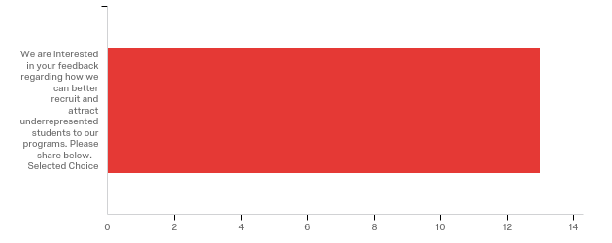

# | Field | Minimum | Maximum | Mean | Std Deviation | Variance | Count
1 | We are interested in your feedback regarding how we can better recruit and attract underrepresented students to our programs. Please share below. - Selected Choice | 1.00 | 1.00 | 1.00 | 0.00 | 0.00 | 13

# | Answer | % | Count
1 | We are interested in your feedback regarding how we can better recruit and attract underrepresented students to our programs. Please share below. - Selected Choice | 100.00% | 13
 | Total | 100% | 13

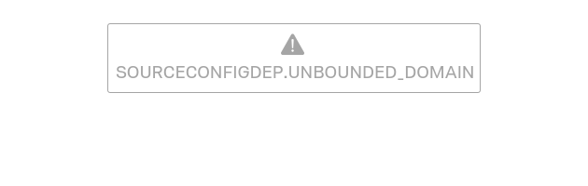
Data source misconfigured for this visualization

# | Answer | % | Count
the | the | 2.86% | 8
and | and | 2.14% | 6
program | program | 2.14% | 6
that | that | 2.14% | 6
a | a | 1.79% | 5
classes | classes | 1.79% | 5
for | for | 1.79% | 5
i | i | 1.79% | 5
to | to | 1.79% | 5
campus | campus | 1.43% | 4
in | in | 1.43% | 4
is | is | 1.43% | 4
students | students | 1.43% | 4
are | are | 1.07% | 3
be | be | 1.07% | 3
of | of | 1.07% | 3
they | they | 1.07% | 3
what | what | 1.07% | 3
with | with | 1.07% | 3
all | all | 0.71% | 2
being | being | 0.71% | 2
believe | believe | 0.71% | 2
feel | feel | 0.71% | 2
field | field | 0.71% | 2
get | get | 0.71% | 2
good | good | 0.71% | 2
have | have | 0.71% | 2
jump | jump | 0.71% | 2
more | more | 0.71% | 2
offering | offering | 0.71% | 2
on | on | 0.71% | 2
opportunities | opportunities | 0.71% | 2
out | out | 0.71% | 2
student | student | 0.71% | 2
them | them | 0.71% | 2
this | this | 0.71% | 2
underrepresented | underrepresented | 0.71% | 2
were | were | 0.71% | 2
accept | accept | 0.36% | 1
active | active | 0.36% | 1
advertise | advertise | 0.36% | 1
after | after | 0.36% | 1
agencies | agencies | 0.36% | 1
allow | allow | 0.36% | 1
allowing | allowing | 0.36% | 1
already | already | 0.36% | 1
also | also | 0.36% | 1
although | although | 0.36% | 1
an | an | 0.36% | 1
apply | apply | 0.36% | 1
area | area | 0.36% | 1
around | around | 0.36% | 1
as | as | 0.36% | 1
at | at | 0.36% | 1
because | because | 0.36% | 1
before | before | 0.36% | 1
beneficial | beneficial | 0.36% | 1
but | but | 0.36% | 1
can | can | 0.36% | 1
career | career | 0.36% | 1
cheaper | cheaper | 0.36% | 1
class | class | 0.36% | 1
classwork | classwork | 0.36% | 1
close | close | 0.36% | 1
cns | cns | 0.36% | 1
cohort | cohort | 0.36% | 1
comes | comes | 0.36% | 1
committing | committing | 0.36% | 1
comprised | comprised | 0.36% | 1
connected | connected | 0.36% | 1
connections | connections | 0.36% | 1
could | could | 0.36% | 1
csi | csi | 0.36% | 1
demonstrate | demonstrate | 0.36% | 1
department | department | 0.36% | 1
describing | describing | 0.36% | 1
did | did | 0.36% | 1
different | different | 0.36% | 1
do | do | 0.36% | 1
does | does | 0.36% | 1
dr | dr | 0.36% | 1
dye | dye | 0.36% | 1
evidence | evidence | 0.36% | 1
expierence | expierence | 0.36% | 1
explain | explain | 0.36% | 1
expressing | expressing | 0.36% | 1
face | face | 0.36% | 1
favoritism | favoritism | 0.36% | 1
felt | felt | 0.36% | 1
filled | filled | 0.36% | 1
freely | freely | 0.36% | 1
full | full | 0.36% | 1
gain | gain | 0.36% | 1
getting | getting | 0.36% | 1
great | great | 0.36% | 1
groups | groups | 0.36% | 1
has | has | 0.36% | 1
having | having | 0.36% | 1
health | health | 0.36% | 1
her | her | 0.36% | 1
if | if | 0.36% | 1
importance | importance | 0.36% | 1
including | including | 0.36% | 1
internship | internship | 0.36% | 1
it | it | 0.36% | 1
job | job | 0.36% | 1
knowoledge | knowoledge | 0.36% | 1
levels | levels | 0.36% | 1
like | like | 0.36% | 1
making | making | 0.36% | 1
many | many | 0.36% | 1
mason | mason | 0.36% | 1
maybe | maybe | 0.36% | 1
me | me | 0.36% | 1
meet | meet | 0.36% | 1
mental | mental | 0.36% | 1
minority | minority | 0.36% | 1
need | need | 0.36% | 1
networking | networking | 0.36% | 1
nicely | nicely | 0.36% | 1
not | not | 0.36% | 1
offer | offer | 0.36% | 1
opportunity | opportunity | 0.36% | 1
opposing | opposing | 0.36% | 1
or | or | 0.36% | 1
other | other | 0.36% | 1
our | our | 0.36% | 1
owensboro | owensboro | 0.36% | 1
particular | particular | 0.36% | 1
pay | pay | 0.36% | 1
people | people | 0.36% | 1
person | person | 0.36% | 1
personal | personal | 0.36% | 1
picked | picked | 0.36% | 1
prepare | prepare | 0.36% | 1
price | price | 0.36% | 1
programs | programs | 0.36% | 1
proogram | proogram | 0.36% | 1
properly | properly | 0.36% | 1
reach | reach | 0.36% | 1
really | really | 0.36% | 1
recruit | recruit | 0.36% | 1
representation | representation | 0.36% | 1
requirements | requirements | 0.36% | 1
requiremnt | requiremnt | 0.36% | 1
requirment | requirment | 0.36% | 1
resource | resource | 0.36% | 1
said | said | 0.36% | 1
say | say | 0.36% | 1
scoring | scoring | 0.36% | 1
seeking | seeking | 0.36% | 1
setting | setting | 0.36% | 1
shadow | shadow | 0.36% | 1
shadowing | shadowing | 0.36% | 1
shares | shares | 0.36% | 1
sharing | sharing | 0.36% | 1
she | she | 0.36% | 1
showed | showed | 0.36% | 1
since | since | 0.36% | 1
so | so | 0.36% | 1
some | some | 0.36% | 1
south | south | 0.36% | 1
speaking | speaking | 0.36% | 1
start | start | 0.36% | 1
study | study | 0.36% | 1
target | target | 0.36% | 1
theories | theories | 0.36% | 1
theraputic | theraputic | 0.36% | 1
there | there | 0.36% | 1
these | these | 0.36% | 1
those | those | 0.36% | 1
through | through | 0.36% | 1
time | time | 0.36% | 1
times | times | 0.36% | 1
toward | toward | 0.36% | 1
trying | trying | 0.36% | 1
types | types | 0.36% | 1
undergraduate | undergraduate | 0.36% | 1
video | video | 0.36% | 1
views | views | 0.36% | 1
virtual | virtual | 0.36% | 1
visits | visits | 0.36% | 1
weekend | weekend | 0.36% | 1
welcome | welcome | 0.36% | 1
well | well | 0.36% | 1
when | when | 0.36% | 1
who | who | 0.36% | 1
why | why | 0.36% | 1
wonderful | wonderful | 0.36% | 1
work | work | 0.36% | 1
worth | worth | 0.36% | 1
would | would | 0.36% | 1
wrong | wrong | 0.36% | 1
you | you | 0.36% | 1
your | your | 0.36% | 1
 | Total | 100% | 280

Q33 - Do you have any other comments/suggestions you would like to share to help improve the courses and the Department of Counseling and Student Affairs?

Do you have any other comments/suggestions you would like to share to help improve the courses and the Department of Counseling and Student Affairs?
The COMPs exams should be taken later in the spring semester. There were many of us that did not think we were adaquately prepared for the exam because we had either not taken the classes that were on the test or were currently in that class and had not covered the material on the test yet. Also, providing more study material for the exam. SAGA's steering committee had some information, but did not have as much as they needed to have to help their fellow students.
In the section of "If you sought graduate/professional school admission (i.e., doctoral degree program), were you admitted? (APR B.5)" I put no, however, I am still in the stages of the selection process. I have been selected for an interview for a PH.D program.
Thank you Dr. Burke and Hughey for ALL you’ve done! I will miss you and will always keep you all near and dear to my heart!
Dr. Mason no longer needs to teach theories.
Applicable interventions from a theoretical orientation. Less favoritism towards graduate assistants.
We do have a good amount of courses offered, but if we had more courses that go into specializations that could be helpful for students who are entering practicum/internship. It also gives more students a chance to find areas they may want to get specialized in for the future. Play Therapy was a course that gave more exposure to a different type of counseling, so if we had more courses that give exposure to various types of counseling, it could benefit future students.
I have enjoyed my courses here in the Clinical Mental Health program. The only suggestion I can offer for improvement is possibly more flexible class times (i.e., the same course offered on different dates or times). But honestly, overall-- this really has not been an issue for me personally while in this program.
Thank you for your continued support! I have enjoyed getting to know everyone and enjoyed learning so much about myself and how to serve the needs of others.
Make sure that whoever is going to teach theories is actually going to teach all the major theories. Telling the students to review the textbook and then only expanding on Reality Therapy and Solution focused therapy in class and nothing else is ridiculous. Dr. Mason should not teach theories. Fred also needs to learn to be more accepting of other viewpoints. Telling students that Gottman is crap is not acceptable. He isn't open to theoretical lenses that aren't his own-- and yet he claims he's eclectic.

