

Graduate Council

Agenda—Thursday, November 9, 2017, 3:00 p.m.

Academic Affairs Conference Room WAB 239

1. Call to Order
2. Consideration of October 12, 2017 minutes (Appendix A)
3. Graduate Enrollment Report (Appendix B)
4. Committee Reports
   1. Policy Committee
   2. Curriculum Committee (Appendix C)
   3. Student Research Grants Committee
5. Report from Dean of the Graduate School
6. Public Comments
7. Announcements & Adjourn

**APPENDIX A**



Graduate Council

Minutes - October 12, 2017, 3:00 p.m.

Academic Affairs Conference Room WAB 239

Members Present: Kirk Atkinson, Martha Day, Carl Dick, Dominic Lanphier, Richard Dressler, Laurie Branstetter, Amy Cappiccie, Kristie Guffey, Ron Mitchell, Scott Lyons, Kristin Wilson, Justanun Tillman, Divya Gangavelli, Clarissa Lighsy, Allie Crume, Mercy Ebusetse, Eric Reed, Wes Berry, Ann Ferrell, Molly Kerby

Members Absent: Carl Myers, Leyla Zhuhadar, Alex Lebedinsky, Chris Groves

Guests: Sylvia Gaiko, Scott Gordon, Colette Chelf, Laura Burchfield, Lance Hahn, Cathleen Webb, Danita Kelley, Andrea Pasanelli, Veletta Ogaz, Bob Hatfield

1. Call to Order *Wilson
2. Consideration of September 14, 2017 minutes *Atkinson/Guffey motion to approve; amendment to include Steve Wininger, Carl Myers, and Mercy Ebuestse to attendance list; passed.
3. Graduate Enrollment Report (see attached pdf) *Lyons reported that there would still be more students to register before Census and that we will likely be down 60 students primarily due to the Geopolitical climate.
4. Committee Reports
   1. Policy Committee *No Report.

*Mitchel commented that the Dean would like the Policy Committee to take back up the Admission’s Policy; Lyons has Mitchell’s draft, will make suggestions, and the Policy Committee can look it over at next month’s meeting; Atkinsons inquired about the policy regarding students who already have a degree vs undergraduate gpa and it falls under the same policy.

* 1. Curriculum Committee (Appendix B) *Atkinson discussed utilizing Courseleaf and it worked quite well in its transitionary period; commented that it will be time consuming to click and approve each one. *Atkinson makes a motion to approve agenda as sent electronically.

*Atkinson addressed concerns that the strike through is not in different colors.

*Chelf explains that rollback is if it is voted down and it goes back through workflow; If it is approved then it will go to Senate; shows approval screen and how you can see where a proposal is in the approval process; Atkinson explains how he will try to make friendly amendments at the current level in order to keep it moving; Wilson says it will be rolled back for substantial changes; The two links are separate; The courses feed straight to banner and program changes go to the catalog; Chelf states that the way they see on their approval screen is the packet. It is just no longer on paper; Dressler asks if he is a reviewer for the curriculum committee how he can make notes; Chelf explains that the program does not have a way to make notes on the proposal. Wherever the proposal is you can click the yellow button and it will email whomever it needs to go to.

*Kristin moves to vote on the consent agenda; approved.

*Dick inquired about duplicated learning outcomes and Wilson informed him it had been fixed.

*Chelf announced the report was successfully sent to the Senate.

* 1. Student Research Grants Committee

*Berry stated that the deadline for student research grants is coming up.

1. Report from Dean of the Graduate School

*Lyons reports on Lunch & Learn events; Cocktail hour with Graduate Advisors on October 26th; Graduate School IMPACT Speaker Series on November 2 with President Caboni; Tentative tailgating on Friday, November 17; Graduate School twitter chat with Corie Martin; launched rotating Facebook ad campaign; addressed part-time status for summer GAs and that they still only have to be registered for one hour in the summer; addresses how undergraduates planning to take graduate courses did not graduate in the spring as expected but they still managed to start taking classes this fall.

*Lyons reported on the appeals which have been reconciled from 2014 to the present; there were 680 appeals and 93% have been approved; 340 of the appeals came from two colleges; Dr. Reed suggests the council takes up how the departments use appeals to prevent having to change their curriculum and Lyons agrees.

*Lyons reported on the Program of Study which is in testing and bugs were found; it has been fixed and is back in testing for a second go round; testing will also be taking place within The Graduate School.

*Ogaz asked if courses would have to be put in the Program of Study and they will be. Branstetter asked if it could be pre-populated and Chelf stated that it is not possible; Branstetter asked if the program of study can be edited and requests it be made editable; Lyons will pass on the request to IT.

*RFP for enrollment management software is still active and the deadline is November 1; three will be invited to campus to show their products.

*Every GA agreement submitted by the deadline was done by the first day of the semester; Lyons is working on how the GA process will be paperless

*Reported that Laura Upchurch has taken another job and to have patience with records.

*GA was hired in the Graduate School to work on PR and Marketing.

1. Public Comments

*None

1. Announcements & Adjourn
   1. Regent Election Thursday, October 12,2017
   2. President Caboni will address the new budget and funding model for WKU at the next Senate meeting at 3:45 pm on Thursday, October 19th.

**APPENDIX B**

Graduate School final Fall 2017 enrollment report

Final enrollment was 2601, which is -75 compared to the Fall 2016 census data.

Overall enrollment:

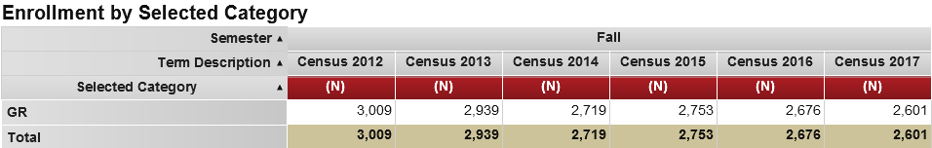

By residency:

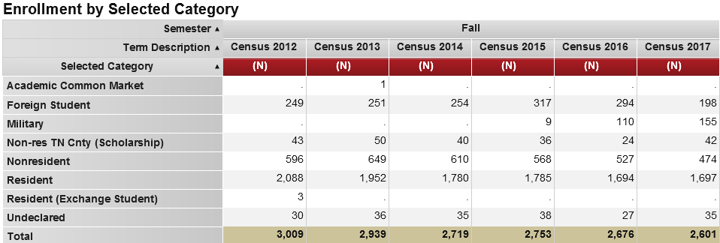

By degree type:

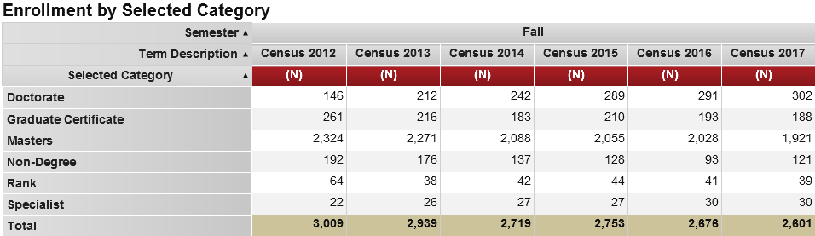

By academic college:

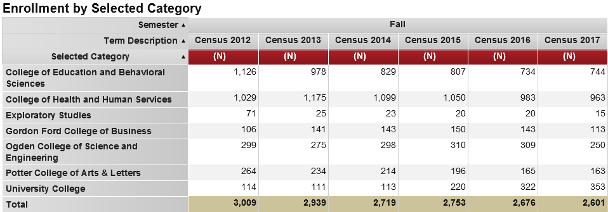

By department (sorted alphabetically):

|  |  |  |  |  |  |  |  |
| --- | --- | --- | --- | --- | --- | --- | --- |
| Semester | Selected Category | 2012 | 2013 | 2014 | 2015 | 2016 | 2017 |
| Fall | 99AR: Exploratory/Undeclared | 4 | 2 | 5 | 8 | 2 | 3 |
| Fall | 99BU: Exploratory/Undeclared | 83 | 111 | 115 | 118 | 115 | 94 |
| Fall | 99ED: Exploratory/Undeclared | 149 | 150 | 143 | 140 | 124 | 126 |
| Fall | 99HH: Exploratory/Undeclared | 62 | 93 | 67 | 57 | 39 | 72 |
| Fall | 99IS: Exploratory/Undeclared | 9 | 18 | 12 | 17 | 12 | 10 |
| Fall | 99SC: Exploratory/Undeclared | 11 | 11 | 9 | 7 | 8 | 4 |
| Fall | Accounting | 2 | 7 | 11 | 6 | 7 | 7 |
| Fall | Agriculture | 20 | 11 | 18 | 12 | 27 | 29 |
| Fall | Applied Human Sciences | 19 | 15 | 14 | 12 | 16 | 27 |
| Fall | Art | 2 | 2 | 6 | 2 | 1 |  |
| Fall | Biology | 49 | 51 | 43 | 32 | 32 | 35 |
| Fall | Chemistry | 35 | 30 | 26 | 30 | 29 | 23 |
| Fall | Communication | 35 | 23 | 25 | 23 | 14 | 17 |
| Fall | Communication Sciences and Disorders | 226 | 221 | 203 | 180 | 173 | 177 |
| Fall | Counseling and Student Affairs | 134 | 145 | 131 | 111 | 96 | 97 |
| Fall | Diversity and Community Studies | 42 | 39 | 37 | 38 | 41 | 29 |
| Fall | Economics | 21 | 23 | 17 | 26 | 21 | 12 |
| Fall | Ed Admin, Leadership, and Research | 223 | 156 | 117 | 141 | 117 | 121 |
| Fall | English | 43 | 31 | 27 | 27 | 32 | 31 |
| Fall | Folk Studies and Anthropology | 30 | 30 | 24 | 21 | 17 | 18 |
| Fall | Geography and Geology | 38 | 33 | 28 | 27 | 27 | 24 |
| Fall | Graduate College Office | 71 | 25 | 23 | 20 | 20 | 15 |
| Fall | History | 39 | 38 | 35 | 23 | 17 | 22 |
| Fall | Kinesiology, Recreation, and Sport | 248 | 284 | 272 | 261 | 248 | 209 |
| Fall | Mathematics | 34 | 43 | 42 | 36 | 45 | 38 |
| Fall | Music | 15 | 15 | 17 | 21 | 23 | 15 |
| Fall | Philosophy and Religion | 8 | 10 | 5 | 6 | 3 | 1 |
| Fall | Physical Therapy |  | 30 | 60 | 90 | 91 | 87 |
| Fall | Physics and Astronomy | 14 | 9 | 7 | 9 | 8 | 7 |
| Fall | Political Science | 55 | 53 | 44 | 43 | 32 | 22 |
| Fall | Psychological Sciences |  |  | 38 | 29 | 23 | 22 |
| Fall | Psychology | 66 | 81 | 47 | 54 | 67 | 74 |
| Fall | Public Health | 122 | 149 | 149 | 140 | 144 | 137 |
| Fall | School of Engineering and Applied Sciences | 98 | 87 | 87 | 128 | 110 | 68 |
| Fall | School of Nursing | 235 | 255 | 221 | 198 | 163 | 155 |
| Fall | School of Professional Studies | 63 | 54 | 64 | 165 | 269 | 314 |
| Fall | School of Teacher Education | 554 | 446 | 391 | 361 | 330 | 326 |
| Fall | Social Work | 117 | 128 | 113 | 112 | 109 | 99 |
| Fall | Sociology | 33 | 30 | 26 | 22 | 24 | 34 |
| Fall | Total | 3,009 | 2,939 | 2,719 | 2,753 | 2,676 | 2,601 |

By academic program (sorted alphabetically):

|  |  |  |  |  |  |  |  |
| --- | --- | --- | --- | --- | --- | --- | --- |
| Semester | Selected Category | 2012 | 2013 | 2014 | 2015 | 2016 | 2017 |
| Fall | Total | 3,009 | 2,939 | 2,719 | 2,753 | 2,676 | 2,601 |
| Fall | Accountancy, MACC (#0445) | 2 | 7 | 11 | 6 | 7 | 7 |
| Fall | Adult Education, CER (#0450) |  | 2 | 2 |  | 6 | 5 |
| Fall | Adult Education, MAE (#047) | 44 | 49 | 42 | 26 | 15 | 17 |
| Fall | Advanced Worksite Health Promotion, CER (#0465) |  |  |  | 1 | 1 | 1 |
| Fall | Aging Studies, CER (#0419) | 9 | 5 | 4 | 4 | 1 | 3 |
| Fall | Agriculture, MS (#052) | 20 | 11 | 18 | 12 | 27 | 29 |
| Fall | Applied Economics, MA (#0410) | 21 | 23 | 17 | 26 | 21 | 11 |
| Fall | Applied Psychology, PSYD (#0476) |  |  |  | 12 | 19 | 28 |
| Fall | Art Education for Teacher Leaders, MAE (#0443)~ | 2 | 2 | 6 | 2 | 1 |  |
| Fall | Autism Spectrum Disorders, CER (#0441) | 7 | 8 | 5 | 2 | 2 | 2 |
| Fall | Biology for Teacher Leaders, MAE (#0442) | 1 | 2 | 1 | 2 | 2 | 1 |
| Fall | Biology, MS (#056) | 48 | 49 | 42 | 30 | 30 | 34 |
| Fall | Brewing and Distilling Arts & Sciences, CER (#0486) |  |  |  |  |  | 1 |
| Fall | Business Administration, MBA (#057) | 82 | 106 | 110 | 116 | 110 | 87 |
| Fall | Business Core Competencies, CER (#0487) |  |  |  |  | 1 | 2 |
| Fall | Business Sustainability, CER (#0474) |  |  |  |  | 1 | 1 |
| Fall | Career Counseling, CER (#0440)~ | 4 | 5 | 5 |  |  |  |
| Fall | Career Services, CER (#0468) |  |  | 5 | 6 | 1 | 4 |
| Fall | Chemistry, MS (#059) | 35 | 30 | 26 | 30 | 29 | 23 |
| Fall | Child and Family Studies, MS (#0489) |  |  |  |  | 5 | 14 |
| Fall | College and Career Readiness, CER (#1737) |  |  |  |  |  | 4 |
| Fall | Communicating in Organizations, CER (#0471) |  |  |  | 3 | 1 | 4 |
| Fall | Communication Disorders, MS (#114)~ | 220 | 213 | 131 | 40 | 4 | 1 |
| Fall | Communication Disorders, R1 (#164)~ | 6 | 8 | 4 | 4 | 7 |  |
| Fall | Communication, MA (#109)~ | 23 | 6 | 2 |  |  |  |
| Fall | Community College Faculty Preparation, CER (#162) | 1 | 1 |  | 2 |  | 2 |
| Fall | Computer Science, MS (#117) | 46 | 33 | 30 | 54 | 51 | 39 |
| Fall | Counseling, C (#159) | 15 | 18 | 12 | 7 | 4 | 2 |
| Fall | Counseling, MAE (#043) | 32 | 38 | 32 | 34 | 41 | 35 |
| Fall | Counselor Education, EDS (#112) |  | 1 |  |  |  |  |
| Fall | Creative Writing, MFA (#0478) |  |  |  | 6 | 13 | 13 |
| Fall | Criminology, MA (#0421) | 11 | 14 | 17 | 15 | 18 | 22 |
| Fall | Dietetic Practice, CER (#0451) | 10 | 10 | 10 | 8 | 10 | 10 |
| Fall | Director of Special Education, R1 (#0426) | 5 | 3 | 7 | 1 |  | 2 |
| Fall | Early Childhood Education, R1 (#156) | 1 |  |  |  |  |  |
| Fall | Economic Data Analytics, CER (#0491) |  |  |  |  |  | 1 |
| Fall | Education and Behavioral Science Studies, MAE (#042) | 2 | 4 | 6 | 1 | 6 | 6 |
| Fall | Education/UL, CD (#142) | 1 | 1 | 1 |  |  |  |
| Fall | Educational Leadership, C (#131) | 135 | 92 | 54 | 79 | 67 | 66 |
| Fall | Educational Leadership, EDD (#0010) | 113 | 124 | 121 | 122 | 109 | 106 |
| Fall | Educational Technology, CER (#167) | 2 | 1 | 6 | 2 |  | 5 |
| Fall | Elementary Education for Teacher Leaders, MAE (#0433) | 66 | 67 | 61 | 70 | 46 | 38 |
| Fall | Elementary Education Teacher Leader, R2 (#0430) | 1 | 1 | 1 |  |  |  |
| Fall | Elementary Education, EDS (#118)~ | 3 | 1 |  |  | 1 | 1 |
| Fall | Elementary Education, MAE (#065)~ | 33 | 1 |  |  |  |  |
| Fall | Elementary Education, R1 (#084) | 3 | 6 | 4 | 2 | 4 | 4 |
| Fall | Elementary Education, R2 (#091)~ | 4 |  |  |  |  |  |
| Fall | Elementary Math Specialization, P-5, CER (#0485) |  |  |  |  |  | 2 |
| Fall | Engineering Technology Management, MS (#0447) | 41 | 48 | 50 | 71 | 55 | 28 |
| Fall | English, MA (#067) | 39 | 27 | 24 | 18 | 17 | 18 |
| Fall | Environmental and Occupational Health Science, MS (#0473) |  |  |  | 16 | 19 | 16 |
| Fall | Environmental Health and Safety, CER (#0427) | 1 | 3 | 3 | 3 | 2 | 2 |
| Fall | Exceptional Education - LBD, MAE (#0424)~ | 42 | 9 |  | 1 | 1 |  |
| Fall | Exceptional Education - MSD, MAE (#0425)~ | 8 | 1 |  |  |  |  |
| Fall | Exceptional Education, MAE (#107)~ | 3 |  |  |  |  |  |
| Fall | Facility and Event Management, CER (#0455) | 6 | 2 | 1 | 1 | 6 | 5 |
| Fall | Family Nurse Practitioner (Post MSN), CER (#0449) | 7 | 5 | 3 | 7 | 10 | 13 |
| Fall | Folk Studies, MA (#069) | 28 | 29 | 23 | 20 | 17 | 17 |
| Fall | Gender and Women's Studies, CER (#1712) | 4 | 8 | 6 | 10 | 14 | 9 |
| Fall | Geographic Information Science, CER (#203) | 2 | 1 |  |  |  |  |
| Fall | Geography Education for Teacher Leaders, MAE (#0444) |  |  |  |  | 1 |  |
| Fall | Geoscience, MS (#072) | 36 | 32 | 28 | 27 | 26 | 24 |
| Fall | Gifted Education and Talent Development, EDS (#0490) |  |  |  |  |  | 4 |
| Fall | Gifted Education and Talent Development, MAE (#0482) |  |  |  | 4 | 22 | 22 |
| Fall | Health Administration, MHA (#153) | 63 | 78 | 75 | 69 | 70 | 54 |
| Fall | Historic Preservation, CER (#0423) | 2 | 1 | 1 | 1 |  | 1 |
| Fall | History Education, MAE (#111)~ | 2 | 1 |  |  |  |  |
| Fall | History, MA (#078) | 37 | 37 | 35 | 23 | 17 | 22 |
| Fall | Homeland Security Sciences, MS (#0413) | 14 | 9 | 7 | 9 | 8 | 7 |
| Fall | Instructional Design, CER (#0418) | 5 | 5 | 8 | 9 | 9 | 2 |
| Fall | Instructional Design, MS (#0428) | 3 | 10 | 18 | 21 | 18 | 8 |
| Fall | Instructional Leadership, School Principal, MAE (#151)~ | 20 | 2 |  |  |  |  |
| Fall | Intercollegiate Athletic Administration, CER (#0481) |  |  |  | 5 |  | 5 |
| Fall | Interdisciplinary Early Childhood Education, Birth to Primary, for Teacher Leaders, MAE (#0461) | 1 | 4 | 5 | 4 | 5 | 4 |
| Fall | Interdisciplinary Early Childhood Education, Birth to Primary, Initial Certification, MAT (#0460) | 1 | 9 | 11 | 6 | 6 | 10 |
| Fall | Interdisciplinary Early Childhood Education, MAE (#0436)~ | 12 | 1 |  |  |  |  |
| Fall | Interim Non-Degree, ND (#128) | 9 |  |  |  |  |  |
| Fall | International Student Services, CER (#0415) | 1 | 2 | 6 | 6 | 1 | 1 |
| Fall | Kinesiology, MS (#0454) | 4 | 13 | 22 | 15 | 18 | 22 |
| Fall | Leadership Dynamics, MA (#0422)~ | 44 | 17 | 1 | 1 |  |  |
| Fall | Leadership Studies, CER (#163)~ | 19 | 12 | 4 |  | 1 |  |
| Fall | Leadership Studies, MA (#0464)~ |  | 25 | 20 | 4 | 1 |  |
| Fall | Lean Sigma, CER (#0452) |  |  | 4 | 2 | 3 |  |
| Fall | Library Media Education, MS (#083) | 110 | 89 | 62 | 73 | 78 | 67 |
| Fall | Library Media Education, R1 (#0429) | 2 | 1 | 3 | 3 | 1 | 1 |
| Fall | Literacy Education, MAE (#044) | 22 | 15 | 17 | 16 | 13 | 11 |
| Fall | Literacy in Post-secondary Settings, CER (#0462) | 1 | 1 | 3 | 3 |  |  |
| Fall | Mathematics, MA (#049) | 22 | 32 | 33 | 26 | 30 | 26 |
| Fall | Mathematics, MS (#085) | 12 | 11 | 9 | 10 | 15 | 12 |
| Fall | Measurement, Evaluation and Research, CER (#0488) |  |  |  |  |  | 1 |
| Fall | Middle Grades Education for Initial Certification, MAT (#0458) |  | 1 | 2 | 3 | 2 | 1 |
| Fall | Middle Grades Education for Teacher Leaders, MAE (#0434) | 17 | 17 | 19 | 21 | 29 | 21 |
| Fall | Middle Grades Education, MAE (#139)~ | 4 | 1 |  |  |  |  |
| Fall | Middle Grades Education, R1 (#158) | 2 | 2 |  |  |  |  |
| Fall | Middle Grades Education, R2 (#154)~ | 1 |  |  |  |  |  |
| Fall | MSD Certification, C (#0477)~ |  |  |  | 2 |  |  |
| Fall | Music Education for Teacher Leaders, MAE (#0439)~ | 7 | 1 |  |  |  |  |
| Fall | Music Education, MAE (#089)~ | 3 |  |  |  |  |  |
| Fall | Music, MM (#0453) | 5 | 14 | 17 | 21 | 23 | 15 |
| Fall | Non-Degree Arts and Letters, ND (#0002) | 4 | 2 | 5 | 8 | 2 | 3 |
| Fall | Non-Degree Business, ND (#0001) | 1 | 5 | 5 | 2 | 3 | 4 |
| Fall | Non-Degree Education, ND (#0005) | 34 | 22 | 16 | 17 | 9 | 14 |
| Fall | Non-Degree Health and Human Services, ND (#0003) | 62 | 93 | 67 | 57 | 39 | 72 |
| Fall | Non-Degree Science, ND (#0004) | 11 | 11 | 9 | 7 | 8 | 3 |
| Fall | Non-Degree University College, ND (#0006) | 9 | 18 | 12 | 17 | 12 | 10 |
| Fall | Nonprofit Administration, CER (#0463) |  | 11 | 12 | 10 | 7 | 4 |
| Fall | Not Pursuing a Degree, ND (#126) | 62 | 25 | 23 | 20 | 20 | 15 |
| Fall | Nurse Administrator (Post MSN), CER (#0420) |  |  |  | 1 |  |  |
| Fall | Nursing Education (Post MSN), CER (#172) | 3 |  | 2 | 1 | 1 |  |
| Fall | Nursing Practice, DNP (#0011) | 32 | 57 | 60 | 65 | 72 | 81 |
| Fall | Nursing, MSN (#149) | 193 | 193 | 156 | 119 | 71 | 50 |
| Fall | Organizational Communication, CER (#175)~ | 2 | 1 | 2 |  |  |  |
| Fall | Organizational Communication, MA (#0012) | 10 | 16 | 21 | 20 | 13 | 13 |
| Fall | Organizational Leadership, CER (#1723) |  |  | 7 | 8 | 16 | 4 |
| Fall | Organizational Leadership, MA (#0467) |  |  | 32 | 152 | 251 | 310 |
| Fall | Physical Education, MS (#090)~ | 20 | 2 |  |  |  |  |
| Fall | Physical Therapy, DPT (#0013) |  | 30 | 60 | 90 | 91 | 87 |
| Fall | Psychiatric Mental Health Nurse Practitioner, CER (#0479) |  |  |  | 5 | 9 | 11 |
| Fall | Psychology, MA (#092) | 50 | 59 | 24 | 20 | 23 | 22 |
| Fall | Psychology, MS (#0469) |  |  | 38 | 29 | 23 | 22 |
| Fall | Public Administration, MPA (#051) | 55 | 53 | 44 | 43 | 32 | 22 |
| Fall | Public Health, MPH (#152) | 58 | 68 | 71 | 51 | 52 | 64 |
| Fall | Recreation and Sport Administration, MS (#095) | 218 | 256 | 237 | 230 | 217 | 173 |
| Fall | Religious Studies, MA (#0446) | 8 | 10 | 5 | 6 | 3 | 1 |
| Fall | School Administration, EDS (#098) | 3 | 2 | 3 | 5 | 4 | 1 |
| Fall | School Administration, R1 (#121) | 19 | 7 | 15 | 29 | 25 | 29 |
| Fall | School Counseling, MAE (#046) | 37 | 41 | 20 | 13 | 13 | 16 |
| Fall | School Psychology, EDS (#147) | 16 | 22 | 23 | 22 | 25 | 24 |
| Fall | Secondary Education for Initial Certification, MAT (#0495) |  | 10 | 16 | 16 | 14 | 16 |
| Fall | Secondary Education for Teacher Leaders, MAE (#0435) | 28 | 42 | 42 | 27 | 22 | 28 |
| Fall | Secondary Education Teacher Leader, R2 (#0432) |  |  | 1 |  |  |  |
| Fall | Secondary Education, EDS (#119)~ |  |  | 1 |  |  |  |
| Fall | Secondary Education, MAE (#103)~ | 16 | 1 | 1 |  |  |  |
| Fall | Secondary Education, R1 (#124) | 3 | 2 | 2 | 3 | 2 | 2 |
| Fall | Secondary Education, R2 (#125)~ | 3 |  |  |  |  |  |
| Fall | Social Responsibility and Sustainable Communities, MA (#0448) | 38 | 31 | 31 | 28 | 27 | 20 |
| Fall | Social Work, MSW (#157) | 117 | 128 | 113 | 112 | 109 | 99 |
| Fall | Sociology, MA (#105) | 22 | 16 | 9 | 7 | 6 | 12 |
| Fall | Special Education for Teacher Leaders: Learning and Behavioral Disorders, MAE (#0457) | 5 | 19 | 24 | 20 | 20 | 44 |
| Fall | Special Education Initial Certification: Learning and Behavioral Disorders, MAT (#0456) | 2 | 14 | 15 | 12 | 11 | 7 |
| Fall | Special Education, LBD, MAE (#0437)~ | 78 | 42 | 15 | 7 |  |  |
| Fall | Special Education: Moderate and Severe Disabilities, MAE (#0438) | 39 | 44 | 27 | 14 | 7 | 9 |
| Fall | Speech-Language Pathology, MS (#0466) |  |  | 68 | 136 | 162 | 176 |
| Fall | Standard Guidance - Rank 1, R1 (#048) | 14 | 8 | 5 | 2 | 2 | 1 |
| Fall | Student Affairs in Higher Education, MAE (#145) | 31 | 32 | 46 | 43 | 34 | 34 |
| Fall | Teacher Education, C (#132) | 21 | 18 | 15 | 19 | 17 | 15 |
| Fall | Teaching English to Speakers of Other Languages, CER (#0416) | 4 | 4 | 3 | 3 | 2 |  |
| Fall | Technology Management, MS (#045)~ | 11 | 6 | 3 | 1 | 1 | 1 |

**APPENDIX C**

**Graduate Council Program and Curriculum Committee (GCC)**

**Report to the Graduate Council** Date: November 7, 2017

GCC Meeting: November 2, 2017

From: Kirk Atkinson, Chair November 9, 2017 Graduate Council

**Consent Agenda Report**. The GCC deals with actionable items using the Course Inventory Management (CIM) System. The electronic approval process will then forward for approval to the Chair, Graduate Council. Minutes along with the approved agenda of each meeting will be posted on [GCCC web site](http://www.wku.edu/gcc/current.php).

**Voting Members Present:** Kirk Atkinson, Martha Day, Richard Dressler, Kristie Guffey, Ann Ferrell

**Guest:** Collette Chelf, Shannon Vaughan, Danita Kelley, Ken Crawford, Kathy Croxall

In order to review program and course revisions, click on the links below and enter your WKU log-in credentials. You will be logged into the CourseLeaf system. Type “Graduate Council” in the search string, and all the programs or courses under review by the Graduate Council will populate. Double click on the program or course to review. Additions are denoted with green font. Deletions are denoted with red font.

Program Proposals: <https://nextcatalog.wku.edu/programadmin/>  
Course Proposals: <https://nextcatalog.wku.edu/courseadmin/>

Note: Programs and courses are found on separate screens. If you click to view program proposals, you will not see course revisions.

For October, there are 11 course changes and 0 program changes.