Reviewing a Staff Applicant Pool in
Interview Exchange

LOG IN
Using Chrome or Firefox, access Interview Exchange by going to MyWKU and selecting Interview Exchange from the menu or by clicking this link:
https://www.interviewexchange.com/moduleredirect.jsp

MANAGE JOBS
After a successful sign in, the Interview Exchange Console/Dashboard will appear on your screen. “Manage Jobs” is the default menu choice; “Open Jobs” is the default tab selection. Only those jobs assigned to you will appear on your dashboard. Closed jobs can be accessed by clicking the “Closed Jobs” tab. If you are unable to see a particular job, it is because you have not been added as a Reviewer. Contact HR or the Search Committee Chair to be added to the job.
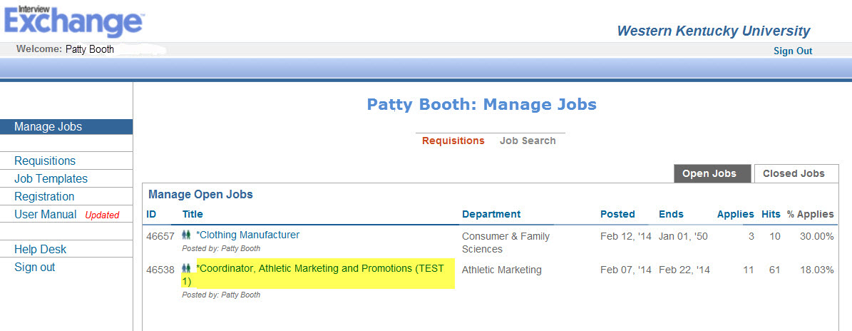
Click the title of any job to display a toolbar containing time saving tools to help you review your applicant pool as well as a list of applicants who have applied for the job. The toolbar is displayed in the screenshot below:

TOOLBAR OPTIONS
View
Click “View” on the Job Toolbar to see the advertisement as it was displayed to the applicant. The view option also includes the “Apply URL”. This is the internet link to your posting which can be sent to applicant sources if desired. From the “View” option, you can also see any notes that have been recorded by the Search Committee.

Alerts
Interview Exchange will allow Reviewers to begin evaluating the applicant pool as soon as candidates complete the application process. To receive an email each time a candidate applies, click the “Alerts” link in the toolbar at the top of the page. By default, no alerts will be sent when candidates apply but the options available allow you to specify preferences that will generate an email each time another candidate is added to the applicant pool. You can specify the types of candidates about which you wish to be alerted and the frequency of notification.
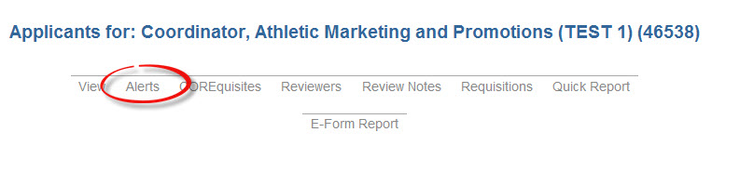
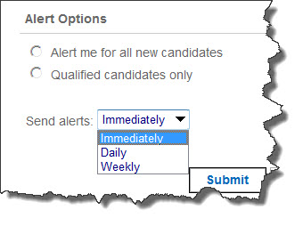
COREquisites
Applicants are considered to be “Qualified” based upon answers given to questions that were presented as part of the application process. This feature of Interview Exchange is called COREquisites. CORE stands for Comprehensive Occupational Requirements Evaluator. It is an online interactive, applicant questionnaire that serves as a screening tool for identifying those applicants who possess the minimum required qualifications for the job as it was described in the posting. The Yes/No questionnaire includes up to 10 questions which address the specific skills, experience, education, and other related information that are judged to be essential to job success. They are created during the posting process by staff in Human Resources. Each individual question can be defined as “Must Have” and if that designation is given, then that question must be answered with a “Yes” response in order for that applicant to be included in the “Qualified” list. Applicants who give a “No” response to a “Must Have” COREquisite question are defined as Job Seekers and will not appear under the “Qualified Applicants” tab. The questionnaire serves only as a tool to aid the selection process and to differentiate Applicants from Job Seekers. The COREquisites for your position can be accessed by clicking the COREquisites option in the toolbar.
Reviewers
The Chair of the Search Committee is responsible to add the members of the committee to this job so that each member will be able to access the applicant pool. To see a list of reviewers and their role in the search, click “Reviewers” in the toolbar at the top of the screen.
Review Notes
Review Notes is a feature that allows Reviewers and others who have been given access to a particular job to communicate one with another. Review Notes can be generated in regard to a specific applicant or about the search in general. Clicking this option from the toolbar will allow you to see all activities that have transpired since the job was posted. It will also allow you to create a note.

Requisitions
The Requisitions option will display a table containing a list of all Requests to Fill or Hiring Proposal(s) that are associated with this job.
Quick Report
The Quick Report Option allows the user to create a report that can either be shown on the screen or downloaded into Excel. Clicking “Quick Report” displays a list of options related to the applicants that are available to be selected and included in the report. This option is helpful in order to create a list of all applicants or selected groups of applicants.

REVIEWING APPLICANTS
The Search Committee Chair is responsible for coordinating the timeline whereby applicants will be reviewed by the members of the Search Committee. While you are able to access and begin reviewing application materials from the moment an applicant applies, you should wait to hear from the Search Committee chair regarding the specific process and close date for the search before recording your comments in Interview Exchange.
The ShortList
To access a list of applicants who have applied for particular job, click the title of the job on the “Manage Jobs” table. This list of applicants is known as the “ShortList”. Two tabs labeled “Qualified” and “All Applicants” appear on the top right corner of the ShortList as shown in the screenshot below:
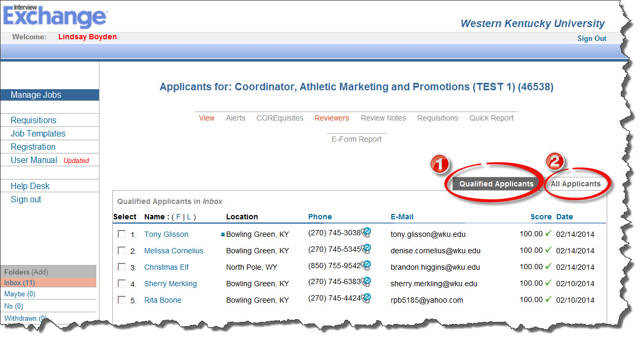

- contains only Qualified Applicants (based on CORErequisite questions)
- contains All Applicants BOTH qualified and not *qualified
Those applicants listed in the “Qualified” tab are also listed in the “All Applicants” Tab. The applicants that appear on the screen correspond to the tab that is currently selected.

Clicking a name in the ShortList will take you to the Candidate Page from which you will be able to:
- view all documents submitted i.e., resume, cover letter, examples of work, etc.
- access links to electronic forms that were uploaded during the application process
- view answers to the COREquisites
- record your evaluation of the applicant as a candidate for this position

NOTES FROM REVIEW TEAM
All Reviewers should document their evaluation of each applicant by using the “Add a Note” feature in the “Notes from Review Team” field near the bottom of the candidate page. Follow the directions of the Search Committee Chair with regard to deadlines by which the comments need to be entered. By default, these notes are viewable by anyone who has been given access to that job. The Search Committee Chair and Hiring Official will be responsible for the remainder of the duties pertaining to the processing of the applicant pool and the hiring of the successful candidate.

