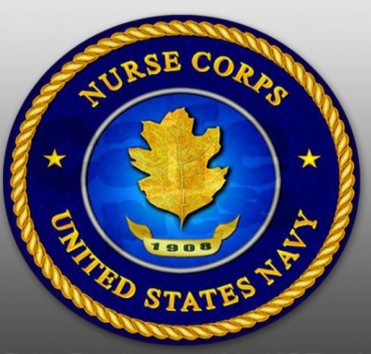
EARN MONEY IN NURSING SCHOOL
Taking care of others is what you do. You have worked long and hard to get where you are - Now, think about taking care of yourself. With the Navy Nurse Candidate Program you can concentrate on becoming the best nurse possible and look forward to a great career as a Nurse Corps Officer in the United States Navy!
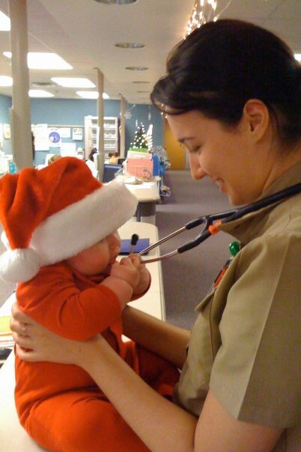
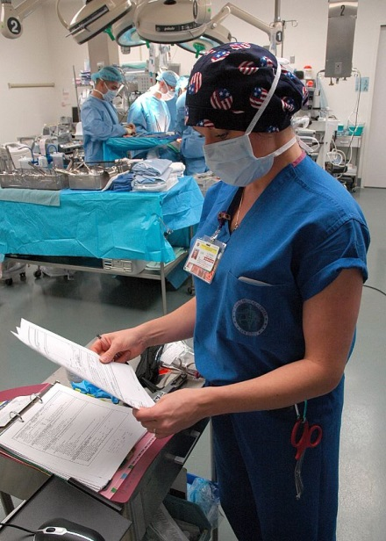
To Qualify:
- U.S. Citizen, medically and physically qualified.
- Enrolled or accepted into a full-time BSN program accredited by NLNAC or CCNE.
- Have a cumulative GPA greater than 3.0 on a 4.0 scale.

Earn up to $34,000 while in school!

Guaranteed employment as a U.S. Navy Nurse upon graduation, NCLEX, and state licensure.
- FULL medical, dental, and malpractice coverage.
- 30 days of paid leave a year and unlimited sick days.
- Opportunities for advanced training and graduate school.

APPLY EARLY! For more information contact:
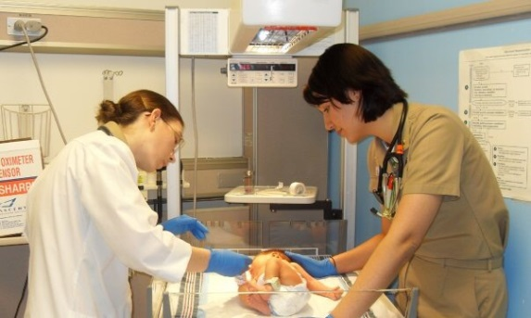

HM1 Joshua Swindle
Cell: (931) 787-6675
Email: joshua.b.swindle@navy.mil

