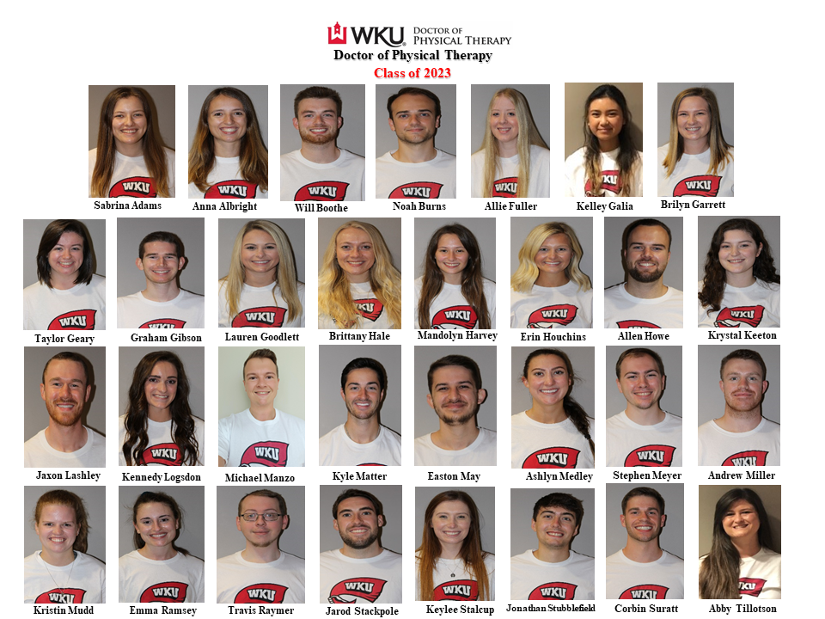

Class of 2022 Officers
President – Noah Burns
Vice President – Jaxon Lashley
Secretary / Treasurer – Sabrina Adams
Social Chair – Kyle Matter
APTA / APTA-KY Representative – Abby Tillotson
Class Advisor – Dr. Kurt Neelly

