GrAPEs Overview

# Who*

3 students who waited until their semester of graduation to begin looking at GrAPE requirements

36 students have done GrAPE work for which I have at least one document (proposal, summary report, or product)

44 proposals were turned in – not all before the project actually began.

About 33 summary reports. Given the way they are organized with products on my database, this is my best estimate without going thru them one-by-one.

*OUT OF 63 TOTAL PROJECTS

# What – Highlights of Student Projects**

* **Disaster Preparedness**
  + Research and create non-pharmaceutical strategies for various emergency situations that can be incorporated into the district’s disaster preparedness plans - 11 pages.
  + FEMA certification for active shooter situation.
  + Update local protocols and emergency plans for seven county health departments. This included standardizing protocols, whenever possible, and editing them to include missing information needed by emergency responders.
* **Prenatal Care for Latina Women**
  + Created culturally and linguistically appropriate prenatal education.
  + Analyzed quantitative data provided by grant partners (local hospitals and health services).
  + Collected and analyzed qualitative data through focus groups and interviews with pregnant Latina women.
  + Recruited a promotora or bicultural, bilingual peer educator and coordinate the prenatal education course, using the March of Dimes curriculum Becoming a Mom/Comenzando bien.
  + Resulted in 13 products.
* **Recovery Support for College Students with Substance Use and Other Addiction Disorders**
  + Created, organized, and facilitated a group to empower students in recovery from substance use and other addictive disorders.
  + Established community connections to support the group.
  + Planned events, especially during September’s National Recovery Month.
  + Researched recovery to provide the best kind of support system for the students.
    - Including visiting other schools with the same program to see how their programs were run and how their programs started.
  + Ran social media, marketing, and the group’s website.

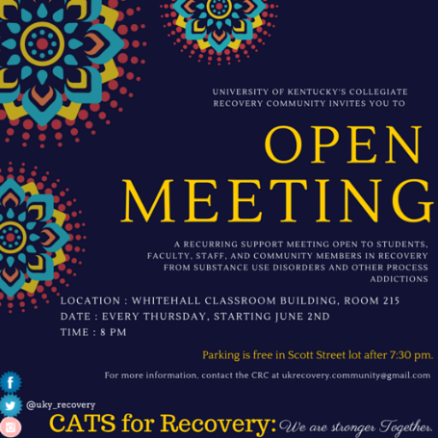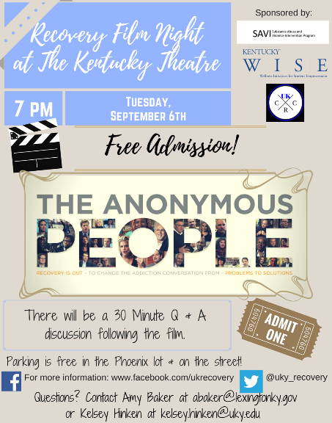

* **Palliative Care Abroad**
  + Created a palliative care program for the area.
  + Needs assessment within the community for health services.
  + Determining resources needed and affordable to create a sustainable program.
  + Gave presentations and led discussions about palliative care needs in the area.
  + Focused on education, training, and attitudes to palliative care.
    - PSAs for local radio and TV station.
* **Combating Obesity with Public Physical Activity Equipment**
  + In a county with high obesity rates, organizations teamed together to purchase and install physical activity equipment in the county.
  + Surveyed community members to gauge their satisfaction with the new equipment.
  + Evaluated which areas of the community were best for the equipment to be placed.
    - Parks, tracks, basketball courts, playgrounds, etc. were mapped.

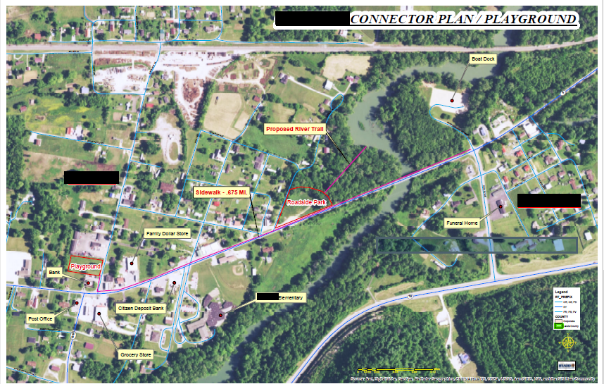

**All of the information in this section was taken out of student proposals and summary reports. Therefore, the phrasing and word choice is mostly that of the students’, except in the case where there was identifying information about the agency with which the student worked. To keep agency information protected, I have not included the students’ names either.

# When

A total of at least 3,342.5 hours. This is about 83 weeks of full time (40 hours/week) work.

2016 – 1

2017 – 11

2018 – 34

2019 – 17

*Please note, not every project fit into a single year, so I used the proposal date when available or the date in which I became aware of the project. Each project is only counted once in these year counts.

# Where*

|  |  |  |
| --- | --- | --- |
| BRDHD | 6 | 9.52% |
| WKU Organizations  ***Not including any below | 4 | 6.34% |
| UK Organizations | 7 | 11.11% |
| K-PHAST (Bowling Green) | 3 | 4.76% |
| Other Health Departments (7) | 9 | 14.28% |
| KHA | 3 | 4.76% |
| Fund for Global Health | 3 | 4.76% |
| AHEC (Southern KY and AHEC Scholars) | 3 | 4.76% |
| Other | 25 | 39.68% |



38.09% of placements in Bowling Green; 12 organizations in Bowling Green

47.61% of the organizations support rural populations

60.31% of the organizations support marginalized populations

*OUT OF 63 TOTAL PLACEMENTS

# Why – Competencies that are Addressed

|  |  |
| --- | --- |
| Evidence-based Approaches to Public Health |  |
| 1. Apply epidemiological methods to the breadth of settings and situations in public health practice. | 12 |
| 2. Select quantitative and qualitative data collection methods appropriate for a given public health context. | 14 |
| 3. Analyze quantitative and qualitative data using biostatistics, informatics, computer-based programming and software, as appropriate. | 9 |
| 4. Interpret results of data analysis for public health research, policy or practice. | 14 |
| Public Health & Health Care Systems |  |
| 5. Compare the organization, structure and function of health care, public health and regulatory systems across national and international settings. | 15 |
| 6. Discuss the means by which structural bias, social inequities and racism undermine health and create challenges to achieving health equity at organizational, community and societal levels. | 11 |
| Planning & Management to Promote Health |  |
| 7. Assess population needs, assets and capacities that affect communities’ health. | 32 |
| 8. Apply awareness of cultural values and practices to the design or implementation of public health policies or programs. | 26 |
| 9. Design a population-based policy, program, project or intervention. | 21 |
| 10. Explain basic principles and tools of budget and resource management. | 14 |
| 11. Select methods to evaluate public health programs. | 17 |
| Policy in Public Health |  |
| 12. Discuss multiple dimensions of the policy-making process, including the roles of ethics and evidence. | 10 |
| 13. Propose strategies to identify stakeholders and build coalitions and partnerships for influencing public health outcomes. | 15 |
| 14. Advocate for political, social or economic policies and programs that will improve health in diverse populations. | 12 |
| 15. Evaluate policies for their impact on public health and health equity. | 10 |
| Leadership |  |
| 16. Apply principles of leadership, governance and management, which include creating a vision, empowering others, fostering collaboration and guiding decision-making. | 24 |
| 17. Apply negotiation and mediation skills to address organizational or community challenges. | 16 |
| Communication |  |
| 18. Select communication strategies for different audiences and sectors. | 32 |
| 19. Communicate audience-appropriate public health content, both in writing and through oral presentation. | 30 |
| 20. Describe the importance of cultural competence in communicating public health content. | 16 |
| Interprofessional Practice |  |
| 21. Perform effectively on interprofessional teams. | 29 |
| Systems Thinking |  |
| 22. Apply systems thinking tools to a public health issue. | 10 |
| WKU MPH Program Competencies |  |
| 23. Apply health behavior theories and models to address public health problems. | 13 |
| 24. Describe the role of budgeting; methods of seeking extramural funding; and methods of financial analysis in making decisions about policies, programs and services. | 13 |
| 25. Discuss theoretical models and methods used to understand, explain, and ameliorate health disparities. | 6 |
| 26. Integrate social determinants into public health science, practice, and research. | 15 |
| 27. Identify the direct and indirect population health effects of environmental hazards (biological, chemical and physical) on humans, animals and the ecology. | 8 |

# How

**Conferences/Trainings/Summits/Workshop – 7**

1. K-PHAST
2. Children's Environmental Health Summit
3. Kentucky Rural Health Association
4. AHEC Scholars
5. 2018 North American Refugee Health Conference

**Individual/Internships/Worksite – 55**

**Group – 0**

**Embedded – 1 (not yet included in any stats above)**

1. Colin Farrell
   1. In-class connections: Feb 19,
   2. Access Database, Biometric Screening Results, HIPAA
   3. Entering data, analyzing data, creating infographics and easily understood stats, presenting the results to the organization
   4. 8 counties were originally included in this project – narrowed these down to the ones the organization would like to focus on first so as not to take on too much before knowing how it would work with the course
   5. GOAL from the organization: to give employers better understanding of employees’ health status. The organization wants to be able to go back to these sites, show them what the employees’ greatest risks are and how the organization can help educate/prevent in those risk areas