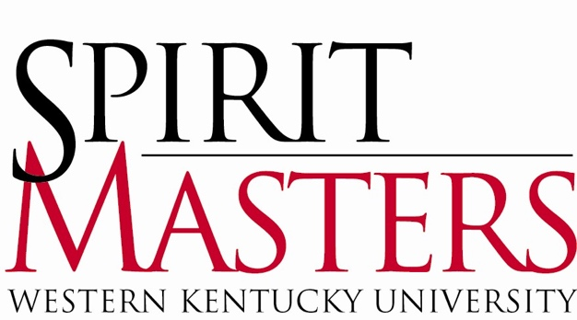
Spirit Master Reference Form

Dear Recommender,

A student has asked you for a reference in support of the student’s Spirit Master application. Spirit Masters are the official student ambassadors of WKU. The purpose of a Spirit Master is to provide an extra measure of hospitality at WKU, making visitors feel they have had a truly exceptional experience. Spirit Masters work closely with those interested in promoting WKU, including the Office of the President, the Office of Admissions, the Office of Alumni Affairs, the Office of WKU Athletics, and various community groups.

The Spirit Master selection process is highly competitive; therefore, the selection committee relies heavily on your reference as it evaluates the student’s ability and maturity to excel in various professional settings.

Directions: Please type the requested information along with your Letter of Reference below into this document. Then, save as a Word Document and email the document as an attachment to: spirit.masters@wku.edu. For security purposes, your attached Letter of Reference must be sent from your WKU email address. It is the student’s responsibility to inform you of the deadline for submission, but you may always contact michael.holt539@topper.wku.edu or karsyn.walling712@topper.wku.edu (Spirit Master Chair and Vice-Chair, respectively) if you have any questions.

Name:
Department and/or Title:
Email:
Name of Student:

Compared to the entire population of students with whom you have worked, please rank the applicant along the following dimensions:

 | Top 10% | Top 25% | Upper 50% | Lower 25% | Lower 10%
SELECTION COMMITTEE USE ONLY | (5) | (4) | (3) | (2) | (1)
- Work Ethic
- Attendance/Punctuality
- Communication Skills
- Academic Competence
- Professionalism/Maturity
- Interpersonal Relationships

Use the next page to attach your Letter of Reference. Please limit your comments to one page.

