Budgeting, Efficiency, and Infrastructure Strategic Planning Working Group
Members: Kari Aikins, Susann deVries, Michelle Dvoskin, Breanna Harris, Blair Jensen, Gil Johnson,
Jason McKinney, Bryan Russell, Christian Ryan, Helen Sterk, Todd Stewart,
Jennifer Tougas, and Brad Wheeler

Introduction
The title of the Budget, Efficiency, and Infrastructure (BEI) working group is both ambiguous and expansive, allowing for a great degree of interpretation and directional development. We recognize that our charge touches on many aspects of the University, and as a result overlaps considerably with the efforts of other strategic planning working groups. We see this as a strength that allows themes to emerge across working groups.
To focus our efforts, we developed working definitions that served to guide our process. In particular, we needed a shared understanding of what budget and infrastructure meant for our work. Our definitions are as follows:
Budget: For the purpose of the campus-wide strategic planning effort, the BEI working group interprets “Budget” as fiscal stewardship. To put it simply, “Our budget is our values statement.” We must align our budget resources with the WKU mission to support the people, places, programs and services that ensure the success of our student body and our institution.
Infrastructure: The BEI working group considers “Infrastructure” to include not only physical spaces, such as buildings and building systems, but also organizational structures, and information technology.

Process
Rather than conduct formal SWOT or SOAR analyses, the BEI working group took a different approach to identifying strengths and weaknesses at WKU. With a focus on WKU as a “student-centered, applied research University,” our committee began by asking two questions: “What does an efficient operation look like?” and “What is the student experience at WKU?” These questions allowed us to compare our vision of WKU’s ideal operation with the current reality, to identify our strengths and weaknesses, and to develop strategies that can lead us to realize our vision.
In the brainstorming process, some common themes became evident from our ideas and concepts. These themes led us to produce a concept map with an overarching goal of “Transforming lives by mobilizing resources to enhance student success” with corresponding strategies focused on People, Programs, pServices (to keep with the “p” theme), Policies and Procedures, and Places (Figure 1). Throughout the process, the group was encouraged to be aspirational, to reach beyond the basics to identify strategies which would strategically elevate the institution. We all agreed that If WKU is to remain competitive in the higher education, we must be innovative to adapt to change and the changing needs of our students.

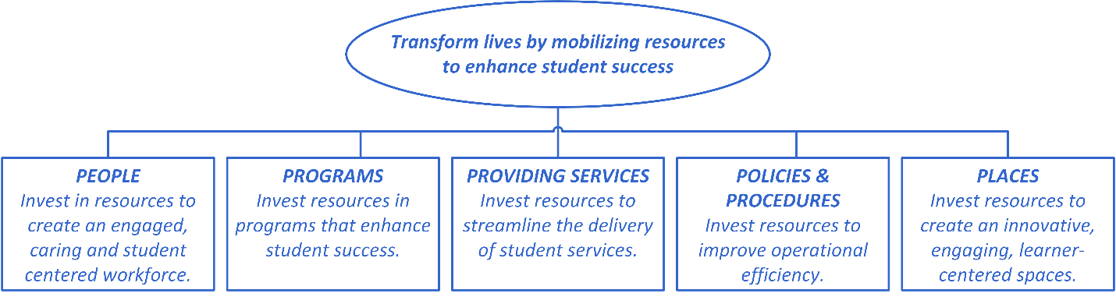
Figure 1. Early BEI concept map containing an overarching goal and strategies that emerged through several brainstorming sessions.
Another key concept for the BEI working group involved the “student-centered” portion of WKU’s shared mission. We asked the question “What would a student-centered institution look like?” Rather than remaining constrained by the conventional layered and hierarchical institutional model, with its associated operational silos, we created an organizational structure that literally places students at the center (Figure 2). All of the supporting elements are aligned to promote student success, but are connected as a network to maximize communication, coordination and efficiency. This model inspired our work and offered a philosophical compass to measure our ideas.

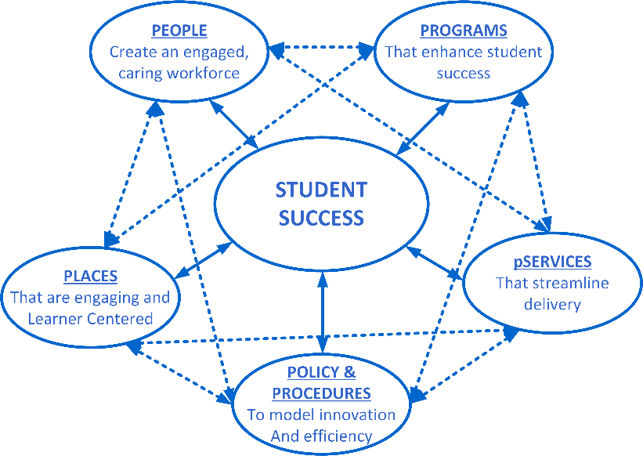
Figure 2. Student centered concept map. All elements are focused on the central goal of student success, and are networked to maximize communication, coordination and efficiency.

As we continued to hone our ideas, we struggled with what separates “programs” from “services”. We found that Maslow’s Hierarchy of Needs provided the insight we needed to separate the two. According to the model, each level of need is foundational and must be met in order to advance to the next level. The ultimate goal is for students to reach the top level of the hierarchy – self-actualization - that enables them to become not only WKU graduates, but productive citizens and lifelong learners who can adapt successfully to our changing world. We defined “Services” as meeting the basic needs of students (food, water, shelter, transportation, safety) and “Programs” as helping the student develop a sense of belonging, self-esteem and self-actualization (Figure 3).

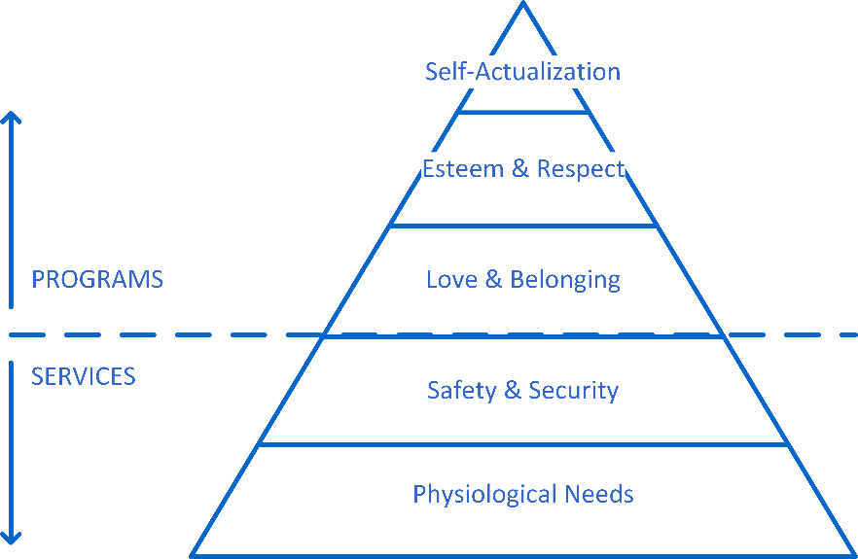
Figure 3. Maslow's Hierarchy of Needs served as a model to separate "Services" from "Programs".

A student who is experiencing food insecurity or who feels unsafe on campus cannot reasonably focus sufficient energy on their studies. Once those basic needs are met, creating a sense of belonging and connection encourages students to stay enrolled at WKU and gives them a support network to help them face challenges. When a student is operating at the peak of the pyramid, the creativity and problem solving skills that are developed are precisely the skills needed to succeed in the fluid 21st century economy.
It’s important to note that we include faculty and staff in this model. Faculty and staff must have their own needs met in order to be able to help students reach their full potential.
In our discussions, we found that the meaning of “programs” differed between academics and non-academics. From the Academic Affairs point of view, “programs” are degree programs. From the Student Affairs point of view, programs support student development outside the classroom. In the end, we took “programs” to be inclusive of both the Academic Affairs and Student Affairs meanings. We recognize that programs outside the classroom contribute to student development, sense of belonging and success as much as programs inside the classroom, particularly when those efforts are coordinated.
As we whittled and refined the organizing principles for our final product, we dropped “Policies and Procedures” as a separate category. We kept finding that policies and procedures appeared in each of our other strategies, so rather than have it as a separate topic, let them appear as appropriate under each strategy. This reduced redundancy in our final paper and left us with four categories: People, Spaces, Services and Programs.

In the final phase of our process, the group identified the six core principles that served as the bedrock of our work. These overarching guiding principles permeate the four categories of People, Spaces, Services, and Programs and serve to guide the efforts of the BEI working group to develop the goals, objectives and strategies described in this white paper.

Vision
WKU is a Student Centered, Mission Focused University that:
- Leverages resources effectively,
- Rewards proven innovation,
- Governs responsibly,
- Practices continuous improvement,
- Embodies a culture of caring, and
- Fosters transparency and collaboration.

An important theme that emerged in multiple ways throughout the strategic planning process was creating a “culture of caring.” A culture of caring contributes to a sense of well-being for faculty, staff and students. It contributes to the sense of belonging to the WKU community, and contributes to student persistence and life-long association. Fundamentally, WKU must embody a culture of caring to be successful as we work through this challenging time in our history.

Goals, Objectives, and Strategies

For each of the final four categories (People, Spaces, Services and Programs) we identified goals, measurable objectives and actionable strategies related to our core charge: budget, efficiency and infrastructure.

People- Create an engaged, caring workforce

As WKU works to claim our role as a national leader among public institutions, we must fully engage our greatest resource, our people, to achieve this mission. WKU will create a student-centered workforce by strategically and intentionally investing in our people to attract, reward and retain a diverse and highly talented workforce.

Goal: Create a workforce that
- Carries out the institutional mission
- Values diversity
- Operates efficiently
- Experiences high job satisfaction

Objective 1: Strategically right size the University.
Strategies:
- Hire a consultant to provide an objective 3rd party operational and organizational assessment.
- Develop an informed multi-year plan to adopt and implement recommendations through shared governance.
- Develop a strategic staffing model for faculty and staff; allocate resources accordingly.
- Prioritize and allocate funding to upgrade enterprise workflow processes.

Objective 2: Adopt a competency model to recruit, develop, and reward employees.
Strategies:
- Perform a comprehensive compensation and classification review.
- Develop a multiyear plan to implement recommendations.
- Collaboratively identify core competencies.
- Implement an efficient technology solution to manage recruitment, training, development, performance, and succession planning.
- Ensure fair and equitable pay practices.
- Prioritize resources for professional development.

Objective 3: Maintain a stable and competitive core benefits package for WKU employees.
Strategies:
- Allocate 8% increase annually to the WKU Health Plan as a fixed cost increase.
- Continuously monitor and lobby for a secure retirement plan and sustainable contribution levels.
- Partner with KY Public Institutions to leverage buying power in benefit purchasing contracts.
- Invest resources in a holistic wellness program with a focus on physical, mental, financial, and social well-being.

Spaces- That are engaging and learner-centered

Physical and virtual spaces are essential to physical, physiological, and psychological wellbeing, and have enormous impact on learning, living, and work. Spaces require constant maintenance and use in order to function well and adapt over time. WKU will strive to create inspiring spaces where people engage with each other, the community, and technology to create new knowledge and understanding.

Goal: Prioritize resources to support spaces that
- Stimulate Learning
- Inspire Innovation
- Model Sustainability
- Promote Community

Objective 1: Implement a proactive, strategic capital maintenance plan.
Strategies:
- Monitor and update facilities capital assessment plan (FCAP).
- Develop a prioritized, phased implementation plan.
- Allocate funding for routine maintenance and long term strategic priorities (reserve for each building).
- Form campus advisory committee to increase campus communication and stakeholder engagement.

Objective 2: Ensure safety and accessibility for all.
Strategies:
- Create universal access for all facilities.
- Prioritize safety through facility design, maintenance and use of technology.
- Maintain multimodal transportation plan to access campus.
- Leverage technology to accommodate diverse learning needs.

Objective 3: Develop physical and virtual spaces for active and collaborative learning for all disciplines.
Strategies:
- Provide centralized facilities to support development for students of all majors.
- Develop the Libraries as the intellectual hub of the university.
- Engage students in the creation of ecologically sound and sustainable spaces.
- Develop flexible collaborative and individual environments to support a range of focus and concentration.
- Create collaborative spaces that facilitate exchange of ideas using modern and traditional technologies.

Objective 4: Efficiently utilize building space.
Strategies:
- Assess space use effectiveness for all campus properties.
- Develop shared governance process for classroom space management to facilitate efficient space use and prioritize classroom upgrades.
- Centrally fund classroom upgrades.
- Ensure that every classroom meets or exceeds baseline technology and resource standards.
- Consolidate off-peak building use (use most efficient buildings first).

Services- That streamline delivery

Services are resources — literally, sources of supply, support, or aid. Because the fulfillment of basic, physiological and safety needs is required for upper level needs to be met, the Committee felt it necessary to address Services separately and intentionally from Programs.

Interactions with these Services can positively or negatively affect integration into the campus community. As a result, Services affect student persistence, retention, and graduation. In order to do so positively, Services must be appropriately structured, efficiently operated, adequately funded, and strive to achieve the following goal and objectives.

Goal: Deliver services that
- Ensure safety and security
- Enrich health and well-being
- Model innovation and efficiency
- Advance student success

Objective 1: Maintain a safe and secure campus.

Strategies.
- Assess and improve processes which evaluate and maintain the physical environment.
- Devote resources to adequately staff, train and develop personnel involved in providing public safety services.
- Strengthen partnerships with outside entities to prevent or respond to threats to campus safety.
- Devote resources to adequately staff, train and develop personnel who provide access to needed physical and mental health services.

Objective 2: Align services with student needs.

Strategies:
- Assess student needs and existing services to identify gaps and redundancies.
- Develop prioritized, phased plans to meet identified needs.
- Increase the efficiency in the delivery of services by consolidating services to reduce duplication of effort or eliminating outdated services.
- Invest in new services where needs gaps are identified.

Objective 3: Improve student service experience.

Strategies:
  - Centralize the location of services, creating a “one stop shop” for services.
  - Employ business partner/shared services model, identifying services “liaisons” to colleges.
  - Prioritize technological solutions to improve access to and delivery of services.
  - Educate students, faculty, and staff about available services and the referral process during orientation.
  - Implement proven best practices to ensure consistent delivery of high quality service.

Objective 4: Ensure student financial security.

Strategies:
- Prioritize resources to reduce financial aid shortfalls.
- Require financial literacy training for students receiving aid.
- Centralize student employment job postings and application process.
- Incentivize departments to employ students.
- Guarantee need-based financial aid for students progressing toward degree completion in four years.

Programs-That enhance student success

Programs (curricular, as well as co- and extra-curricular) address higher order needs on Maslow’s Hierarchy, including belonging, self-esteem, and self-actualization. Effectively attending to these needs will increase retention and graduation rates by giving students a strong sense of connection to WKU, as well as the confidence and creativity to develop as learners and citizens. Programming must be stable enough to provide a sense of continuity and security, while also flexible and dynamic enough to meet student needs that will necessarily change over time.

Goal: Increase retention through the development of dynamic programs that:
- Foster a holistic learning environment
- Build internal and external partnerships
- Prepare students for life-long citizenship
- Cultivate a sense of belonging

Objective 1: Position academic programs to support our student-centered, applied research university.
Strategies:
- Assess all academic and student support programs.
- Prioritize resources to maintain, expand or grow successful and impactful programs.
- Consolidate or eliminate redundant programs.
- Conduct cyclical comprehensive program evaluations.
- Leverage resources for high impact practices.

Objective 2: Engage students beyond the classroom through a range of extra-curricular and co-curricular programming.
Strategies:
- Enhance student internship and work-study opportunities.
- Develop mentorship programs that connect students with alumni, staff, and community members.
- Expand service-learning opportunities to allow for problem solving through applied research.
- Develop processes for measuring student engagement.
- Leverage technology to elevate visibility for engagement opportunities. (student organizations, events, etc)

Objective 3: Improve 4-year graduation rate.
Strategies:
- Assess efficacy of current advising structure. (central vs decentralized).
- Expand effort for professional advisors.
- Develop a robust training program for advisors.
- Leverage technology to streamline advising process.
- Devote resources to improve student-advising program.

Objective 4: Strengthen relationships in the WKU community.
Strategies:
- Assess existing coordinating efforts.
- Strategically invest in programs that encourage community involvement with WKU.
- Intentionally invest in programs that encourage student involvement in the surrounding community.
- Coordinate efforts to engage with the community.

Conclusion
The Budgeting, Efficiency, and Infrastructure Committee, made up of a representative cross-section of people, roles, and areas across the university, united around the concept of transforming student lives by placing them at the center of our organizational structure. If the way in which we allocate our resources reflects our values, our plan values the success of our students above all else. It places students at the heart of a wise, sustainable strategic plan for WKU. Our plan mobilizes People, develops Spaces, delivers Services, and provides Programs to achieve our vision of a student-centered university.

