MONITORING YOUR BANNER INDEX

A Resource Guide to Understanding Your Account Activity

MONITORING YOUR BANNER INDEX

Table of Contents

Crystal Reports 3-22

FRIGITD Grant Inception to Date Form 23-24

FGIBDST Organization Budget Status Form 25-26

FOIDOCH Document History Form 27-30

FGIDOCR Document Retrieval Form 31-34

FRIGTRD & FGITRND Detail Transaction Forms 35-37

Questions & Answers

CRYSTAL REPORTS
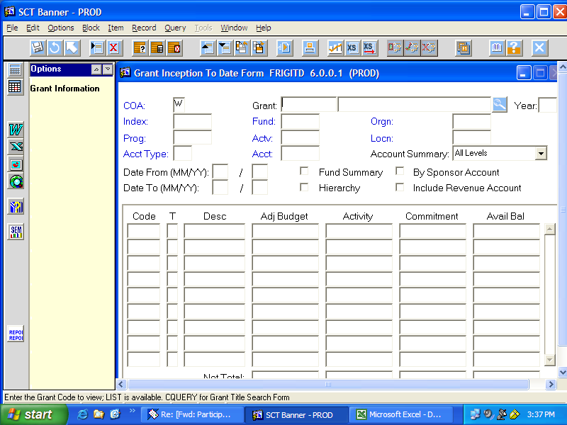

The Crystal Reports are accessed by going into any BANNER screen from the menu options and clicking on the “Report/Report” symbol in the lower left corner. A menu of options will appear.

Grant related indexes will use either:
- Grant Budget Management Combo Reports (4 reports in 1), or
- Grant Budget Summary Report (only)

All non-grant related indexes will use either:
- Budget Management Combo Reports (4 reports in 1), or
- Budget Summary Report (only)

-3-
Online Banner Reports

NOTE: The first time you run a report from the list below, it gives you a
"Security Warning" about the Crystal Reports ActiveX viewer. Click the YES
button and you will not be asked to do this again.

FINANCE Reports

1. Requisition Print Report
With Account Distribution by Line item (With Name Lookup option)

2. Budget Management Combo Reports (Four Reports in One)
Budget Summary, Transaction Detail
Open Commitments, Vendor Checks Paid Detail

3. Budget Summary Report (Only)
This is the Budget Summary by itself, no detail reports included
4. Commodity Codes Report (by Comm Code)

5. Commodity Codes Report (by Acct Code)

6. Invoice Transaction Summary

7. Transmittal Transaction Summary

8. Outstanding Invoice Summary

9. Year To Date Transaction Report

10. Grant Budget Management Combo Reports (Four Reports in One)
Grant Budget Summary, Transaction Detail
Open Commitments, Vendor Checks Paid Detail

11. Grant Budget Summary Report (Only)
This is the Budget Summary by itself, no detail reports included

12. Bookstore Charges Date Prompt Report

-4-

Type your User ID and Password identically to how your logged onto BANNER at the beginning of your session. (i.e. u_fordgs and your password)
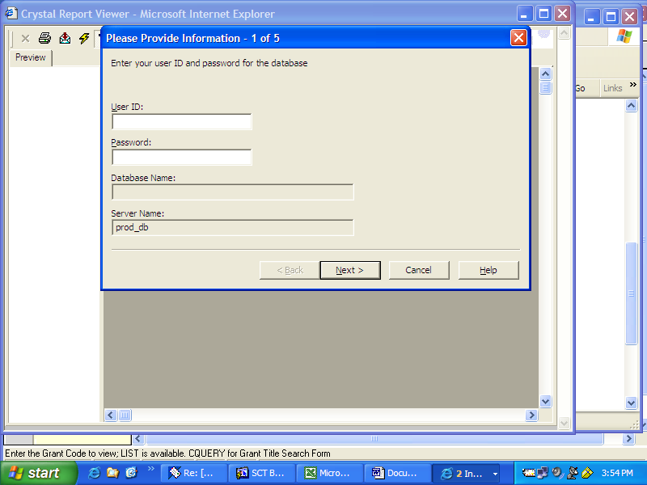

-5-

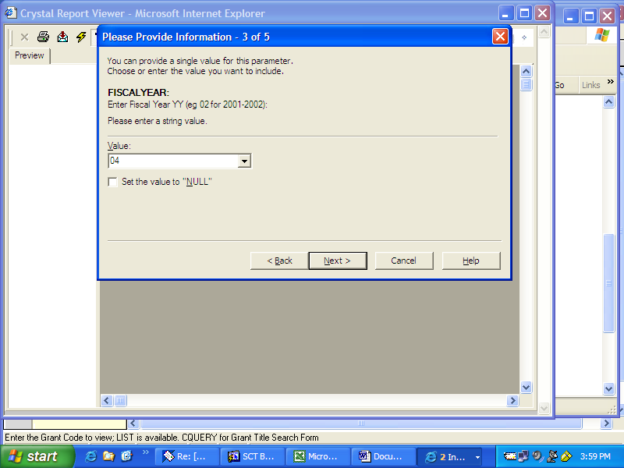

Enter the last two digits of the fiscal year you wish to see. Default is set at 04 for the current “03/04” fiscal year.

-6-

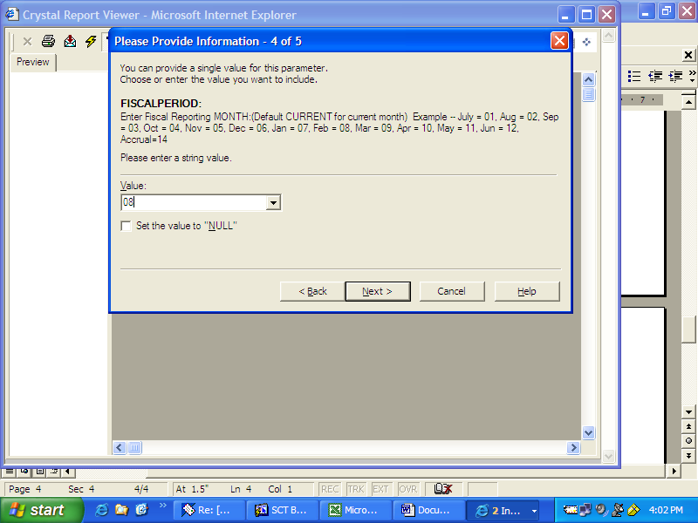

Enter the number of the month you wish to review.

Note: July is the first month of the fiscal year & is designated as 01

The default is set at CURRENT & will give you the current month’s report in which you are making the request.

-7-

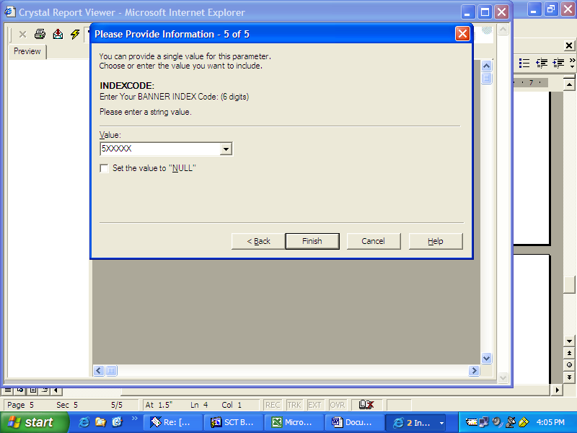

Enter the six digit index number & follow the prompts at the bottom and Finish to complete the query.

-8-
E
D
A
3
4
FUND:
ORGN:
ACCOUNT
525118
241401
Western Kentucky University
Banner Finance Budget Summary - Grants
Financial Manager:
Sharon Young
Test Grant
------------ ACTUALS -------------
Curr Month
Fiscal Year
Project
Available Balance
Revised
---------- BUDGETS ----------
Commitments
Account Title
2/20/2004
10:07:30AM
Fiscal
Page 9
For Fiscal Year
04
02 - Aug
Period Status:
Closed
Project Budget
Project Year
0.00
0.00
118,491.52
167,660.35
962,312.53
0.00
-962,312.53
54110
Grants & Contracts - Federal
Government Grants & Contracts
Total:
54
0.00
118,491.52
167,660.35
0.00
-962,312.53
0.00
962,312.53
0.00
396,581.00
31,462.80
62,618.81
327,014.50
0.00
69,566.50
61111
Wages - Regular
0.00
0.00
0.00
0.00
0.00
0.00
0.00
61118
Wages - Fac & Staff Supplemental
0.00
38,129.00
3,266.76
4,534.70
15,721.96
0.00
22,407.04
61123
Wages - Part-time
0.00
0.00
0.00
0.00
6,692.70
0.00
-6,692.70
61150
Wages - Occasional
0.00
675.00
0.00
0.00
684.33
0.00
-9.33
61160
Wages - Consulting
9,981.00
35,925.00
5,427.88
7,999.37
41,627.58
0.00
-5,702.58
61501
Wages - Student Institutional
Employee Salaries & Wages
Total:
61
9,981.00
40,157.44
75,152.88
0.00
79,568.93
471,310.00
391,741.07
2,780.00
123,099.00
0.00
0.00
0.00
0.00
123,099.00
62050
Fringe Benefits (Budget)
0.00
0.00
522.50
977.85
4,875.84
0.00
-4,875.84
62115
Emplyr - MQFE
0.00
0.00
2,234.11
4,181.25
20,848.25
0.00
-20,848.25
62120
Emplyr - FICA
0.00
0.00
1,150.11
2,282.14
12,958.57
0.00
-12,958.57
62122
Emplyr - Retirement KERS
0.00
0.00
1,279.28
2,558.56
13,645.47
0.00
-13,645.47
62123
Emplyr - Retirement KTRS
0.00
0.00
151.62
303.24
1,289.96
0.00
-1,289.96
62125
Emplyr - Retirement KTRS OPT
0.00
0.00
221.10
442.20
2,437.16
0.00
-2,437.16
62126
Emplyr - Retirement OPT
0.00
0.00
3,326.21
6,857.39
37,918.88
0.00
-37,918.88
62223
Emplyr - Health Insurance
0.00
0.00
28.32
57.23
290.20
0.00
-290.20
62224
Emplyr - Life Insurance
0.00
0.00
66.06
131.47
666.60
0.00
-666.60
62227
Emplyr - Disability Insurance
0.00
0.00
224.88
420.85
2,193.80
0.00
-2,193.80
62232
Emplyr - Worker's Compensation
0.00
0.00
1,329.90
2,659.80
10,682.27
0.00
-10,682.27
62240
Emplyr - Medical Waiver
Fringe Benefits
Total:
62
2,780.00
10,534.09
20,871.98
0.00
15,292.00
123,099.00
107,807.00
0.00
26,750.00
0.00
0.00
0.00
0.00
26,750.00
71100
Supplies
0.00
0.00
31.98
31.98
3,824.12
0.00
-3,824.12
71102
Supplies - Office
0.00
0.00
538.37
538.37
3,663.55
0.00
-3,663.55
71103
Supplies - Janitorial & Maintena
0.00
0.00
336.49
336.49
10,573.71
0.00
-10,573.71
71109
Supplies - Classroom
0.00
0.00
0.00
0.00
0.00
399.90
-399.90
71111
Supplies - Photo
0.00
0.00
15.93
15.93
410.76
0.00
-410.76
71120
Supplies - Food Products
0.00
0.00
52.60
52.60
356.31
0.00
-356.31
71122
Supplies - Grounds Maintenance
0.00
0.00
0.00
0.00
55.54
0.00
-55.54
71149
Supplies - Other Miscellaneous
0.00
112.00
0.00
0.00
0.00
0.00
112.00
71200
Utilities & Telephone
0.00
0.00
1.39
1.39
3.52
0.00
-3.52
71202
Telephone - Long-distance
0.00
290.00
0.00
0.00
0.00
0.00
290.00
71300
Postage & Freight
0.00
0.00
0.00
26.68
499.07
0.00
-499.07
71310
Postage & Freight - Postage
0.00
1,035.00
0.00
0.00
0.00
0.00
1,035.00
71400
Insurance
0.00
5,310.00
0.00
0.00
0.00
0.00
5,310.00
71500
Equipment Purchase (< $500)
B bA
C
2
FUND:
5
6
7
ORGN:
ACCOUNT
525118
241401
Western Kentucky University
Banner Finance Budget Summary - Grants
Financial Manager:
Sharon Young
Test Grant
------------ ACTUALS -------------
Curr Month
Fiscal Year
Project
Available Balance
Revised
---------- BUDGETS ----------
Commitments
Account Title
2/20/2004
10:07:30AM
Fiscal
Page 10
For Fiscal Year
04
02 - Aug
Period Status:
Closed
Project Budget
Project Year
0.00
0.00
0.00
0.00
48.50
0.00
-48.50
71507
Equip - Maintenance (< $500)
0.00
720.00
0.00
0.00
0.00
0.00
720.00
71700
Rental & Leases (< $ 10,000)
0.00
405.00
0.00
0.00
0.00
0.00
405.00
71800
Subscriptions & Dues
0.00
0.00
0.00
0.00
150.00
180.00
-330.00
71801
Subscriptions & Dues - Dues
0.00
3,800.00
0.00
0.00
0.00
0.00
3,800.00
72100
Repairs & Maintenance
0.00
0.00
0.00
0.00
0.00
0.00
0.00
72101
Maintenance - Copy Machine
0.00
0.00
0.00
0.00
2,632.80
0.00
-2,632.80
72105
Maintenance - Computer Software
0.00
450.00
0.00
0.00
0.00
0.00
450.00
72204
Non-Emplyee Serv - Consulting
0.00
3,875.00
120.00
300.00
5,290.00
0.00
-1,415.00
72209
Non-Emplyee Serv - Medical
0.00
0.00
0.00
0.00
0.00
0.00
0.00
72301
Sub-Grants & Contracts (< $ 25,0
205,914.00
532,677.00
60,000.00
60,000.00
386,763.00
142,094.00
3,820.00
72311
Sub-Grants & Contracts (> $ 25,0
0.00
1,800.00
0.00
0.00
0.00
0.00
1,800.00
73500
Miscellaneous Expenses
0.00
0.00
0.00
0.00
374.62
0.00
-374.62
73502
Misc - Advertising
0.00
0.00
0.00
0.00
375.00
0.00
-375.00
73514
Misc - Accreditation Fees
25.00
0.00
0.00
0.00
25.00
50.00
-75.00
73515
Misc - Licensing Fees
0.00
0.00
0.00
0.00
0.00
0.00
0.00
73549
Misc - Other
0.00
5,043.00
0.00
0.00
0.00
0.00
5,043.00
73900
Interdepartmental Charges
0.00
0.00
0.00
0.00
198.68
0.00
-198.68
73901
Charges from - Fac Mgt - Labor
0.00
0.00
0.00
0.00
0.00
0.00
0.00
73902
Charges from - Fac Mgt - Supplie
0.00
0.00
180.00
180.00
1,620.00
0.00
-1,620.00
73910
Charges from - Local Phone
0.00
0.00
11.52
11.52
115.57
0.00
-115.57
73911
Charges from - Long Distance Pho
0.00
0.00
1,862.85
1,862.85
2,408.01
0.00
-2,408.01
73920
Charges from - Printing Services
General & Administrative Expense
Total:
71
205,939.00
63,151.13
63,357.81
142,723.90
20,155.34
582,267.00
419,387.76
0.00
1,000.00
0.00
0.00
0.00
0.00
1,000.00
74000
Travel Expenses
0.00
0.00
0.00
0.00
171.20
0.00
-171.20
74101
In-State - Emplyee Travel
0.00
0.00
0.00
0.00
205.00
0.00
-205.00
74110
In-State - Emplyee Registration
0.00
0.00
75.00
75.00
275.00
0.00
-275.00
74130
In-State - Non-Emplyee Travel
0.00
0.00
0.00
0.00
130.00
0.00
-130.00
74201
OutState - Emplyee Travel
0.00
0.00
250.00
250.00
250.00
0.00
-250.00
74210
OutState - Emplyee Registration
0.00
0.00
0.00
0.00
24.60
0.00
-24.60
74231
OutState - Non-Emplyee Consultan
Travel Expenses
Total:
74
0.00
325.00
325.00
0.00
-55.80
1,000.00
1,055.80
0.00
0.00
0.00
0.00
30.00
0.00
-30.00
77911
Part Support - Tuition & Fees
0.00
0.00
0.00
0.00
100.00
0.00
-100.00
77916
Part Support - Travel
Student Aid & Scholarship Expens
Total:
77
0.00
0.00
0.00
0.00
-130.00
0.00
130.00
0.00
6,162.00
0.00
0.00
0.00
0.00
6,162.00
78100
Inventoried Equipment (> $ 500)

8
11 109

10 10
12
13
14

15\
9

FUND:
ORGN:
ACCOUNT
525118
241401
Western Kentucky University
Banner Finance Budget Summary - Grants
Financial Manager:
Sharon Young
Test Grant
------------ ACTUALS -------------
Curr Month
Fiscal Year
Project
Available Balance
Revised
---------- BUDGETS ----------
Commitments
Account Title
2/20/2004
10:07:30AM
Fiscal
Page 11
For Fiscal Year
04
02 - Aug
Period Status:
Closed
Project Budget
Project Year
Property, Plant & Equipment
Total:
78
0.00
0.00
0.00
0.00
6,162.00
6,162.00
0.00
1,021.00
51,693.00
4,323.86
7,952.68
42,190.90
0.00
9,502.10
79110
F & A - Federal
Facilities & Admin Cost Expense
Total:
79
1,021.00
4,323.86
7,952.68
0.00
9,502.10
51,693.00
42,190.90
0.00
118,491.52
167,660.35
0.00
-962,312.53
Total Fund REVENUE
0.00
962,312.53
12,761.00
206,960.00
50,691.53
67,799.99
96,024.86
71,635.49
0.00
142,723.90
94,860.93
35,633.64
Total PERSONNEL EXP
Total NON-PERSONNEL EXP
Total Fund EXPENSE
219,721.00
118,491.52
167,660.35
142,723.90
130,494.57
594,409.00
641,122.00
1,235,531.00
499,548.07
462,764.46
962,312.53

Trans
Date
Trans
Code
Transaction Description
Doc
Code
Budget
Activity
Current Transaction
Activity (ACTUAL)
Commitment
Activity
525118
Orgn:
241401
Test Grant
Fund:
Page 12
2/20/2004
Test Org
Western Kentucky University
Banner Finance Budget Transaction Summary
10:07:30AM
02 - Aug
Fiscal
For Fiscal Year
04
Period Status:
Closed
Reference
Code
54110
Grants & Contracts - Federal
G0000506
GRRV
08/31/2003
118,491.52
Grant - Accrued Revenue
Total:
54110
Grants & Contracts - Federal
0.00
118,491.52
0.00
61111
Wages - Regular
F0004503
HGNL
08/08/2003
787.50
HR Payroll 2003 BW 16 0
F0004566
HGNL
08/15/2003
9,082.60
HR Payroll 2003 SM 15 0
F0004803
HGNL
08/22/2003
787.50
HR Payroll 2003 BW 17 0
F0004931
HGNL
08/29/2003
12,268.42
HR Payroll 2003 MN 8 0
F0004988
HGNL
08/29/2003
9,570.78
HR Payroll 2003 SM 16 0
F0005094
HGNL
08/27/2003
-1,034.00
HR Payroll 2003 SM 15 1
Total:
61111
Wages - Regular
0.00
31,462.80
0.00
61123
Wages - Part-time
F0004503
HGNL
08/08/2003
1,667.30
HR Payroll 2003 BW 16 0
F0004803
HGNL
08/22/2003
1,599.46
HR Payroll 2003 BW 17 0
Total:
61123
Wages - Part-time
0.00
3,266.76
0.00
61501
Wages - Student Institutional
F0004502
HGNL
08/08/2003
2,897.55
HR Payroll 2003 ST 16 0
F0004802
HGNL
08/22/2003
2,530.33
HR Payroll 2003 ST 17 0
J0016058
RB2
08/22/2003
9,981.00
Additional Allocations
Total:
61501
Wages - Student Institutional
9,981.00
5,427.88
0.00
62050
Fringe Benefits (Budget)
J0016058
RB2
08/22/2003
2,780.00
Additional Allocations
Total:
62050
Fringe Benefits (Budget)
2,780.00
0.00
0.00
62115
Emplyr - MQFE
F0004502
HGRB
08/08/2003
33.82
HR Payroll 2003 ST 16 0
F0004503
HGRB
08/08/2003
34.86
HR Payroll 2003 BW 16 0
F0004566
HGRB
08/15/2003
122.85
HR Payroll 2003 SM 15 0

Trans
Date
Trans
Code
Transaction Description
Doc
Code
Budget
Activity
Current Transaction
Activity (ACTUAL)
Commitment
Activity
525118
Orgn:
241401
Test Grant
Fund:
Page 13
2/20/2004
Test Org
Western Kentucky University
Banner Finance Budget Transaction Summary
10:07:30AM
02 - Aug
Fiscal
For Fiscal Year
04
Period Status:
Closed
Reference
Code
62115
Emplyr - MQFE
F0004802
HGRB
08/22/2003
27.40
HR Payroll 2003 ST 17 0
F0004803
HGRB
08/22/2003
33.80
HR Payroll 2003 BW 17 0
F0004931
HGRB
08/29/2003
162.58
HR Payroll 2003 MN 8 0
F0004988
HGRB
08/29/2003
121.28
HR Payroll 2003 SM 16 0
F0005094
HGRB
08/27/2003
-14.09
HR Payroll 2003 SM 15 1
Total:
62115
Emplyr - MQFE
0.00
522.50
0.00
62120
Emplyr - FICA
F0004502
HGRB
08/08/2003
144.55
HR Payroll 2003 ST 16 0
F0004503
HGRB
08/08/2003
149.07
HR Payroll 2003 BW 16 0
F0004566
HGRB
08/15/2003
525.22
HR Payroll 2003 SM 15 0
F0004802
HGRB
08/22/2003
117.16
HR Payroll 2003 ST 17 0
F0004803
HGRB
08/22/2003
144.54
HR Payroll 2003 BW 17 0
F0004931
HGRB
08/29/2003
695.25
HR Payroll 2003 MN 8 0
F0004988
HGRB
08/29/2003
518.54
HR Payroll 2003 SM 16 0
F0005094
HGRB
08/27/2003
-60.22
HR Payroll 2003 SM 15 1
Total:
62120
Emplyr - FICA
0.00
2,234.11
0.00
62122
Emplyr - Retirement KERS
F0004503
HGRB
08/08/2003
46.38
HR Payroll 2003 BW 16 0
F0004566
HGRB
08/15/2003
534.96
HR Payroll 2003 SM 15 0
F0004803
HGRB
08/22/2003
46.38
HR Payroll 2003 BW 17 0
F0004931
HGRB
08/29/2003
19.57
HR Payroll 2003 MN 8 0
F0004988
HGRB
08/29/2003
563.72
HR Payroll 2003 SM 16 0
F0005094
HGRB
08/27/2003
-60.90
HR Payroll 2003 SM 15 1
Total:
62122
Emplyr - Retirement KERS
0.00
1,150.11
0.00
62123
Emplyr - Retirement KTRS
F0004931
HGRB
08/29/2003
1,279.28
HR Payroll 2003 MN 8 0
Total:
62123
Emplyr - Retirement KTRS
0.00
1,279.28
0.00
62125
Emplyr - Retirement KTRS OPT

Trans
Date
Trans
Code
Transaction Description
Doc
Code
Budget
Activity
Current Transaction
Activity (ACTUAL)
Commitment
Activity
525118
Orgn:
241401
Test Grant
Fund:
Page 14
2/20/2004
Test Org
Western Kentucky University
Banner Finance Budget Transaction Summary
10:07:30AM
02 - Aug
Fiscal
For Fiscal Year
04
Period Status:
Closed
Reference
Code
62125
Emplyr - Retirement KTRS OPT
F0004931
HGRB
08/29/2003
151.62
HR Payroll 2003 MN 8 0
Total:
62125
Emplyr - Retirement KTRS OPT
0.00
151.62
0.00
62126
Emplyr - Retirement OPT
F0004931
HGRB
08/29/2003
221.10
HR Payroll 2003 MN 8 0
Total:
62126
Emplyr - Retirement OPT
0.00
221.10
0.00
62223
Emplyr - Health Insurance
F0004503
HGRB
08/08/2003
157.38
HR Payroll 2003 BW 16 0
F0004566
HGRB
08/15/2003
1,023.00
HR Payroll 2003 SM 15 0
F0004803
HGRB
08/22/2003
157.38
HR Payroll 2003 BW 17 0
F0004931
HGRB
08/29/2003
1,306.45
HR Payroll 2003 MN 8 0
F0004988
HGRB
08/29/2003
852.50
HR Payroll 2003 SM 16 0
F0005094
HGRB
08/27/2003
-170.50
HR Payroll 2003 SM 15 1
Total:
62223
Emplyr - Health Insurance
0.00
3,326.21
0.00
62224
Emplyr - Life Insurance
F0004503
HGRB
08/08/2003
0.71
HR Payroll 2003 BW 16 0
F0004566
HGRB
08/15/2003
11.83
HR Payroll 2003 SM 15 0
F0004803
HGRB
08/22/2003
0.71
HR Payroll 2003 BW 17 0
F0004931
HGRB
08/29/2003
4.44
HR Payroll 2003 MN 8 0
F0004988
HGRB
08/29/2003
11.23
HR Payroll 2003 SM 16 0
F0005094
HGRB
08/27/2003
-0.60
HR Payroll 2003 SM 15 1
Total:
62224
Emplyr - Life Insurance
0.00
28.32
0.00
62227
Emplyr - Disability Insurance
F0004503
HGRB
08/08/2003
1.65
HR Payroll 2003 BW 16 0
F0004566
HGRB
08/15/2003
19.08
HR Payroll 2003 SM 15 0
F0004803
HGRB
08/22/2003
1.65
HR Payroll 2003 BW 17 0
F0004931
HGRB
08/29/2003
25.74
HR Payroll 2003 MN 8 0
F0004988
HGRB
08/29/2003
20.11
HR Payroll 2003 SM 16 0
F0005094
HGRB
08/27/2003
-2.17
HR Payroll 2003 SM 15 1

Trans
Date
Trans
Code
Transaction Description
Doc
Code
Budget
Activity
Current Transaction
Activity (ACTUAL)
Commitment
Activity
525118
Orgn:
241401
Test Grant
Fund:
Page 15
2/20/2004
Test Org
Western Kentucky University
Banner Finance Budget Transaction Summary
10:07:30AM
02 - Aug
Fiscal
For Fiscal Year
04
Period Status:
Closed
Reference
Code
Total:
62227
Emplyr - Disability Insurance
0.00
66.06
0.00
62232
Emplyr - Worker's Compensation
F0004502
HGRB
08/08/2003
16.23
HR Payroll 2003 ST 16 0
F0004503
HGRB
08/08/2003
13.75
HR Payroll 2003 BW 16 0
F0004566
HGRB
08/15/2003
50.86
HR Payroll 2003 SM 15 0
F0004802
HGRB
08/22/2003
14.19
HR Payroll 2003 ST 17 0
F0004803
HGRB
08/22/2003
13.36
HR Payroll 2003 BW 17 0
F0004931
HGRB
08/29/2003
68.69
HR Payroll 2003 MN 8 0
F0004988
HGRB
08/29/2003
53.59
HR Payroll 2003 SM 16 0
F0005094
HGRB
08/27/2003
-5.79
HR Payroll 2003 SM 15 1
Total:
62232
Emplyr - Worker's Compensation
0.00
224.88
0.00
62240
Emplyr - Medical Waiver
F0004566
HGRB
08/15/2003
664.95
HR Payroll 2003 SM 15 0
F0004988
HGRB
08/29/2003
664.95
HR Payroll 2003 SM 16 0
Total:
62240
Emplyr - Medical Waiver
0.00
1,329.90
0.00
71102
Supplies - Office
F0004961
JE16
08/22/2003
31.98
07/03 BEST BUY 00004408
Total:
71102
Supplies - Office
0.00
31.98
0.00
71103
Supplies - Janitorial & Maintena
F0004961
JE16
08/22/2003
39.96
07/02 THE HOME DEPOT #2318
F0004961
JE16
08/22/2003
498.41
07/28 KENWAY DISTRIBUTORS INC
Total:
71103
Supplies - Janitorial & Maintena
0.00
538.37
0.00
71109
Supplies - Classroom
F0004961
JE16
08/22/2003
64.75
07/14 BOOKS/CDS
F0004961
JE16
08/22/2003
31.57
07/17 WM SUPERCENTER
F0004961
JE16
08/22/2003
102.04
07/22 PARENT-TEACHER STORE
F0004961
JE16
08/22/2003
138.13
07/22 WM SUPERCENTER
R0022196
P0021036
POLQ
08/27/2003
-399.90
Presentation Solutions

Trans
Date
Trans
Code
Transaction Description
Doc
Code
Budget
Activity
Current Transaction
Activity (ACTUAL)
Commitment
Activity
525118
Orgn:
241401
Test Grant
Fund:
Page 16
2/20/2004
Test Org
Western Kentucky University
Banner Finance Budget Transaction Summary
10:07:30AM
02 - Aug
Fiscal
For Fiscal Year
04
Period Status:
Closed
Reference
Code
71109
Supplies - Classroom
R0022196
R0022196
REQP
08/20/2003
399.90
Ann Workshop
Total:
71109
Supplies - Classroom
0.00
336.49
0.00
71111
Supplies - Photo
P0021036
P0021036
PORD
08/27/2003
399.90
Presentation Solutions
Total:
71111
Supplies - Photo
0.00
0.00
399.90
71120
Supplies - Food Products
F0004961
JE16
08/22/2003
15.93
07/23 KROGER #585 SL9
Total:
71120
Supplies - Food Products
0.00
15.93
0.00
71122
Supplies - Grounds Maintenance
F0004961
JE16
08/22/2003
16.62
07/07 LOWE'S #451
F0004961
JE16
08/22/2003
35.98
07/09 TARGET 00009589
Total:
71122
Supplies - Grounds Maintenance
0.00
52.60
0.00
71202
Telephone - Long-distance
I0088504
INNI
08/26/2003
1.39
Qwest
Total:
71202
Telephone - Long-distance
0.00
1.39
0.00
71801
Subscriptions & Dues - Dues
R0022368
R0022368
REQP
08/27/2003
180.00
Testing Source
Total:
71801
Subscriptions & Dues - Dues
0.00
0.00
180.00
72209
Non-Emplyee Serv - Medical
P0020479
I0086555
INEI
08/07/2003
120.00
-120.00
Lifeline Private Duty
R0021550
P0020479
POLQ
08/04/2003
-120.00
Lifeline Private Duty
P0020479
P0020479
PORD
08/04/2003
120.00
Lifeline Private Duty
Total:
72209
Non-Emplyee Serv - Medical
0.00
120.00
-120.00

Trans
Date
Trans
Code
Transaction Description
Doc
Code
Budget
Activity
Current Transaction
Activity (ACTUAL)
Commitment
Activity
525118
Orgn:
241401
Test Grant
Fund:
Page 17
2/20/2004
Test Org
Western Kentucky University
Banner Finance Budget Transaction Summary
10:07:30AM
02 - Aug
Fiscal
For Fiscal Year
04
Period Status:
Closed
Reference
Code
72311
Sub-Grants & Contracts (> $ 25,0
P0017654
I0086781
INEI
08/11/2003
60,000.00
-60,000.00
Sub Gant
J0016058
RB2
08/22/2003
10,444.00
Additional Allocations
P0017654
P0017654
CORD
08/25/2003
6,624.00
Sub Grant
Total:
72311
Sub-Grants & Contracts (> $ 25,0
10,444.00
60,000.00
-53,376.00
73515
Misc - Licensing Fees
R0022251
P0021040
POLQ
08/27/2003
-25.00
Kentucky State Treasurer
P0021040
P0021040
PORD
08/27/2003
25.00
Kentucky State Treasurer
R0022251
R0022251
REQP
08/22/2003
25.00
Testing Source
Total:
73515
Misc - Licensing Fees
0.00
0.00
25.00
73910
Charges from - Local Phone
F0005097
JE16
08/29/2003
180.00
Phone-Loc-Jul
Total:
73910
Charges from - Local Phone
0.00
180.00
0.00
73911
Charges from - Long Distance Pho
F0005097
JE16
08/29/2003
11.52
Phone-L/D-Jul
Total:
73911
Charges from - Long Distance Pho
0.00
11.52
0.00
73920
Charges from - Printing Services
F0004933
JE16
08/21/2003
92.50
Print - Jul 9216
F0004933
JE16
08/21/2003
245.35
Print - Jul 9350
F0004933
JE16
08/21/2003
257.00
Print - Jul 9354
F0004933
JE16
08/21/2003
1,013.00
Print - Jul 9355
F0004935
JE16
08/21/2003
95.00
Print - Jul 9349A
F0004935
JE16
08/21/2003
160.00
Print - Jul 9359B
Total:
73920
Charges from - Printing Services
0.00
1,862.85
0.00
74130
In-State - Non-Emplyee Travel
J0016053
R16
08/22/2003
75.00
I - Univ Vehicle
Total:
74130
In-State - Non-Emplyee Travel
0.00
75.00
0.00

Trans
Date
Trans
Code
Transaction Description
Doc
Code
Budget
Activity
Current Transaction
Activity (ACTUAL)
Commitment
Activity
525118
Orgn:
241401
Test Grant
Fund:
Page 18
2/20/2004
Test Org
Western Kentucky University
Banner Finance Budget Transaction Summary
10:07:30AM
02 - Aug
Fiscal
For Fiscal Year
04
Period Status:
Closed
Reference
Code
74210
OutState - Emplyee Registration
F0004961
JE16
08/22/2003
250.00
07/10 EDUCATIONAL SERVICES INC
Total:
74210
OutState - Emplyee Registration
0.00
250.00
0.00
79110
F & A - Federal
G0000506
GRIC
08/31/2003
4,323.86
Grant - Indirect Cost Charge
J0016058
RB2
08/22/2003
1,021.00
Additional Allocations
Total:
79110
F & A - Federal
1,021.00
4,323.86
0.00
Revenue Grand Totals:
0.00
118,491.52
Expense Grand Totals:
POCL - Purchase Order Close
PCRD - Cancel Purchase Order
RB1 - Research Acct. Permanent Adopted Budget
RB2 - Research Acct. Permanent Adjust. to Orig.
RB3 - Research Acct. Temporary Budget
RB4 - Research Acct. Adjust. to Temp Budget
R16 - Research Acct. Restricted Jounal Entry
RCQP - Cancel Requisition
REQP - Requisition Reservation
E010 - Original Encumbrance
BD01 - Permanent Adopted Budget
CHS1 - Banner Student Charges/Non-Cash Pay
CORD - Establish Change Order
HGNL - Payroll Gross Expenditures - No Liquidation
HGRB - Payroll Gross Benefit Expenditure
INEI - Invoice with Encumbrance
INNI - Direct Pays (Travel Voucher, Payment Auth.
INEC - Credit Memo with Encumbrance
JE16 - General Journal Entry (Interfund)
POLQ - Purchase Order Liquidation
PORD - Establish Purchase Order
Transaction Code Definitions:
24,226.00
118,491.52
-52,891.10
BLANK PAGE

----------------------------- COMMITMENT AMOUNTS ------------------------------
ORIGINAL
ADJUSTED
LIQUIDATED
Doc Code / Reference
Account
Vendor / Entry User Description
Orig Trans
Date
Status
Net
Outstanding
Western Kentucky University
Banner Finance Total Outstanding Commitment Summary
Sorted by Account Code
Encumbered in Fiscal Year
Through Fiscal Month:
2/20/2004
10:07:30AM
FUND:
ORGN:
INDEX
03
525118
525118
241401
Page 20
02
Test Grant
105,084.00
0.00
-64,954.00
40,130.00
P0017655 / R0018357
Sub Grant 2
04/16/2003
Open
72311
182,144.00
6,624.00
-86,804.00
101,964.00
P0017654 / R0018358
Sub Grant
04/16/2003
Open
72311
Total for Account:
72311
142,094.00
25.00
0.00
0.00
25.00
P0019657 / R0020579
Kentucky State Treasurer
06/27/2003
Open
73515
Total for Account:
73515
25.00
Total Outstanding Commitments through Posting Period:
142,119.00
02
----------------------------- COMMITMENT AMOUNTS ------------------------------
ORIGINAL
ADJUSTED
LIQUIDATED
Doc Code / Reference
Account
Vendor / Entry User Description
Orig Trans
Date
Status
Net
Outstanding
Western Kentucky University
Banner Finance Total Outstanding Commitment Summary
Sorted by Account Code
Encumbered in Fiscal Year
Through Fiscal Month:
2/20/2004
10:07:30AM
FUND:
ORGN:
INDEX
04
525118
525118
241401
02
Test Grant
Total for Account:
71109
0.00
399.90
0.00
0.00
399.90
P0021036 / R0022196
Presentation Solutions
08/27/2003
Open
71111
Total for Account:
71111
399.90
180.00
0.00
0.00
180.00
R0022368
Testing Source
08/27/2003
Open
71801
Total for Account:
71801
180.00
120.00
0.00
-120.00
0.00
P0020479 / R0021550
Lifeline Private Duty
08/04/2003
Liquidated this Period
72209
25.00
0.00
0.00
25.00
P0021040 / R0022251
Kentucky State Treasurer
08/27/2003
Open
73515
Total for Account:
73515
25.00
Total Outstanding Commitments through Posting Period:
604.90
02
----------------------------- COMMITMENT AMOUNTS ------------------------------
ORIGINAL
ADJUSTED
LIQUIDATED
Doc Code / Reference
Account
Vendor / Entry User Description
Orig Trans
Date
Status
Net
Outstanding
Western Kentucky University
Banner Finance Total Outstanding Commitment Summary
Sorted by Document Code
Encumbered in Fiscal Year:
Through Fiscal Month:
2/20/2004
10:07:30AM
FUND:
ORGN:
INDEX
03
525118
525118
241401
Page 21
02
Test Grant
25.00
0.00
0.00
25.00
P0019657 / R0020579
Kentucky State Treasurer
06/27/2003
Open
73515
105,084.00
0.00
-64,954.00
40,130.00
P0017655 / R0018357
Sub Grant 2
04/16/2003
Open
72311
182,144.00
6,624.00
-86,804.00
101,964.00
P0017654 / R0018358
Sub Grant
04/16/2003
Open
72311
Total Outstanding Commitments through Posting Period:
142,119.00
02
----------------------------- COMMITMENT AMOUNTS ------------------------------
ORIGINAL
ADJUSTED
LIQUIDATED
Doc Code / Reference
Account
Vendor / Entry User Description
Orig Trans
Date
Status
Net
Outstanding
Western Kentucky University
Banner Finance Total Outstanding Commitment Summary
Sorted by Document Code
Encumbered in Fiscal Year:
Through Fiscal Month:
2/20/2004
10:07:30AM
FUND:
ORGN:
INDEX
04
525118
525118
241401
Page 1 of 1
02
Test Grant
180.00
0.00
0.00
180.00
R0022368
Amber L Reed
08/27/2003
Open
71801
25.00
0.00
0.00
25.00
P0021040 / R0022251
Kentucky State Treasurer
08/27/2003
Open
73515
399.90
0.00
0.00
399.90
P0021036 / R0022196
Presentation Solutions
08/27/2003
Open
71111
120.00
0.00
-120.00
0.00
P0020479 / R0021550
Lifeline Private Duty
08/04/2003
Liquidated this Period
72209
Total Outstanding Commitments through Posting Period:
604.90
02
525118
02
04
Test Grant
525118
241401
FUND:
ORGN:
INDEX:
Western Kentucky University
Banner Finance Vendor Checks Paid Summary
For Fiscal Year
Fiscal
Invoice
Code
Acct
Vendor / Description
Page 22
02/20/2004
10:07:30AM
Document
Code
Trans
Code
Check Number
Check Date
Check Amount
Vendor Invoice Code
71202
Qwest
I0088504
INNI
00133477
08/27/2003
1.39
565141070
72209
Lifeline Private Duty Services Inc
I0086555
P0020479
INEI
00126769
08/08/2003
120.00
105371
72311
Sub Grant
I0086781
P0017654
INEI
00126899
08/12/2003
60,000.00
P0017654A

FGIBDST – Organization Budget Status Form
This form is one of the most used forms by those who need information about their Operating Budget. It displays expenses, revenue and encumbrances for an index, and leads to three other very helpful forms.

- Type in Chart W

- Type in Fiscal Year 04 for 2003-2004
Fiscal Year 03 for 2002-2003

- Type in your assigned index

- Your Organization, Fund & Program should populate.
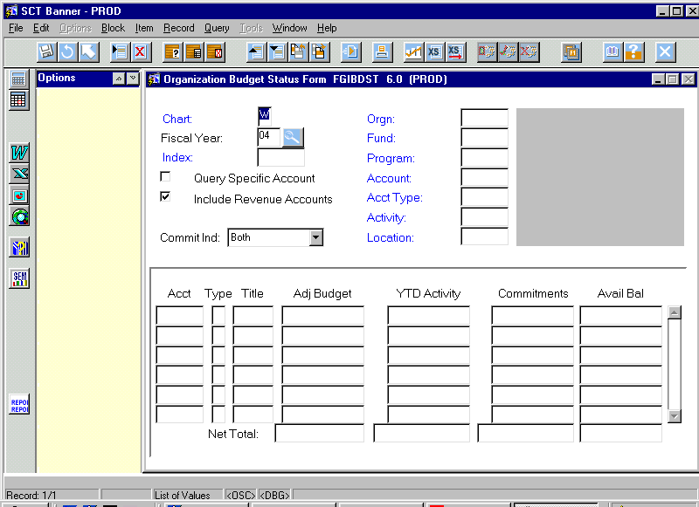

Banner Questions: I have a Negative line on my Adjusted Budget?

My Organization’s revenue nets against my expenses and I can not quickly determine my Adjusted Budget?

Answer: If you have revenue included in your account, or if you have no revenue, you must remove the check that includes revenue accounts in the appropriate item. If you do not remove the check, then your bottom available amount will not show correctly.

-23-

Go to the next block to see your next level of activity
Banner Question: When I open the form, the adjusted budget, the year to data activities, commitments, & available balances do not reflect my totals!

Answer: The end user must scroll down to the end of all your account numbers in your organization to see total of all your columns.
.

Account & Title: The account is the type of revenue and expenses charged to your accounts.

Adjusted budget: The number includes any and all budgets to your organization.

YTD Activity: This line will include all expenses. These will include invoices processes on the system, inter-accounts, & system feeds (i.e. postage, phone, Procard, etc.).

Commitments: When a requisition is approved and turned into a purchase order then the amount will encumber and reserve against your budget.

-24-

FRIGITD: Grant Inception to Date Form

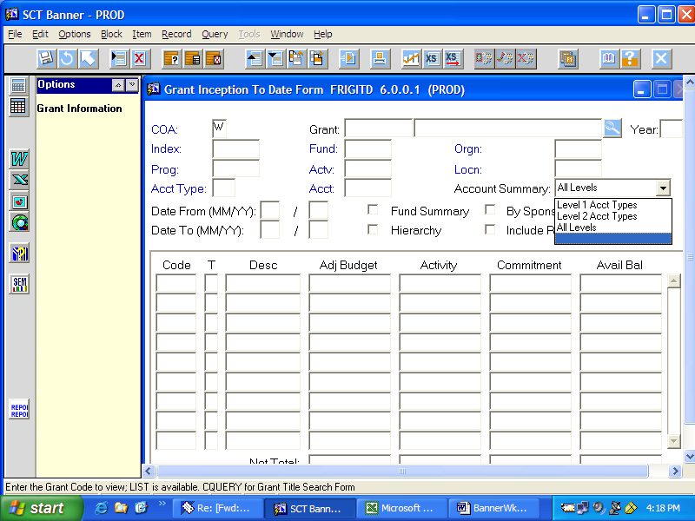

Enter your index #, tab to the next block and use the control/page down keys (or next block) to see the account code detail.

This form summarizes the grant budget & activity from the inception date to the current date or “today’s” date and summarizes each account code for indexes beginning with either a 5 or 6 (grants or cost-sharing). It does not work for other indexes.

In the Account Summary section you have 3 options of viewing the information:
- All levels shows you each account code that has budget and or activity (from here you can drill down to more detail.)
- Level 2 shows you a rolled up summary
- Level 1 shows you a summary segregated between payroll and non-payroll items.

You can also request expenditure information within a certain time period.

-25-

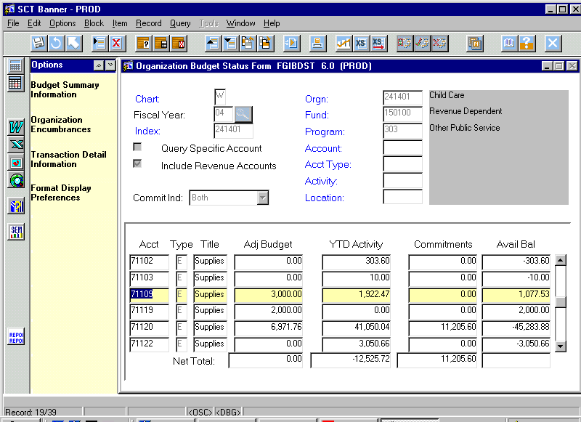
How do I examine detail transactions in my accounts?

- Banner will allow you to examine your detail for you Adjusted Budget, YTD Activity, & Commitments columns for each line

Banner Hint: You will not be able to view the detail under your available balance column since this is just a combination of the other three columns.

- Place your cursor on the block that you wish to examine your detail. You can examine entries to your

- Click on the above description on your side bar.

- You will now be in the second level of banner information.

Banner Hint: Examine these forms in different ways so that you are comfortable with the information that these forms provide. These forms are only inquiry so that you can not adjust the related transactions. One of Banner’s strength is the end user’s ability to access data.
-26-

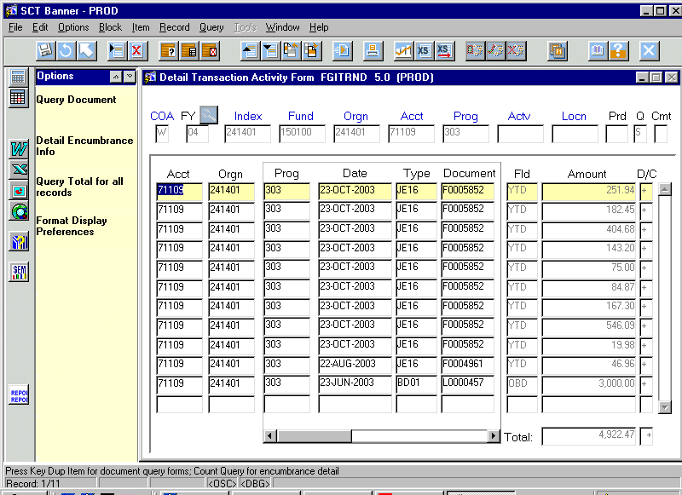
Second Level Account Examination

- Now you have all the detailed information behind this account total
- A positive is a debit or charge to as listed on your inter-account form, and a credit is a reduction of the expenses charged to your account.
- The form gives you the type of entry that was performed to your account. Entries will be accounting feeds, payroll entries, general accounting entries, budget entries, travel entries, grant entries, cash receipts (for revenue dependant accounts), cash disbursements & encumbrance entries. Some of the more comment entries that you will find are follows:
BD01 Permanent Adopted Budget
BD02 Permanent Budget Adjustments
BD03 Temporary Adopted Budget
BD04 Temporary Budget Adjustment
JE16 General Journal Entry (Inter-fnd)
JE15 General Journal Entry (Intra-fnd)
CR05 Cash Receipt Entry
E010 & E012 Posts an original encumbrance
E011 & E013 Posts an original budget reservation for encumbrance.
E020 Posts an encumbrance adjustment
-27-

- The document number helps you determine the type of transaction that was processed against your account.

Banner Example: P000000 would mean the document is a purchase order.

- To further examine a document for detail information, highlight that document and click on Query Document on your left menu panel.

-28-

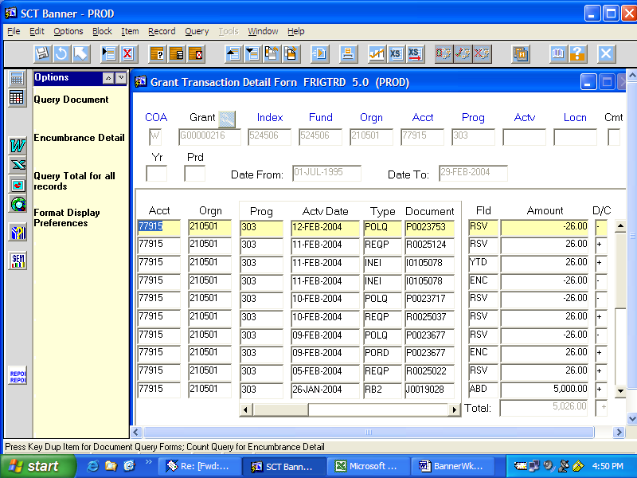

To locate a specific item or items in the transaction detail form one can:

- Hit the F7 key to clear out all information listed
- Go to a particular field such as FLD or AMOUNT and type in the information you wish to find (i.e. to look at all expenditures that have posted you would type YTD in the FLD column)
- Hit F8 to initiate your query

-29-

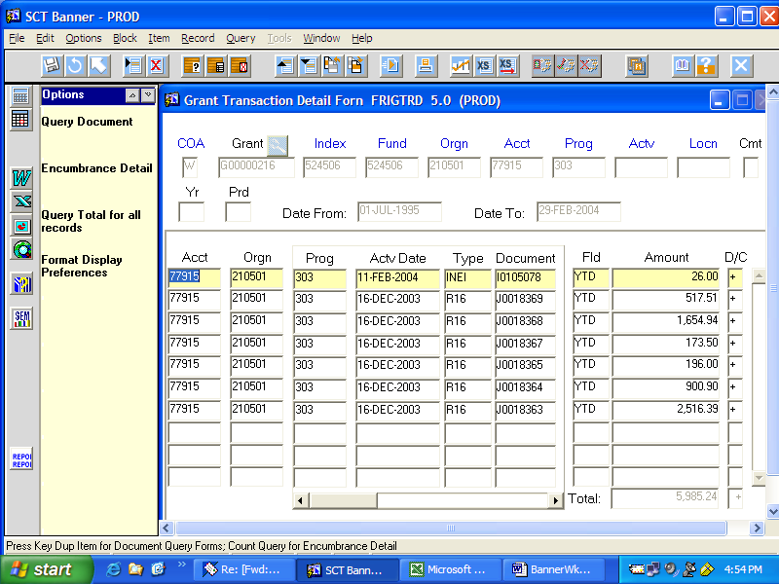

-30-

Third Level Account Examination
- Clicking on the Query Document brings you into Banner’s Document Retrival Form (FGIDOCR). You can directly access this form with out going to your account if you know the document number and would like to check this information.

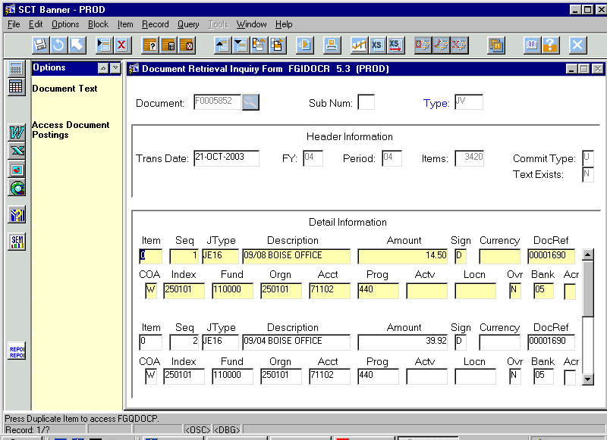
- Go to Next Block

- This screen gives you detail information on the transaction that was processed. It lists all the information that was processed with this transaction.

Banner Hint: Any More Drilldowns is the internal processing of the system and it does not provide any additional data information to the department. Don’t let this confuse you!

Banner Question: What do I do if I want to go back and check to see if I have correctly sent an inter-account or to verify if the inter-account has been processed correctly against someone else’s account?

Answer: Examine the accounts and organizations to verify if this information is correct as seen above.
-31-

FGIBSUM – Organization Budget Summary

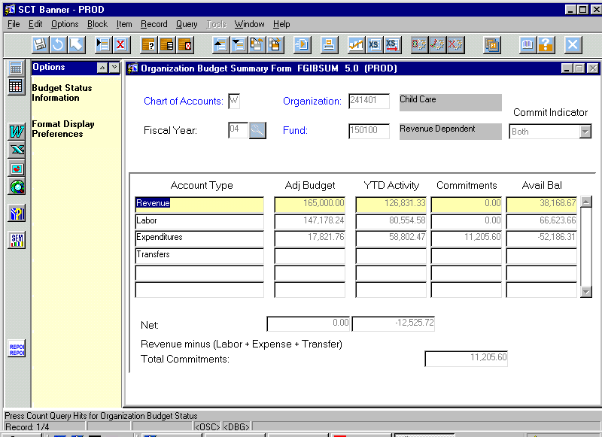
This form provides a summary of budgetary information by Organization and Fund. Summary information is obtained by four major category types: Revenue, Labor, Direct Expenditures and Transfers.

Th

- Enter organization and fund. Totals will be returned for all funds and programs within the organization.
- Click next block to retrieve data.

-32-

FGIOENC – Organizational Encumbrance List Form

FGIENCD – Detail Encumbrance Activity

These are two forms you can use to obtain encumbrance information.

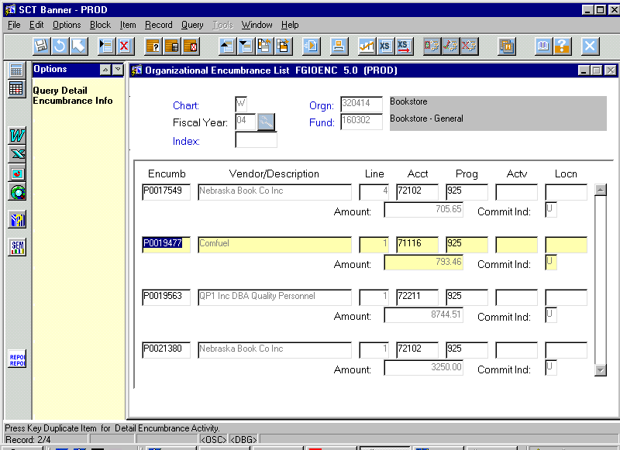

- Enter in your index number, click on NEXT BLOCK to process query.

- To obtain detail summarized in this form, you can scroll up or down to select an encumbrance.

- Then click on Query Detail Encumbrance Info’ in the Options Menu.

-33-

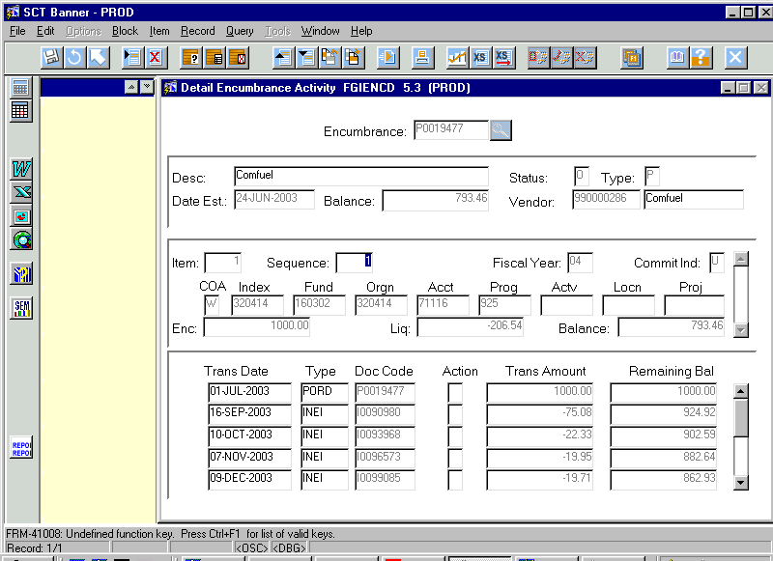
- This will bring you to the form FGIENCD, Detail Encumbrance Activity, for viewing the detailed activity of an encumbrance.

-34-

FOIDOCH: Document History Form

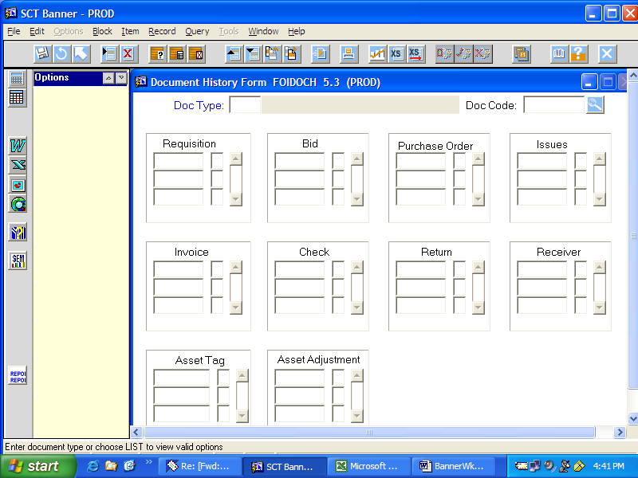

The Document History Form allows you to research any type of expenditure that will result in a check being issued from Accounts Payable. From here, one can track the progress of a purchase from its inception to the point of final payment. Any information known about the purchase can be used to pinpoint it and reveal all of its activity.

The following document types are some of the more commonly used options:
REQ Requisition
PO Purchase Order
CHK Check
INV Invoice
RCV Receiver
The document code is the action transaction number assigned by Banner (i.e. PO# or Requisition #)
-35-
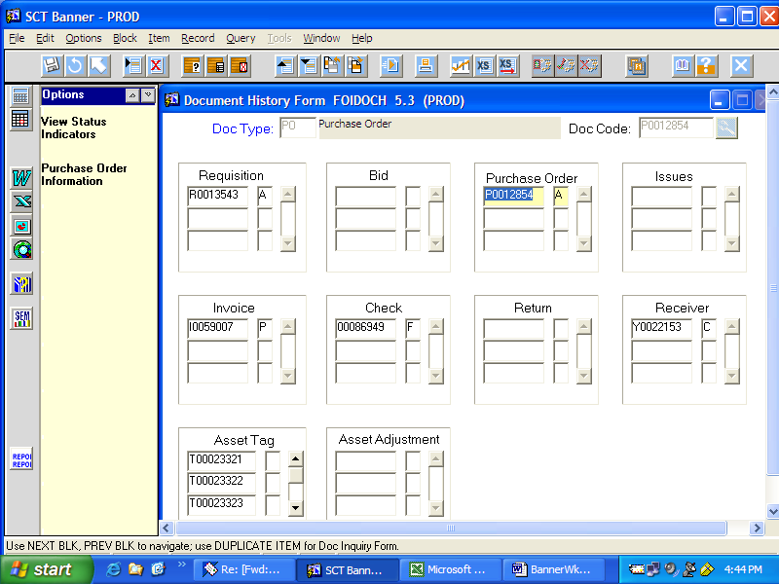

Based on the field highlighted, the options in the yellow column will change to provide the information needed. In other words, if you have highlighted the purchase order number, Banner will provide you with the option of obtaining information concerning the vendor, buyer, order date, text material and commodity information.

Highlighting the check information will allow you to obtain information concerning that payment such as a check date, amount, invoices that were paid on that check and information about where the check is mailed to.

-36-

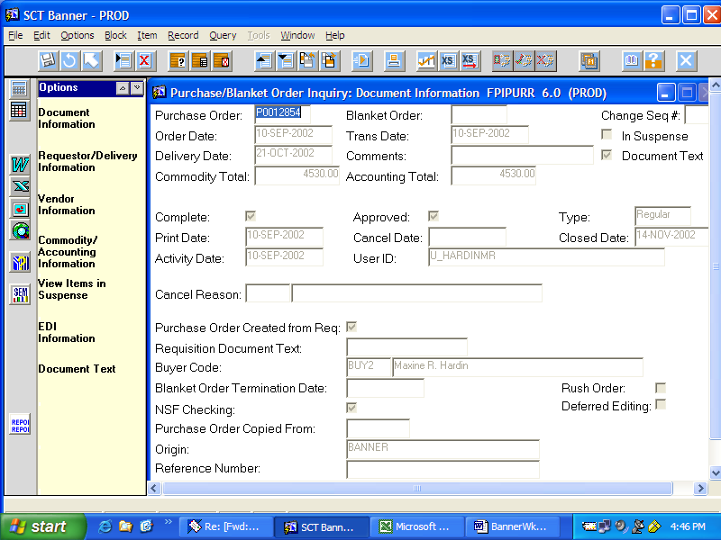

-37-

