WKU Infoview Reports

To generate Labor Distribution Reports that provide the detail of labor and fringe expenses charged to the department, follow the procedures listed below.
To be able to create the reports listed below, you must have an Info View account and you must have HR Organizational security established. If you do not have an Info View account, contact Administrative Systems and Applications at 745-8812. If you do not have HR organizational security, contact Patty Booth in Human Resources at 745-3038 or patty.booth@wku.edu.
These reports reside in the HR Secure folder under WKU Campus Community in Info View and are scheduled differently than other reports. The following outlines the correct way to schedule reports that rely on HR organization security.

Step 1: Click on Document List
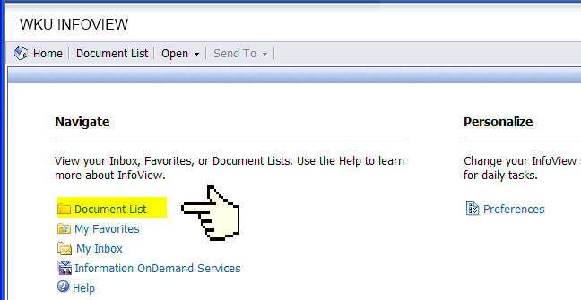

Step 2: Click on Public Folders
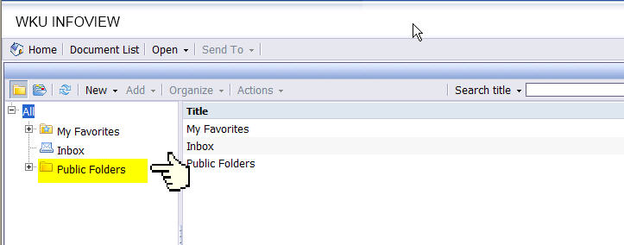

Step 3: Double - Click on WKU Campus Community
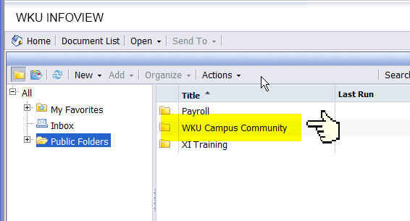

Step 4: Double - Click on HR Secure
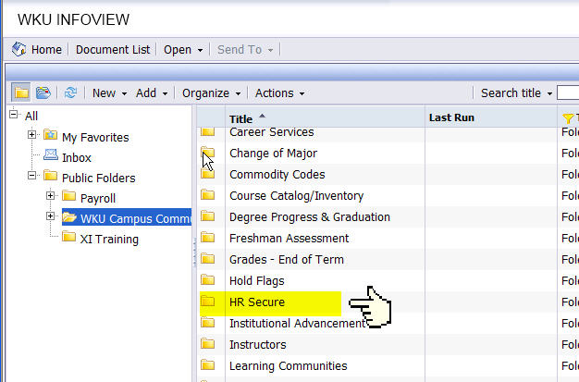

Step 5: Double right-click on the report you want to run. (Very Important)
Choose View the report.

HR_pay_nhrdist_byemployee_secure.rpt . . . Labor expenses by Fund, Orgn, and Employee -- Login required
or
HR_nhrdist_pickemp_foapal_secure.rpt . . . . Labor expenses by employee between specified dates--Login required
or
HR_pay_nhrdist_fytd_secure.rpt . . . . Labor expenses by fund grouped by account code, includes fiscal ytd totals--Login required

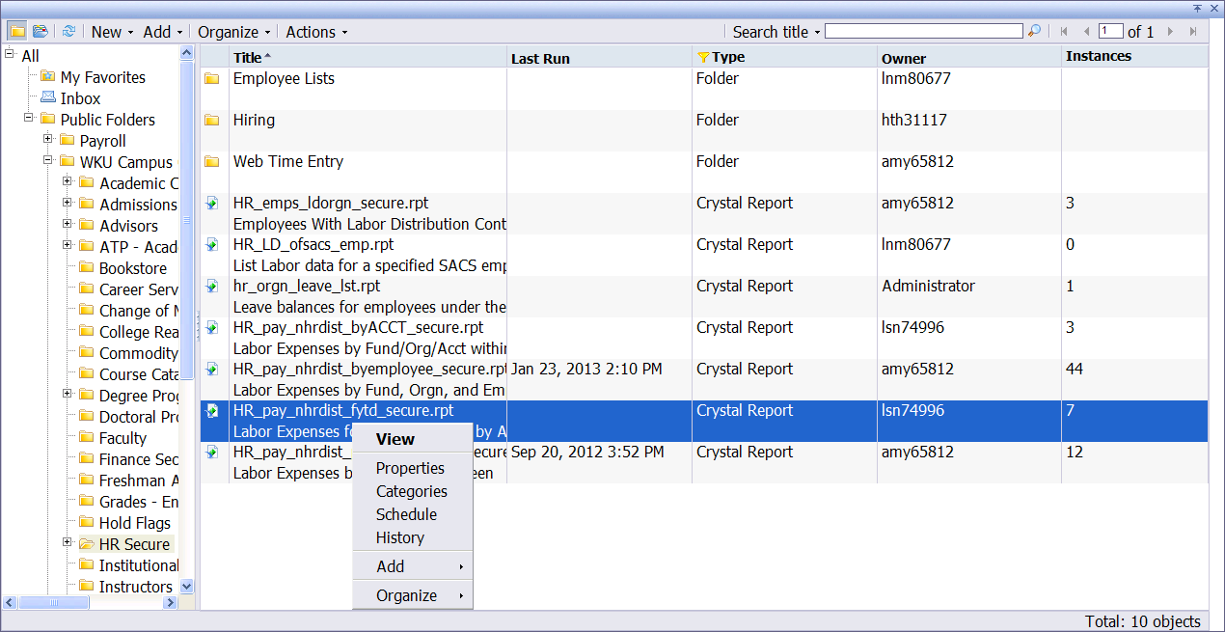

Step 6: Enter all the parameter(s) and click the OK button. (See image below for an example of date parameters).
Besides the dates (begin and end dates), you will need to know the fund and org to specify in the parameters to create the desired results in your report.

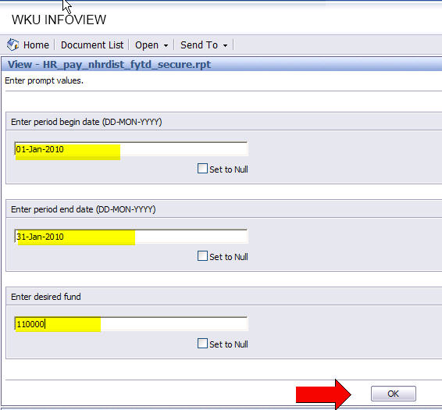

Step 7: The DATABASE LOGON prompt will appear. Enter your Oracle/Banner user id and password.
Click the OK button.

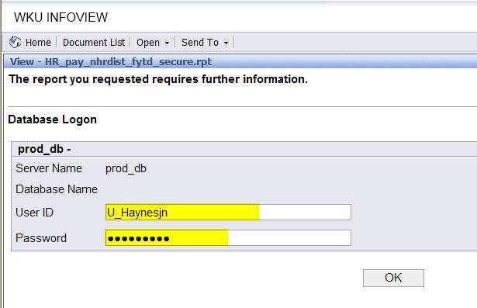

If you have the appropriate HR organizational security established and you have entered the parameters and database logon correctly, the report will execute and return the desired report. .
Users will only see report occurrences that belong to them. They will not be able to see reports that have been executed by someone else.
If you need additional assistance in running/viewing these reports or with your Oracle/Banner user id and password, please call 745-8812.
Thank you.
Payroll Department
01-28-2013

