Western Kentucky University National Pan-Hellenic Council proudly sponsors & presents One (1) $1400 scholarship

NPHC Community Engagement Scholarships

REQUIREMENTS:

* Student from an underrepresented community
* 2.75 cumulative GPA
* Fall 2024, full-time enrollment
* Open to all undergraduate students, regardless of NPHC affiliation
* 2 letter of recommendation (from a university staff/faculty member/leader of community)
* Resume included with application (include community service)
* Essays (of no more than 900 words each) answering the following prompts:
  + How has your community engagement impacted the community and yourself?
  + How has these experiences influenced your personal growth, values, and future goals?
  + How do you plan to continue or expand your efforts in community service?

DATES TO REMEMBER:

* November 6th - Deadline for the application. ***Incomplete or late applications will be NOT be accepted.***
* TBA - Recipients will be emailed and recognized on WKU NPHC Instagram account.

QUESTIONS?

Contact Yaniyah Taylor, NPHC Scholarship Chair, [yaniyah.taylor324@topper.wku.edu](mailto:yaniyah.taylor324@topper.wku.edu)

Or Jaida Tooley, NPHC President, Jaida.tooler733@topper.wku.edu

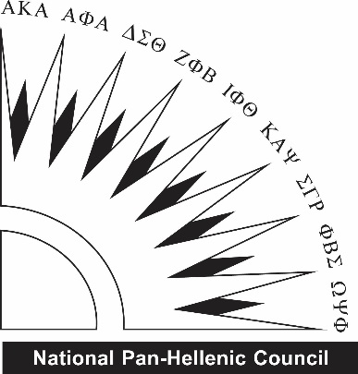

Western Kentucky University National Pan-Hellenic Council

NPHC Community Engagement SCHOLARSHIPS

**All applications are due November 6th.**to **nphc@wku.edu.** All questions should be directed to Yaniyah Taylor, NPHC Scholarship Chair or Jaida Tooley, NPHC President.

|  |  |
| --- | --- |
| **Name:** | **Email:** |
| **Cell Phone:** | **Current Class (Fr/So/Jr/Se):** |
| **Overall GPA:** | **WKU ID#:** |

|  |
| --- |
| **How has your community engagement impacted the community and yourself?** |

|  |
| --- |
| **How has these experiences influenced your personal growth, values, and future goals?** |

|  |
| --- |
| **How do you plan to continue or expand your efforts in community service?** |

DON’T FORGET TO ALSO SUBMIT:

* Resume