Western Kentucky University National Pan-Hellenic Council proudly sponsors & presents two (2) $800 scholarships

OUTSTANDING MINORITY STUDENT SCHOLARSHIPS

REQUIREMENTS:

* Student from an underrepresented community
* 3.0 cumulative GPA
* Fall 2024, full-time enrollment
* Open to all undergraduate students, regardless of NPHC affiliation
* 1 letter of recommendation (from a university staff/faculty member)
* Resume included with application (include community service)
* Essays (of no more than 250 words each) answering the following prompts:
  + Why do you feel you are deserving of a NPHC Outstanding Minority Student scholarship?
  + Explain the importance of education for those in underrepresented communities.

DATES TO REMEMBER:

* November 6th - Deadline for the application. ***Incomplete or late applications will be NOT be accepted.***
* TBA - Recipients will be emailed and recognized on WKU NPHC Instagram account.

QUESTIONS?

Contact Yaniyah Taylor, NPHC Scholarship Chair, [yaniyah.taylor324@topper.wku.edu](mailto:yaniyah.taylor324@topper.wku.edu)

Or Jaida Tooley, NPHC President, Jaida.tooler733@topper.wku.edu

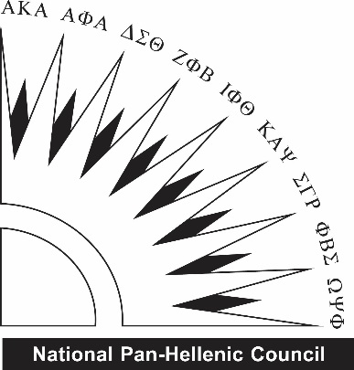

Western Kentucky University National Pan-Hellenic Council

OUTSTANDING MINORITY STUDENT SCHOLARSHIPS

**All applications are due November 6th.**to **nphc@wku.edu.** All questions should be directed to Yaniyah Taylor, NPHC Scholarship Chair or Jaida Tooley, NPHC President.

|  |  |
| --- | --- |
| **Name:** | **Email:** |
| **Cell Phone:** | **Current Class (Fr/So/Jr/Se):** |
| **Overall GPA:** | **WKU ID#:** |

|  |
| --- |
| ***Why do you feel you are deserving of a NPHC Outstanding Minority Student scholarship?*** |

|  |
| --- |
| ***Explain the importance of education for those in underrepresented communities.*** |

DON’T FORGET TO ALSO SUBMIT:

* Resume